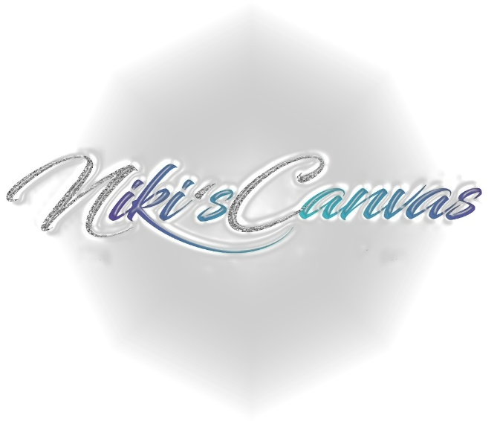
Client Loyalty & Referral Rewards Program:

Client Loyalty Program: Niki will always provide Loyal service to her clients; so in return, my loyal clients will receive a punch card. Every time client comes to receive a waxing service they must bring in their punch card to be stamped by Niki. When the tenth slot stamped on their punch card has been reached, they will receive a Complimentary Brazilian Wax service!!!

Referral Rewards Program: When a client refers a family or friend to get serviced by Niki’s Canvas LLC.; They will receive $5.00 off their next service. The client they refer must come in to receive their service before the referrer will receive their $5.00 credit.

