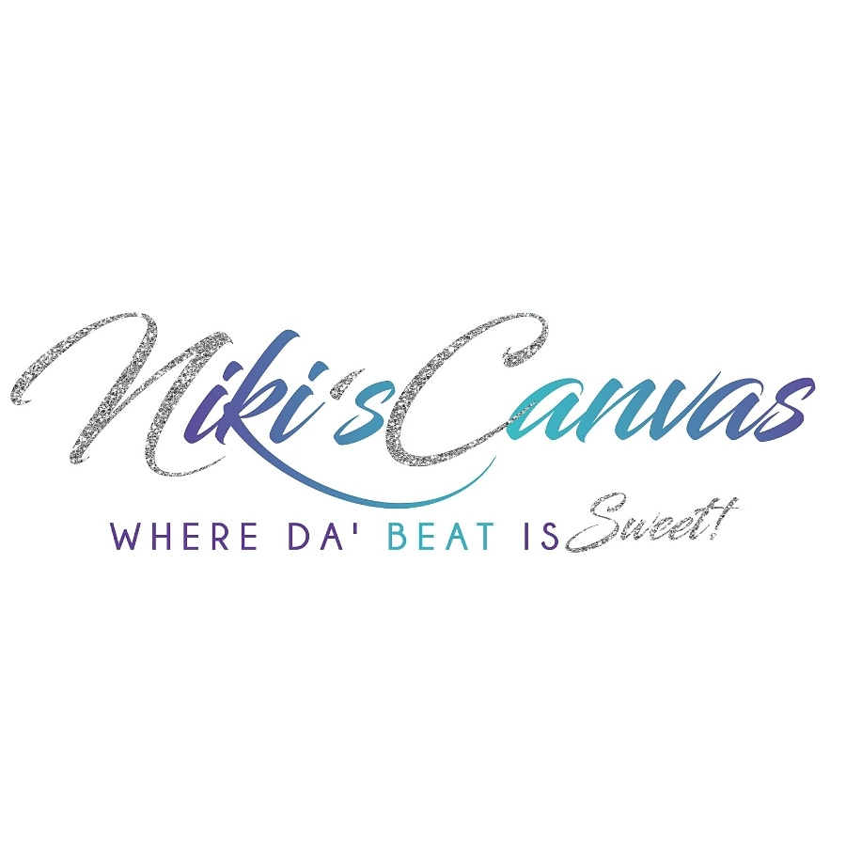

Minor Consent/Waiver Release Form

If client receiving waxing service are under the age of 18 years old, your Parent must assist in filling out this form. Parent must be present at the studio with their license or state identification as proof to ensure consent is given for the minor. All information below will regard information pertaining to the minor. Parent or Legal Guardian signature must be signed at the end of this form.

First Name: _______________________ Last Name: ________________________

Email Address: ___________________________

Date of Birth: ____________________________

Address: ________________________________ City/State: ____________________

Zip Code: ____________

Phone Number: _____________________

Have you shaved within 1 to 3 weeks from todays date? Yes [ ] or No [ ] **If yes, I am aware that some hairs will not be able to be picked up. Hairs must be at least ¼ inch to be picked up during waxing. (Description: At least a grain of w**h**ite rice).**

Have you currently used any of the following on the past 7 days?

[ ] Retin A [ ] Chemical Peels [ ] Tanning Beds/Sun Exposure [ ] Renova [ ]Tazarotene [ ] Differn

[ ] Glycolic Acid or Alpha Hydroxy Acid [ ] Skin Thinning Products [ ] Antibotics [ ] Asprin [ ]

[ ] Blood Pressure Medication

[ ] or any other acne topical/oral medications (Please list if so): _________________________________________________________________________

Have you used Accutane within the past year or currently taking Accutane? Yes [ ] or No [ ]

If yes, you cannot get waxed until you have officially been off of Accutane for a year. This may cause your skin to easily rip off during you wax services.

Are you a Diabetic? Yes [ ] or No [ ]

List any allergies: ________________________________________________________

List any medications recently taken: _________________________________________

Do you have any tendencies with the following?

In-Grown Hairs/Blackhead/ Bumps/Breakouts [ ]

Hyperpigmentation/Scaring [ ]

Eczema/Psoriasis [ ]

I have completed this form to the best of my ability. I have given an accurate account of the questions asked above including any allergies and topical or oral medications. I give permission to my Esthetician to perform waxing services or skincare procedure and will release and hold her Nicole “Niki” Smith, Niki’s Canvas LLC. from any and all liability that may result from waxing or skincare procedure treatments. Including but not limited to disability or personal injury arising from the treatment or table.

Minor Signature: ___________________________________ Date: __________

I am the Parent/ Legal Guardian of ________________________________ who will be receiving services from Niki’s Canvas LLC. I agree to the information provided on this form that it is filled out to the most accurate information of my knowledge. I hearby give consent to my child to receive waxing services and skincare treatments from Niki’s Canvas LLC. And do fully consent to hold my child’s Esthetician (Nicole “Niki” Smith), Niki’s Canvas LLC. Harmless from any liability that may result from this treatment.

Parent or Legal Guardian Signature: _______________________________ Date: __________