DOMESTIC VIOLENCE
The Power and Control Wheel
- Abuse is the demand that one partner surrender control of her life, and the things that make her a unique human being, in order to pacify the abuser. Abuse is not random; it occurs within a system of behaviors designed to exert control.
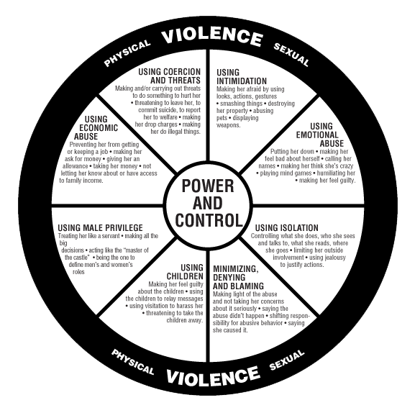
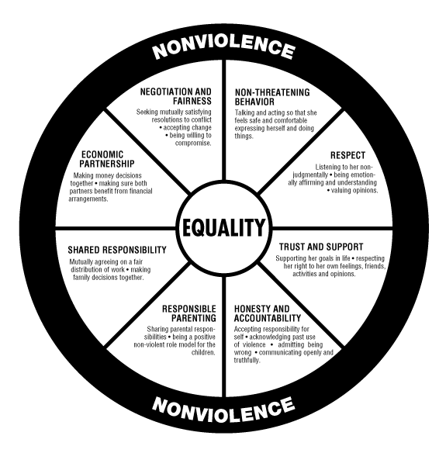
Abuse never takes place in isolation, but is part of a whole system of behaviors, the purpose of which is to maintain power and control over the partner in the relationship. Abusive behavior can be thought of as a wheel. At the heart of the wheel is power and control. This is the motivation behind the abuse to ensure that the batterer remains in control of how the partner thinks, feels and behaves. On the outside of the wheel is physical abuse. This is the behavior that most people see as "the problem," is easy to identify and is usually the only form of abuse that is illegal.
Inside the hub of the wheel are a variety of behaviors or tactics, which the abuser uses to gain control. Not all of these forms of abuse are used in every relationship, and the abuser may switch tactics often to keep the victim on the defensive. When the victim learns to respond to one type of attack, the batterer may change strategies. Eventually the struggle may become so exhausting that the victim begins to modify her behavior, and thereby gives up control of her life in order to avoid further abuse.
Some examples of abusive behaviors are:
- Physical abuse: slapping, punching, kicking, biting, scratching, shaking, choking or smothering, throwing down stairs, smashing eyeglasses, tickling until victim panics.
- Assaults with weapons: knives, guns, vehicles, ropes, cords, shoes, baseball bats, broken bottles, frying pans, cigarettes, poison - any object which causes pain or fear.
- Impairment of physical condition: sleep interferences; deprivation of food, medicine or heat; holding victim hostage; locking victim in a closet or other confined space.
- Sexual Abuse: Rape, sex on demand, weapons utilized sexually, physical assaults during sex, involuntary prostitution or pornography, forced sex with others, denying reproductive freedom, extreme jealousy, sexual degrading language, sexual criticism, threats to have affairs with others.
- Threats and Intimidation: Threat displays: property damage, arson, animal abuse, vehicle damage, breaking and entering home or business, destruction of clothing, pulling out telephone, punching walls, breaking furniture or household objects, driving recklessly.
- Verbal threats: threats to commit physical or sexual abuse or property destruction; threats against family, friends or pets; threats of suicide.
- Intimidation: stalking, harassment, stealing of pets or property, standing close to victim and shouting or making frightening gestures.
- Isolation: Extreme jealousy, threatening or driving away friends or family of victim, refusing victim time alone with others, insisting victim have no contact with others, degrading family or friends of victim, monitoring mail or phone calls, questioning or harassing victim for spending time with others, forcing victim to account for her time.
- Using Children as a Weapon: Kidnap, child abuse, refusal of custody or visitation rights, threats to kidnap or injure children, jealousy of children, buying children's affection, humiliating or attacking victim in front of children, blaming victim for breakup of family.
- Economic Control: control over income and assets; interference with employment or education; economic fraud or theft; property destruction or theft; use of savings, checks or credit cards of victim without permission; forcing victim to support abuser.
- Using Male Privilege: Telling victim that she deserves the abuse because she is a woman; blaming victim for violence because she is "sick" or "masochistic," denying that anyone will believe she has been assaulted because nobody will believe a woman; discounting her options by convincing her that no one will help a married woman.
- Using a doubled standard for conflict, for example: giving himself permission to yell and be out of control because he is angry, but if she raises her voice or criticizes him, she is a "bitch" or a "nag;" or the abuser may leave for several days to demonstrate that "she can't take him for granted," but if she leaves, she may be accused of abandoning her children or "running around."
- Emotional Abuse: Humiliation; degradation; name-calling; ridiculing opinions, feelings or accomplishments; unrelenting criticism; fault-finding; unfavorably comparing victim's physical appearance or achievements to others; demanding perfection.
- Psychological Abuse: Withholding information, lying, rewriting history or denying reality, shifting blame, withdrawing, using the "silent treatment," refusing to allow victim to set limits or boundaries, not permitting the victim to say no, labeling victim's self-nurturing behavior as "selfish," setting up no-win situations, convincing the victim that she is crazy.

These are only some of the controlling behaviors that an abuser might use to keep the victim always on the defense. The abuser will switch tactics often, shift the blame to the victim, and criticize relentlessly. The victim is forced to account for her time, money, thoughts and actions. She spends most of her time trying to compensate, to prevent the abuser from getting angry. Gradually, the victim begins to give up control of important aspects of her life in an effort to keep the peace. Each forfeit seems like one less thing to fight about. Eventually, she gives up on herself, her hopes, dreams and pleasures.
- Violence is not constant. There are three phases in the cycle. The three phases vary in time and frequency. Violence increases in severity and frequency if the cycle is not broken.
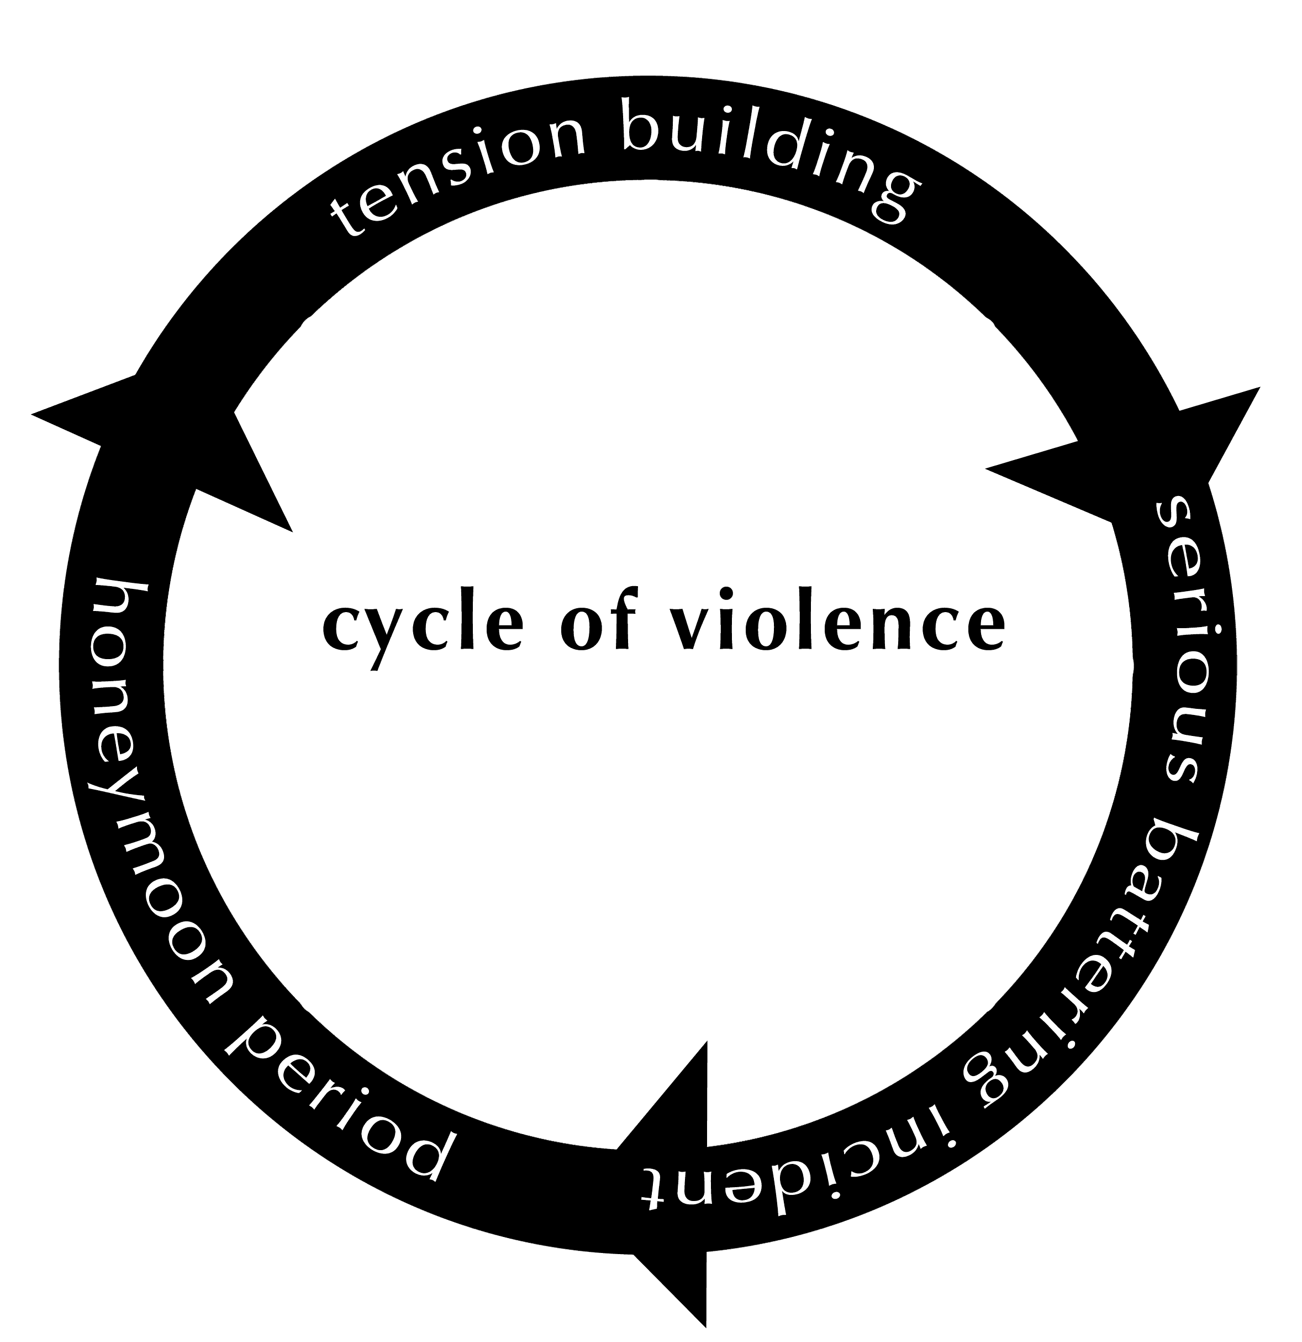

ABUSER |  |  |  | VICTIM
Tension Building  - Minor battering incidents, includes much verbal, psychological abuse.  - Abuser doesn't control own behavior, abuse increases.  - Abuser may be aware of own inappropriate behavior, but does not take responsibility.  - Afraid that she will be disgusted, and leave, jealousy increases. Possessiveness increases in hope that brutality will keep her captive.  - Frantic, more control. Misinterprets her behavior, takes withdrawals as rejection.  - Outside events can affect this stage.  - Abuser feels uncontrollable. |  |  |  | Tension Building  - Becomes nurturing, compliant, will stay out of the abuser's way.  - Denies abuse and inevitability of serious incident in order to feel safer. Also denies feelings of fear and anger.  - Accepts the abuse - doesn't believe she should be abused but tries to prevent his anger from escalating as a way of providing safety.  - Rationalizes she did something to cause abuse-marriage problems, etc.  - Blames external factors, work, alcohol.  - Stress-related illnesses, depression, fatigue, sleeplessness, eating problems, headaches.
Serious Battering Incident  - Almost always occurs privately.  - Batterer's rage feels overwhelming.  - Batterer justifies behavior.  - Trigger can be anything. May occur with drug or alcohol use to allow easier release of violent behavior.  - Sexual assault may occur during or after the violence.  - May deny incident occurred.  - Blames her for the incident.  - If police are called, abuser may appear cool and calm when they arrive.  - After the battering both minimize severity and rationalize the event. |  |  |  | Serious Battering Incident  - Attempts to control the severity of the violence. Begs, pleads, bargains, maintains nurturing, compliant behavior even during attack.  - Sense of futility of trying to "resist" further battering.  - May not seek help unless severely injured, usually not until a day after incident.  - May call police. When police arrive it may appear that woman is attacking them or protecting her partner. This is a survival skill.  - Shame and disbelief. May feel she has betrayed herself.
Honeymoon  - Loving, contrite, begs forgiveness, promises won’t happen again.  - May believe abuse won’t occur again, that the abuse taught her a lesson, she will never act up again.  - Promises no drugs or alcohol.  - Pleads with and attempts to blame the woman and engages family to do the same.  - Aware of need for the woman as a victim, someone to take responsibility for abusive actions. |  |  |  | Honeymoon  - Translates abuser's depression and extreme need for her as deep love.  - Takes responsibility for the abuse.  - Guilt - Believes in the permanency of the relationship, believes it’s her responsibility to keep it together.  - Bargains with the abuser. If she stays, abuser will get help.  - Wants to believe she is needed and wanted, will no longer suffer abuse, and that this calm, loving phase is what her partner is "really" like.  - Her self-esteem has been shattered.
Why Women Stay
- They are in love with their abusive partner
- Fear of physical danger/death to themselves, their children or family if they leave
- Fear of emotional damage to children, of losing custody of children
- Economic dependence
- Cultural and religious constraints
- Fear of retaliation
- Guilt about failure of marriage
- Belief that partner will change
- Ambivalence and fear over making formidable life changes
- Lack of alternative housing
- Fear of involvement in court processes
Effects of Domestic Violence - ON ADULTS:
- Death (of either perpetrator or victim) by homicide or death by suicide
- Disabling injuries
- Depression
- Difficulty in obtaining, maintaining and adjusting to employment
- Emotional abuse and deprivation
- Break-up of family unit
- Court fights regarding separation, divorce and custody of children
- Perpetuation of social isolation for fear of violence being disclosed
- Continuing violence which will escalate if alternative behaviors are not learned
- Recurrence of violent behavior with new partner
- Expansion of violence into the community
ON CHILDREN:
- Death by homicide or death by suicide
- Anxiety (that another beating will occur)
- Depression, Emotional injuries, low self-esteem
- Guilt from not being able to stop the abuse or for loving the abuser
- Aggressive behavior toward others/delinquency/gang involvement
- Poor school adjustment
- Modeling behaviors learned: victim/aggressor roles
- Fear of abandonment
- Runaway episodes
- Alcohol/drug experimentation
- Early marriage
- Continuation of violent behavior in their adult relationships
- Expansion of violence into the community
- Regression

