DESTINY MILESTONES

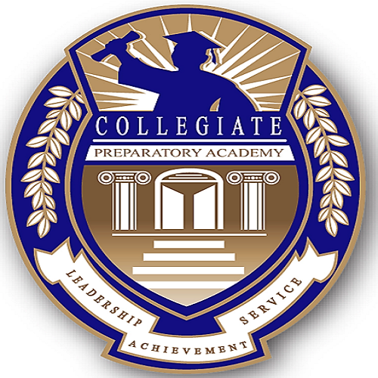

FIVE YEAR STRATEGIC PLAN OF ACTION

Table of Contents

Introduction 3
Strategic Planning Team 4
Strategic Planning Process 5
The Next Steps 6
Mission 6
Theory of Action 7
2021-2026 Board Goals and Aligned Plan 9
Achievements & School District Analysis 10
Overview of Destiny Milestones 2026 11
Strategic Goal –Improve Academic Achievement 12
Strategic Goal – Improve Professional Practice 18
Strategic Goal – Powerful Partnerships with the Community 19

Introduction
“Every great dream begins with a dreamer. Always remember, you have within you the strength, the patience, and the passion to reach for the stars to change the world.” – Harriet Tubman

Destiny is often believed to be a fate or an inevitable end. Often, destiny is defined as a predetermined end. Destiny 2026 is a Strategic Five-Year Strategic plan of action to help students realize that they can achieve greatness and create a great destiny for themselves. This plan seeks to renew a sense of hope in our schools and district.
Three strategic goals would drive the plans and focus of the district for continual improvement while keeping the whole child at the center of all decisions:

- Goal: To increase Academic Achievement
  - Strategy: Create a standards-based, rigorous curriculum infants to PreK – 12 to lead to college, and career readiness. There will be technology integration, enhancement of the Arts with an emphasis on early childhood PreK-3, middle grades and high school infusing post-secondary success and endeavors. There will be data - driven focus to address ESSA indicators.
- To Build Professional Capacity of Faculty and Staff
  - Strategy: Provide individualized, customized professional development focusing on instructional strategies, culturally and linguistically relevant practices, social emotional learning and trauma informed care.
- To Establish Powerful Partnerships
  - Strategy: Create, develop and nurture strong Family-Home-Community- Business Partnerships and Directory of Services

Stakeholder groups are integral to the success of the strategic plan along with the leadership of the new Superintendent of Schools and the Board. The collaboration is key to the success of the plan.

Strategic Planning Team
Board of Education
Katrina Vandiver, President
Raishawn Harris, 1st Vice President
Archbishop Dr. Barbara Jackman, 2nd Vice President
Jeff Horne, Trustee
TBD, Trustee
TBD, Board Clerk

Central Administration

Dr. Claytisha Walden, Superintendent of Schools
TBD, Assistant Superintendent for Business
TBD, Assistant Superintendent for Elementary Education
TBD, Assistant Superintendent for Secondary Education
TBD, Assistant Superintendent for Human Resources/Professional Development

School Based Administration
Prinicipals/Directors
TBD, Director, Baby University Early Childhood Center
TBD, Principal, Collegiate Prep Elementary School
TBD,Principal, Collegiate Prep Middle School
TBD, Principal, Collegiate Prep HighSchool

Assistant Principals/Lead Teachers
TBD, Asst. Director, Baby University Early Childhood Center
TBD, Asst. Principal, Collegiate Prep Elementary School
TBD,Asst. Principal, Collegiate Prep Middle School
TBD, Asst.Principal, Collegiate Prep High School
TBD, Lead Teacher, Collegiate Prep Elementary School
TBD,Lead Teacher, Collegiate Prep Middle School
TBD, Lead Teacher, Collegiate Prep HighSchool

Instructional Coaches
Teachers
Support Staff

Strategic Planning Process

Members of the Roosevelt School Board and professional staff would review the Five-Year Strategic Plan focusing on instruction in a three-phase process.

PHASE | ACTION STEPS | TIMELINE
PHASE 1 | The new Superintendent of Schools and the Board reviews and refines the plan with key administration representatives. During this phase other stakeholders’ groups are convened through the process of data collection and analysis to include:  - Community forums  - Focus groups with faculty and staff as well as high school and middle school students  - Individual interviews with Board of Education members, district administrators and association leaders  - Electronic surveys for all faculty, parents, and students in grades 4-12, support staff, and community members without children in the schools  Additionally, the District’s Strategic Planning committee will analyze standardized test results, AP and SAT results and other student performance data. | July 2021 – Sept 2021
PHASE 2 | The action plan will be formally presented to the key stakeholder groups for comment/approval. | December 2021
PHASE 3 | Plan formally adopted by the Board | January 2022

The entire strategic plan is available for public viewing on the district website at https://www.collegiateprep.academy. The online plan is updated quarterly through School Board reports for public accountability. Goal managers are required to demonstrate measurable improvement of programs over time.

The Next Steps

The Five-Year Strategic Plan will be disseminated to appropriate personnel on a yearly basis. Identified objectives and tasks have been developed in a business plan format to support the plan. Pertinent information has been included in this document. The following milestones will assure accountability of the plan:

Conduct Management Reviews Monthly
Status Report to the School Board Monthly
Reports to the Public Quarterly
Publish Interim Changes As Required
Plan Review/Revision Process October through June/ Annually

Mission of Collegiate Preparatory International Academy School District
To educate the whole child to excel, thereby ensuring achievement for ALL. “Failure is not an OPTION!”

The overall objective of the Strategic Planning is to provide clear objectives with measureable goals to accomlish the District mission. As such, the Whole Child/Continuous Improvement Cycle will be the theory of action.

Theory of Action
We aim to deepen our systemic academic and social-emotional supports for the health, safety, and the well-being of the whole child. We recognize that our diverse learners need to balance academic, physical, social, and emotional demands. We will focus on meeting the needs of the whole child. As we keep the whole child at the center of all decisions and actions; engulfing them with coherent instruction in a supportive learning environment, academic achievement will increase for all. By building up the professional capacity of faculty and staff through on-ongoing professional development we will have success for our students through effective, coherent instruction. Our families and community engage and support our schools as our leaders ensure high quality educational experiences. We recognize that when we identify student needs, we must also select appropriate interventions, plan, implement and continually examine and monitor progress.

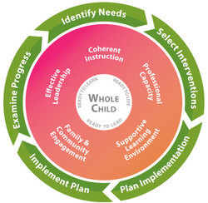

The Continous Improvement Cycle
The Five-Year Strategic Plan is in alignment with the New York State Every Student Succeeds Act (ESSA) and Next Generation Learning Standards (NGLS), the District Comprehensive Improvement Plan (DCIP) and Instructional Foci and the School Comprehensive Education Plans (SCEPs). The strategies will evolve through a Continuous Improvement Cycle which involves the four steps- plan, do, check, and act.

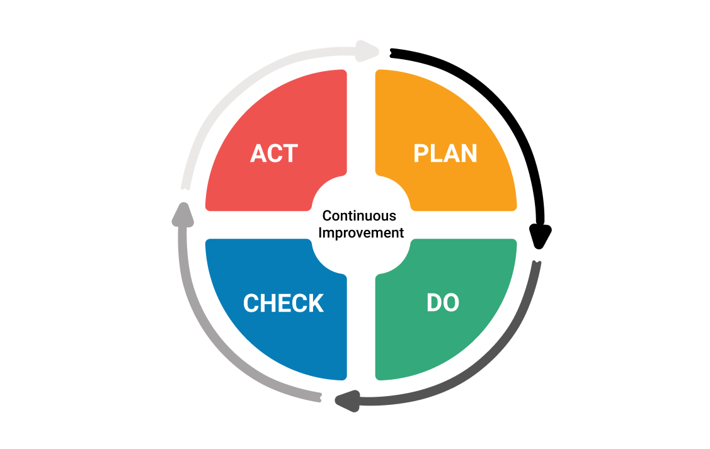

This will ensure cohesive vertical and horizontal alignment to provide clear articulation of measurable goals which address the essential question:
Are the decisions and actions in the best interest of the whole child aligned to our mission?
These strategies are attainable by collective commitment and sustained efforts among stakeholders.

Reflection of 2020-2021 District Goals and Destiny MIlestones 2026
In celebration of the 2020-2021 Board goals and achievements, Destiny MIlestones 2026 is a launchpad from the work that the community has embarked on while raising the bar.
On-going 2020-2026 Board Goals | Destiny Milestones 2026  Alignment & Intricacies to Jumpstart the Strategic Five-Year Plan
To educate the whole child to excel | Aligned Goal: Develop a standards-based, rigorous curriculum PreK – 12 to lead to college, and career readiness.  - Technology integration  - Enhancement and expansion of the Arts with an emphasis on early childhood PreK-3, middle grades and high school  - Social Emotional Learning
Equity for All | Aligned Goal: To improve academic achievement for All Students  - Analysis of Disaggregated Data to target students with appropriate interventions  - Expansion of technology – blended learning format – synchronous and asynchronous teaching
Monitor capital reserves and provide updates to the community | Aligned Goal: To Establish Powerful Partnerships  - Community Forums  - On-going Community Updates of Strategic Plan  - Establish Community Council  - Conduct Survey to assess needs  - Ongoing community meetings  - Reports to the Public
Improve quality and effectiveness of leadership | Aligned Goal: To Build Professional Capacity of Faculty and Staff  - Provide individualized, customized professional development focusing on instructional strategies, culturally and linguistically relevant practices, social emotional learning and trauma informed care.  - Assessment Survey to teachers to address needs.
Transparency with Community in Budget Process | Aligned Goal: To Refine Structures and Systems of Operations to become more automated  - Student Information System (SIS)  - Learning Maagement System (LMS)
Innovative Learning Environment | Aligned Goal: To Adress and Support the Whole Child  - Social Emotional Learning  - Multi-Tier System of Supports  - Appropriate intervention  - Encourage Student Voice and Agency

2020-21 Significant Achievements

- Development of structures & systems
  - Registration/Enrollment
  - Student Information System
  - Learning Management System
  - Professional Development

- On-boarding of Staff – Recruitment, Selection, Training, Retaining
- Galvanize/Enlist Strategic Partnerships with accredited curriculum providers
- Garner partnership with Arizona State University Digital Prep
For curriculum/Dual Enrollment program
- Creation of proprietary authentic curriculum around the themes of Service Learning, Social Justice, Leadership, Poetry/Spoken Word

DISTRICT ANALYSIS
Strengths, Challenges, Opportunities, Risks
District’s Strengths  Considering the stated Mission, the following are the identifiable STRENGTHS of the district: | District’s Challenges  Perceived CHALLENGES of the district are:
- Proactive and committed School Board  - Commitment to strategic planning  - Commitment of Stakeholder groups | - Development of additional curriculum  - Increase enrollment  - Recruitment of Staff
District’s Opportunities  The current environment offers the following OPPORTUNITIES: | District’s RISKS  Environmental RISKS to the district are:
- Increase student performance in all areas  - Improve curriculum alignment, articulation and formative assessments  - Increase extended learning opportunities/ engagement  - Increase opportunities for college credits while in high school | - Natural disasters and other threats to staff and student safety (i.e. Coronavirus poses a disruption to traditional school environment, hence a need for blended learning approach)  - Private funding ; not receiving State and federal funding

STRATEGIC GOALS
- To increase Academic Achievement- Create a standards-based, rigorous curriculum PreK – 12 to lead to college, and career readiness. There will be technology integration, enhancement of the Arts with an emphasis on early childhood infant to PreK-4, middle grades and high school infusing post secondary success and endeavors. There will be a data - driven focus to address federal Every Student Succeeds Act (ESSA) indicators.
- To build Professional Capacity of Faculty and Staff - Provide individualized, customized professional development focusing on instructional strategies, culturally and linguistically relevant practices, social emotional learning and trauma informed care.
- To establish Powerful Partnerships - Create, develop and nurture strong Family-Home-Community- Business Partnerships and Directory of Services
- To refine Structures and Systems of Operations to become more automated

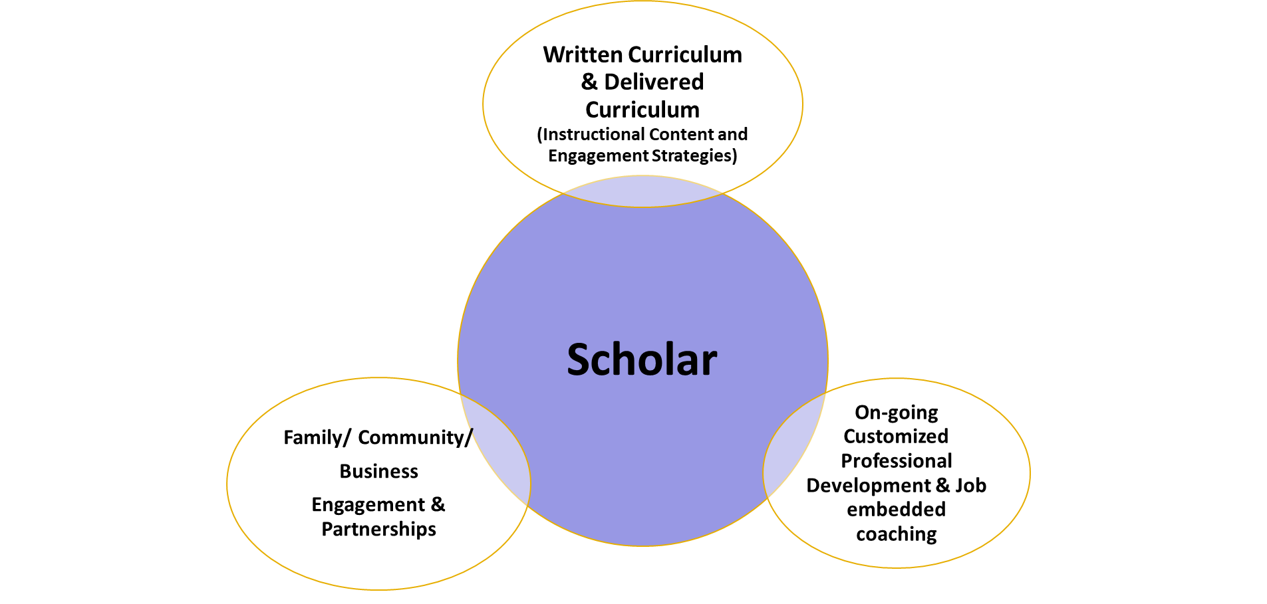

2021 - 2026 Strategic Goals
To Improve Academic Achievement of All Students

Strategy: To Create a standards-based, rigorous curriculum PreK – 12 to lead to college, and career readiness. There will be technology integration, enhancement of the Arts with an emphasis on early childhood infants to PreK-4, middle grades and high school infusing post secondary success and endeavors.
Our lens is on the written and delivered curriculum to ensure academic excellence, equity and engagement for all students.
Action Steps/Implemention Tasks | Timeline | Stakeholder Groups
Review and Refine curriculum and existing programs in Curriculum Committee. Committee makes recommendations.  - Research and adopt or develop criteria/guidelines for screening and recommendations of new resources if needed through Committee Recommendation and Stakeholder Input | Sept 2021 – June 2026 | Administrators  Lead Teachers  Teachers  Families
Implement Social Emotional Learning PreK-12  - Conduct Student and Parent Surveys | Sept 2021 – June 2026 | Administrators  Lead Teachers  Teachers  Families
 | Sept 2020 – June 2025
Analysis of student work and performance data will be continuously examined through grade level and department meetings, congruence, faculty meetings and within Professional Learning Communities (PLCs), to plan for and adjust instruction. | Sept 2021 – June 2026 | Aministrators  Lead Teachers  Teachers
Increase student voice/agency within the K-12 system * Clubs and activities generated/created by and led by students/annual interest surveys for all students grades 4-12 | Sept 2021 – June 2026 | Teachers  Tutors  Students
Research Early Learning Programs to begin to connect school and community resources to support preschool aged students and their families | October 2021 – June 2026 | Administrators  Teachers
Ensure vertical and horizontal alignment of the district’s curriculum, resources and support. | October 2020 – 2026 | Administrators  Teachers
Review district formative and summative assessments to track student progress | October, January, May | Administrators  Teachers
Intervisitations to audit district curriculum and lesson delivery | October 2020 -April 2021 | Administrators  Teachers  Staff Developers
Training administrators on Special Education policy,processes, and procedures. | November 2020 | Staff Developers
Research and pilot Special Education curriculum in ELA,  Math and Social Emotional for PreK-12 | November 2020 | Administrators  Lead Teachers  Teachers  Families
Review Technology Learning Model | November 2020 | Administrators  Lead Teachers  Teachers  Families
Conduct Cohort Analysis of Secondary School Students | November 2020, February 2021, June 2021 | Administrators  Lead Teachers  Teachers  Families
Expand mentoring prgrams to connect to college and business partnerships and experiences. | November 2020 – June 2021 | Administrators  Lead Teachers  Teachers  Families
Examine curriculum, instruction, resources, and assessments to ensure that they reflect principles, values and lessons of inclusivity and equity | Sept 2020 – June 2025 | Administrators  Lead Teachers  Teachers  Families
Provide school/classroom libraries and online resources that reflect the diversity of our community, region, nation and world | September 2021 - December 2026 | Administrators  Lead Teachers  Teachers  Families
Measure students’ opinions of our schools’ cultures and climate annually | February 2021 – June 2025 | Administrators  Lead Teachers  Teachers  Families

Strategy: Data - driven focus to address Evry Student Succeeds Act (ESSA) indicators as part of school and district accountability
The Every Student Succeeds Act(ESSA) indicators hold all schools accountable for student performance in English language arts (ELA), Mathematics, Science and Social Studies and set targets for test performance and graduation for all students and for a variety of sub-groups including English Language Learners, as well as:
- Graduation Rate indicator
- College, Career, and Civic Readiness indicator, factors that different end-of-high-school goals are appropriate for different groups of students;
- Composite Performance indicator at the elementary/middle and Secondary status.

Success Measures:

- Refining Structures and Systems to increase automation and efficiency
  - Refine Student Registration Process from website to CRM system to Onboarding of Classes
  - Refine Staff Recruitment, HR checks, interviewing, Offers, Benefits to Professional Development schedule
  - Refine Diagnostic Assessments and Formative Assessments to align tutoring goals for students in the creation of Student Success Plans
  - Encourage parents to utilize payment link to refine tuition payments
  - Increase parental workshops – parenting, pre-natal care, life insurance, retirement savings
- Achievement
  - Early Childhood – 85% of age 4- 5 years olds will increase their phonemic awareness
  - Elementary/Middle – 85% of scholars will make at least two years growth in Reading (Comprehension and Vocabulary) and math
  - Middle – 95% of students will receive high school credit
  - High School –
    - 100% of Scholar Teams will launch their own Virtual Enterprise/Business or Create an Investment Club
    - 90% of Scholars will receive a Career and Technical certification
    - 90% of Scholars will obtain college credit (Advanced Placement of Dual Enrollment with Arizona State University)
    - 95-100% High School Graduation Rate ( in 2 – 4 years)

Strategy: To develop the indicators of success, baseline data will be studied and the Measures of Interim Progress (MIPs) that is set for the district. The data informed the success indicators that reflect the District’s priorities, while balancing the need for goals to be both rigorous and achievable. All indicators are in alignment with growth expectations for District performance.
Progress Measures of Success:
- Increase of Student Mastery in Grades 3-8
- Increase of Student Post Secondary Plans in 2 and 4 year colleges
- Increase of Graduation Rates
- Increase in college and career experiences for all students

Action Steps/Implemention Tasks | Timeline
Research and Review the District’s MTSS formerly Response to Intervention (RtI) Plan | Every August
Provide disaggregated data for building leaders to use in supporting students, data analysis and school improvement efforts. | Every Sept/October
Target specific students that are 1-15 points from the next performance level to increase insructional time and secific interventions Review and Refine curriculum and existing programs in Curriculum Committee. Committee makes recommendations. | Sept 2021 – May 2026
Review District Grading Policy and make recommendations | Sept 2021- June 2022
Launch Graduation Taskforce to increase graduation rates | Every October
Align academic intervention qualifying criteria with core classroom and benchmarking assessment tools at the elementary and middle school levels. | Every October
Disaggregate student data in to track student progress and success | October 2021
Calendar on -going district MTSS (or RtI) team meetings | October, January, May
On-going log of interventions for Tier 2,3,4 Students | October 2021 – April 2026
Training for Classroom teachers on small group instruction | November 2021 – February 2022
On going afterschool tutoring sessions | November 2021 – May 2026
Conduct Cohort Analysis of Secondary School Students | Every November, February, June
Review district formative and summative assessments to track student progress | Every October, January, May
Review district technology supports and programs (Digital Learning platforms) | May 2020 – June 2025
Implementation Plan - Timeline

To Improve the Professional Practice of Faculty and Staff

Strategy: Provide individualized, customized professional development focusing on instructional strategies, culturally and linguistically relevant practices, social emotional learning and trauma informed care
Progress Measures of Success:
- Survey Data
- Teacher Retention
- Teacher Evaluation Data
- Track success of Mentor Program

Action Steps/Implemention Tasks | Timeline
Conduct Needs Assessment Survey to teachers to address needs. Teachers will choose course study during Supt’s Conference Days | September 2021 – June 2026
Embedded Microsoft Teams or Zoom into staff professional learning. | September 2021 – June 2022
Implement PBIS training for Elementary, Middle and the High School. | September 2021 – June 2025
Review District PD plan | October 2020  updated annually
Provided grade and department specific professional learning based on staff feedback and district level priorities. | November, January, April
Training on Multi-Tiered Systems of Support (MTSS) for administrators and counseling staff. | November 2021
Professional learning for teachers to be able to welcome and integrate diverse thoughts, experiences and opinions in their classrooms | September 2021 – June 2026
Professional development will be high quality, multimodal, protocol-driven, interactive, and aligned to the Learning Standards and District Instructional Foci. It will be focused, continuous, and its impact measured by student outcomes. | September 2021- June 2026

Establish Powerful Partnerships with the Community and Stakeholder Groups

Strategy: Create, develop and nurture strong Family-Home-Community- Business Partnerships and Directory of Services

Action Steps/Implemention Tasks | Timeline
Establish Community Council to increase partnerships with community stakeholders | September 2021- June 2026
Hold learning sessions for the community on various topics of interest | October 2021 – June 2026
Incorporate site-based teams and PTA as resources for community goals, opportunities, and lessons to greater parent community | October 2021 – June 2026
Invite stakeholders and alumni to participate in the exploration of new and better ways to expand authentic learning opportunities for students. Some examples: Career Fair, Community Days, Math Nights, Poetry Slams  Holiday events, College Fairs, Student Internships, Family Fridays | Annual events
Invite PTA leaders to trainings | Monthly
Graduation Task Force | Quarterly
ELL Task Force | Quarterly
Create Directory of Community Services and Resources | December 2021 -updated yearly
Establish College/University Partners – college credit, tours, etc. | January 2022 – June 2025
Parent University | December 2021 – June 2026
Ongoing Social Emotional Check-ins | Monthly
Establish Wellness Center – prenatal care, Parenting classes, wellness checks for the family | Ongoing

