Contact Us  CLOVERLEAF INDUSTRIES LTD  KING STREET  HIGH ONGAR  ESSEX  CM5 9NP  Phone: 01277 366002  Email: clover.leaf@btconnect.com  Web: www.cloverleaf.uk.net  12 volt operation-7 day timer |  |  | CLOVERLEAF PROFESSIONAL  FISH FEEDER  12 volt operation-7 day timer  - [Subtitle]

Table of Contents  Assembly 1  Getting Started 2  Programmable Timer 4 |  |  | To put the timer into “Auto” please do the following.  Step 1. Set the times you wish to feed as page opposite.  Step 2. Press the “clock button” to return to the current time and day display.  Step 3. Press the “Auto/Man” button until the arrow in the display is above the “off” position then press the “auto/Man” button one more time the arrow should now be above the “Auto” position and you are now set.  The timer will now switch the power on and off to the feeder at the selected times powering on the feeder controls.  PLEASE TAKE NOTE THIS FEEDER IS 12 VOLT DC ONLY  Battery type 12v DC 40amp  Max size 250mm L x 130mm W x 200mm H
 |  |  | 5

Timer operation  - Adjust clock  Before using the timer please set the clock display to the current day and time by holding down the “clock” button and use the “hour” “minute” and “week” button to set.  - Timer setting  You can set the timer to feed up to 16 times a day you can also set for 7 day operation or various days.  Time setting.  Step 1. Press timer button :Display shows “1 on”  Step 2. Press “Hour” and “Minute” buttons to set time to start  Step 3. Press “week” button and select days to operate  Step 4. Press “timer” button again: Display shows “1 off”  Step 5. Press “hour” and “minute” buttons to set the time to stop feeding  Step 6. Press “week” button and select the same days as you selected in step 3  Repeat the above steps through “2 on” and “16 on” if you wish to set more than one feeding time.  Please make sure any unused programs show “_ _ : _ _“ in the display windows and not “00 : 00” otherwise the timer will operate at midnight Press the “ reset “ button to remove all numbers in unused programs from both “on” and “off” programs. |  |  | Overview of assembly  1.  Attach the food hopper to the base by placing on top of the base and insert the screws supplied into the holes inside the hopper and hand tighten to secure.  2  Place the lid on top of the food hopper and push the supplied pin into the hinge part at the rear of the feeder to hold the lid in place then place the supplied washer over the end and secure using the split pin.  3  Attach the lid support using the pin – washer and split pin to the food hopper as shown then attach the other end to the lid using the supplied screw as shown.  Attach the supplied angled plastic deflector to the front of the feeder by the supplied screws just above the food exit mechanism. Angled upwards.  Your feeder is now ready for use.
4 |  |  | 1

Getting Started  Switch A (image No. 1)  Move to “on” for continual running.  Move to “off “ when using interval feeding  Knob B (image No. 1)  Turn to set running time: when using timer F set to “off ” turn fully anti clockwise.  Switch C (image No. 1)  Adjust time that the food is ejected for when using interval timer.  Knob D (image No. 1)  Interval timer: set the delay time between food ejection i.e. timer F set for one minuet eject food every 7 seconds.  Switch F (image No. 1)  Increase or decrease the distance of food throw.  Image No. 2  Food hopper adjuster: adjust to suite size of pellet used to reduce the amount that is emitted.  Image No. 3  Fuse position: situated under the feeder base. |  |  | 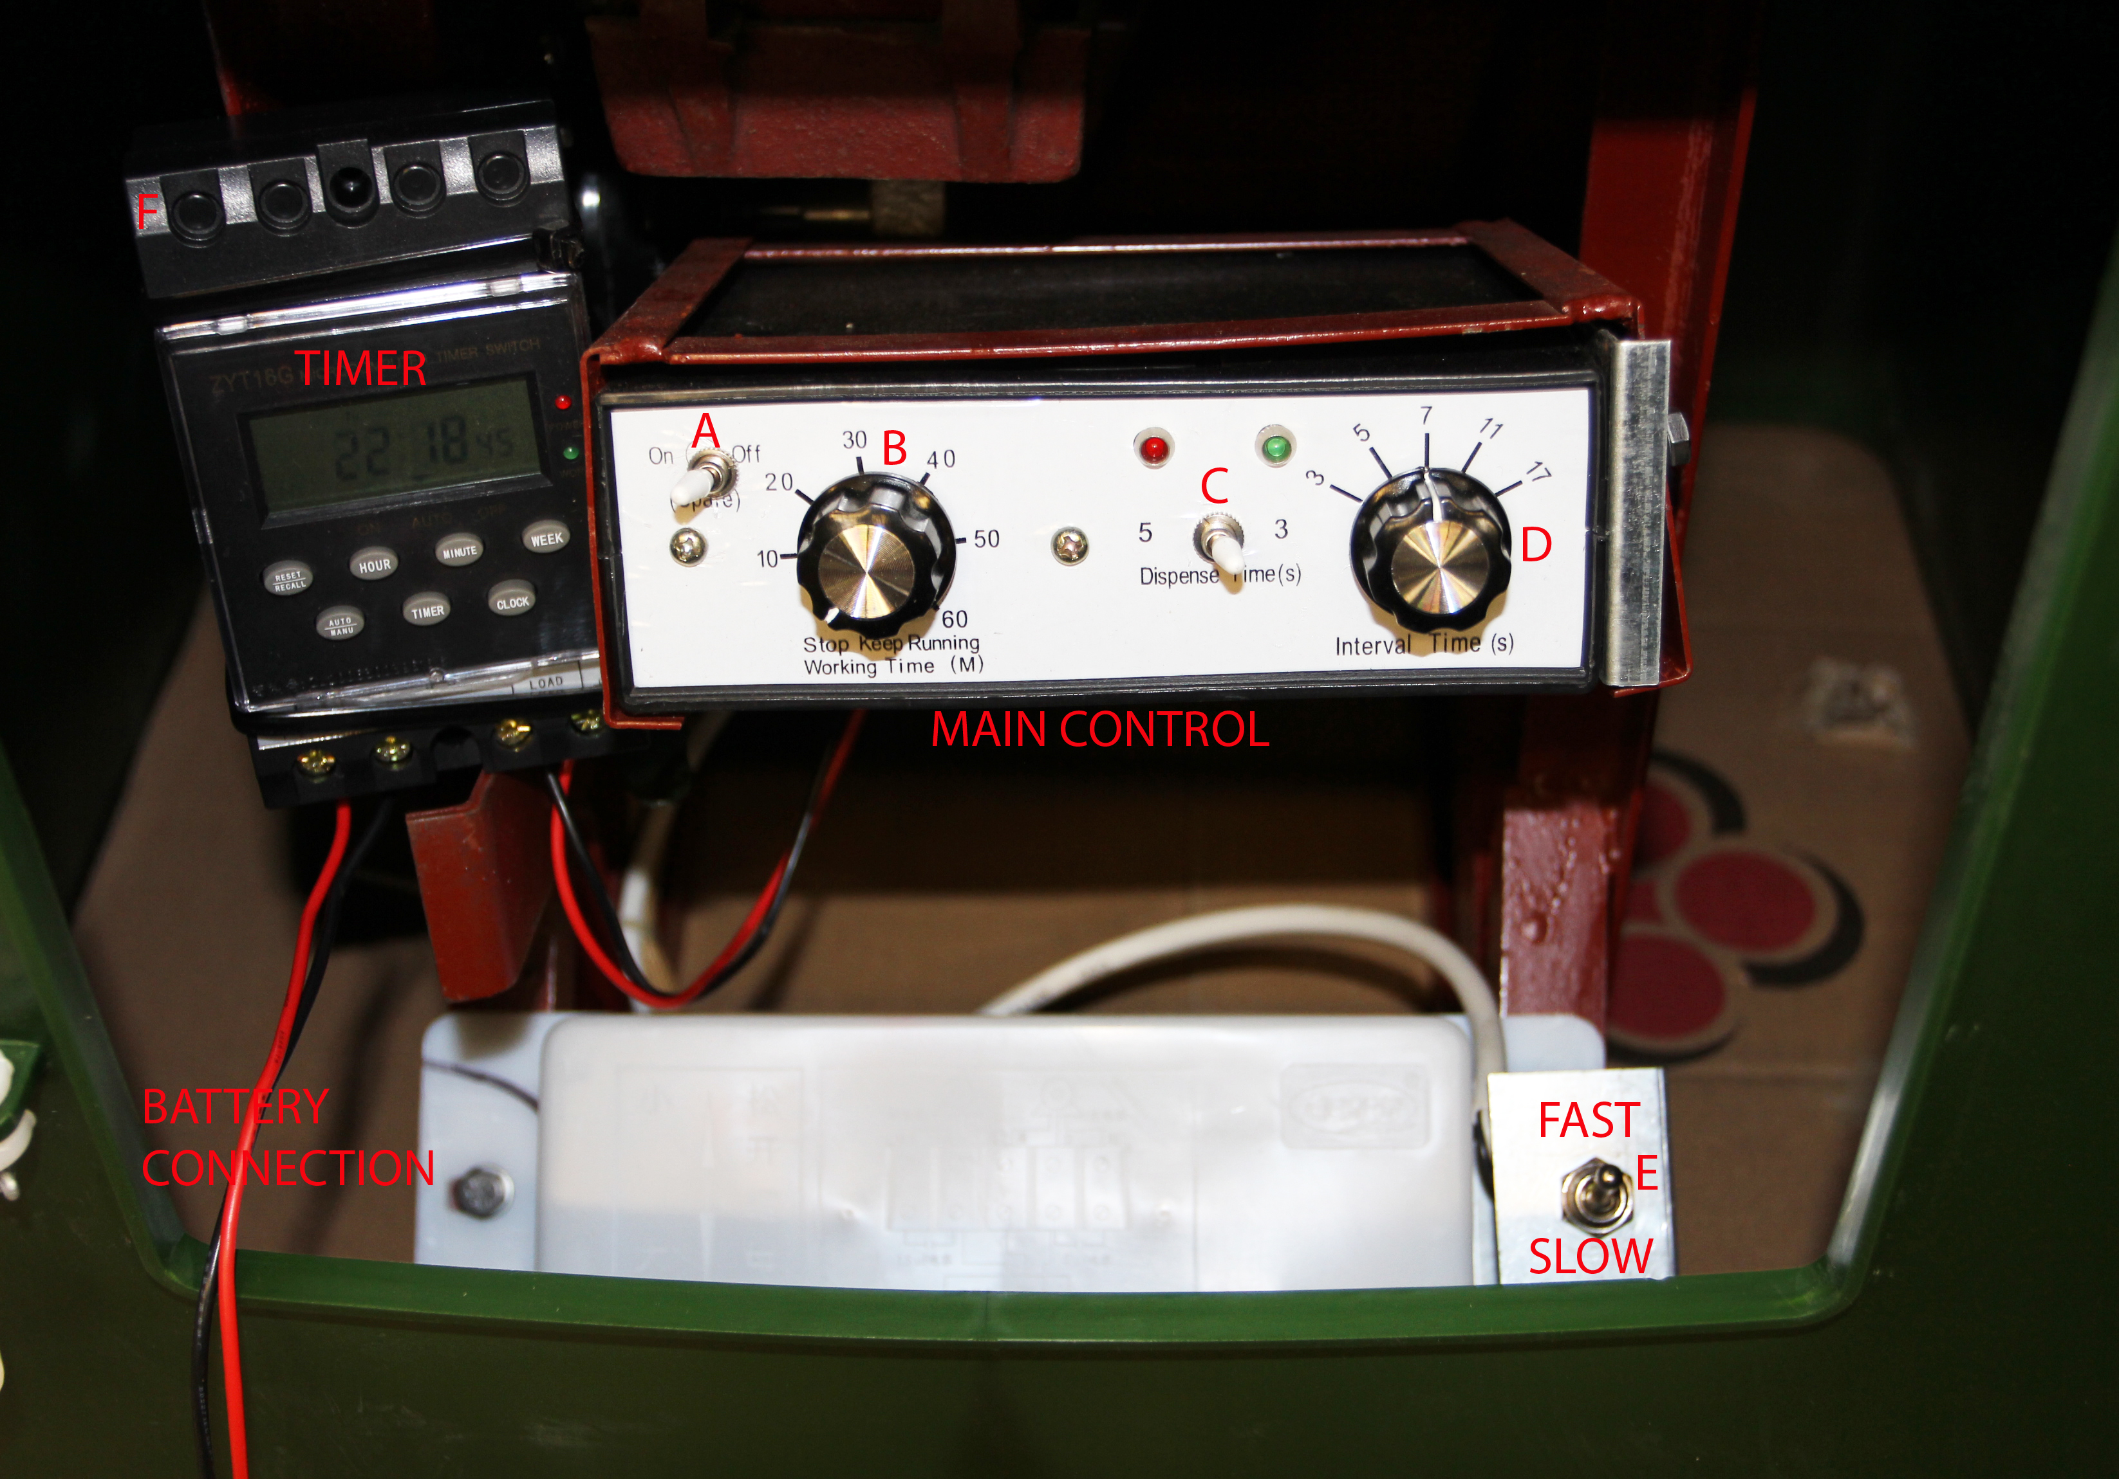  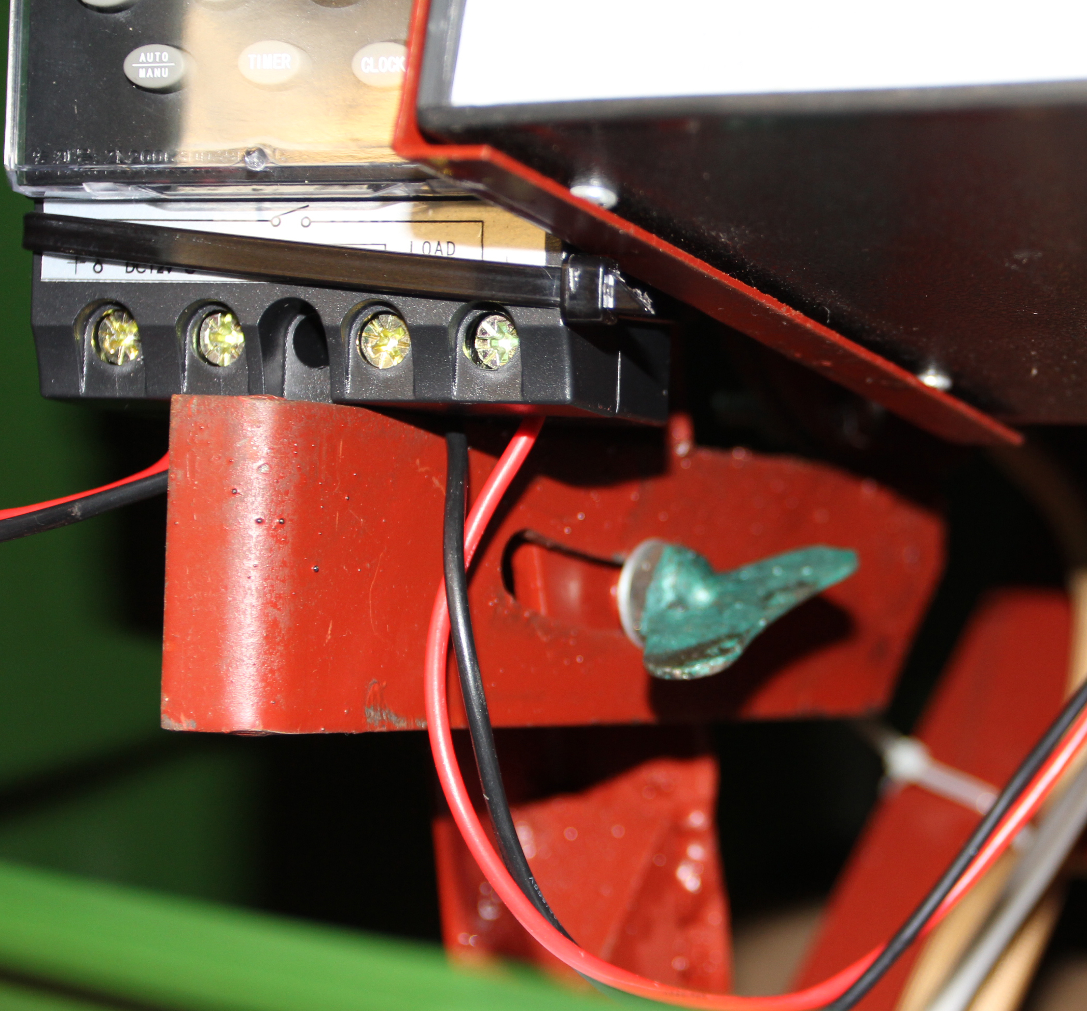  Image No.1  Image No. 2  Image No. 3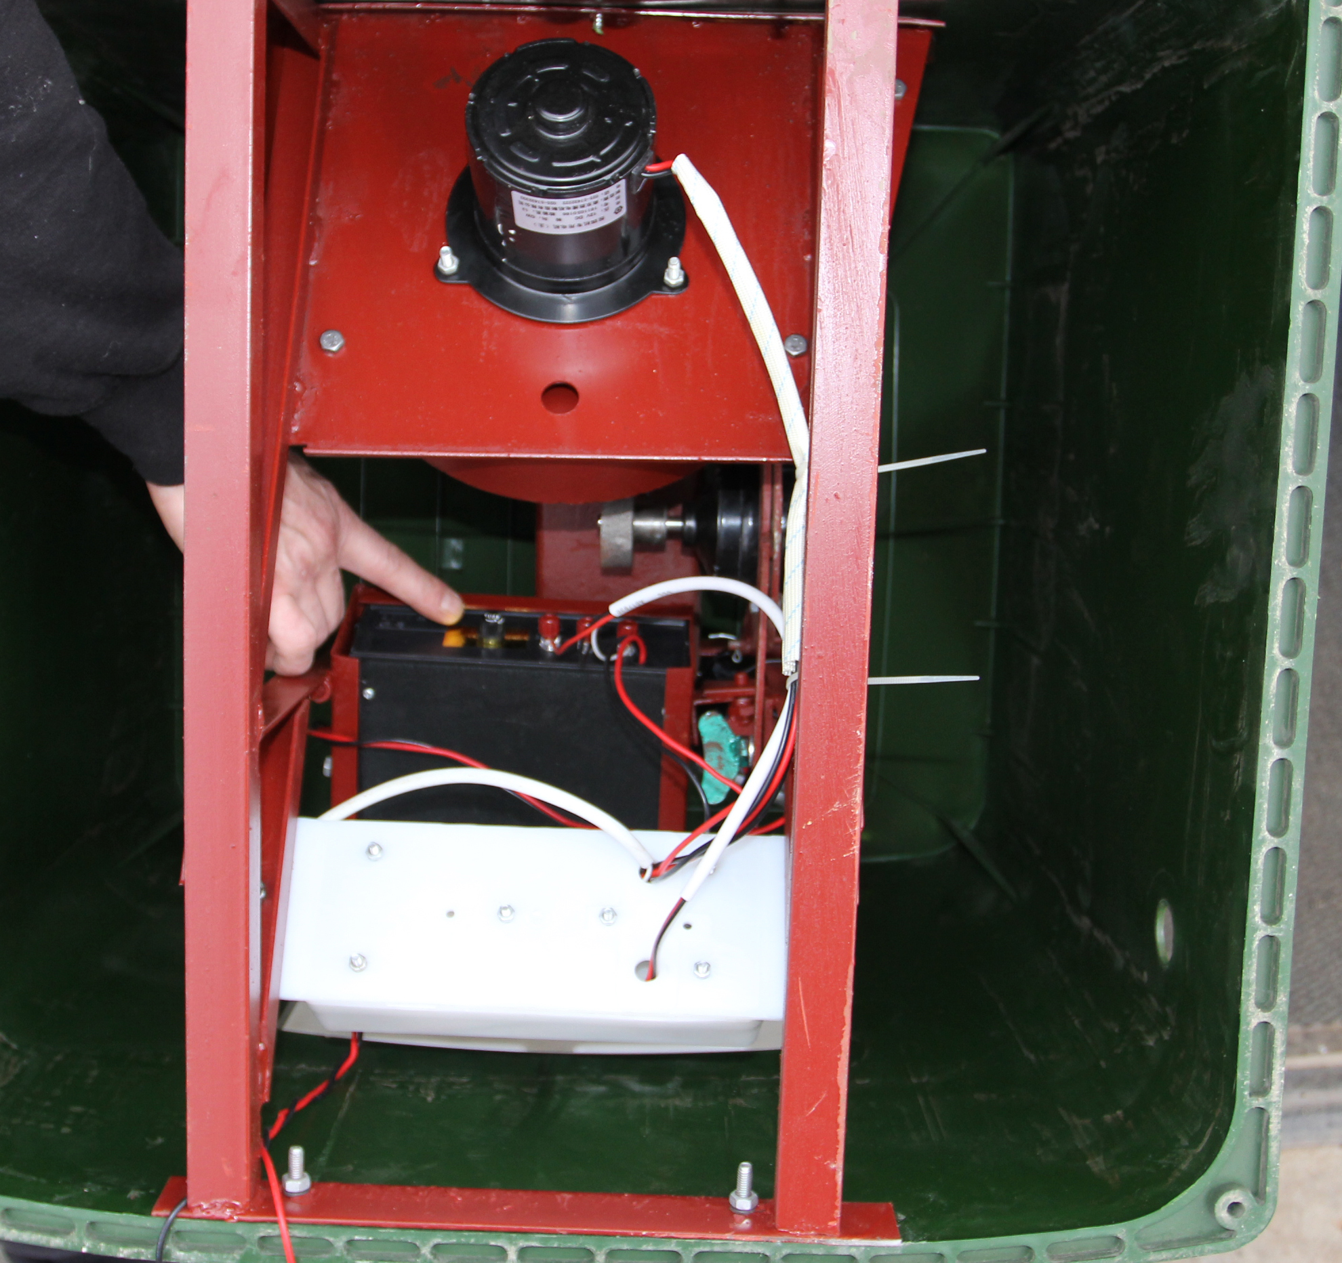
2 |  |  | 3

