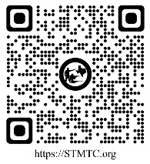
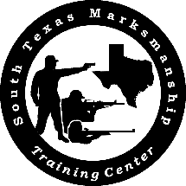
South Texas Marksmanship
Training Center
Practical Tactical Training
Event Schedule:2026

January 17 | Regular Training Event
February 21 | Share The Love Event (shoot with your Special Person stage)
March 21 | Leprechaun Event (shoot with your Youth stage)
April 18 | Regular Training Event
May 16 | Murph Challenge ("Murph" Workout Theme)
June 20 | Regular Training Event
July 18 | Independence Day Event (Red, White and Blue steel targets)
August 15 | Regular Training Event
September 19 | Regular Training Event
October 17 | Halloween Event (Pumpkin shooting stage)
November 21 | Thanksgiving Event (Turkey shooting stage)
December 19 | Regular Training Event

Match Director: AJ Carr
Email: ajcarr13@gmail.com

About:
The intent of Practical Tactical Training (PTT) is to provide a form of recreational training to enhance the familiarity of both rifle & pistol marksmanship. Our goal is to provide a safe, supportive and enjoyable training environment intended for novice through intermediate shooters. The training environment is “dynamic” and includes a level of duress, body movements and the use of multiple shooting positions to improve the shooting skills of each participant.

