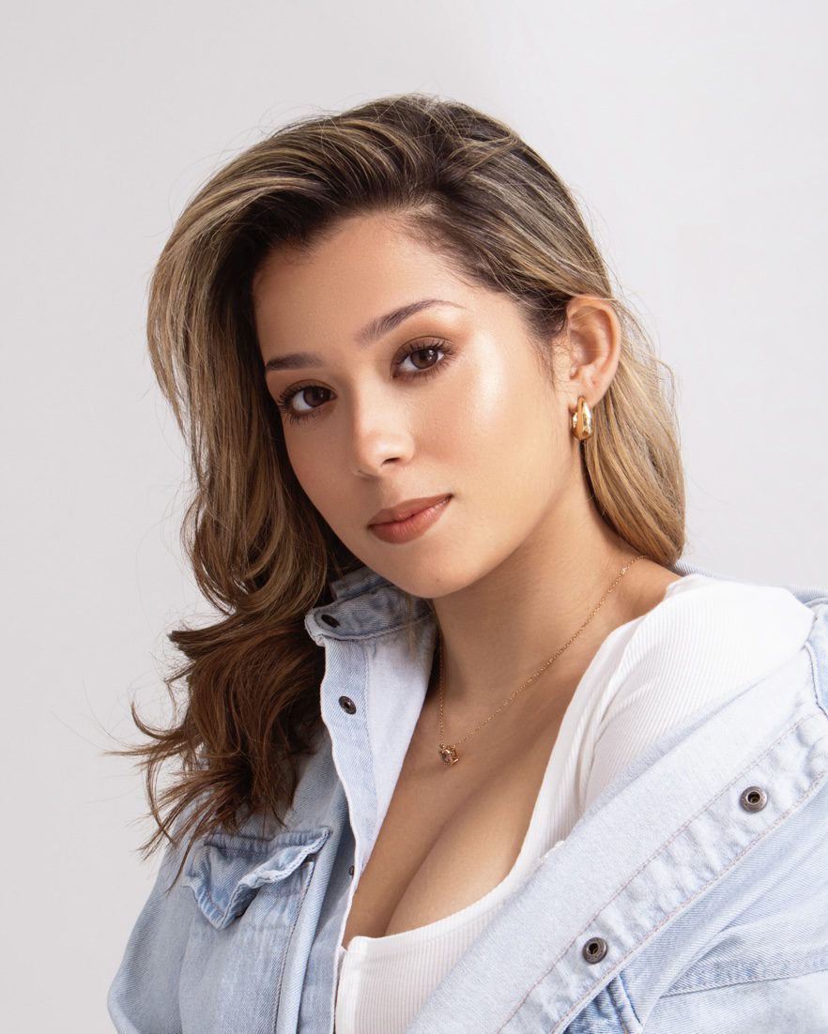
Carmen Cecilia Muñoz
Contact:​ carmenmtg12@icloud.com/Social: @carmencmunozt
Attributes: ​Height: 5’2 Eyes: Brown Hair: Brown
Voice: ​Mezzo Soprano/Mix Belter (G3-D6)

PERFORMANCE EXPERIENCE

Songs for a New World
R & H Cinderella
Christmas Cabaret
Godspell
In the Heights
Polka Dots: A Cool Kids Musical
And the World Goes ‘Round
Carousel
My Favorite Year
RENT
The Magician of OZ
CATS
Bring It On

RELATED EXPERIENCE
La Torre De los Sueños
And the World Goes ‘Round
GODSPELL
Telethon 20-30
Summer Panama Canal
In the heights

EDUCATION AND TRAINING
BFA Musical Theatre/Dance Minor
Voice

Dance

Acting

Woman 2
Ensemble
Soloist
Morgan
Graffiti Pete
Dance Captain
Woman 1
Dance Ensemble
Dance Ensemble
Joanne
Munchkin
Rumpleteazer
Danielle

Lead Character
Asst. Choreographer
Asst. Choreographer
Soloist
Soloist
Asst. Choreographer

Shorter University
Dr. Timothy Renner
Indra Thomas
Faith Im
Ahmed Burgos
D Triana Productions
Sherrie Peterson
Drew Davidson
Sue Gaukel
Melvin Tunstall III

Shorter University
Shorter University
Rome Playhouse
Shorter University
National Theatre PTY
Shorter University
Shorter University
Shorter University
Shorter University
Guild Theatre PTY
Circle Theatre PTY
Circle theatre PTY
Theatre A.A PTY

Television
Shorter University
Shorter University
Panama
Panama
Panama

2 Years
2 Years
4 Years
2 Years
5 Years
2 Years
4 Years
4 Years
1 Year

SPECIAL SKILLS: Valid F1 Student Visa, Valid U.S Work Permit , Native Spanish speaker , Latina , Hip hop Training, Special FX Makeup, Salsa Dancer, Intermediate Piano Skills, Panamanian Passport, Ballroom Training, High mix belt.

