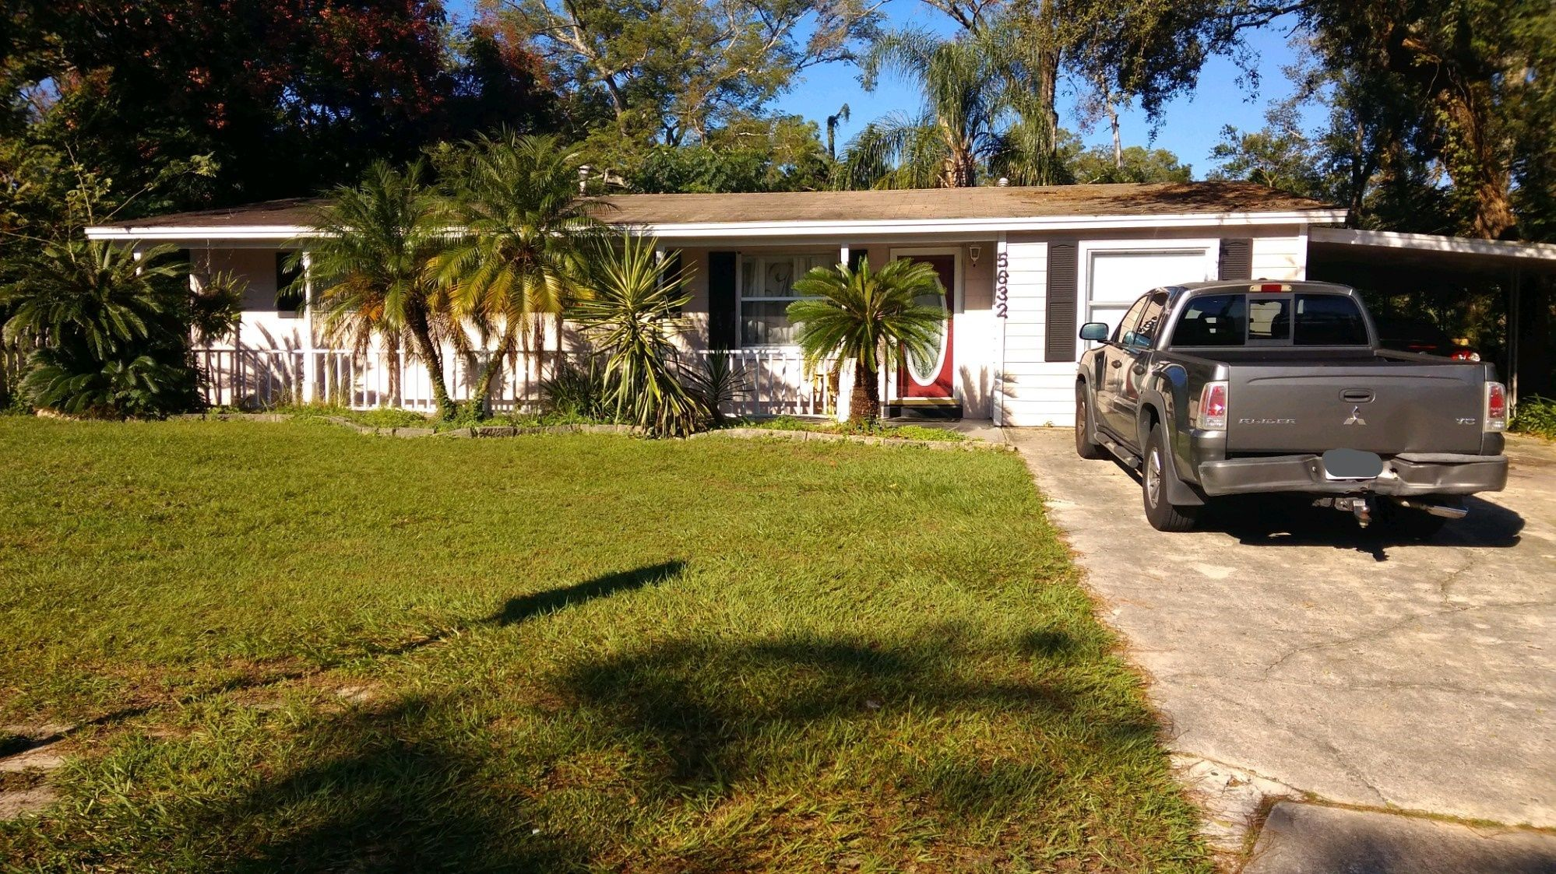  Striving to provide affordable housing to offenders.  OUR GOAL  We find housing for sex offenders throughout the Central Florida Region.  We find apartments, houses and other homes to rent or buy near your desired areas of interest.  We also provide homes for individuals along with shared rooms. | Who We Are  About Us  We are always looking out for your best interests and working towards a brighter tomorrow as we continue securing homes for your distinct needs.  Contact Us  Director / Founder  Randy Young  Phone: 407-925-4471  Email: hfouro@aol.com  Office Manager  Ricardo Garcia  Phone: 407-300-3583  Email: hfourorg@gmail.com  Property Manager (Zephyrhills)  Victor Andrews  Phone: 407-984-8080  Email: hfourova@aol.com  Web: www.housingforsexoffenders.com  ABFY LLC ABFY LLC 1316 W Concord St. Orlando, Fl 32805 | ABFY LLC  - Helping to change one life at a time.
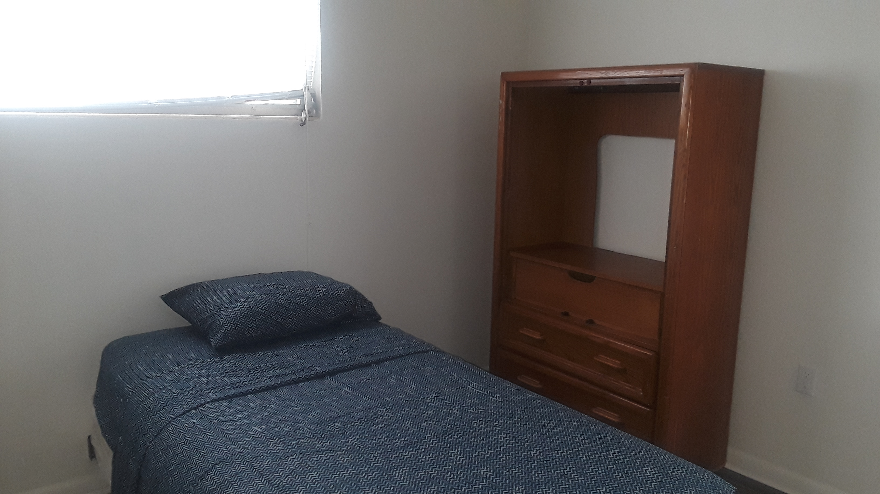  Quality Rooms Available.  Available Resources Near You.  While we facilitate your initial compliance, it falls to each individual to stay compliant.  ORLANDO AREA  Orange County Sheriff's Office*  2500 W Colonial Dr, Orlando, FL 32804  (407)254-7000 Hours: 8AM–4PM  Orange County Tax Collector*  2110 W Colonial Dr, Orlando, FL 32804  (407) 845-6200 Hours: 8:30AM–5PM  4101 Clarcona Ocoee Rd, Orlando, FL 32810  (407) 845-6200 Hours: 8:30AM–5PM  Probation & Restitution Center  644 Ferguson Dr, Orlando, FL 32805  (407) 290-0888  Probation & Parole Services  3201 W Colonial Dr, Orlando, FL 32808  (407) 297-2000  Intense Treatment Modalities  1310 W Colonial Dr, Orlando, FL 3280  (352) 379-2829  Orlando Social Security Center**  5520 Gatlin Ave Suite 102, Orlando, FL 32812  (800) 772-1213 Hours: 9AM–4PM  Orange County ACCESS Application Center** - 6218 Colonial Drive, Suite 240,  Orlando, FL 32808  (866)-762-2237 / (407) 317-7000 | Community Health Centers (Free Clinic)  840 Mercy Dr, Orlando, FL 32808  (407) 905-8827  Orange Blossom Family Health Center  232 N Orange Blossom Trail, Orlando, FL 32805  (407) 428-5751  Health Central Hospital  10000 W Colonial Dr, Ocoee, FL 34761  (407) 296-1000  LYNX Central Station  455 N. Garland Ave., Orlando, Fla. 32801  (407) 841- 5969  Mears Transportation  (407) 422-4561  Diamond Cab Company  (407) 523-3333  Walmart Supercenter  3101 W Princeton St, Orlando, FL 32808  (321) 354-2096  Winn-Dixie  1401 S Hiawassee Rd, Orlando, FL 32835  (407) 521-9333  5732 N Hiawassee Rd, Orlando, FL 32810  (407) 523-2427  Harveys Supermarket  2722 N Pine Hills Rd, Orlando, FL 32808  (407) 292-3300  Ross Dress for Less  7445 W Colonial Dr, Orlando, FL 32818  (407) 296-8373  306 E Michigan St, Orlando, FL 32806  (407) 649-8834  ZEPHYRHILLS AREA  Pasco Sheriff's Office*  Land O’ Lakes Detention Center  20101 Central Blvd, Land O’ Lakes, FL  813-235-6170  Central Pasco Government Center*  4111 Land-O-Lakes Blvd. Land-O-Lakes, FL 34639  (813)-235-6020 | Tampa Social Security Admin. Office  Address: 4010 Gunn Highway, Suite 100,  Tampa, FL - 33618  (800)-772-1213  Tampa Service Center  9393 North Florida Avenue  Tampa, FL 33612  Zephyrhills Family Health Center  37920 Medical Arts Ct.  Zephyrhills, FL - 33541  (352)-518-2000  Florida Hospital Zephyrhills  Address: 7050 Gall Blvd, Zephyrhills, FL 33541  Phone: (813) 788-0411

