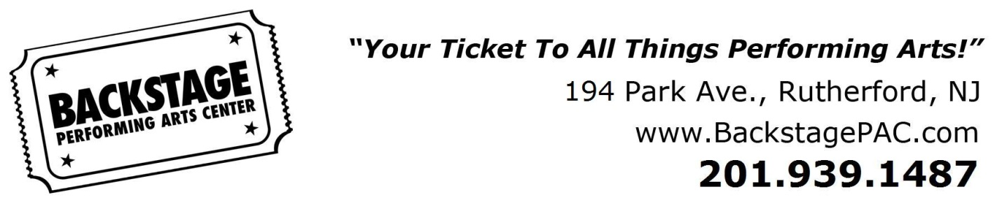

**Dress Code**

Tiny Tots & Pre-K 3

**Pink Ballet Slippers**

**Black Tap Shoes**

**Pink Footed Tights**

**Pink Bodysuit**

**Skirt (optional)**

Hip Hop Kids

**Black Jazz Shoes**

**Tan Tights**

**Black Bodysuit**

**Black Shorts or Leggings**

**(No Skirt)**

Jazz & Song & Dance

**Tan Tights**

**Black Bodysuit**

**Black Shorts or Leggings**

**Shoes style and color will be based on class.**

Hip Hop

**Black Hip Hop Sneakers**

**Black Bodysuit or**

**Black Backstage T-shirt**

**Black Shorts or Leggings**

*No street shoes allowed on Dance floor

Boys

**Black Backstage Shirt**

**Black Shorts or Pants**

**Appropriate Shoes for Dance Style**

**-Black Split-Sole Tap Shoes**

**-Black Hip Hop Sneakers**

**-Black Ballet Shoes**

**-Black Jazz Shoes**

Broadway Kids

**Black Jazz Shoes**

**Tan Tights**

**Black Bodysuit**

**(or) Black Backstage T-shirt**

**Black Shorts or Leggings**

Tap

**Black Split-Sole Tap Shoes**

**Tan Tights**

**Black Bodysuit**

**Black Shorts or Leggings**

Ballet/Tap

**Pink Ballet Slippers**

**Black Tap Shoes**

**Pink Footed Tights**

**Black Bodysuit**

**Ballet Skirt (optional)**

Ballet & Pointe

**Pink Ballet Slippers**

**Pink Footed Tights**

**Black Bodysuit**

**Ballet Skirt**

**Hair in bun**

**Bangs secured back**

Acro & Tumble Tots

**No Shoes - Barefoot**

**Tan Convertible Tights**

**Black Bodysuit**

**Black Shorts or Leggings**

**(or) BPAC Biketard**

Lyrical

**Tan Lyrical Shoes**

**Tan Convertible Tights**

**Black Bodysuit**

**Black Shorts or Leggings**

All Classes

**All hair must be pulled back into a ponytail for all classes!**

**Hair must be in bun for Ballet.**

**All students must be in dress code as soon as they receive their merchandise.**

**Shoes and tights must be purchased at Backstage PAC.**

**Absolutely no jewelry can be worn in class.**

Different merchandise may be required for recital.