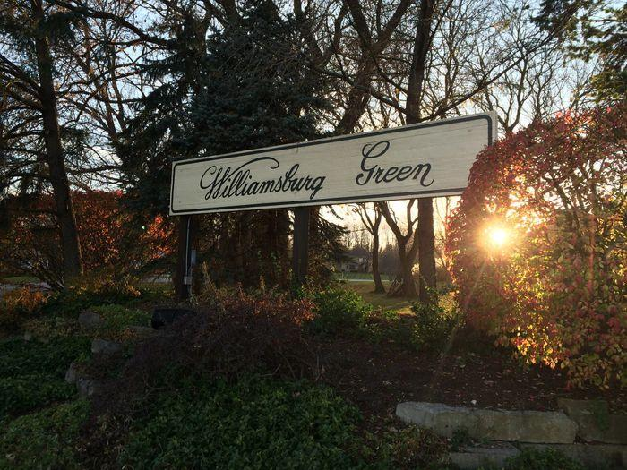
Welcome to Williamsburg Green
The Property Owners Association Board of Directors consist of:
Jill Kostock, President
Henry David, Treasurer Email: henry.x.david@gmail.com
Pat Gieske, Secretary
Cara Campbell, Board Member
Mike Smerek, Board Member
The Williamsburg Green Annual Meeting is held in January of every year at the Elgin Country Club. A complimentary breakfast buffet is served. Invitations are sent via property owner email on file. The meeting is also published on the wgpoa.com website. We look forward to seeing you there, all are welcome!
The meeting has several goals:
- Approving the annual budget, after which the assessment will be distributed to all property owners, payment will be due within 30 days of receipt. Meeting minutes can be found on the wgpoa.com website.
- Vote for new WGPOA Board Members when appropriate
- Discussing any member’s concerns and planning for the future improvements.
We e-mail the assessment to the members to save the association on printing and mailing costs.
Attached are the Restrictive Covenants and By-Laws, they are also located on the website.
Please reach out to the board if you have any questions concerning the Restrictive Covenants and By-Laws.
If you are interested in serving on the Board, we are always looking for new members to help manage the association.

