**Welcome to Williamsburg Green**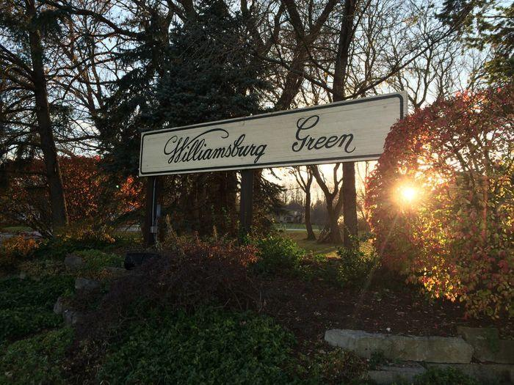

The Property Owners Association Board of Directors consist of:

Larry Ollice, President – 630-940-8720, larry.ollice@gmail.com

Henry David, Treasurer

Pat Gieske, Secretary

Jill Kostock, Vice President

Kristian Hively, Vice President

Our next Annual Meeting is 9 AM Saturday 17 Jun at the Elgin Country Club, you will receive an invitation in the mail. We look forward to seeing you there, all are welcome!

The meeting has several goals:

1. Approving the annual budget, after which the assessment will be distributed to all property owners, payment will be due in 30 days of receipt. 2022 Minutes are attached.
2. Discussing the member’s concerns and planning for the future improvements.

We e-mail the assessment to the members to save the association on printing and mailing costs.

Attached are the Restrictive Covenants and By-Laws, they are also located on the website.

Please reach out to the board if you have any questions concerning the Restrictive Covenants and By-Laws.

If you are interested in serving on the Board, we are always looking for new members to help manage the association.