Peak Fall Color Timing Map for the North Carolina Mountains

This map was developed jointly by Dr. Howard Neufeld and Michael Denslow. Michael was responsible for building the map while Dr. Neufeld provided the algorithms used. My thanks to Michael for doing such a great job on this.

The unique aspect of this map is that we considered both latitude and elevation in developing our estimates of peak leaf color timing. For elevation, we used the adiabatic lapse rate to determine the rate at which temperatures decline with elevation. We used -3.3ºF for every 1,000’ increase in elevation (6.0ºC/1000 meters).

The latitude of the most southwestern corner of the mountains in North Carolina was set historically at 35ºN (technically it is 34º59’55”) while the most northeastern corner resides at 36º34’25”. Thus, there is about 1 ½ degrees of latitudinal difference between the southern and northern portions of the mountains in NC. This is important because locations farther south should turn color later than those in the north because on average, they would be warmer at equivalent elevations.

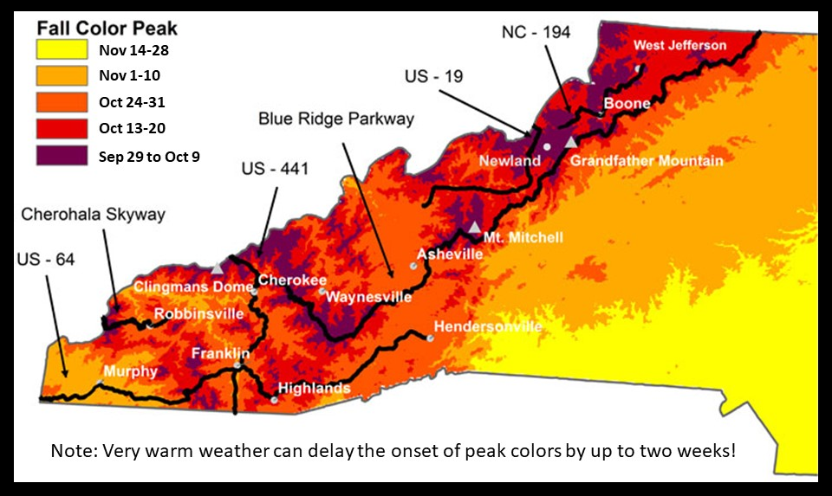
We used Hopkins Bioclimatic Law to estimate how temperatures change with latitude. This “law” states that moving 1º north in latitude is the same as moving up in elevation by 400’ (122 meters).

As example of how this helps with predicting the timing of fall leaf colors, consider that peak leaf colors are often reached at the same time in Highlands, NC as in Boone, NC, even though Highlands is more than 1º farther south than Boone. But Highlands is also 1,000’ higher in elevation, so in this case, elevation compensates for latitude, resulting in similar peak color times.

