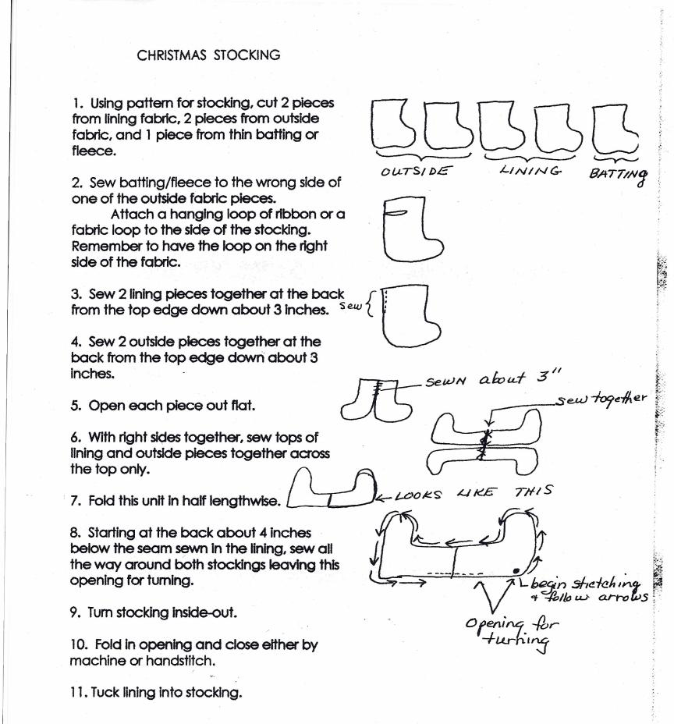
Please come out and join us May 24th for a Community Service Workshop. The fun will begin at 9:30. If you don’t wish to sew, you can still join us to assist in the cutting of batting, stockings and linings, as well as assemble kits. Be sure to bring your own drink; pizza will be provided and door prizes will be awarded. We hope to see you there.

