JANUARY
Block of the Month – Quilt of Valor

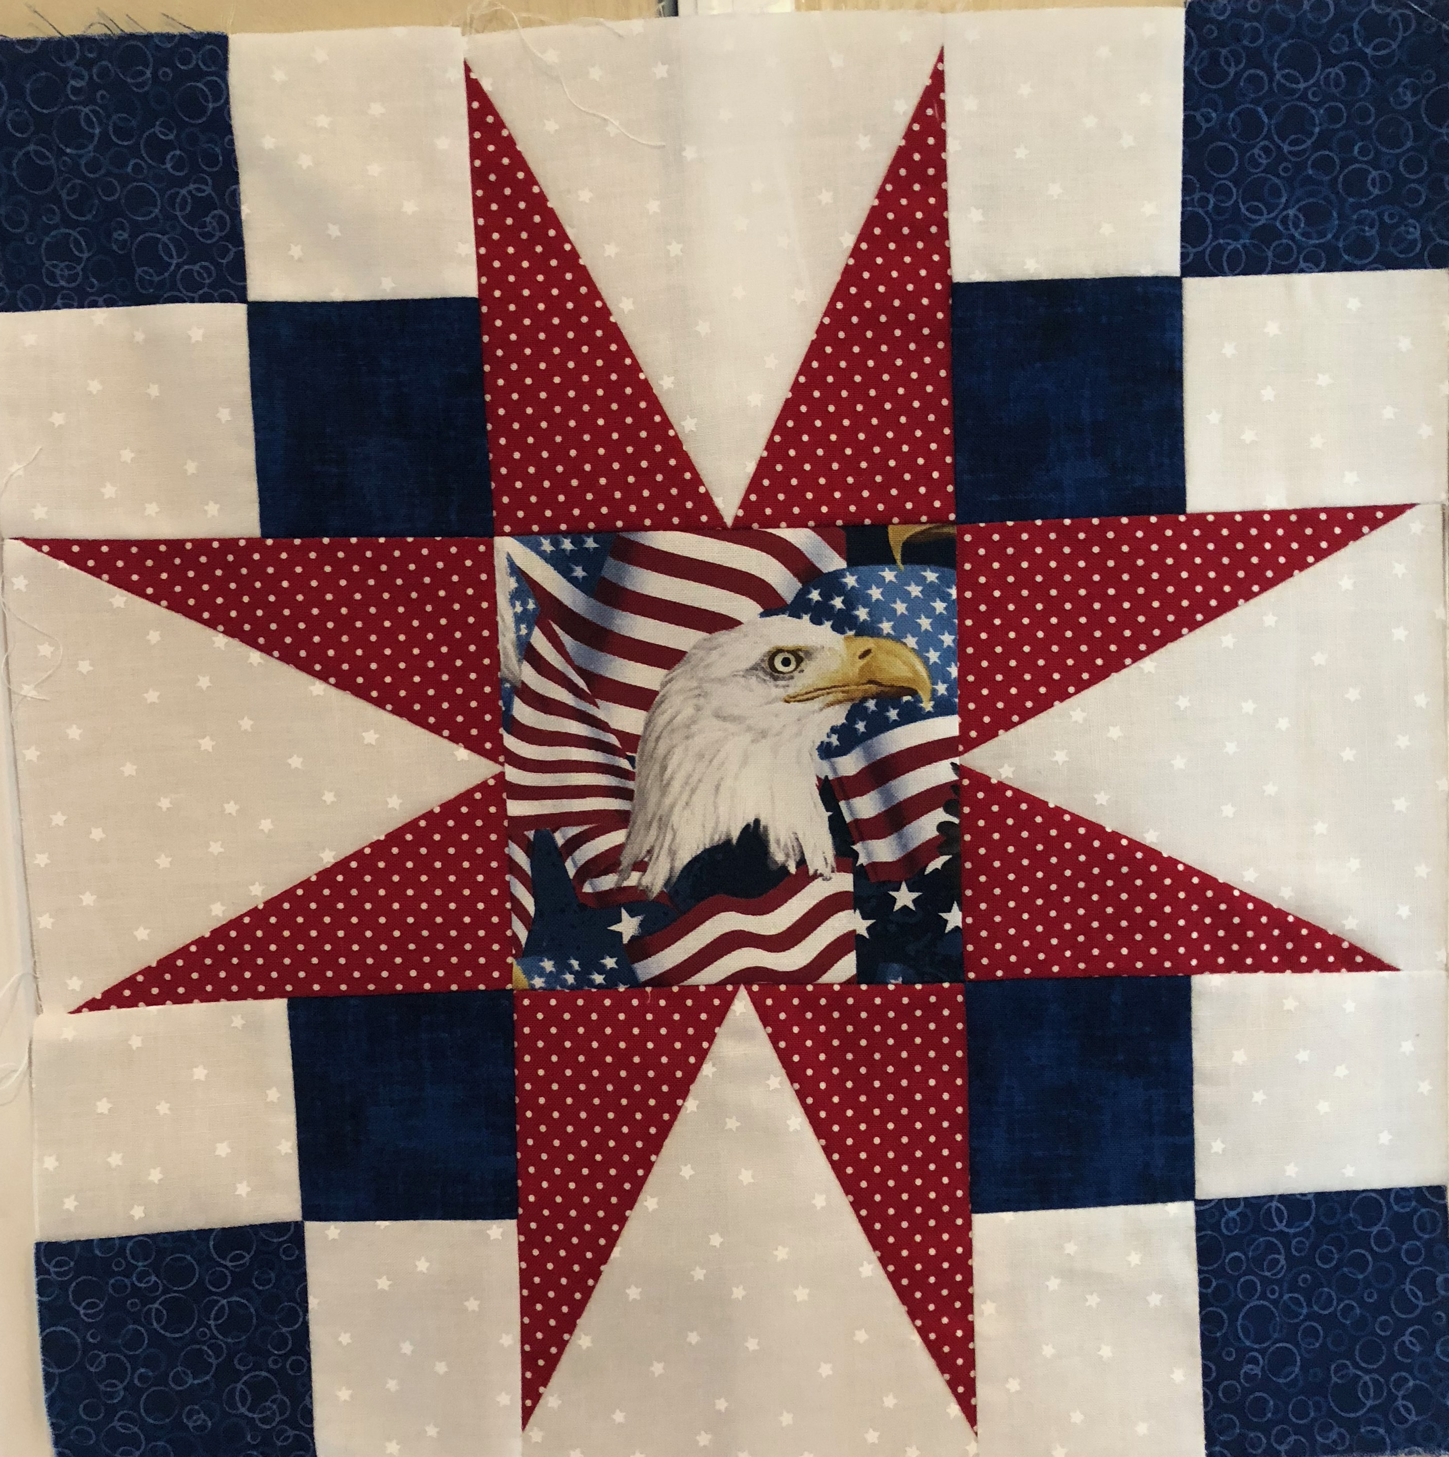

FEBRUARY
Block of the Month – Quilt of Valor

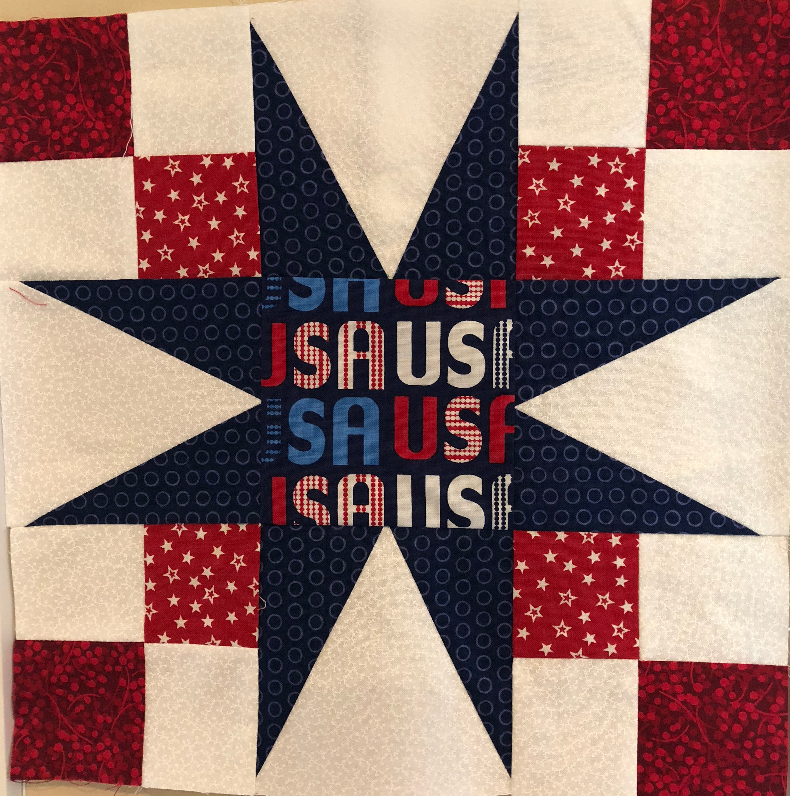

MARCH
Block of the Month – Quilt of Valor
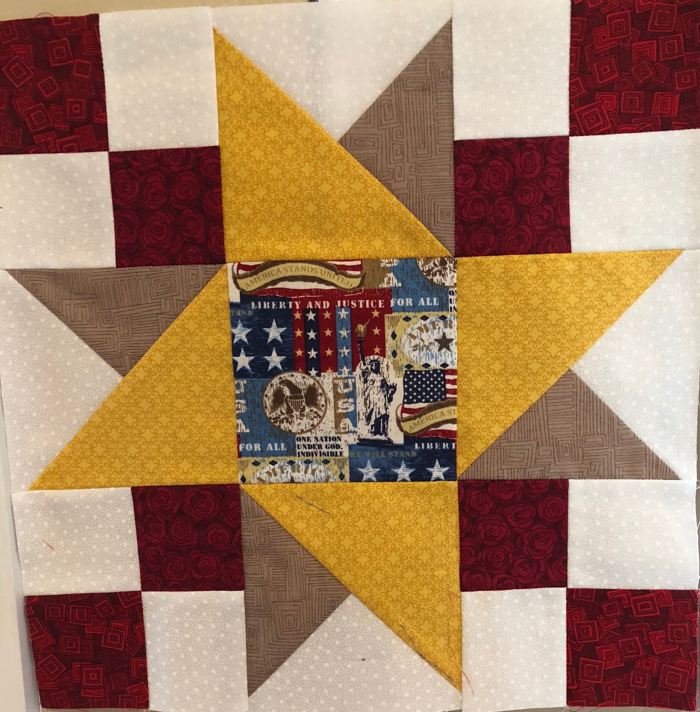

MARCH
Block of the Month – Quilt of Valor

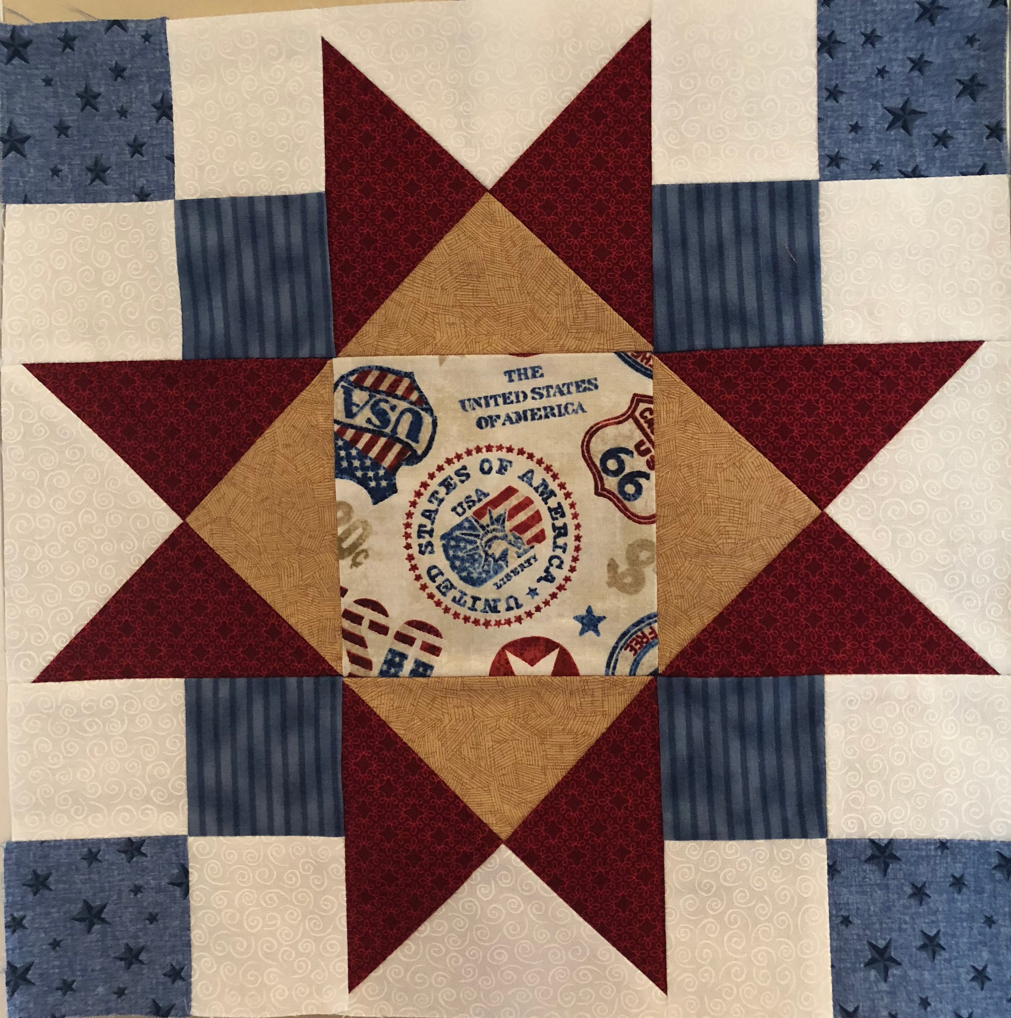

APRIL
Block of the Month – Quilt of Valor
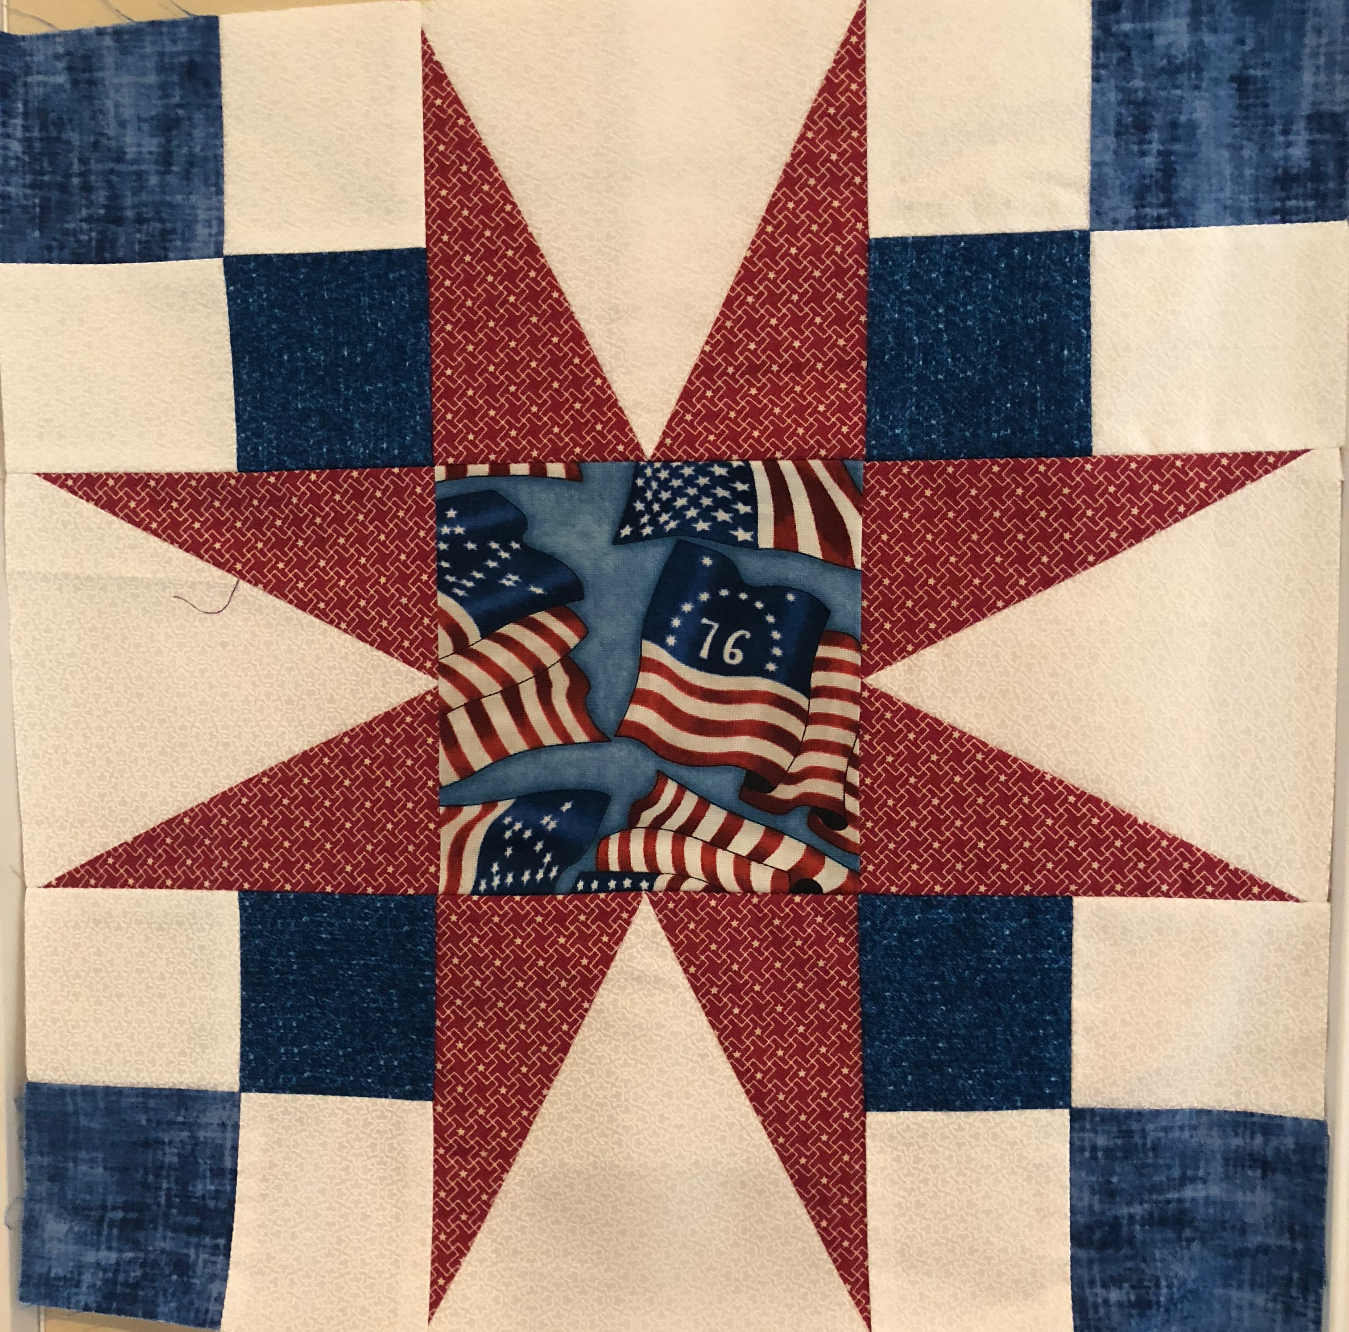

MAY
Block of the Month – Quilt of Valor

