QUILT OF VALOR

COMMUNITY SERVICE WORKSHOP

The July workshop will focus on Quilt of Valor quilts. We will be assisting Ginger Maddox in cutting fabric, making kits and sewing together blocks for quilts. The workshop will be held on Thursday, July 26th from 9:30 – 2:00 at New Hope Baptist Church, 108 Aurora Street, Valparaiso, FL. This is a community service workshop, so lunch will be provided (pizza) and door prizes will be awarded. Please bring your own drinks.

Materials needed:  
Sewing machine  
Rotary cutters  
Cutting mats  
Rulers  
Basic sewing supplies

If you would like to donate fabric to Ginger, please bring 1 yard minimum cuts in appropriate red, white, blue or patriotic colors.

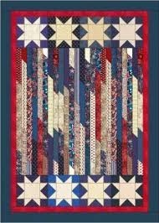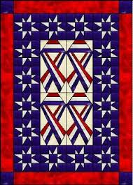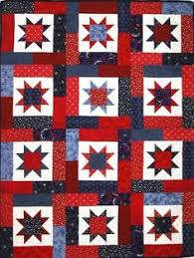This workshop promises to be loads of fun, so please come out and join Ginger as we create beautiful Quilts of Valor.