**Wonderful 1 Fabric Quilts Workshop** taught by Kathy Everett

August 23, 2018 from 9:30 a.m. until 2:00 p.m.

For those of you who did not get to take Sue Donavan’s class for this quilt, now is your chance to sign up.  Brought back by popular demand, Kathy Everett is teaching this class again. Sign up sheets will be on the table at our general meeting through August 9th. There’s plenty of space left so sign up soon.

**Materials needed:**

- If making a Wall hanging - 4 yards of a “wallpaper” fabric

- If making a Lap Quilt - 6-8 yards of a “wallpaper” fabric

- Kay Nickols book Wonderful 1 Fabric Quilts (if you cannot get this book let Kaye Joachim know and there will be copies of just the pattern at the workshop)

- Sewing machine

- Rotary cutter

- Flat head pins are great to use.

- Cutting mat (there are a few in the storage room)

- Ruler (there are a few in the storage room)

- Whatever sewing supplies you might also need

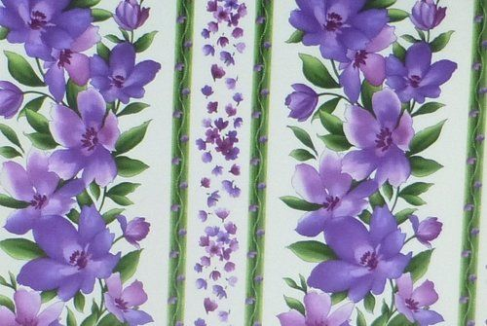**Samples of Fabric:**

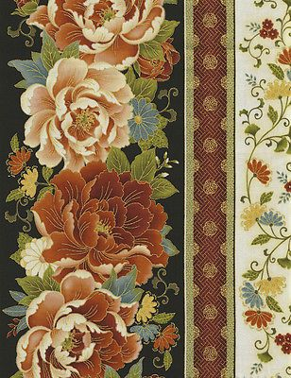

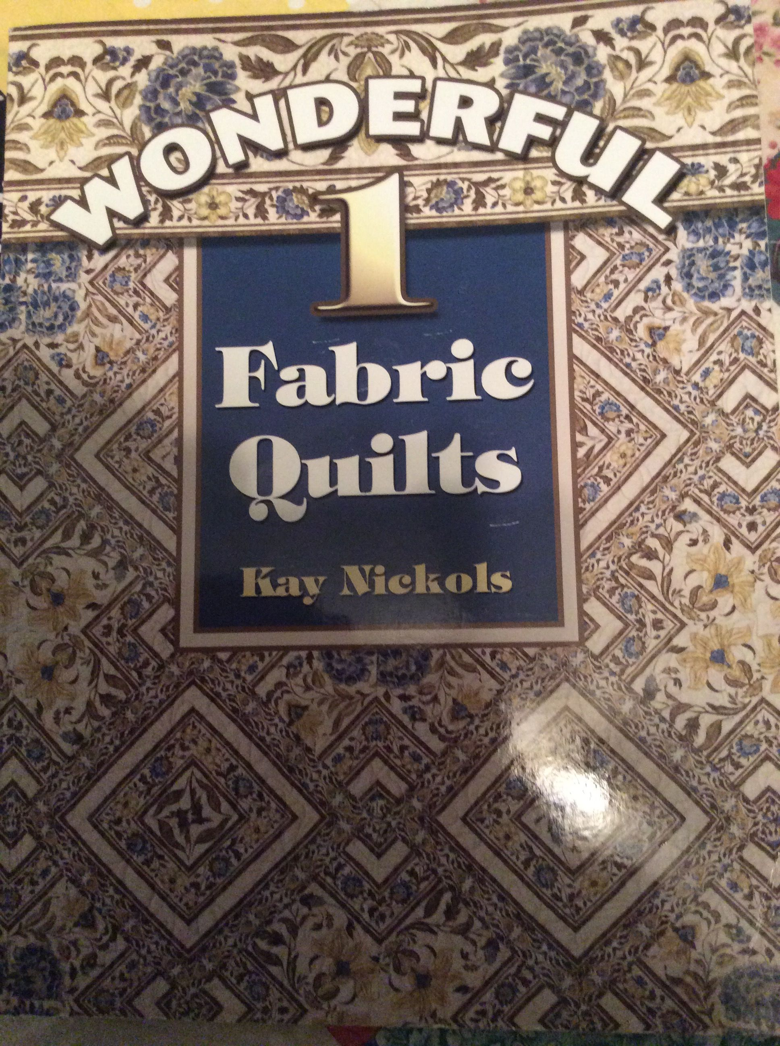**Required Book:**