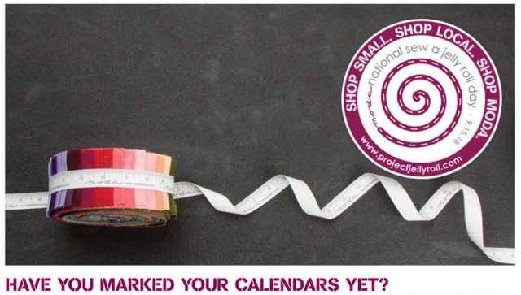
International Sew a Jelly Roll Day is September 15, the third Saturday of September.

Please come and join the fun for this charity/QOV workshop at New Hope Baptist Church from 9:30 - 2:00. There is still time to sign up. We will have pizza and door prizes but bring your own drink. Jelly rolls will be provided if you are sewing for charity or QOV. If you’d like to come and join in on the fun but sew something for yourself, please bring your own jelly roll. Also bring your sewing machines, supplies, rotary cutters and rulers.

