**Christmas Tree Skirt taught by Grace Grimsley**

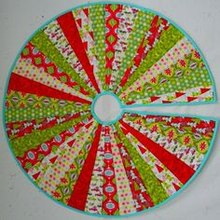

Please join us to learn how to make this beautiful Christmas Tree Skirt October 25, 2018 from 9:30 - 2:00 at New Hope Baptist Church. There is still time to sign up.  Please bring your own lunch.

**Materials Needed:**

9 Fat Quarters

If you want a pieced backing then another 9 fat quarters

Batting if want batting in your tree skirt

10 degree ruler (wedge ruler)

Sewing machine

Supplies

Rotary cutter

Mat

Scissors