Meet our featured teacher -- Nancy Mahoney 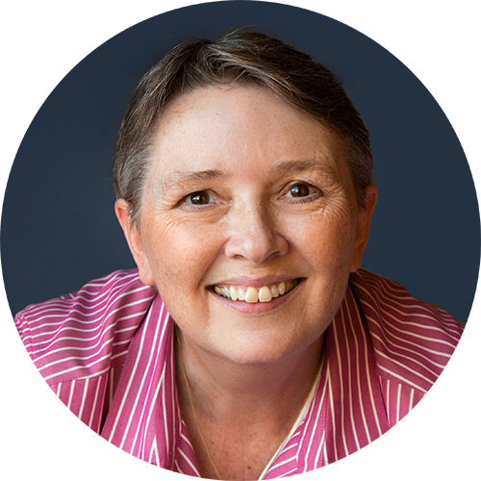

Author, teacher, and fabric designer Nancy Mahoney has enjoyed making quilts for over thirty years, during which time an impressive range of her beautiful quilts have been featured in many books and in over 200 national and international quilt magazines, with more books and patterns always in the works. She has also created over 100 free quilt patterns for a number of fabric manufactures. Nancy has designed 15 fabric collections for P&B Textiles and Clothworks.

She has authored 14 books, all published by Martingale. Her bestselling books include Learn to Paper Piece (2016), Simple Circles and Gentle Curves (2013), Kaleidoscope Paper Piecing (2012), Fast, Fusible Flower Quilts (2011), Treasures from the 30s (2010), Applique Quilt Revival (2008), and Quilt Revival (2006).

Nancy has taught many workshops nationwide for guilds, shops, and conferences, including International Quilt Festival (Houston), AQS Quiltweek, Minnesota Quilter’s Conference, Kentucky Getaway, Road to California, A Mountain Quiltfest (Tennessee) and many more.

Nancy believes making a quilt should be fun. In her classes, her goal is for students to have a good time, learn something new, and make a quilt that they will enjoy for many years.

Classes: (Material list attached)

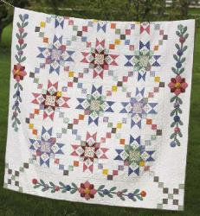
Thursday – February 21 – Full Day: Granny’s Stars – Star blocks, simple applique and yo-yo flowers make this traditional looking quilt a real beauty. Students will learn how to make the big block stars using Nancy’s quick and easy piecing. Fusible applique techniques and tips for making perfect yo-yo are included in the class. If reproduction prints aren’t for you, batiks on a dark background make a spectacular, eye-catching quilt. Shown on the cover of Fons and Porter’s Love of Quilting magazine, July/August 2009. Pattern included for each student. Finished size 76” x 94”.

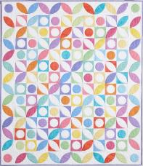
Friday – February 22 – Full Day: Gum Drops – Nancy combined brightly colored fabrics and a traditional design to create a fabulous quilt – with a new twist. In this class, Nancy will share her machine applique techniques using plastic templates and spray starch for flawless applique results. Class will encompass all aspects of invisible machine applique including template and pattern piece preparation, tips for laying out perfectly placed designs, and instruction for using your sewing machine to achieve finished applique that truly look hand stitched. Pattern included for each student. Quilt shown in Fons’ & Porters’ Love of Quilting, Jan/Feb 2014. Finished size 50” x 58”. Based on Simple Circles and Quick Curves book.

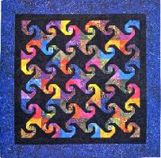
Saturday – February 23 – Full Day: Twist and Shout – In this class, you’ll learn an easier, quicker, and less-waste method of paper foundation piecing. All aspects of foundation paper piecing will be covered, including how to correctly position the right fabric piece. With Nancy’s helpful in-class directions, you can relax and have fun in this information packed class. Pattern included for each student. Finished size 48” x 48”.

Granny's Stars - by Nancy Mahoney
Thursday: 9:00am – 4:30pm
Class Fee: $65.00
Skill Level: Confident Beginner
Class Size: No minimum, No Maximum

Quilt size: 76½" x 94½" - Block size: 16"

Supply list:

Materials - Yardage is based on 42"-wide fabric.
5 ³⁄₄ yards of cream solid (or light print) for background
21 fat quarters of assorted light, medium, and dark prints for star blocks and yo-yos
¹⁄₄ yard of light-green print for star blocks and corner blocks
1 yard of dark-green print for star blocks and appliqué
¹⁄₂ yard of red print for star blocks and appliqué
1 ¹⁄₄ yards of brown print for corner blocks, sashing squares, and binding
¹⁄₄ yard of medium-pink print for appliqué Fusible web (not required for class)

Tools
• Rotary Cutter (45 mm)
• Cutting Mat (12" x 18")
• Rulers: 6" x 12" ruler and 6 ¹⁄₂" square ruler
• Trimming rulers: Corner Trimmer by Marti Michell or Triangle Trimmers by Fons and Porter
• Sewing Machine and Basic Sewing Supplies (scissors, pins, thread, seam ripper, and any special sewing tools you use.)

Cutting
Cut the following pieces to make the entire quilt. Before class, cut enough pieces to make at least four blocks and bring those pieces to class. .
From the background fabric, cut:
• (7) 4½" x 42" strips; cut into: (112) 2½" x 4½" rectangles
• (8) 2½" x 42" strips; cut into: (128) 2½" squares
• (8) 1¼" x 42" strips; cut into: (48) 1¼" x 3⅜" rectangles (48) 1¼" x 2⅝" rectangles
• (12) 5¼" squares, cut twice diagonally to yield (48) quarter-square triangles
From each of 3 light prints, cut:
• (16) 2⅝" squares (48 total)

From each of 3 light or medium fat quarters, cut:
• (4) 4½" squares (12 total; block center)
From each of 1 dark fat quarter, the red print, and the dark-green print, cut:
• (16) 2⅞" squares, cut diagonally in half to yield (32) half-square triangles (96 total; inner star points)
From each of 3 medium or dark fat quarters, cut:
• (8) 5¼" squares, cut twice diagonally to yield (32) quarter-square triangles (96 total; outer star points)

From the remaining fat quarters, cut a combined total of:
• (136) 2½" squares
From the light-green print, cut:
• (2) 2½" x 42" strips; cut (28) 2½" squares

To make each block, you'll need the following pieces:
Background:
(8) 2½" x 4½" rectangles
(8) 2½" squares
(4) 1¼" x 3⅜" rectangles
(4) 1¼" x 2⅝" rectangles
(4) 5¼" quarter-square triangles
Assorted prints:
(4) matching 2⅝" squares (light print)
(1) 4½" square (light or medium print)
(8) matching 2⅞" half-square triangles (inner star points)
(8) matching 5¼" quarter-square triangles (outer star points
(12) 2½" squares

For class, you'll need the pieces listed above to make at least four blocks. How many blocks you make in class will depend on how fast you sew. Cutting for sashing, corner blocks, and outer border will be provided in class.

Gum Drops - by Nancy Mahoney
Friday: 9:00am – 4:30pm
Class Fee: $65.00
Skill Level: Confident Beginner
Class Size: No minimum, No Maximum

Quilt Size: 50” x 58”

Supply List:

Fabrics
• 12-15 fat quarters (18" x 21") of assorted bright prints for blocks and appliquéd border
• 3 yards of white background print for blocks and border
• ¹⁄₂ yard of purple print for binding (not needed for class)
• 3 ¹⁄₂ yards of backing fabric (not needed for class)

Other Materials
• No-Melt Mylar or heat-resistant template plastic (EZ Quilting preferred)*
• Ultra-fine point Sharpie permanent marker for tracing shapes on template plastic
• Neutral thread for patchwork
• 60 wt thread to match background (white)
• Machine needles - Microtex sharp 60/8 (preferred) or 70/10 for machine appliqué
• Clear monofilament or invisible thread for appliqué **
• Water-soluble fabric glue (Quilter's Choice, Glue-baste-it, or Jillily Studio appliqué glue). A glue stick is not suitable.

* Available for purchase in class
** To achieve the desired results, I use monofilament or invisible thread. However, if you do not want to use invisible thread, bring 60 wt thread that matches the fat quarter prints.

General sewing supplies
• Sewing machine with blanket or zigzag stitch and appropriate presser foot (open-toed embroidery foot recommended)
• Rotary cutting mat, cutter and ruler (6" x 14")
• Sharp scissors for cutting fabric
• Paper scissors for cutting template plastic
• Pencil or other marking tool for tracing shapes
• Any other favorite tools you like to have on hand when sewing

Before Class - Cutting
From assorted bright prints, cut:
• (60) 4 ¹⁄₂" squares
• Bring leftover fat quarters to class to use for appliquéd shapes.
From white background print, cut:
• (8) 4 ¹⁄₂" x 42" strips; crosscut into (60) 4 ¹⁄₂" squares

After Class - Cutting
From white background print, cut:
• (6) 5 ¹⁄₂" x 42" strips. From 1 strip cut (4) 5 ¹⁄₂" squares. Piece the remaining strips to make (2) 5 ¹⁄₂" x 48 ¹⁄₂" side borders and (2) 5 ¹⁄₂" x 40 ¹⁄₂" top and bottom borders.
From the purple print, cut:
• (6) 2 ¹⁄₄" x 42" binding strips

Twist and Shout - by Nancy Mahoney
Saturday: 9:00am – 4:30pm
Class Fee: $65.00 - Kit Fee: $2.00 for foundation pattern
Skill Level: Confident Beginner
Class Size: No minimum, No Maximum

Quilt size: 48" x 48"
Supply list:
You can use my colors or choose your own colors. You can also use a light background instead of black!

Yardage
1 ¹⁄₂ yards total of assorted bright batiks in several color families for blocks
1 ³⁄₄ yards total of black batik for blocks and inner border
1 ¹⁄₂ yards of blue batik for outer border and binding
3 yards of backing fabric
52" square of batting

Tools
• Rotary Cutter (45 mm or small cutter)
• Cutting Mat (12" x 18" or larger)
• Rulers: 6" x 12" ruler (or larger) and 1" x 6" ruler (Add-A-Quarter ruler - optional)
• Wooden Pressing tool OR small iron and ironing pad
• Washable glue stick
• Sewing machine and Basic sewing supplies (scissors, pins, thread, seam ripper, and any special sewing tools you use.)

Cutting
In class, you'll only have time to make a few blocks. How many you get done will depend on how fast you sew and how proficient you are at paper foundation piecing. If desired, only cut enough fabric for a few blocks. You do not need to bring the border or binding strips to class.

From the assorted bright batiks, cut:
Cutting for 2 blocks

From the assorted bright batiks, cut:
(2) 2" x 2" squares
(2) 2" x 2" squares; cut in half diagonally to yield 4 triangles
(2) 2 ¹⁄₂" x 2 ¹⁄₂" squares; cut in half diagonally to yield 4 triangles
(2) 3" x 3" squares; cut in half diagonally to yield 4 triangles
(2) 4 ¹⁄₄" x 4 ¹⁄₄" squares; cut in half diagonally to yield 4 triangles

From the black batik, cut:
(2) 2" x 2" squares; cut in half diagonally to yield 4 triangles
(2) 2 ¹⁄₂" x 2 ¹⁄₂" squares; cut in half diagonally to yield 4 triangles
(2) 3" x 3" squares; cut in half diagonally to yield 4 triangles
(2) 4 ¹⁄₄" x 4 ¹⁄₄" squares; cut in half diagonally to yield 4 triangles
(36) 2" x 2" squares
(36) 2" x 2" squares; cut in half diagonally to yield 72 triangles
(36) 2 ¹⁄₂" x 2 ¹⁄₂" squares; cut in half diagonally to yield 72 triangles
(36) 3" x 3" squares; cut in half diagonally to yield 72 triangles
(36) 4 ¹⁄₄" x 4 ¹⁄₄" squares; cut in half diagonally to yield 72 triangles

From the black batik, cut:
(36) 2" x 2" squares; cut in half diagonally to yield 72 triangles
(36) 2 ¹⁄₂" x 2 ¹⁄₂" squares; cut in half diagonally to yield 72 triangles
(36) 3" x 3" squares; cut in half diagonally to yield 72 triangles
(36) 4 ¹⁄₄" x 4 ¹⁄₄" squares; cut in half diagonally to yield 72 triangles
(2) 2 ¹⁄₂" x 36 ¹⁄₂" strips (side inner borders)
(2) 2 ¹⁄₂" x 40 ¹⁄₂" strips (top/bottom inner borders)

From the lengthwise grain of the blue batik, cut:
(2) 4 ¹⁄₂" x 40 ¹⁄₂" strips (side outer borders)
(2) 4 ¹⁄₂" x 48 ¹⁄₂" strips (top/bottom outer borders)
(5) 2 ¹⁄₄" x 42" strips (binding)
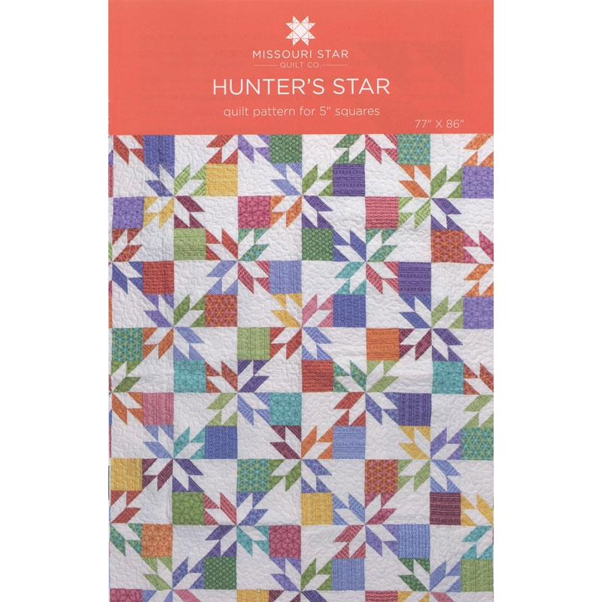
Hunters Star
Instructor: Grace Grimsley
Thursday: 9:00am – 4:30pm
Class Fee: $45.00
Skill Level: Beginner
Class Size: Min. 5 Students, Max. 20 Students

Size of Quilt: 77” x 84”

This stunning Hunters Star quilt is much easier to make than it looks. Using four-patches and half-square triangles, you can make this in no time and have a gorgeous quilt to be cherished forever. You can make this quilt using just about any combination of colors, or make it in just two colors. Batiks makes a very striking quilt.

Supplies List:

1 pack (42) 10” squares of a print (or 4 pkgs of 5” squares or yardage equivalent)
1 pack (42) 10” squares of a solid (or 4 pkgs of 5” squares or yardage equivalent)
¾ yard Inner Border
1-3/4 yard Outer Border
¾ yard Binding
Rotary Cutter
6 x 12 Ruler
Small Square up Ruler
Sewing Machine (also routine sewing supplies – don’t forget power cord and pedal)

Prior to class: Cut all 10” squares into 5” squares (both print and solid).
Make 28 4-patch blocks. If you make these at home, you will get a lot further along in class.

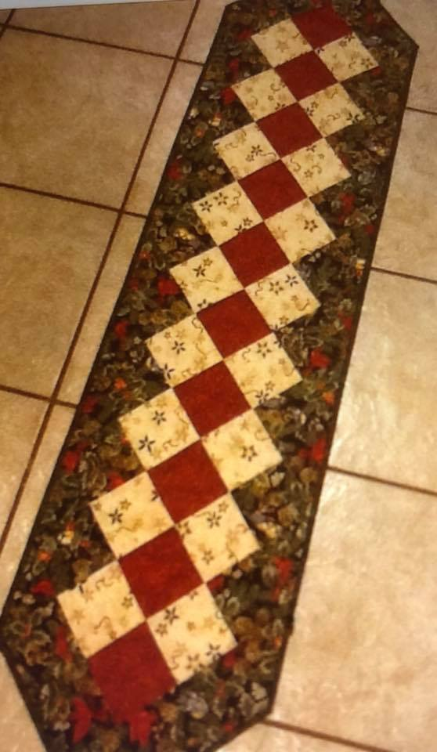
Country Table Runner
Instructor: Grace Grimsley
Saturday: 9:00am – 12:00pm
Class Fee: $25.00
Skill Level: Beginner
Class Size: Min. 5 Students, Max. 20 Students

Supply List:

45” wide Cotton Fabric
1/3 yard Dark Fabric
1/3 yard Medium Fabric
¾ yard Light Fabric
One 17” x 62” piece for backing
One 17” x 62” piece of batting
Rotary Cutter
6 x 24 inch Ruler
Sewing Machine (also routine sewing supplies – don’t forget your power cord and pedal)

Cutting:
Dark: Cut 1 strip of fabric 4” x WOF
Medium: Cut 2 strips of fabric 4” x WOF
Light: Cut 2 strips of fabric 7-1/2” x WOF
Light: Cut 2 strips of fabric 4” x WOF (then cut these strips in half = 2 strips 4” x ½ of WOF)
Light: Cut 4 strips of fabric 2-1/2” x WOF. This is the binding so sew all together end to end then fold
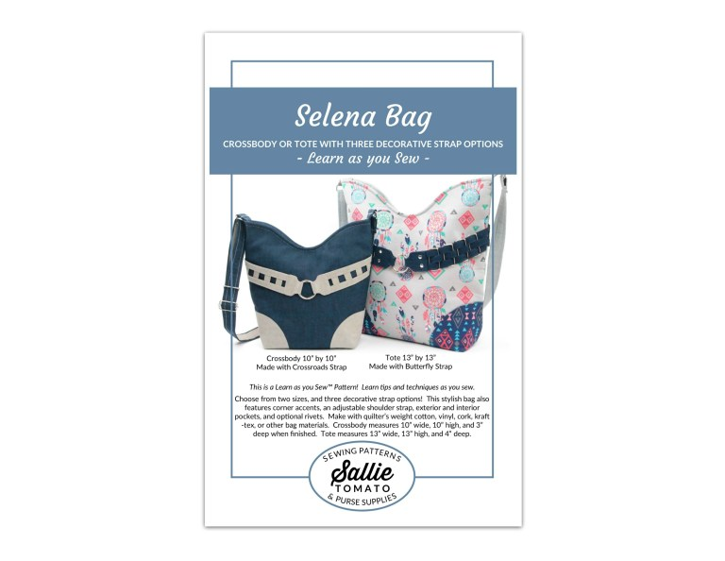
The Selena Bag
Instructor: Merilee Kennedy
Thursday: 9:00am – 4:30pm
Class Fee: $35.00
Skill Level: Beginner
Size of Wallet: 8’L x 4”H x 1”D
Class Size: Min. 3 Students, Max. 10 Students

I hope you will enjoy making Selena, a unique and stylish bag!
With the 10” wide, 10” high, and 3” deep crossbody or the 13” wide, 13” high, and 4” deep tote, you have a choice of two different sizes and three decorative strap options. This stylish bag features corner accents, an adjustable strap, exterior and interior pockets and optional rivets. Perfect for learning to sew with cork.
This is a Learn as you Sew™ Pattern! Learn tips and techniques as you sew this project. Included are step-by-step graphics to help make the written directions easier to understand. Also included are many sewing techniques and tips to help you achieve a quality, finished project. This pattern is designed to help you learn and expand your sewing skills!
Supply List:
- Machine, cleaned, oiled and in good working condition with all normal sewing accessories to include
the power cord, foot control, slide on tray if your machine has one and the manual you received when you purchased your machine.

- Pattern - The Selena Bag by Sallie Tomato and all supplies as listed on the back of the pattern. This bag is especially suited for using cork for the accent pieces if you would like to lean to sew with cork. You have the option of doing either the Butterfly or Basket Weave decorative strap. Please purchase hardware associated with your choice. If you wish to explore using rivets, I will furnish the rivet setter for class.

Additional Supplies:

A. Good fabric scissors.
B. Glass head straight pins and Wonder Clips.
C. A fabric marking pen.
D. A quarter inch foot, zipper foot, and general purpose foot for your machine.
E. Thread: good quality construction thread such as Mettler polyester.
F. Microtex 90/14 needles.
G. Wonder Tape.
H. Pressing sheet.
I. Height compensation tool.
J. Rotary cutter with a new blade, cutting mat and cutting ruler.
K. Fabric Shield (optional but recommended).

PRIOR TO CLASS: Please cut all pieces as stated in the instructions. Labeling all pieces as you cut them will keep this process organized and make your class time more productive. I suggest you bring extra fabric, interfacing and cork in the event you should need extra.

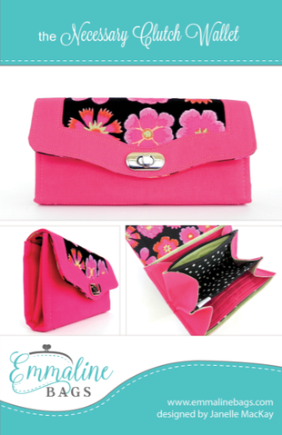
The Necessary Clutch Wallet Handbag
Instructor: Merilee Kennedy
Friday: 9:00am – 4:30pm
Class Fee: $35.00
Skill Level: Intermediate
Class Size: Min. 3 Students, Max. 10 Students

The Necessary Clutch Wallet (NCW) isn’t just your ordinary wallet. Carry your cell phone/mobile, checks, cash, cards, coins and still have room for your personal items, etc. With its closed ends, everything is safe and secure and there is never any worry about anything sliding out. The Necessary Clutch Wallet is suitable for fabric and/or cork. You can add a wristlet strap or crossbody strap.

Supply List:

- Machine, cleaned, oiled and in good working condition with all normal sewing accessories to include the power cord, foot control, slide on tray if your machine has one and the manual you received when you purchased your machine.

- Pattern - The Necessary Clutch Wallet by Emmaline and all supplies as listed on the back of the pattern. This pattern lends itself nicely to cork, vinyl or leather accents if you wish to use one of these to give your clutch wallet a unique and personalized look.

Additional Supplies:

A. Good fabric scissors.
B. Glass head straight pins and Wonder Clips.
C. A fabric marking pen.
D. A ¼” foot, zipper foot and general purpose foot for your machine.
E. Thread: good quality construction thread such as Mettler polyester or silk-finish cotton.
F. Microtex 90/14 needles.
G. Wonder Tape.
H. Pressing sheet.
I. Height compensation tool.
J. Rotary cutter with a new blade, cutting mat and cutting ruler.
K. Fabric Shield (optional but recommended).

PRIOR TO CLASS:

Please cut all pieces as stated in the instructions. Labeling all pieces as you cut them will keep this process organized and make your class time more productive. I suggest you bring extra pieces of your fabric and interfacings in case the need arises for any reason. If you wish to add the optional wristlet or shoulder strap, please bring the extra fabric and hardware to do so.

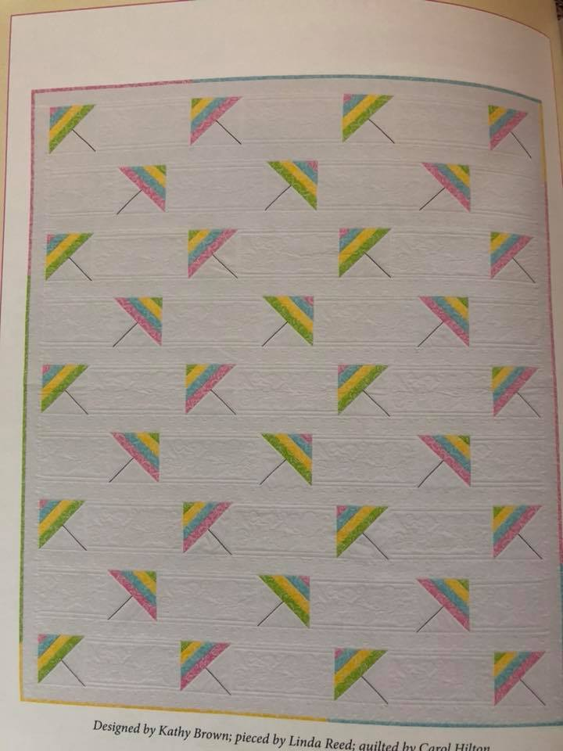
Strip-Smart Quilts II
Instructor: Carolyn Tilburg
Thursday: 9:00am – 4:30pm
Class Fee: $35.00
Skill Lever: Beginner
Class Size: No minimum, No Maximum

The quilt we will be using is on page 24 called Just Beachy.
Finished Quilt is 59-1/2” x 70”. The finished block is 5-1/2” x 5-1/2”.

Supply List:

4-1/2 yards white tone-on-tone for blocks, filler pieces, sashing and border
½ yard each of pink, blue, yellow, and green
4-1/4 yard of fabric for backing
68” x 78” piece of batting
Air-soluble pen
Book – Strip-Smart Quilts by Kathy Brown
Thread, ruler 24”, rotary cutter (sharp blade), 6” square ruler, pins, seam ripper, sewing machine in good working order with ¼” foot, spray starch
You will also need a triangle cutting ruler: Strip Tube ruler, Bonnie Hunter’s Essential Triangle, or Companion Angle

Cutting:

From each of the pink, blue, yellow, and green fabric, cut:
6 strips, 1-1/2” x WOF (24 total)
2 strips, 2-1/2” x WOF (8 total)

From the white tone-on-tone fabric cut:
10 strips, 6” x WOF; subcut into:
8 rectangles, 6” x 8-3/4”
23 rectangles 6” x 11-1/2”
6 strips, 4-1/2” by WOF
24 strips, 2-1/2” by WOF

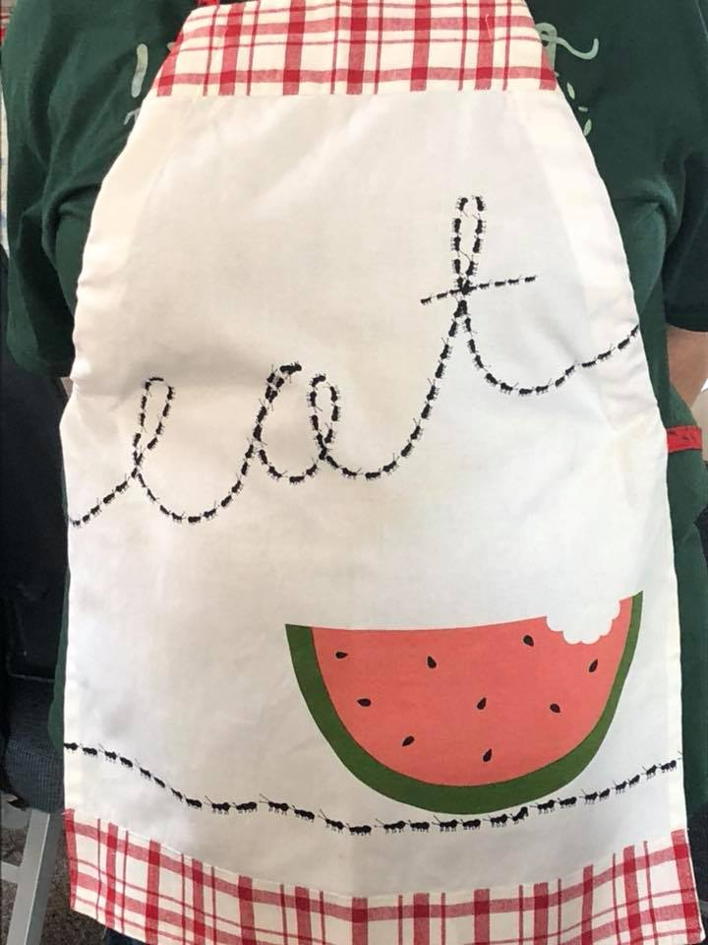
Tea Towel Apron
Instructor: Carolyn Tilburg
Saturday: 9:00am – 12:00pm
Class Fee: $20.00
Skill Lever: Beginner
Pattern Included
Class Size: No minimum, No Maximum

Supply List:
1 decorative tea towel, 18” x 26”
½ yard fabric that matches (goes with) your tea towel

No preparation is needed before class

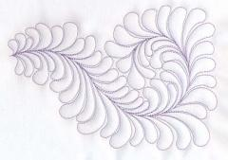
Beginning Feathers
Instructor: Nina Clotfelter
Thursday: 9:00am – 12:00pm
Class Fee: $45.00
Skill Lever: Confident Beginner (You MUST be comfortable with free motion quilting)
Class Size: Min. 5 Students, Max. 20 Students

Feathers are FABULOUS!!! Put your inhibitions aside… You will be making feathers by the end of this class. You’ll learn how to create all the elements of a basic feather. (We break it down to simple parts…you’ll see…you can do this!) There are many different ways to make feathers…we will find the way that works for you! I love feathers and plan to pass that love onto you. Let’s learn to make them.

Supply List:

Sewing Machine and supplies (also your sewing manual, power cord and pedal)
Free Motion Quilting Foot
Extension Table (this is a must)
Single Hole Needle Plate (if you don’t have one yet, DON’T go buy one…I have a trick you can use.
4 Fat Quarter Sandwiches (light color fabric on top, batting, and a backing. Basted or pinned and ready
Thread (I suggest your favorite thread. A color that shows very well on your fabric. My favorite is Trilobal
Polyester
Needles – 90/14 Topstitch
Marking Pen/Pencil – Frixion pen, water soluble pen, or chalk pencil. Be sure it will show up on fabric
Quilting Gloves
Paper and Pencil to draw on – notebook paper is fine.

-----------------------------------------------------------------------------------------------------------------------------------------------
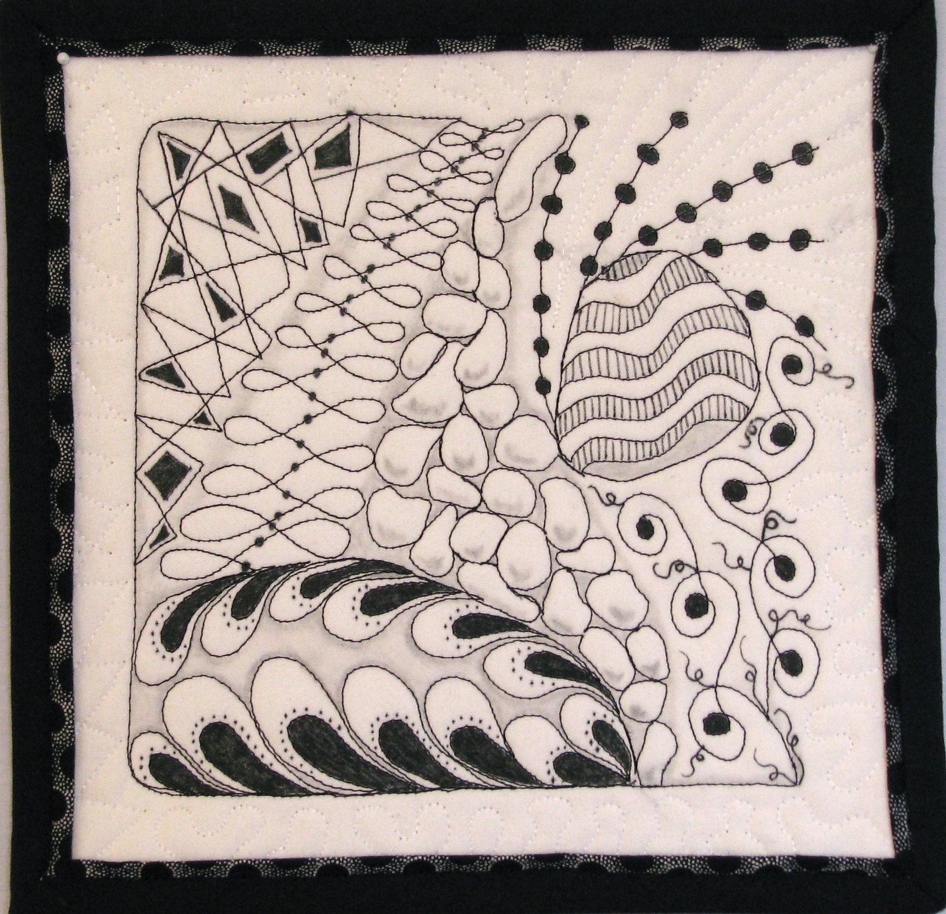
Zen Quilting
Instructor: Nina Clotfelter
Thursday: 1:30pm – 4:30pm
Class Fee: $45.00
Skill Lever: Confident Beginner
Kit/Pattern Fee: $10.00 (included in kit 90/14 Topstitch Needle and Pattern)
Class Size: Min. 5 Students, Max. 20 Students

Zentangling is a form of drawing most of us are familiar with. Let’s have fun using our needle as a pencil. In this fun filled class you’ll quilt a design with zentangle designs inside it. You’ll learn to make them all as a continuous line, so no stops and starts! This would make a beautiful block for a quilt, a wall hanging, or simply frame your work! You’ll get a pattern already designed for you, but you have the creativity to make any changes you want.

Supply List:

Sewing Machine and supplies (also your sewing manual, power cord and pedal)
Free Motion Quilting Foot (if you have more than one, bring them all. We will talk about them.
Extension Table (this is a must)
Single Hole Needle Plate (if you don’t have one yet, DON’T go buy one…I have a trick you can use.
1-2 Fat Quarter Sandwiches (solid color fabric, batting, and a backing basted together. If spray basting, please only use 505 spray and ready to go)
Thread (Bring a few colors of your favorite thread to go on your solid fabric)
Quilting Gloves
Slider – if you have one.

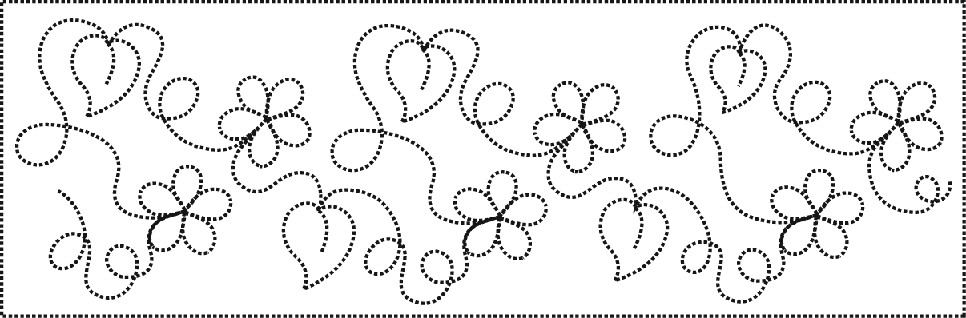
Beginning Free Motion Quilting
Instructor: Nina Clotfelter
Friday: 9:00am – 4:30pm
Class Fee: $50.00
Skill Lever: Beginner
Kit/Pattern Fee: $15.00 (includes Fat Quarter with Design for sandwich without top, 90/14 Topstitch Needle, Booklet
Class Size: Min. 5 Students, Max. 18 Students

In this class you’ll learn the basics and beyond of machine free motion quilting on your domestic sewing machine and how much fun it can be, (not to mention rewarding)! We start at the very beginning…Starting with setting up your machine, tensions, needles, threads, and through many different free motion designs. You’ll find a rhythm that works for YOU, as you learn to listen to your machine, and you’ll make a sampler you can refer to later. You’ll come away with new found confidence to carry you forward in this wonderful world of free motion quilting! This is my favorite part of making a quilt and I hope to make it yours.

Supply List:

Sewing Machine and supplies (also your sewing manual, power cord and pedal)
Free Motion Quilting Foot (If you have more than one, bring them all, we will talk about them)
Extension Table (this is a must)
Single Hole Needle Plate (If you don’t have one yet, DON’T go buy one…I have a trick you can use.
4-6 Fat Quarter Sandwiches (light color fabric on top, batting, and a backing. If spray basting, please only use 505 spray, pinned or hand basted and ready to go. Please leave 1 sandwich without a top.)
Thread-2 different colored spools (Each spool needs to be a contrast from the other. This is so we can get your tensions right during class.)
Quilting Gloves
Drawing Paper and Pencil (school lined paper is fine)

Prep Before Class:

Needed:

Solid color Fat Quarter (probably white, so your thread will show up)
Marking tool (Choose 1 method to mark, Frixion pen, water soluble blue marker, etc.)
24” Ruler

Directions:

Please do this on ONE fat quarter
- Stand your Fat Quarter TALL (21” tall, 18” wide)
- Measure to find the meddle of the 18” width, should be 9”
- Draw a line down the middle of the 21” tall fat quarter
- Measure to be sure you have a 21” tall fat quarter. If so, draw a line across the 18” width every 3.5”. If your fat quarter is only 20” tall, draw a line across every 3-3/8”.
- You should have 12 rectangles, 6 on each side of a center line.
- Now, on one of the lower 4 sections, just choose 1, make 1” square grid. This will not come out even because your rectangle is not an even measurement. Just make a grid using 1” measurement and let it come out as it does.
- Sandwich this up with batting and a back and baste in your favorite method.
- Sandwich up 3 other fat quarters to practice on.
- Make 1 more fat quarter sandwich with the fat quarter from your quilt shop.

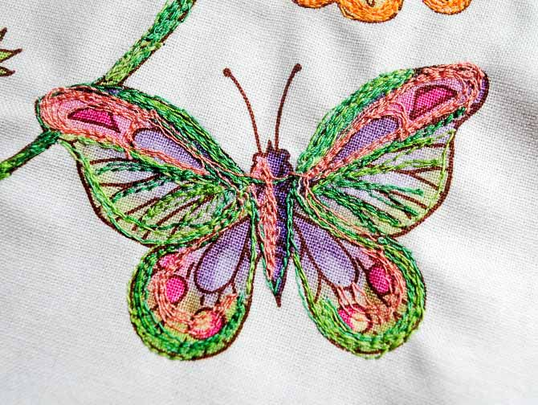
Thread Painting
Instructor: Nina Clotfelter
Saturday: 9:00am – 12:00pm
Class Fee: $45.00
Skill Lever: Beginner
Kit/Pattern Fee: $15.00 (included in kit 90/14 Topstitch Needle and A Fat Quarter – quilt quality)
Class Size: Min. 5 Students, Max. 20 Students

Thread painting is many things…creating a picture, adding details, dimension, and/or depth to an applique, making fur on an animal, or just adding little details to make your creation come alive. You will learn loads of techniques in this class, from basic to shading to fur and filling in. This is a fabulous technique to add to your skills. You’ll be surprised how often you’ll use it. Let yourself be warned…this is such addicting fun!

Supply List:

Sewing Machine and supplies (also your sewing manual, power cord and pedal)
Free Motion Quilting Foot
Extension Table (this is a must)
Free Motion Quilting Foot
Single Hole Needle Plate (if you don’t have one yet, DON’T go buy one…I have a trick you can use.
2 Fat Quarter Sandwiches (1 with all 3 layers, 1 with batting and back only. If spray basting, please only use 505 spray, pinned, or hand basted and ready to go)
Thread (Bring a variety, all colors, weights, kinds. Usually we like to share during class)
Bobbin Thread is optional – you can use one color or change bobbin color as you change top color thread
Quilting Gloves

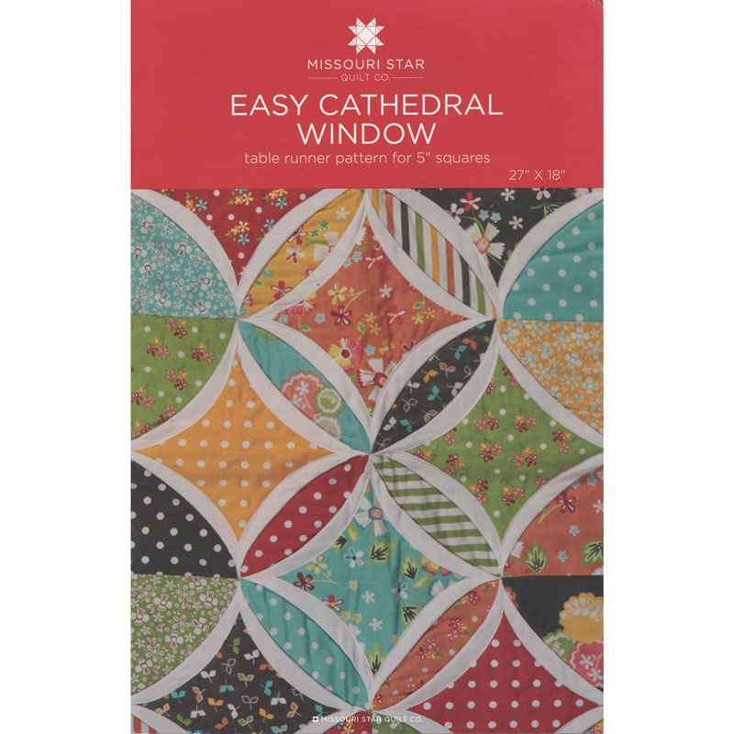
Quilt As You Go Cathedral Window Table Topper
Instructor: Kaye Joachim
Friday: 9:00am – 4:30pm
Class Fee: $45.00
Skill Level: Beginner
Pattern included
Class Size: No minimum, No Maximum

Quilt Size: 26” x 18”

MAKE THIS LITTLE QUILT AS LARGE AS YOU WANT!
This charming Cathedral Window table topper is constructed with a quilt-as-you-go technique. Once each block is done, all you’ll need to do is stitch them together and the quilt will be finished. No matter what size you are making, this quilt uses the same size blocks throughout the quilt, (e.g. if using a charm pack – 5” squares, all blocks are 5” square. If using a layer cake – 10” blocks, all blocks are 10” and so on. No cutting is required unless you are using yardage instead of precuts.

Supply List:

1 pack of (42) 5” squares – colored or prints (charm pack or equivalent yardage)
1 pack of (42) 5” squares – solids (charm pack or equivalent yardage)
¾ yard backing (or enough fabric to have about 2” each side overlap
Batting (approximately 30” x 22” or enough to have overlap)
¼ yard for binding
Pins, basting spray, hand basting (your choice)

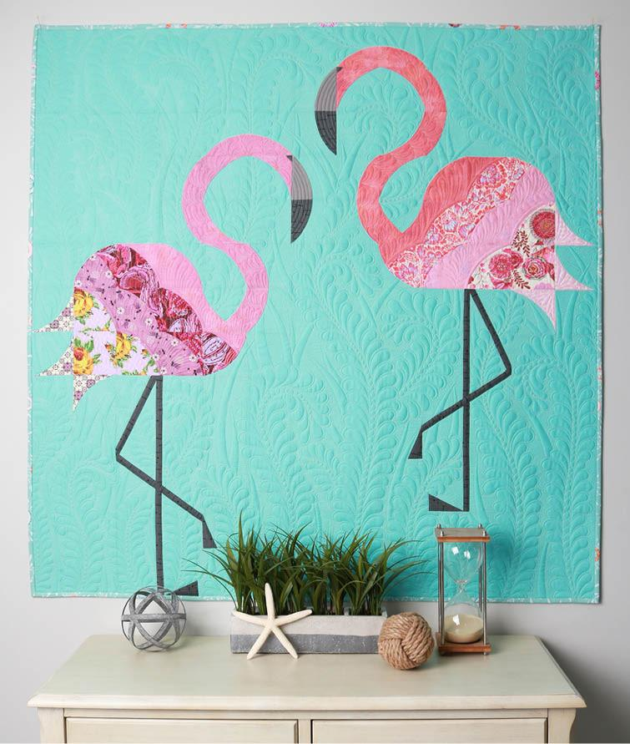
Mod Flamingos by Sew Kind of Wonderful
Instructor: Michelle Stewart
Friday: 9:00am – 4:30pm
Class Fee: $40.00
Skill Level: Confident Beginner
Kit Fee: $28.00 (includes Mod Flamingos Pattern and Quick Curve Mini Ruler, unless you already have these. They are required.)
Minimum of 6 Students, No Maximum

Quilt Size: 46” x 46”

Supply List:

2 1/4 yards background fabric
1 fat quarter dark fabric for legs/feet/beak
(1) 5” x 5” gray fabric for beak
(2) fat quarters pink fabric for head/neck/body (as shown in picture above, the head/necks of each flamingo are a different shade of pink – this it totally your design choice, have fun with it!)
(8) fat eighths assorted prints for flamingo bodies
Quick Curve Mini Ruler
12” or larger straight edge ruler
Sewing machine in good working order with fresh needles
45mm rotary cutter with new blades (very important)
Rotary cutting mat
Thread (for piecing)

CUTTING INSTRUCTIONS (MUST BE DONE BEFORE COMING TO CLASS):

From Background fabric cut:
Cut (2) 3 ¾” x wof, from strips cut (4) 3 ¾” x 18 ½”
Cut (3) 4” x wof, from strips cut
(10) 4” x 4”
(2) 4” x 11 ½”
(2) 4” x 3 ½”
(1) 4” x 18”
Cut (2) 5” x wof, from strips cut (16) 5” x 5”
Cut (1) 5 ½” x wof, from strip cut
(3) 5 ½” x 5 ½” (cut in half diagonally)
(2) 5 ½” x 4”
Cut (4) 7 ½” x wof, from strips cut
(8) 7 ½” x 4 ½”
(2) 7 ½” x 21 ½”
(2) 7 ½” x 14 ½”
(1) 7 ½” x 25”
Cut (1) 11” x wof, from strip cut (2) 11” x 11”
Cut (2) 1” x 2” for standing foot

From Dark Fabric for legs/feet/beak cut:
Cut (4) 1” x 20” strips, from strips cut
(2) 1” x 18 ½”
(2) 1” x 9”
(2) 1” x 11”
(2) 2 ½” x 4 ½” for beak
(2) 1” x 1” for eyes
(2) 2” x 3 ½” for standing foot
(2) 1 ½” x 3 ½” for lifted foot

From Gray fabric cut:
(2) 2 ½” x 4 ½” for upper beak

From Pink Fat Quarter for EACH flamingo cut the following:
(6) 2 ½” x 4 ½”
(1) 5” x 5”
(4) 5 ½” x 5 ½” (cut in half diagonally)

Not including the head/neck, there are four different fabrics in EACH flamingo (the fat eights). The pattern instructions refer to these four fabrics as

Color ^
Color +
Color >
Color =

From Fat Eights for EACH flamingo cut the following:
Color ^ (3) 5” x 5”
Color + (3) 5” x 5”
Color > (3) 5” x 5”
Color = (3) 5” x 5”

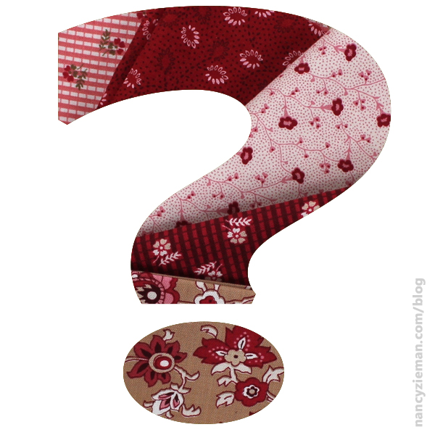
2019 Mystery Quilt Class
Instructor: Pat Ferrell
Saturday: 9:00am – 4:30pm
Class Fee: $45.00
Skill Level: All Quilters
Class Size: No minimum, No Maximum

Quilt Size: 67” x 98-1/2”

This year’s mystery quilt is so stunning and so easy to sew. You can use any theme fabric that you like or just scraps. It is so easy that you might want to make more than one.

Think floral, (shabby chic), reproduction prints, camping theme, or any school colors for those special young fans and of course children prints, batiks, you choose.

I chose floral for mine, but the choice is yours.

Supply List:

11 fat quarters (18” x 21”)
¾ yard solid fabric (pieced rows)
4-1/2 yards solid color, (sashing and border). This should be lighter than the other fabrics.
¾ yard binding, use a solid color, not necessary for class
5-7/8 yards backing fabric, not necessary for class
Sewing machine with new needles and extra wound bobbins
Cutting mat
Rotary cutter
Pins
Scissors
Thread to match your fabric and pre-cut fabric listed below

Cutting:

Cut fabrics in the following order: Cut sashing and border strips lengthwise, parallel to the selvages

From each themed fabric (fat quarters) cut:
(8) 7-1/2” x 4-1/2” rectangles

From solid fabric pieced rows cut:
(72) 1-1/2” x 4-1/2” rectangles

From solid white or light sashing & border cut:
(2) 6-1/4” x 87” border strips
(2) 6-1/2” x 67” border strips
(11) 4” x 55-1/2” sashing strips

From solid fabrics (binding) cut:
(9) 2-1/2” x 42” binding strips

