QUILT reTREAT

Save the date: February 28, 29 – March 1, 2020 (note the date change)

Planning is well underway for our quilt retreat. The reTREAT will be held at The Hilton Garden Inn on Okaloosa Island in Fort Walton Beach, FL. The featured teacher will be Karen Combs from Columbia, Tennessee. There will be three days of festivities, including classes, a demonstration, door prizes, a quilter's walk, and games. This retreat is open to all members as well as the general public. Come join us and bring a friend.

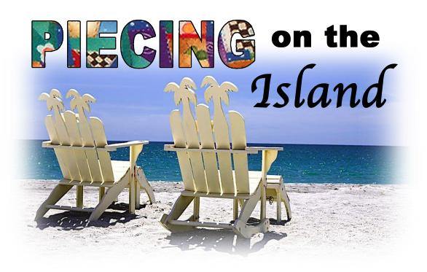

A finalized list of all teachers and classes offered, as well as a registration form and a menu will be available in September. Please direct all questions concerning registration to Konnie Glaze at FNQGretreatreg@gmail.com.

