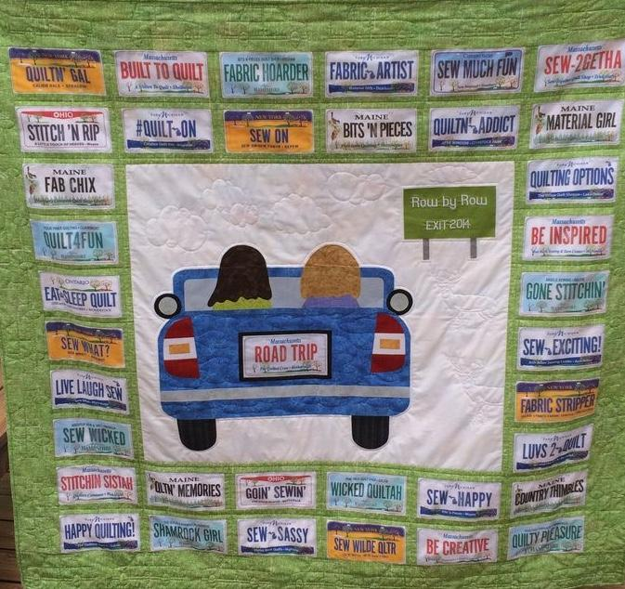

Please join us for our Annual Mystery Road Trip on Thursday, September 26, 2019. There is still time to sign up. Plan to be at New Hope Baptist Church at 7:45 a.m. as we will be leaving the church at 8:00 sharp. Please bring $5.00 to give to your driver to help pay for gas.

