“The Life And Time Of A Warner” By Muntheru ( مُنْذِر )
Biography
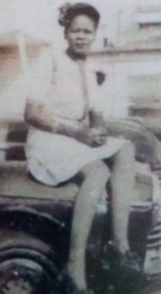
Mildred Verdell Shaw gave birth to her second child on December 21, 1948 at 1:05 PM in Hope Arkansas (May the God of hope fill you with all joy and peace in believing, so that by the power of the Holy Spirit you may abound in hope.) to Reginald Barry Shaw, but as soon as his father saw the baby, he renamed his son, “Warner Raymon Bernard Shaw Jr.” (We send not the messengers save as bearers of good news and warners. Whoso believeth and doeth right, there shall no fear come upon them neither shall they grieve.) Warner Jr was the only one of his siblings born in Hope Arkansas. (Rejoice in hope, be patient and tribulation, be constant in prayer.) Due to the change of name at birth Warner Jr. has two birth certificates and three names. He has a birth name, Christian name, and holy name. His holy name is yet to be made legal which is in the planning to be done shortly. His name in the future would read as Muntheru Saadiq Mujaahid Shah Ibn Warner Raymon Bernard Shaw (Muntheru son of Warner) this title would correctly identify him as the son of his father bearing the same name Warner. Muntheru is the Arabic translation for Warner.
1948
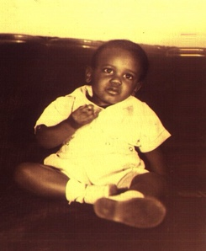
A man child coming quietly into this world with eyes wide open into the loving embrace of his parents and older brother. He spent the early part of his life following in the footsteps of his father, with obedience to spiritual guidance and moral teachings of his mother. His best friend was his older brother Demetrius from whom he learnt many worldly things. They would play together and do everything together their mother even dressed them to look like twins. Demetrius was mischievous, would often get in a lot of trouble and get punished. Warner Jr would see his brother receiving corrective measures and know not to imitate his brother’s behaviors. Demetrius is a biblical name from the New Testament: “Demetrius, a man who seems to fall out of love as quickly as he falls in love, acts as a symbol of this fleeting nature of love. He falls in love with Helena, but then falls out of love with her and quickly falls in love with Hermia and then hates Helena. He is the delicate balance between love and hate.”

1949
In the early years of his life, Warner Jr can remember living in the close knit family environment on the Southside of Chicago 61st & Aberdeen, where their uncle Johnny, and aunt Bell Jones on his father side of the family, owned an extensive apartment complex that was home for relatives on his
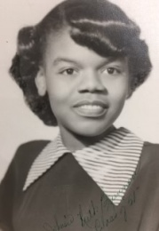
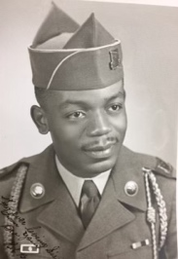
mother’s side of the family who were all nurses; aunt Ruth, uncle Lunzzi,
their daughter, his cousin Stephanie Hyde, and
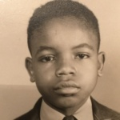
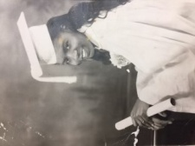
aunt Nellie Mae Brunson. His mother’s younger brother uncle James Brunson lived on 62nd and carpenter a couple blocks away. His maternal Grandfather, Henry Clay Brunson Sr owned a bungalow not far from there at 61st and Sangamon. Back then everything was real. The “Wanzer” milkman would come every Saturday morning to leave two half gallons of milk on the porch that the cream would have to be skimmed off the top before putting them in the icebox. The iceman would deliver ice. In the summertime he’d also sell multicolored flavored ice cones with fruit syrup, for a nickel to children in the neighborhood. There was a man, “The Watermelon Man” on a horse driven wagon selling fresh watermelon, the fish truck man selling fresh fish on Fridays and the man with the pushcart that had a grinding wheel to sharpen knives, all street vendors that would come through their neighborhood...

1950
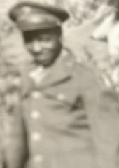
Times were difficult Warner Sr, who had enlisted into the United States Army as a radio operator mechanic at camp Blanding, Florida November 19, 1942. He was an Army Air Force air crew member who received his member badge wings, July 16, 1943, he was decorated with the American Theater, Ribbon and World War II Victory Medal recently discharged as a radio operator mechanic from the United States Army February 13, 1946, was now working at the United States Post Office, after completing the civil service exam for the position of mail clerk. He would come home with his scheme box practicing the sorting of mail with hundreds of small business card sized scheme cards that Demetrius and Warner would love playing with each night. Their mother, Mildred would always have Warner Jr with her when she went out. One night she went across the court way to talk with their uncle Johnny about the rent. It is evident that they had argued about it before because as soon as Johnny Jones opens the door, he raised a baseball bat and hit Mildred in the forehead, causing blood to splatter everywhere. Her blood flowed like a river. When he and his mother got home, she managed to stop the bleeding over the bathtub. The imagery of the violent assault would be etched in his mind forever. Years later, uncle Johnny and Aunt Bell Jones were both decapitated in a head on auto collision.
1951
The southside of Chicago was a very cold place. It seemed kind of like the Lou Rawls’ song “Tobacco Road” in the wintertime it was cold really cold. Demetrius and Warner Jr had matching snowsuits and bomber jackets with the fur lined helmet caps that their father got for them. They really looked like little aviators. They love playing in the snow with their father.
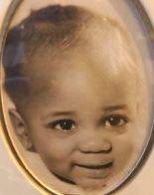
This year, their sister, Bernadine was born. She was a welcomed new addition to the family. Everyone made a big fuss over her arrival. She was their father’s prize. He called her little nicknames like “chum-a-lum” “sugarplum” and “peaches n’ cream”.
1952
Warner Jr’s talent in music started at an early age, singing in the Shiloh, missionary Baptist church with his brother and sister. His mother would drag the three of them from church to church searching for the right one to settle down from Methodist, Presbyterian, Pentecostal, and Lutheran to Baptist. Not being able to find what she was looking for, finally settling at the Reverend Daniels’ Antioch Missionary Baptist Church on the Southside’s Englewood community many years later. This is where the family, including their father Warner Sr, an Elks Lodge Mason, were all baptized, in the name of Jesus, (PBUH) with the exception of Warner Jr. He knew even at an early age that what he saw heard and felt in that church was not the truth. The images of God as a white man with blonde hair and blue eyes on the walls with statues of angels and saints, all looking like white people made him wonder why there were no images of anyone looking like himself. All of the people in the church were Black. They would be yelling, crying, stomping, whooping, and hollering, falling out with what they called the Holy Ghost. This terrified him.

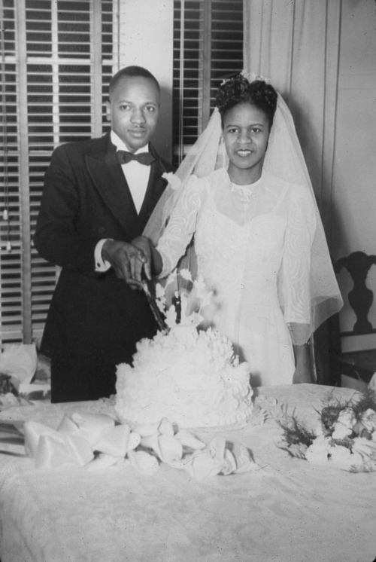
Their mother Mildred born, February 14, 1925, still a very young woman 25 yrs would take them out for walks through the neighborhood where they were living at the time after leaving their uncle Johnny’s estate. They were living in an apartment building around Marquette Road and Normal Avenue. Mildred and Warner Sr were married in Chicago, IL 5740 S. South Parkway Blvd. on December 15, 1946. Their father would be working two jobs in order to provide a better life for them. By day he would work self-employed as an electrician at night at the post office as a mail clerk. Mildred no longer nursing would stay home, caring for the children, teaching them, keeping them entertained by listening to the radio, singing and dancing around the apartment. She loved listening to Nat King Cole, Ray Charles, Perry Como. and Bing Crosby.
1953
He was sent to Sunday school every Sunday morning where he learns about the fantastic stories of the Bible, which greatly intrigued him. His grandmother Mary, who was the second wife of his grandfather, Henry Clay Brunson Sr. gave both him and his brother Demetrius Bibles with pictures on the inside cover. Demetrius’ book had the picture of Jacob wrestling with an angel and Warner‘s book had the picture of Jacob, dreaming of angels, climbing a ladder into heaven. Grandmother, Mary was a fair skinned white woman or a mulatto. His grandfather Henry Clay Brunson was a dark skin, black man, who successfully sold Fuller fragrances and Hair Care products door-to-door gave them both silver bracelets with their names engraved on the front of them. These were cherished gifts they both keep throughout their childhood. Their grandfather would always make sure to give them some type of coin made of silver. Always would be a dime, quarter, half dollar or silver dollar. Back in those days the government issued dollar bills in federal reserve notes, silver certificates and gold certificates. Their grand daddy used to give them different types of dollars to see if they knew the difference. They never got a gold certificate though. They never met their biological maternal grandmother, Johnsie who died when his mother Mildred was 13 years old. The difference between the brothers is that Warner Jr. loved having his Bible read, although he did not quite understand. Demetrius did not make many attempts at having his read.

1954
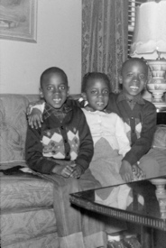
At home Warner Jr played with his brother and sister but had a real close relationship with his mother. She would have him in the kitchen with her as she prepared the daily meals for the family. The children played with little toy foods like fruit, vegetables and meats. They also played games like Parcheesi, Chinese checkers, Keno and Bingo. Their mother would read them books such as Peter Rabbit, Little Red Riding Hood, Hansel and Gretel, Goldilocks and the Three Bears, Pinocchio, The Three Little Pigs, Little Black Sambo, and many others. She would buy them stamp books to paste in stamps with pictures of the various state birds, the different types of trees, and the many flower varieties. They had fun, matching the images with the names, and descriptions for each item.

1955
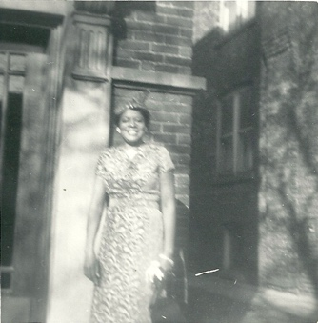
In grammar school he acquired the joy for reading and writing. While attending Bass Elementary School across the street from Ogden Park, he lived in a first-floor apartment on 64th and Morgan. Warner Jr was overjoyed when the Shaw family moved into this apartment. He and his brother Demetrius now had their own bedroom with bunk beds. The family had a new television set where he could watch cartoons, Howdy Doody and his favorite show, “Pinky Lee”. Their mother would spend a lot of time fussing over Bernadine styling her hair, dressing her up in fancy skirts, blouses and dresses. On Saturdays, their mother would take them on the south side 91st and Dorchester to their aunt Shug’s house to get their hair done, (shampooed, dried, hot combed, oiled and curled) while the boys played at the aunt Lerette’s house with their cousins Bonnie and her twin brothers, Gerald and Stanley.
Buying Bernadine dolls, doll houses, paper dolls, easy bake oven where Bernadine would bake little cakes, seemed to be something very important to their mother. Strangely enough she would also buy little dolls and things for the boys. Demetrius had a doll named “Baby Mary”. Warner’s doll was named “Junior Pirate”. These were really fun times growing up. It was just the three of them. They were new to the neighborhood, so they didn’t have any friends and Bernadine was still the baby. There was also a backyard where they were all able to play outdoors and from there the boys could walk to school by themselves. At school he enjoyed the company of both black and white students. He did not realize any difference until one day at lunch his friend Jimmy, who was a blonde hair blue-eyed, Caucasian, boy, made a comment by saying, “I’m white milk and you’re chocolate milk”. It made him feel good because everybody likes chocolate milk. In the classroom, he was engaged in learning reading books about Dick, Jane, Sally and their dog Spot. He was able to bring home books with his own library card. He loved the smell of books, graphite in #2 wood pencils, paper, Crayola crayons, finger paints, and all the different school supplies that he cherished like a treasure.
1956
His financial ability was nurtured when he was quite young. He began to understand numbers and how they related to money by watching his parents do bills and plan budgets. He was given a passbook for his savings account. Saving money he earned from chores, received as gifts and weekly allowances he was able to grasp the concept to the value of money. The family was about to move again they had been accepted into the CHA housing project and were able to rent their new apartment at 4321 W. 43rd St. near Midway Airport. These were low rise ground level structures with upstairs and downstairs. The living room, kitchen and utility room were on the first floor, two large bedrooms and bathroom upstairs. Their mother and father in the master bedroom and the three children in the other. Bernadine now had her own bed. Demetrius and Warner Jr still had their bunk beds stacked up Demetrius on top, Warner on the bottom. One day they were caught by their mother doing arial somersaults from the top bunk bed onto Bernadine‘s bed. She had all three of them strip naked and beat them with a strap (leather belt).
He transferred to the Hearst elementary school from Bass elementary school. This neighborhood was nothing like living on the Southside Englewood neighborhood. There were rows and rows of apartments next to each other unlike the separate building plots with front, backyards and gangways separating the buildings. Now they had a lot of friends and neighbors Demetrius’ best friend was Earl Bazan. Warner Jr and Bernadine became friends with Junior and Cynthia Broom.
1957
He developed an interest in healing from medicines with all their different smells found in the fully stocked home Medicine cabinet. His mother Mildred and two of his aunts Ruth and Nellie Mae were nurses. His mother would often say he’s going to be a baby doctor when he grows up. There were already many diseases that afflicted children in America, such as measles, chickenpox, diphtheria, whooping cough, mumps, and polio but now came a global pandemic, known as the Asiatic Flu! The Center for Disease Control. CDC had just produced a vaccine for polio, making it mandatory for all children to be vaccinated. Years later children had to be vaccinated for the other diseases before being allowed to enter public school system, but around this time Warner Jr was infected by chickenpox, measles, and the mumps. Warner Jr after receiving his polio vaccination passed out unconscious. Throughout his life up to then he would have experiences of losing consciousness, sleepwalking, asthma attacks, and hay fever. Their mother worried about them constantly in fear that the plague would ravage their home. She became obsessive about cleanliness and hygiene. She had a strict discipline about bathing, brushing teeth, washing their behind, that she called their “sitty”. She would say, “keep your sitty clean” the children all thought she was saying keep your city clean. What she really meant was that they had to keep the part of their body that they would sit on really clean so after they had a bowel movement, they had to wash their behind with soap and water, and not just toilet paper and clean the toilet after using it. There were so many people dying from the Flu and people getting taken away she wanted to do everything in her power to keep the family safe. She demanded that their father help her by providing her with the new modern appliances that would make her life easier because at that time everything was done by hand, washing dishes, washing clothes, cleaning windows, mopping floors, and cooking. Their father made sure she had everything she needed. He bought brand new dishwasher and washing machine and hired a maid named Juanita to come in to help her with the daily chores of cleaning the house.
1958
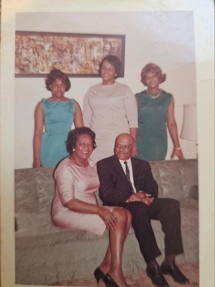
His association with food and nutrition also started at an early age from his mother, who was a nurse in dietetics. She would have him in the kitchen thumbing through her, Better Homes & Gardens cookbook, while preparing well balanced meals. It was around this time that his mother started showing symptoms of mental illness. The stress of poverty weighed heavily upon her. All she did was work around the house keeping it clean and take care of the children. They were living in the projects at the time. Warner Jr can still remember her first nervous break down as they called it in those days. She was permanently institutionalized with a diagnosis of paranoid schizophrenia. She would often come home on visits but did not stay for long. A little while after a few home visits, his mother became pregnant and September 27, 1958, gave birth to his sister, Marilyn Maxine Shaw. The neighbors would help their father take care of Marilyn Maxine until when she was six months old, he decided to send her to Detroit Michigan to be raised by his sister, aunt Olivia and uncle Pike Wilson. They had three daughters, Shirley, Brenda, and Pearl. Many evenings the children would go hungry, unless one of the neighbors will bring food by to feed them one good neighbor by the name of Mamie Mears will try to make sure that the children were not hungry.
1959
As Warner Jr got older technology and mechanics intrigued him. He would watch his father; an electrician working around the house to fix and repair things. He would be given toys to encourage his technical abilities like erector set, Lincoln logs, electric train, model planes, boats, and cars. His father would sometimes wake him and his brother up on weekends to go work with him as an electrician, he called it let’s go pull some wire. Warner and his brother really liked wiring up their beacon set their father bought for them that had a dry cell battery and transformers and different components that help them understand how electricity works but pulling wire that was a dirty nasty job and they didn’t like getting up in the morning on Saturday. But after they got to doing it, they found it, like fun using all the different tools, screwdrivers, pliers, channel locks, and then sometimes his father would say hand me that thigga-ma-bob or give me that whatchamacallumit...
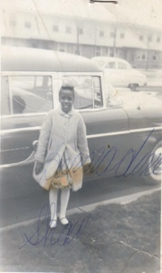
1960
Their father managed to buy a bigger car a mercury station wagon that he was able to use in his electrical contracting business and still be able to drive the children around with no problem. He was able to move them out of the projects into a duplex building in the Englewood community on the southside of Chicago 640 W. 60th St. Where they now lived was a very close-knit neighborhood. The neighbors on the east were Cheryl and Junior Brewer and on the west side of them that were the cousins Clifford Williams, and Monty Chris Jones. A couple of doors east, were the Thompson’s (Bernard, Haywood, AL, Rayfield, Frida and Patsy Patsy, (who had polio and walk with a limp). Above them on the second floor lived the Mays family Pookie, and Precious. A few doors to the west were the Hartford’s Henry “Punchie” and Nancy. Next to them or the Garens, Moses, and all of his brothers and sisters too many to count, and then there were the Carters, Jimmy Dean who was into bodybuilding and his sister Teena who could really fight everybody was scared of her. There was a big guy that lived on the corner that everybody called country because he talked with a southern accent. He always wore army clothes, but he was a gentle giant. He let the little kids beat on him without hurting any of them. Their mother would often be let out of the hospital for home visits. She would interact with her children by learning the latest dances and listening to the latest records by artist like, Sam Cook, Gene Chandler. They would watch Dick Clark’s American Bandstand on television every Saturday. She still had her favorite singers like Nat King Cole, Ray Charles, and Jackie Wilson. In that summer she took them with her to see the incredible Ray Charles perform at the Tivoli Theater.
June 4, 1960 Tivoli Theater, Chicago, IL ('Hitmakers of 1960') after that to see the dynamic live performance of Jackie Wilson at the Regal Theater
June 29, 1960 Regal Theater, Chicago, IL
She would take them on mini cultural outings, like the bud, Billiken day parade, the shed aquarium, museum of natural history, and the Museum of science and industry. Many times, it seemed like she was well no longer sick, but she would have to return to the hospital at the end of her home visit, where she would be drugged, and appear to be mentally ill again…
1961
Warner’s elementary school experience was difficult after his mother was committed to the mental institution; he continues to suffer from the allergies that existed throughout his childhood. They would bring on symptoms of bronchitis, asthma, ringworm and acne. He developed severe dental and visual problems that manifested in some form of dyslexia. He could not see the blackboard and from the pain he suffered from an untreated cavity his grades began to decline. Later, his father finally took him to get medical treatment. His rear molar was extracted, and he was fitted with glasses having corrective lenses. He was once again enthusiastic about attending school.
He was able to sing in his music class.
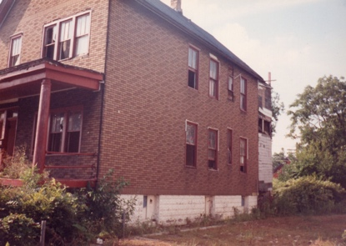
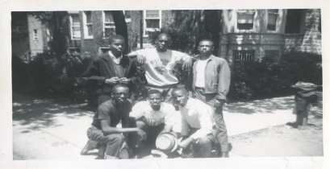
His father was able to move them out of the projects to their very own home back on the Southside of Chicago; they now lived as landlords on the second floor of a two flat apartment building with a basement, attic, garage, front and backyards at 640 W. 60th St. in the Englewood neighborhood. This was a glorious time! Bernadine had her own bedroom in the front by the living room. Their father had the middle master bedroom next to the dining room and the boys at the rear bedroom with their bunk beds next to the kitchen. There was also an enclosed back porch with a stairway that led to the attic. The front part of the attic had been remodeled and could’ve been made into a bedroom. Their father would have men like Jethro Brown, O’Kelley, and Charlie Moore that he knew and worked with live there and keep watch over and protect the children at night while he worked at the post office. During the day Demetrius Warner Jr and Bernadine would go to William G Beale elementary school. Warner and Demetrius would work their paper routes for the Chicago’s American Newspaper and associate with their many friends in the neighborhood.
Every now and then some of the guys (Steve Harris, Bernard Thompson, sherman, Ryan, Demetrius Shaw, Rodney, Washington, Warner Shaw,) and girls (Johnnie Mae, Lena Mitchum, Florence Henderson, Jeannie Washington, Linda, Murray) would all get together and have crash socials down in “Bubbles” basement. Isaac Giles, they called “Bubbles” Would be the host of the social. His father whom they all called “Father John” was a gentle giant of a man over 6 feet tall weighing more than 300 pounds, a single parent, raising his son and daughter, Johnnie Mae after his wife died would be like an absent, chaperone. He was in the house, but not down in the basement. They would listen to music, dance together and have drinks like Orange Rock wine spritzer, Boones Farm Apple wine and Ripple. At the social occasions, they would not drink any hard liquor like Johnny Walker Red Label, Jameson’s, Jim Beam because they cannot buy it or afford it. They would never drink beer, just low alcohol content wine. No one ever got drunk. They just had a lot of fun. Bubbles basement and their crash parties were a secret because there were a lot of gangs around the neighborhood, but they were in a little one block area they called “The Hole” (from 60th St. to 61st St. between Halsted Street and Peoria Street) in the middle of four powerful gangs. West of them were the Satan Lovers who called themselves “The Lovers” on the east where the Devil’s Disciples calling themselves “The Disciples”. To their north were the 50 Niners who protected them from the Lovers. In the south where the Vice Lords protecting them from the Disciples. They would get this protection because members those gangs were their older brothers. Their socials never got crashed like other house parties in the neighborhood. Warner’s friend Rodney Washington, who lived on 60th Pl., taught him how to play the game of chess. Rodney’s house was next to a huge vacant lot that they call vacant lot stadium because that’s where their baseball team “The Comanches practiced. Every year at the end of baseball season Rodney’s family, and the coach, Mr. Deloney, butch, Deloney’s father would host the Comanche Ball. A different set of girls would attend this occasion. All these girls lived on or around 60th Pl. The Washington’s had a huge German Shepherd dog named Champ that everybody feared. Warner was not afraid of dogs. He knew that the dogs could smell fear and got to know people by their scent. Warner became very skilled at the game and could not be beat. Rodney’s nickname was “Cookie”. His father’s name was Lucius who taught Cookie how to play the game, saw Warner beating his son, so consistently challenged him, and was defeated by Warner‘s brilliant moves and strategies on the board. When they were not playing, chess, Warner, Cookie and his younger brother Eddie, whose nickname was “Boo-Boo” would go down into the lavish remodeled basement and wrestle on a large mattress in the middle of the floor. They all like watching professional wrestling on TV wrestlers like Bobo Brazil, Sweet Daddy Seeky, The Golden Boy Buddy Rogers, Jake the Snake Ventura and Hulk Hogan.

1962
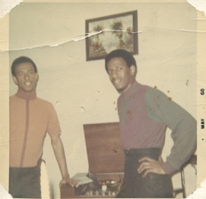
Warner learned about playing the trumpet from his best friend Sherman Ryan, who first taught him to play and read music. His friend Sherman’s family accepted and fed him at family dinner on many occasions. Sherman‘s mother Exzine, father Elihue, and brother Wayne Ryan all lived on 60th and Green Street. That summer the Ryans took Warner along with them to Madison Wisconsin to bring their daughter, Clematis home from college. While on the campus of Wisconsin University, he met sherman’s older brother, Gean Ryan who was studying to become a pharmacist.

1963
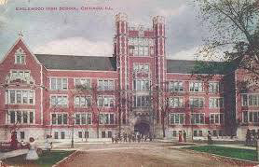
His teenage years offered many challenges and opportunities towards his future development. He graduated from the William G Beale, upper grade center in the top half of his class. His classmates had planned a graduation party the evening of graduation day. Warner was not told that his mother’s wake was scheduled at that time, and he was not allowed to go to the party. He did not grieve that his mother died. He was terribly upset that he could not go to the party with his friends. He attended Englewood high school 61st and Stewart Avenue on the Southside of Chicago from 1963 until he graduated in 1967. John F Kennedy was assassinated that first year he arrived in his freshman class November 22, 1963. Malcolm X was assassinated two years later February 21, 1965. It was a turbulent time in America, the civil rights movement, The Black Power movement, the war in Vietnam, and the students for a democratic society were all making national headlines.
1964
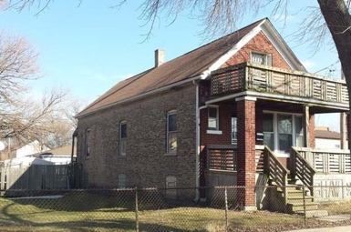
This year, his father purchased a beautiful home on the far south side 8045 S. Emerald Ave., Chicago, IL Auburn Park neighborhood in West Gresham. It was like living in an enchanted forest. There was a lot of green grass, trees, and flowers. There was wildlife, deer, rabbit squirrels and all types of birds. Their property had a front and backyard with a garage and an adjacent lot with beautiful flowers, blackberry bushes and a cherry tree in the backyard. The brick home had a basement an attic that had been remodeled into an apartment with kitchen, bathroom bedroom and living room where tenants moved in later. The main floor where they lived had open space, living room, and dining room having a mantle with mirror shelf and drawers, living room and dining room were separated by bookcases on either side that were filled with the world book encyclopedia set that their mother insisted on having along with collections of magazines (Life, Ebony, Jet, and National Geographic). Their father's bedroom was next to the living room, Demetrius had the bedroom next to the dining room and Warner Jr’s bedroom was next to the kitchen.

The Inception
When Warner met Lena Mitchum, Steve Harris’s cousin they both had an immediate attraction. She had been sent by her mother to live with her grandmother who lived next-door to Bubbles on the second floor. Florence Henderson lived on the first floor of that building. Every night after the crash social Warner and Lena would make out hugging and kissing in her hallway before she went into the house. She was 14 years old Warner was 16 years old. Neither one of them had ever had sexual intercourse. One night they tried right there in the hallway, but it didn’t happen because from their standing position Warner was unable to insert his penis into her vagina. After numerous frustrating attempts, they decided to make a plan to go to Warner‘s house at 8045 S. Emerald Ave. one night and finish the deed. After the next crash social at around 9:00 PM, they both got on the CTA bus for the ride down Halsted Street where the bus would stop at the terminal at 79th and Halsted. They got off the bus and walked and block and a half to Warner‘s house where are they immediately took off all of their clothes and got into his bed. Warner was trying to insert his penis but Lena asked him to stop because her vagina was too dry, so she told Warner to get some Vaseline. After that everything was all right. They were making love and enjoying it. Lena said, “I can do this all night”. it was at 11:00 PM when all of a sudden, the phone rang. Lena said don’t answer it, but Warner got up to answer the phone, not knowing who would be calling at that time of the night. It was Lena‘s cousin Steve asking Warner if he knew where Lena was.
He told Steve that he had not seen Lena since she left the social but he knew that Steve did not believe him. Hanging up the phone he told Lena we have to get you home right now. They put on their clothes and ran to the bus stop. They kissed and Lena got on the bus. Warner ran back home change the bedding then a little while after that the doorbell rang. When Warner answered the door, he saw three police cars with their lights flashing and Steve Harris standing at the door saying I know she’s in there. Warner said no she’s not you can look for yourself. She hasn’t been here. Steve believed him and they left. The next day when Warner went back down to The Hole he was told that the police had taken Lena to The Audy Home (juvenile temporary detention center) known as the “Audy Home,” this facility's overcrowding and economic distress, as well as questions about appropriate programming, punishment, and safety.
It was many years before Warner and Lena saw each other again. They were fully grown adults at that time. Warner was well established living on the north side of Chicago and his studio apartment on Sheridan Road. Lena had become a prostitute, doing really well and looking very good. She was not a streetwalker for sure she was one of those high-end prostitutes. She said I think we need to finish where we left off. I thought of you all of these years, so she got in his car. After they drove to his house, she told him about everything that had happened to her. They then had passionate sex together and never saw each other again…

1965
Warner realized that he had to drop out of the gym class that he was enrolled into because every week it was mandatory that all the boys would swim in the pool buck naked. Warner refused to do this and would cut class on those days. The next semester he enrolled into the ROTC to be like his brother and have those cool uniforms and be a part of the Englewood Eagles marching band going to all the football games for free and have his own drum that he could bring home and play. This was like a dream come true. But it turned into a nightmare. Once he got into the class the drill instructor was mean and abusive. He would have all the boys lineup in a single file and instructed them to march, and if the boy in front of them got out of step, the boy in the back should kick him in the butt. The boy behind Warner decided to kick Warner in the butt. Warner was not having that, so a big fight broke out and Warner was kicked out of the ROTC.
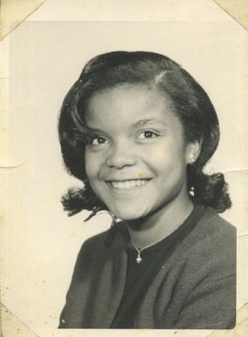
He spent his whole sophomore year excepting the fact that he would never be in the marching band and getting one of those bright, shiny drums. He loves playing basketball in the gymnasium and enrolled in beginner's band. In the band, he learned how to read drum music. It was easy for him because he already knew how to read melodic music. Now he could play the tenor drum in the percussion section of the band, that included bass drum, tenor timpani, multiple percussion, snare, and symbols. All of the different sounds were exciting. Each day he would rush from his gym class to join his friends in the percussion section of the band where they would joke and compete with one another for the position of the lead drummer on snare drum. Every day he would walk to school and try to get there early enough they have breakfast in the cafeteria. Many times, it was just buttered toast with jelly and a carton of chocolate milk, but that would be enough to get him through until lunchtime. One day he arrived at school and before going in the front door, he noticed a beautiful girl sitting in front of the building. He didn’t hesitate. He approached her and introduced himself. After talking with her for a while, he found out that she was a freshman and would be starting classes at Englewood that day because she had transferred from South Shore high school. Her name was Cornita Pullins. They formed an immediate attraction and began seeing each other almost every day. She invited him to her house to meet her mother and sister. While there they wouldn’t listen to records in her bedroom. At school, they would attend football games together. While at one football game, he found out that she was seeing someone else also because the guy she was seeing approach Warner in a threatening way. Warner‘s best friend Daniel Johnson was in the bleachers with him and grab the guy and turn him upside down dropped him on the ground then told him to get lost. Daniel was about 6 feet tall and played the forward position on the basketball team. and was the outfielder on the baseball team. After the incident at the football game, Warner asked Cornita to be his steady girlfriend. she said yes. Now he would visit her at her house in the evenings and they would cuddle on the couch while watching television. One night the doorbell rang, she answered the door Warner was surprised to see that it was the guy that had threatened him at the football game. When he saw Warner sitting on the couch, he pushed his way past Cornita and pulled out a pocketknife. Cornita quickly pulled him away into the hallway before there was an altercation. She came back in, closed the door, and told Warner, that the guy would not be back. Warner knew that he would have to deal with that guy one day at school. Strangely enough, he never saw the guy again. Warner continued to see Cornita whom he started to call Tina. The nickname stuck everyone there after we called her Tina. One day, they both cut classes and went to Warner’s home and had sex in the afternoon on the sofa in the living room. A few days later Warner noticed an itchy irritation at the tip of his penis, then a burning sensation while urinating, and white stinky plus losing from the orifice. He mentioned it to his friend Daniel, who told him that he had “The Claps” that is the ghetto slang for the sexually transmitted disease gonorrhea. That was Warner’s second sexual experience. Unlike his first time, it was not enjoyable or something to be remembered. Daniel told him about “the little red schoolhouse”. This was a free clinic for venereal disease treatment. Warner went there was tested, diagnosed with gonorrhea, given counseling, and a two-week supply of antibiotics. He also had to notify any sexual partners so they could also be treated. This was an embarrassing experience for him. A month later, Tina told him that she was pregnant, and that the father of the child was in the military, and she was going to fly to California to marry him. Warner wished her well and offered to take her to the airport. She got on the plane, got married, had three more children. He had really gotten a good dose of sex education!
Tina contacted Warner some years later while she was visiting her mother in Chicago. Happy to see her and her children he made breakfast with them and took their mother to see Stevie Wonder at the auditorium theater downtown Chicago. Stevie Wonder performance was canceled and replaced by Dionne Warwick, which was not bad. They tried to remain friends but did not ever have sex again.

1966
Englewood high school was a place where Warner was most comfortable, He had a number of favorite classes such as his drafting class where he took up mechanical drawing with his draft board and T square, he was able to apply his analytical abilities and condition is mind towards applying mathematics to dimensional space. His instructor Mr. Hicks gave him guidance and encouraged him to apply himself. He had another class that challenged and motivated him to learn more and more about history and how it related to his understanding of reality. His teacher was Mr. Deaddwyler, all of the students called him Mr. D, but Warner thought the name Deaddwyler was awesome. So, he would always call teacher by his proper name. Mr. Deadwyler took Warner under his wing and encouraged him to apply himself towards increasing his reading skills in poetry. Because at that point, Warner was only interested in American and world history. Mr. Deadwyler somehow knew that poetry would open up Warner‘s abstract, thinking abilities…

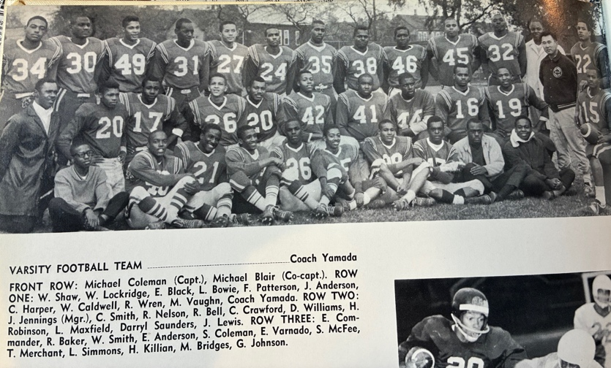
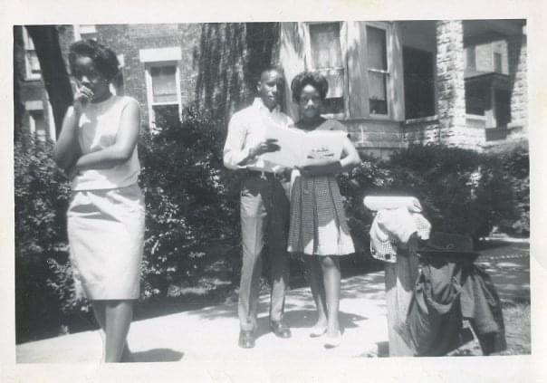
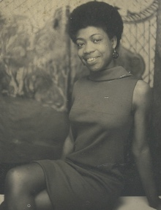
In his junior year he began to exhibit his administrative skills by becoming manager of both the football and basketball team programs. Warner knew many of the football players who had taken a class in print shop, thinking, it would be an easy grade but finding out, it was more difficult than they thought. Warner would help them get by with a passing grade. So, in return, some of the players got together and introduced him to football Coach Yoshimi Yamada who was impressed by Warner‘s enthusiasm, and willingness to serve. Coach Yamada made Warner the team equipment manager. In the gymnasium, Basketball coach Edward Gant, liked, his hustle and fearless competitiveness so he let Warner try out for the basketball team. Warner, at 5‘,5“lacked the height and strength necessary for him to play on the team, but Coach Gant gave him a place on the team, as the statistics manager. Warner won his letterman patch when his homeroom class team became the intramural volleyball champions. He was also the shop foreman for the school print shop where he mastered typesetting editing, and operation of the many different printing press in the shop. Warner’s father was so impressed with his high school grades that he bought him his first car a white four-door, six-cylinder, Ford Galaxy 500. Warner was working at Maling Brothers woman’s shoe store on 63rd and Halsted with his friend Sherman Ryan, who helped get him the job with Mr. Jacobson the owner of the store. His father made the down payment on the car and Warner Jr. had to pay the monthly car note and a portion of his “fair share of the rent”. What is father called, “paying your fair share”. This discipline gave Warner Jr. a very strong work ethic that if there is something that you really want you have to really work hard to get it! Now that he had a car, he and his high school friend Daniel Johnson would start dating girls, going to parties and driving around late at night. They went to nightclubs, lounges and bars… a downward spiral. Warner had a girlfriend Joyce LaGrone, who went to Parker high school that he met working at the woman’s shoe store. He would see her every now and then, but he would date other girls like Joyce Reynolds and Dolores Barnes if he could not see her. This was easy now because he could get around in his car. Joyce LaGrone was his steady girlfriend for many years. They had many things in common health, nutrition, jazz music, Poetry, Black American culture and mysticism. They would spend much time making love in his bedroom which he had painted the walls black allowing for all of his friends that visited to have a section on the wall where they would draw something in psychedelic paint that would identify them. Among these friends was Harold Williams., Willie Coleman, Ted Ray, Joyce LaGrone and her friend Weezy. Warner had his longest relationship with Joyce LaGrone at that time they were together from 1966 through 1969 when Warner was committed to the mental institution. He had been diagnosed with paranoid schizophrenia. He was told that he would be institutionalized for the rest of his life. Joyce would always come to visit him, but it was too painful for him to have her see him in this condition, so he broke her heart by telling her not to come back ever again to see him.
He and his friends would also go to the large dance event held at the southside union hall, called the packing house hosted by WVON DJ, Herb Kent who called it the Times Square. The war in Vietnam was being reported in the news every day. A lot of young black men were being drafted. His brother Demetrius received his draft notice and was trying to get out of being inducted as a conscientious objector to the war. He had all kinds of character references from politicians, businessman, and religious leaders but to no avail. He was thrown head long into the United States Army war machine. Ultimately winding up in Vietnam.

1967
January. 26-27, 1967: The Chicago Blizzard of '67 As of 2024, it remains the greatest snowfall in one storm in Chicago history. Muhammad Ali shook up the world by refusing to be inducted into the United States Armed Forces on April 28, 1967. Warner was in his final semester, and he knew he was going to graduate in the top half of his class. He was receiving A’s and B’s in his course book and was now planning to go to the prom with his new girlfriend, Valerie Searcy who also went to Englewood. Being in the last semester of his senior year while taking his final biology exam, his best friend Daniel Johnson was sitting right next to him copied Word for Word off of his paper, and was caught by the teacher, and both students were given a failing grade, causing Warner not to be able to graduate with his class which was the largest graduating class in the history of the school 418 students walked across that stage to receive their diploma and have the biggest prom celebration and graduation party ever imagined. He failed to be in that class and did not have that wonderful experience. He graduated that same year from the Englewood night school where he received his diploma, with no pomph and ceremony, though he had completed a class in journalism, giving him the required number of credits. He went on to college for his study in architecture at the Chicago State University and attended core classes at the Chicago’s city colleges Woodrow Wilson campus located on the same campus grounds as the Chicago State University and Parker high school. He dropped out after the first semester due to the blatant racism that he experienced in the architecture class. He was the only black student.

Riots and Mayhem
1968
Warner was consciously aware of all of the events, activities and violence, of the counterculture, civil rights and black power movements but did not directly participate in any of it
The Chicago riots
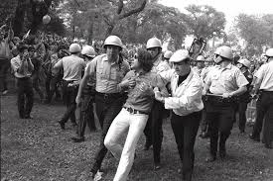
April 5, 1968 – April 7, 1968 The 1968 Chicago riots, in the United States, were sparked in part by the assassination of Martin Luther King Jr. rioting and looting
https://en.m.wikipedia.org/wiki/1968_Chicago_riots

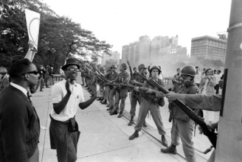
August 23–28, 1968 The 1968 Democratic National Convention protests were a series of protest activities against the Vietnam War that took place prior to and during the 1968 Democratic National Convention.
Like many other American citizens, he watched the events unfold on TV every night… He later enrolled in the newly built all black educational, institution, Malcolm X. campus of the Chicago City Colleges a school administered by Dr. Charles Hurst Jr., having the most advanced black studies program in the nation; there, Warner studied architectural engineering. It was at this time that he was able to associate with members of the Black Panther Party, like Lance Bell, a friend from elementary school, who was assassinated in the same raid as Fred Hampton and Mark Clark. Fredrick Allen Hampton Sr. was an American activist. He came to prominence in Chicago as deputy chairman of the national Black Panther Party and chair of the Illinois chapter.
A few years later Warner’s friend Rodney, Washington, would return from Turkey serving in the United States Air Force introducing him to Ivory Reynolds, a woman officer in the Black Panther Party whom he became physically intimate. She taught him how to clean and handle firearms. While in Turkey, Rodney Washington, would send, Warner, and Harold blocks of pure hashish which they would sell to help pay their way through college and get high the way they wanted.

The Death of a Warner
1969
At the same time Warner began to learn about Elijah Muhammad, and the Nation of Islam from Otis Gregory, a neighborhood friend, who was a member of the Fruit of Islam “FOI”. Warner would attend the temple on 48th and Greenwood with brother Otis 5X. He would attend the Nation of Islam temple #2 meetings three times weekly Sunday, Wednesday and Friday. After hearing the powerful messages delivered to him by ministers, James Shabazz and Yusuf Shah he began processing to become a Muslim. Part of the process was not to eat any pork drink alcohol, smoke cigarettes, or use drugs. He also had to be present at all temple meetings and write a perfect letter to Allah. Warner received his first induction letter from the United States Army to be drafted into the army, to fight in the Vietnam war. He wrote on the letter, FUCK YOU! and mailed it back.
1970
One bright sunny day. Warner was driving home from visiting his friend Michael Howard who lived on 81st and Morgan and had just picked up one marijuana joint was smoking it while driving. He looked to his right side and saw a beautiful young lady. When he looked back to the front, he saw a car right in front of him backing up in reverse real fast. All he had time to do was apply the brakes the other car totaled the Ford Galaxy 500 and did not even leave a scratch on the other car. It was around this time that Warner was influenced by his friend and next-door neighbor Harold Williams to use psychedelic drugs like LSD Lysergic acid diethylamide, commonly known as LSD and known colloquially as acid, is a potent psychedelic drug. Effects typically include intensified thoughts, emotions, and sensory perception. At sufficiently high dosages LSD manifests primarily mental, visual, as well as auditory, hallucinations
Warner and Harold would trip on acid and smoke marijuana and hashish
they would get high on marijuana (Marijuana is a green, brown, or gray mix of dried, crumbled parts from the marijuana plant. The plant contains chemicals which act on your brain and can change your mood or consciousness), hashish (The hashish made from resin is known by many names, including bhong and ganja, and is far more potent than marijuana. It may be either smoked or eaten for its intoxicating effects,) occasionally LSD (At present, there is interest in finding out if psychedelics like LSD can treat mental health issues, like anxiety and depression, and substance use disorders) or mescaline (Peyote is a small, spineless cactus. The active ingredient in peyote is the hallucinogen mescaline. WHAT IS ITS ORIGIN? From earliest recorded time, peyote has been used by indigenous peoples in northern Mexico and the southwestern United States as a part of their religious rites) listening to underground rock music into the night. they would also go on road trips would Make money selling marijuana and hotdogs with Rodney Washington or Ted Ray to rock festivals like

The Counterculture
Kickapoo Creek, IL
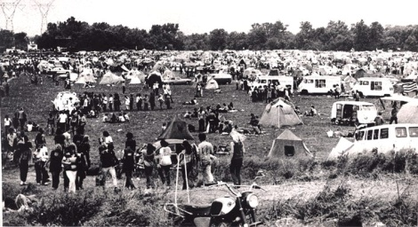
Campers converge on a farm in Heyworth for the Kickapoo Creek Music Festival the memorial day 60,000 gathering that marked, the counterculture’s unwillingness to go away.

https://www.djtees.com/blogs/djtees-blog/incident-at-kickapoo-creek-heyworth-illinois-1970

Wadena Galena, IA. H
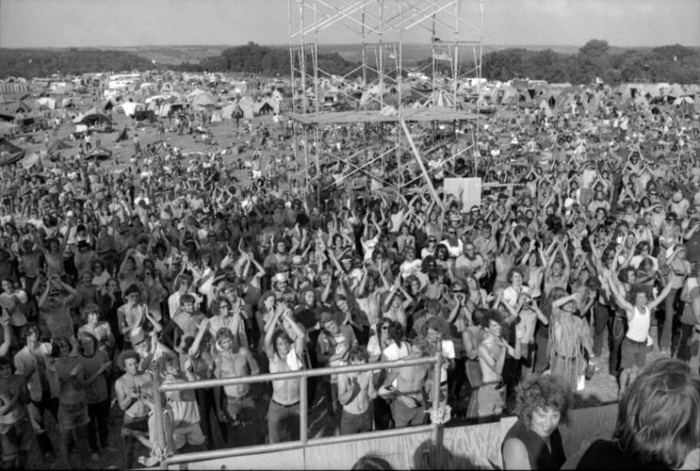
The 1970 Wadena Rock Festival marked the largest gathering of 40,000 youth in Iowa at the time it occurred on July 31 to Aug.

https://www.thegazette.com/news/time-machine-1970-wadena-rock-festival/?amp=1
Grant Park Riot Chicago, IL
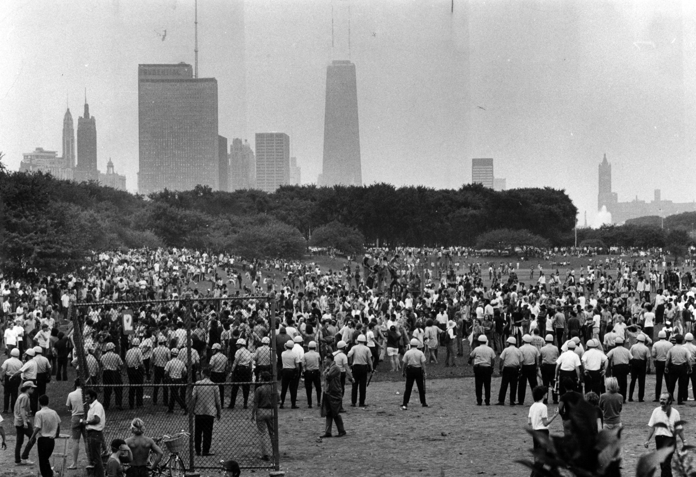
The riot began shortly after 4 P.M. at a free rock concert in downtown Grant Park when the featured band, Sly and the Fam ily Stone, refused to go on stage

https://consequence.net/2022/03/theres-a-riot-goin-on-sly-family-stone-opus-finale/amp/
At the end of that turbulent summer Rodney, Washington, and his brother Eddie showed up at Warner’s house offering to get him high on some marijuana. Warner took one hit of the joint and knew that there was something wrong with it… Rodney and his brother Eddie begin laughing, saying we blew your mind!!! True enough his mind was really blown the marijuana joint that they gave him was laced with PCP Phencyclidine or phenylcyclohexyl piperidine (PCP), also known as angel dust among other names, is a dissociative anesthetic mainly used recreationally for its significant mind-altering effects. PCP may cause hallucinations, distorted perceptions of sounds, and violent behavior.
After being hospitalized from the effects of the drug PCP, Warner spent many years suffering from the mental illness triggered by the drugs influence. While in the hospital, he was determined to overcome, and alter the predictions, prognosis and treatment that the doctors, psychiatrist, psycho analyst, and therapist had planned for him. Like his mother, he found himself in an out of the mental institution for over 15 years, taking psychiatric drugs, with no end in sight until he completely devoted himself to total submission to the Will of Allah. He adopted the disciplines for worship outlined in the holy Bible, and holy Quran, (Prayers. Fasting., dietary laws, behavior: no profanity, Sexual relationships, or intoxicants)

The Resurrection to Warner X
1971
The FBI came looking for Warner but couldn’t find him; though he was not trying to evade them and didn’t know that they were even looking for him. Finally, Agent Bloomfield left a message for Warner with his young nephew, Derrick to call the FBI agent. After receiving his second induction letter, Warner called the FBI agent. Agent Bloomfield warned Warner of the consequences of not responding to the draft and that he should appear at the induction center 6 AM Monday morning. Warner arrived at 1:00 PM Monday along with his father, Warner Sr. At the reception desk Warner looked off into space as the induction clerk questioned him. Not getting a response the clerk directed his questions to Warner Sr. In the meanwhile, Warner Jr was writing on the induction letter “war what is it good for absolutely nothing” he was sent down the hall to a psychologist who gave him a battery of tests, including Roshak finally asked him “what would you do if you were in the army?” Warner said if you put a gun in my hand, I’ll kill every white man I see! The doctor sent him back to the front desk, where his father was waiting, and he was told that he could leave. He received a new draft card in the mail with a 4F classification (unfit for duty). At that time in Vietnam, a lot of the white officers were being killed by friendly fire. The FBI put Warner on the anti-American activist list. Warner was aware of the turbulence of the times and had become actively involved in the revolutionary and counterculture movements of the 60s. Having a great decision to make whether he was going to become a member of the Black Panther Party or the Nation of Islam, he chose to be a Muslim. He stood before the Muslim congregation, and declared “There is no god, but Allah and Muhammad is the messenger of Allah!” it was at that time, he was welcomed into the nation of Islam, and became a registered Muslim, and given the name Warner X. He had been attending temple meetings on 48th and Greenwood from 1969 every Sunday, Wednesday, and Friday to receive the teachings of the honorable Elijah Muhammad delivered by ministers, James Shabazz and Yusuf Shah giving him guidance and instructions, that aided in processing him into becoming a true believer, a Muslim, a lost found member of the tribe of Shabazz, an aboriginal descendent of the original man, the Asiatic black man, the maker, the owner, the cream of the planet, earth, God of the material world and Vice Regent for the Creator in this physical universe. In his mind, he could see himself as the “I am” The sum of what I am experiencing, what I have experienced and what I will experience… I am that, that I will that I am. Past present, and future… Allah is greater!
Warner X was enthusiastic about becoming a Muslim and being a member of the Fruit of Islam. Selling Muhammad speaks newspapers was not enough. He wanted to earn his living working in some of the Nation of Islam businesses. Having experience working in food service at Michael Reese Hospital’s central kitchen he applied and was hired as a dishwasher at the Salaam restaurant. After that he was employed as a custodian at the Sister Clara Muhammad School. He enrolled in evening classes to study the Arabic language, learning how to read and write in Arabic. He learned how to read and write and say his prayers in Arabic. He sought a position later on at El-Amin Development Company and was hired as a researcher. He will go downtown to the federal building department of commerce and industry. Where he would research the foreign letters requesting indentured agents for the purchase of heavy farm and construction equipment. Warner would have to follow up on each of the letters by copying the information and returning to the office to contact the petitioner. If a contract was completed by letter of credit being deposited Warner would receive a 1% commission on the deal from El-Amin Development Company. Warner was involved in the negotiation of many deals but to his knowledge none were successful. He learned a lot from this experience of how to deal with high-level negotiations with manufacturers and buyers. He decided to form his own company. Liking the name El-Amin (The Trustworthy) he named his company El-Amin Life Productions because he was involved in health and nutrition.

1972
Muntheru applied for the job of mail handler at the United States. Postal service took the civil service exam and was hired to work at the air mail facility at AMF O’Hara field Chicago. He was able to become promoted to the position of postal clerk air mail biller coder SSM Sack sorting machine operator. With the money he made here he was able to buy his first drum set, a four-piece Gretsch black diamond Jazzmaster. He was also able to get his car the 1966 Ford galaxy 500 repaired after it being Totaled in an inter-section on South Calumet Ave. at 82nd Street. It had been kept in the garage for years. Muntheru’s artistic abilities begin to manifest in many ways he was writing, poetry, painting, and playing music. He had transformed his entertainment room down in the basement, where he kept his stereo system and record collection into his music studio, where he would practice his drum set day and night, mainly at night, while his father was at work. at this time Muntheru did not drink smoke or get high. He would just read a lot of books. Go to work. And practice drumming.
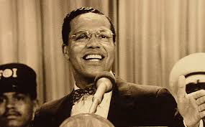
1973

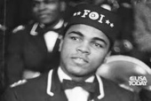
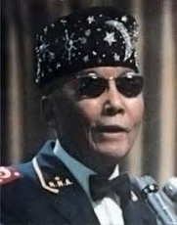
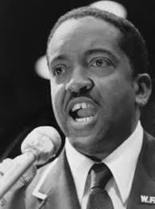
Now he was a Muslim stationed in Chicago Nation of Islam national headquarters, temple #2. After six months he had completed his student enrollment questions and answers, was accepted as a member of the Fruit of Islam “FOI” he was assigned FOI number 1309 special A. In the Bible the FOI are referred to as the God’s 144,000 First Fruit. As a member of the FOI Warner X came to know and associate, with some of the most famous and influential men in the world, such as Elijah Muhammad, Muhammed Ali, Louis Farrakhan, and Wallace D. Muhammad. That year, the honorable Elijah Muhammad would speak every Sunday. At the new temple of Islam located 7351 S. Stony Island Ave. in the south shore community. In those Sunday meetings, Warner X would find himself sitting next to Muhammad Ali. They got to know each other really well, because Warner X was working with the Nation of Islam youth camp teaching self-defense. Muhammad Ali was also involved with the youth camp and was planning exhibition fights. Warner and his friend Floyd Muhammed, who was an amateur boxer participated in the exhibition. One Sunday after the temple meeting Muhammad Ali and his brother Rahman, Ali invited Warner X to have lunch with them at the Salaam restaurant at 83rd and Cottage Grove. Muhammad Ali was nothing like the public image he had on TV. He was very quiet and soft-spoken and did not say much on the other hand. His brother Rahman was the personality that you would see Muhammad Ali imitating on TV.

1974
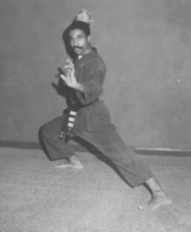
As part of his military training, he studied at the Fard Academy of Martial Arts and became a senior student advancing to the position of instructor under the guidance of master instructors Abdur Rahim Khan, and Hafiz Wali Ahmed. The Academy had been turned over to Abdur Rahim Khan and renamed the Abdur Rahim Khan school of self-defense then moved to its new location at the Tree of Life Health and Beauty Center. Ownership later
transferred to Muntheru Saadiq, Mujaahid Shah who renamed it the Fuad School of Health and Self-Defense Science. He was highly active in community work as a member of the world community of Al-Islam’s Blight Arrest Pioneer Patrol “BAPP”. He was required to become a member of the Chicago Police Department’s Beat Representative Program to help fight crime and violence on the Southside of Chicago. He appeared as a witness in court every session until the warlord of the Black Gangster Disciples was sent back to prison for assaulting him, while on parole. Warner X stepped in between David Damon before he attacked an elderly woman on public transportation.
Warner was working hard as an FOI in the community with the sale of Muhammad speaks newspapers, Muslim Bean Pies and Whiting H&G Fish
In 1974, The NOI set up its International Trades Division, importing whiting fish from Peru caught, headed, and gutted by Polish fishermen aboard Japanese fishing trawlers and the FOI would be selling it door-to-door in African American neighborhoods.
Muntheru would go down to the train yards to unload 50-pound cases of the Whiting H & G Fish, and then take cases to be sold 10 pounds boxes for five dollars each in the Robert Taylor and State Way Gardens projects on the southside of Chicago.

The Second Resurrection to Muntheru
1975
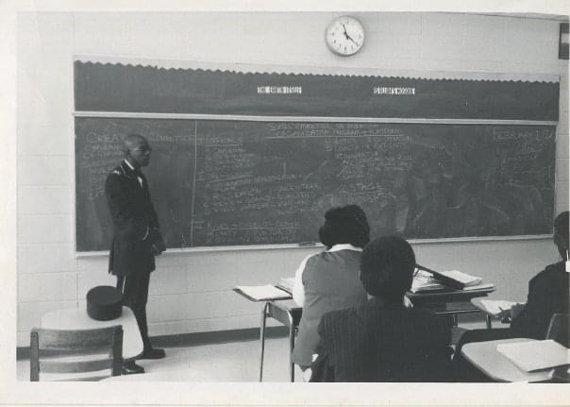
The honorable Elijah Muhammad, died of congestive heart failure at age 77 on February 25, 1975, the day before Saviours' Day. He was survived by many children, including his two daughters and six sons by his wife, most notably future leader Warith Deen Muhammad. Nearly one month later A partial solar eclipse occurred on Sunday, May 11, 1975, with a magnitude of 0.8636. This type of eclipse occurs when the Moon's shadow misses Earth in the polar regions. On this day, Wallace D. Muhammad Became leader of the Nation of Islam, restructuring and renaming it the World Community of Al-Islam in the West. Muntheru was able to raise up in rank receiving his holy name, Muntheru Saadiq Mujaahid Shah to become Chair Person for the Creations Committee, Subcommittee on Invention in the “World Community of Al-Islam in the West” Muntheru was invited to speak before the women’s auxiliary of the creations committee by the president of the creations committee Minnie, Pearl Muwakkil, he recited verbatim The Sun Life Collection, excerpts from his first book of poetry, “Manifestations of Intimate Thought” The women were so impressed they invited him to recite his “Sun Life” collection on a radio broadcast from the University of Illinois Circle campus radio station that was featuring an interview with the Nation of Islam National representative minister, Louis Farrakhan. Minister Farrakhan was very impressed with Muntheru‘s presentation and offered to drive him home after the broadcast. While riding down Lakeshore Drive in minister, Farrakhan Mercedes-Benz they had this deep conversation, and at one-point Muntheru stated his opinion that minister, Farrakhan and Malcolm X were a lot alike. Minister Farrakhan asked, “brother, “In what way do you mean?” by the tone in his voice, Muntheru felt that minister Farrakhan had become upset by the statement, but Muntheru continue to explain by saying “you were both made by the honorable Elijah Muhammad.” Minister, Farrakhan, unable to contain himself retorted that “Allah made me!”
Muntheru thought he had upset minister Farrakhan to the point that he would put him out of the car on the side of Lake shore Drive. But minister Farrakhan return to his mild, gentle demeanor and they continue to talk. Muntheru never really met the honorable Elijah Muhammad in person, but he was part of the FOI security team that guarded THE MICHAEL REESE MAIN HOSPITAL Before the honorable Elijah Muhammad passed away. He died on February 25, 1975, in Chicago, Illinois. Before his death, he appointed his son, Wallace Muhammad as his successor. Muntheru never met chief minister, Wallace D Muhammad personally either. Muntheru was assigned the security post outside Wallace D Muhammed’s private home. Muntheru would spend a lot of time at the masjid and would sit in the front row during the temple meetings he would be taking extensive notes while the chief minister spoke. Many times, he would see himself making eye contact with the chief minister during the lecture. Muntheru would often send copies of his ok writings to Imam Warrithu Deen Muhammed describing in detail his work and operations in the community and throughout the neighborhoods on the southside of Chicago. On one long Sunday meeting at the masjid Imam Warrithu Deen Muhammed gave his acknowledgment of the efforts and duty of this extra ordinary man he kept repeating extra, ordinary, and looking right at Muntheru he did not say his name, or even point him out it was like he was speaking directly to him. Many times Muntheru knew he was getting his orders directly from the Chief Imam right across the podium from which he spoke. Muntheru would not hesitate in his response. He would be taking detail notes and follow all of the directives in carrying out his duties in the community and throughout the city. One of the directives was to sub plant yourself in these organizations, in order to work with them and form alliances also to do Dawa work within the various religious organizations to strengthen our unity among the righteous servants of God.
1976
Muntheru worked in the neighborhood forming community action groups and organizing children into neighborhood, work groups, cleaning up the streets and alleys. His actions were recognized by the 17th Ward alderman, Tyrone McFolling who offered him a position in his office writing as a columnist on the 17th ward community newspaper. Besides that he also worked and traveled as a journalist with Bilalian news columnist Samuel Bilal. The alderman being aware of Muntheru’s crime-fighting efforts in the neighborhood that he introduced him to Edward Williams of the In God We Trust Union, an organization of licensed security guards, so that he could help train them in unarmed grappling techniques. This could help in the event, someone attempted to take their weapon. As one of the requirements for this position, he had to sit before a board of Christian Church, Ministers, Priest, and Reverends after which he was ordained a Christian minister for the Universal Life Church. He was assigned a position of field minister.
It was also around this time that Muntheru, met Alfred Evans, the nephew of his mentor Rosemary Mitchum Secretary for the alderman, who had introduced him to alderman Tyrone McFolling. Al Ricky Evans was a guitar player, singer and songwriter. In the summertime, they would sit on the porch and Muntheru would listen to Al sing songs, popular songs while playing guitar. They were both able to get jobs working at The Hospital of Englewood on 61st and Green Street Muntheru worked in the supply warehouse Alfred Evans worked in dietary they would meet up for lunch talk and plan how they were going to structure an R&B band. Muntheru worked in the Englewood hospital warehouse. One day while taking trash out to the compactor he saw four cases of half ounce medicine bottles and decided to take them home. He said to himself one day I’m gonna fill these with body oils and sell them.
1977
In their neighborhood on the southside, there were a lot of famous bands coming up that they knew and were in competition with groups like Chaka Khan & Rufus, The Elements of Time and Earth, Wind & Fire. They began recruiting some of the best talent they knew on the southside of Chicago. Muntheru became self-conscious as the band leader, because he could not understand what the rest of the band was talking about when they were discussing the music theory, cord, changes, harmony, and all of the technical details that make music music. So that fall he in rolled into the American Conservatory of Music as a full-time student studying percussion arts under Dean Charles Dutton 116 S Michigan Ave., Chicago, IL. He was required to learn how to play the grand piano, study music theory, and harmony, because the piano is also a percussion instrument he had to apply this knowledge to performances on the marimba, an African percussion keyboard instrument. In his R&B band “Cornbred” Muntheru gave up his seat on drum set to a better drummer, David Brashear and moved to percussion, Congas and bongos, female vocalist Laurita was the lead singer, Robert Harvey, Cedrick Langford on keyboards and vocals, Alfred Evans on rhythm, guitar and vocals, David Brown from the west side was on bass guitar. They rehearsed twice a week every week in Muntheru’s basement studio. They were able to perform all of the popular covers of that time. Funk was at the top of the chart. Parliament funkadelic, Prince, Rose Royce, Ohio Players, The Whispers The list just goes on but Cornbread Productions was able to cover all of their songs in their repertory, and were ready for the first engagement, which was the Minnie Ripperton, Memorial. The whole Ripperton family would be attending. The engagement was a great success the band was launched into the world of professional live entertainment. Muntheru gave up the role of band leader and took on the role of business and road manager. He was responsible for drawing up contracts, making sure each member of the band got paid, and that there was money for any incidental expenses such as vehicle rentals to safely transport the band members and equipment to and from gigs. Cedric Langford was the music Director and Alfred Evans the bandleader. Muddy Waters’ nephew, live down the street from Muntheru so he was brought in as lead guitar. The band skyrocketed doing a lot of private shows not so much nightclub. The Ripperton family provided a lot of connections, and also they brought in and additional drummer by the name, Gus Savage Jr the son of the politician, Gus Savage, who referred the band for many corporate engagements.
1978
As an FOI in THE NATION OF ISLAM Muntheru would go to the barbershop and get his haircut in the FOI style, which was called an FOI special in the world it was called “the collegiate” a very close haircut, with a razor line in the front and sides, and a gentle fade in the back. Some black men would get a razor line in the back, but this would often times cause sores that would get infected. One evening he was invited to the barbershop of a Fruit of Islam
friend, Rashid Muhammed. While he was in the chair, he commented to brother Rashid, that he really like the smell of the barbershop. Rashid informed him that it was the smell of the essential oils he had brought back from Saudi Arabia when he went on pilgrimage. Muntheru replied by telling Rashid about all of the references to fragrances he found reading the Bible. Rashid Muhammed went on to gift Muntheru with a 1-pound bottle of each fragrance, (Patchouly Sandalwood, Jasmine Blue Sonata, African Violet) This was the beginning of the Rasheed Natural Fragrances Distribution Company. Muntheru still had the four cases of half ounce medicine bottles in his basement so he began to formulate a balancing solution, and for the essential oils that he had received from brother Rashid that would make them into a non-toxic, non-irritating body oil this solution would also increase the volume of his product, therefore yielding a greater profit from the projected income. This business flourished. Muntheru no longer had to worry about how he was going to make a living. He was able to go out each day just for a few hours and sell a few bottles of fragrance and come home with $100. He sold each bottle for one dollar. He would be all over the southside and many of the cultural events where he would interact with many groups, organization, and members of the black Cultural community. He would sell fragrances to dancers, musicians and poets. He got involved with organizations: the Black United Front, AACM, The Kemetic Institute, The Institute of Positive Education, Sule Yawatoto, All African People’s Revolutionary Party, The Rastafarian Brotherhood, Hare Krishna Temple, Yahweh Ben Yahweh Hebrew Israelites, because he was a musician and drummer. He was able to sell to all the African dance groups Starting with


Muntu Dance Theater
Since its founding in 1972, Muntu Dance Theatre has grown to be one of the most artistically accomplished and stable dance companies in Chicago. The company has achieved an acclaimed reputation locally, nationally and internationally for making consistent artistic statements of cultural and historical significance. A colorful and invigorating professional company, Muntu has brought its audiences into the aisles with its unique synthesis of dance, rhythm, and song.
https://www.chicagoblackdancelegacy.org/companies/muntudance

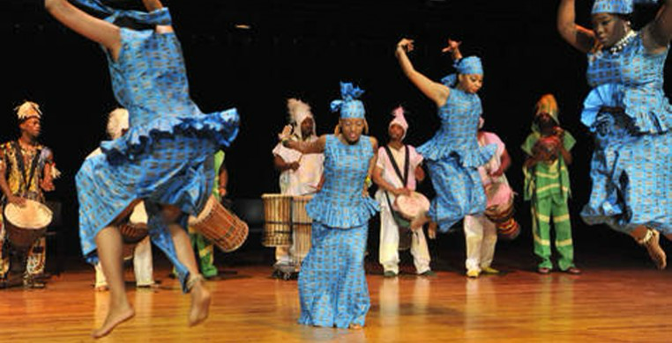
Najwa,
NAJWA Dance Corps (NDC) is a company of professional dancers and musicians dedicated to the preservation of dance styles and techniques of different eras which reflect the African American dance heritage and experience. The company performs dance within a historical context or from an historical perspective that is both educational and entertaining. NDC has grown over the years through presenting traditional and contemporary dances of Africa such as dances from the Old Mali Empire and the Caribbean, traditional (swing) and contemporary jazz, tap, nostalgic dances such as the Cakewalk (1900s), and the developing hip hop styles of the 21st century.
https://www.chicagoblackdancelegacy.org/companies/najwadancecorps

West Indian dance company

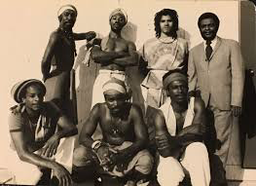
Caribbean dance is diverse by nature, varying from island to island, though most dances at base are African forms inflected by the indigenous Indian and colonial British or Spanish cultures. This company was founded in 1971 in Montego Bay as the Western Jamaica Folk Dance Company; in 1978 it moved to Chicago, where Baker changed the name to reflect the addition of dancers from Barbados, Belize, Trinidad, and other parts of the Caribbean.
https://chicagoreader.com/arts-culture/west-indian-folk-dance-company/

Darlene Blackburn
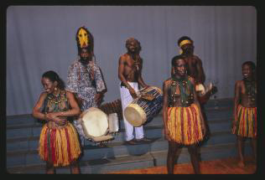
Since the 1960s, Darlene Blackburn has influenced the history of American and African dance in profound ways, spreading knowledge and the love of African dance in America.

https://www.chicagodancehistory.org/darlene-blackburn

Minianka West Afrikan Drum & Dance Ensemble

Al-Lalaka dance group
Jantuwa
The Manifest For Life
Introducing himself as servant of Allah through:


El-Amin Life Productions’
Operation: Life Preserver
Project: “Criterion”
Program: Tree of Life
A State of Illinois Not-For-Profit Organization
Build a CULTURAL INSTITUTE in the city of
Chicago, Illinois, establish Cultural Awareness
Centers throughout the city and neighboring
suburban areas. In this process we intend to
encourage, promote, support, and develop the
Performing Arts, such as music, theater, poetry,
dance, comedy art and crafts. We will be involved
in the production of programs, events, seminars,
and activities designed to help uplift the
economically disadvantaged. Our vision is to
provide the resources necessary for the
cultivation of the creative talents inherent in
each individual that aspires to their highest
abilities. We can have a facility that will provide
for Artist Residence, Academic Scholarship,
Live Performance Stage and Theater, Rehearsal /
Recording Studio...etc.


El-Amin Life Productions’
Operation: Resurrection
Project: Fuwa
Program: Rasheed (Guidance to Faith), Natural Fragrance Distribution Company Aromatherapy: can be defined as the art and science of utilizing naturally extracted aromatic essences from plants to balance, harmonize and promote the health of body, mind and spirit. It is an art and science which seeks to explore the physiological, psychological and spiritual realm of the individual's response to aromatic extracts as well as to observe and enhance the individual's innate healing process. As a holistic practice, Aromatherapy is both a preventative approach as well as an active method to employ during acute and chronic stages of illness or 'dis'-ease.
incense and oils,

He was able to elevate among them by providing other basic human, needs in the way of:


El-Amin Life Productions’
Operation: Survival
Project: Ma’idah
Program: The N.O.W. (natural, organic, wholesome) Community Food Cooperative. “N.O.W. Foods” are Natural, Organic & Wholesome Foods that are good for proper human grow, development and preservation. The food that we eat is sacred because "we are what we eat" and we should know "how to eat to live". We have been given clear Dietary Laws in all of the known scripture so there is no reason that we should be suffering from all of the food born ailment that now plague our society. This is truly the result of greed and ignorance. Now is the time to change your eating habits. So, Eat N.O.W. Foods now!

He continues to initiate further directives from his leader’s mandate by the establishment of

El-Amin Life Productions’
Operation: Life Guard
Project: Kufi
Program: Mujaahid (Crusader) African Drum Ensemble, Sound Systems & Entertainment Services by way of this conduit he was able to expand his acquaintances and connections within the heart of black culture in Chicago.
Muntheru met began rehearsing and performing with Kelan Phil Cohran who was a jazz musician. He was best known for playing trumpet in the Sun Ra Arkestra in Chicago from 1959 to 1961, for his involvement in the foundation of the Association for the Advancement of Creative Musicians and mentoring Earth, Wind and Fire.

Muntheru was fearless while traveling through the many neighborhoods of Chicago. Due to the FOI training, Muslims believed that Allah is greater and that none should be feared, besides Allah. Allah controls all things… using these precepts he was able to operate within the dynamic sphere of reality, manifest in the establishment of community protection efforts by way of the following:


El-Amin Life Productions’
Operation: Life Force
Project: Fuad
Program: American School of Health & Self-Defense Science
Common Sense Self-Defense within the Dynamic Sphere of Reality
in America using the Twin Eagles of the Double Dragon System
- Amir - Form & Control / Strength & Weakness
Having Knowledge of the mathematical principles that
formulate the physical properties of matter.
- Ka - Speed & Power / Truth & Lies
Understanding the ethic of the universal relationship of
Divine Law in the natural order of creation and the moral code of Life.
- Fu - Discipline & Submission / Heart & Soul
Consciousness of the spiritual systems of justice in the universal order of things using sound reasoning in rational judgment for justice based on cause and effect, action and reaction, truth, fact, and reality.
- Ad - Balance & Style / Mind & Body
Awareness of the structural and nutritional needs of the human being to achieve biological proficiency and dexterity
FUAD, the heart is the strongest muscle in the human body. The Muslim man is the strongest force in the human community.

El-Amin Life Productions’
Operation: Life Line
Project: Tawa
Program: Moral Reformation, Promotion of Al-Islamic literature
Whenever he made contact with persons sensitive, receptive or inquisitive to his mission in the Valley “TAWA” (this is the place referred to in the Bible, where prophet Moses “may the peace be upon him”, received revelation in his vision of the burning bush that was not consumed by the fire). Muntheru was able to invite them to Al Islam (The Way of Peace) by way of providing their mind with the information needed for them to have a better knowledge of the aim, goal and purpose of our human existence. He did not have to preach to people. He would just extend a rope down to them, so that they could lift themselves up by way of their own effort.

The Quest for Life
1979
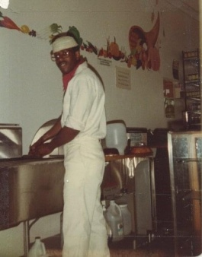
Muntheru became the managing partner with Ali Muhammed and Ahmed Shaif of the Roots Health Food
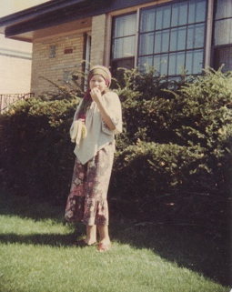
Emporium he also operated the N.O.W. (natural, organic and wholesome) Community Food Cooperative from this location when he met his first wife, Niyah (Sharlene Suwell), who was 15 years old and pregnant at the time. She was a Rastafarian being raised as a Catholic going to Catholic school, but they love talking Scripture over veggie burgers and natural soda while sitting at the counter of Muntheru’s vegan fast food, restaurant. Muntheru and Niyah would spend a lot of time together. She introduced him to some of her friends, like the leaders of the Rastafarian movement in Chicago. He would meet with Charles “Chucky” Ferguson manager of the “One Love” reggae band, co-producer of the Haile Selassie day celebration held in Washington Park every year and owner of the Conquering Lion record store on 79th and Drexel. He was later introduced to Tzaddi Wadadah, leader of the Rastafarian brotherhood, editor of Riddim newspaper, lead vocalist for the “True Democracy” reggae band and executive producer of the Haile Selassie day celebrations. That summer, Niyah and Muntheru attended his first live reggae concert at the University of Illinois Circle campus Pavilion. Muntheru was familiar with reggae music because he had seen Bob Marley perform on the Don Kushner‘s rock concert which aired as a weekly TV show back in 1977. The band that was performing on this college campus was an international Jamaican reggae band formed in Chicago by the name of “The New Era”, reggae band. After a while, Niyah‘s mother and father, thoroughly examined Muntheru and how he cared for their daughter during her pregnancy. They soon welcomed him into the Suwell family circle. They had been given written consent and the signed marriage license by her parents who thought he was the father of the unborn child. Wedding arrangements were being completed. when they found out, he was not the father. They at once withdrew their consent and canceled the wedding on the day of the wedding, but Muntheru and Niyah decided to continue with their plan and eloped to Chicago City Hall where they were married before a judge. Two weeks later there was a marriage annulment under the agreement that the two would no longer see each other.

1980
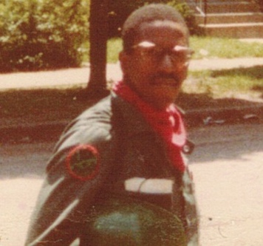
Outside downtown Chicago City Hall, shortly after his failed marriage, Muntheru met Curtis Sliwa, recruiting and soliciting donations for the Guardian Angels. He was having great difficulty establishing the Chicago Chapter due to his conflict with the city government. Muntheru after having his dreams of a wedding and marriage lay in his bed listening to the radio heard about what was going on downtown and quickly got dressed in his El-Amin Life Productions, engineers uniform. When he got downtown, carrying his staff with a sign attached to it he marched through City Hall from the Clark Street entrance straight through the building with the Chicago Police Department security in hot pursuit yelling, “you can’t bring that sign through here” exiting on LaSalle Street and posted himself up across the street sitting on a fire hydrant. Jeffrey Ferguson, the regional Director, who was there with Curtis Sliwa noticed Muntheru sitting there for hours holding a staff having a sign with the slogan “no more alcohol, no more dope, we don’t even want to smoke”. Jeff was curious and intrigued so he went over to find out more about this mysterious person. He became very intrigued after questioning him to find out how much he was doing as an activist in the city of Chicago. So, he recruited Muntheru on the spot and he was later to be appointed the Chicago chapter Guardian, Angel training coordinator. Muntheru, having many connections with members of the Chicago City establishment was able to negotiate a plan that helped mitigate the negative impact of Sliwa‘s character had on city officials. Muntheru introduced Sliwa to the brother of his uncle Johnny Jones, his uncle, E Rodney Jones of radio station WVON, and a chapter of the Guardian Angels became established in the City of Chicago.
1981
Three months later, the regional Director of the Guardian Angels, Jeffrey Ferguson came back to Chicago, saw the work that Muntheru was doing at the Fuad School of Health and Self-Defense Science located on the Southside at the Tree of Life Health and Beauty Center (The tree of life, mentioned in the books of Genesis and Revelation, is a life-giving tree created to enhance and perpetually sustain the physical life of humanity.) and appointed Muntheru Chicago Training Coordinator for the Guardian Angels. (Guardian Angels were divine agents of God sent to protect and aid humans on earth in times of need.) He was also assigned live-in custodial duties at the north side Guardian Angel headquarters. While Jeff Ferguson was in town, he and Muntheru hosted by Joe Bell, warlord for the El-Rukins formally known as “The Almighty Black P. Stone Nation” met with top gang officials to set up a Truce Summit in a vacant Robert Taylor, apartment with some of the Southside gangs that would agree to allow the Guardian Angels to patrol the neighborhoods and public transportation without being attacked. In return the guardian angels would allow the formation of a black guardian angels to patrol all of the Chicago housing projects, wearing the Guardian Angel logo (black beret, black T-shirts with white lettering). The peace treaty was still being negotiated at the time that Muntheru was ousted from the Guardian Angels.
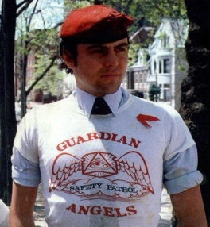
The Almighty Black P. Stone Nation often abbreviated as BPSN is an American street gang founded in Chicago. The gang was originally formed in the late 1950s as the Blackstone Rangers. The organization was co-founded by Eugene Hairston and Jeff Fort. There was turbulence for the Guardian Angel leadership from City Hall and insurrection from the newly recruited volunteers, who had not yet completed training. The recruits made the complaint to Curtis Sliwa in New York City seeking to have Muntheru removed from his leadership position not knowing that if it were accomplished, they would no longer have use of the Tree of Life facilities, because owners, Leo and Selma Hall, who are also Muslims, fully supported Muntheru. The Guardian Angels were cast out of the Tree of Life Health & Beauty Center and the North side Helen Davis Foundation’s mansion, a part of the Coconuts Disco Lounge Estate where the Guardian Angel headquarters was kept in the attic by Muntheru. The disco (like Studio 54 in NY) was called "Coconuts." It was on the west side of Sheridan Road at
Balmoral south of the Wing Hoe Restaurant. After Muntheru’s expulsion from the Guardian Angels, he was allowed to maintain his residence in the mansion by Helen Davis, DD (dr. of dietetics). 93yr old Helen Davis really enjoyed having long talks about food and nutrition with Muntheru. She would often have her rich friends and associates over for dinner parties introducing Muntheru as her beloved servant who helped, protected and accompanied her. She introduced him to the conductor of an orchestra The North Wind Ensemble in Evanston, IL where he was hired to perform as a percussionist.

1982
From within the core of El-Amin Life Productions Cultural Institute he received the mandate from the lectures, delivered by Imam Warrithu Dean Muhammed for the development of project Mujaahid. This came as a directive to organize cultural musicians in the performance of morally, uplifting music. By subplanting himself into the world to develop independent businesses, that would serve as an example of how one can profit from doing what is right. He no longer had the physical appearance of a Nation of Islam Muslim clean cut, face shaven, suit and bowtie. He now looked like a young distinguished black man wearing a mustache, short well-groomed Afro and casually dressed, from the southside of Chicago. He could be seen working in the community as a street merchant with a vendor's license selling religious artifacts: incense, perfume oils, books, cultural garments, artwork, natural food, and beverages. When he was not doing that, he would be practicing his drums as a street performer with a city of Chicago performers permit. Many times, he would be seen practicing either drum set or conga drums at the various street corners and popular locations such as Wrigley Field the Chicago Cubs baseball stadium on the north side of Chicago 1060 west Addison St., Chicago, IL 60613. On Michigan and Monroe, during all of the festivals held in Chicago during the summer, such as the taste of Chicago, the blues festival and the jazz festival out in Grant Park every year. One day while practicing with his group Mujaahid “The Street Warriors” On Michigan Avenue near Wacker Drive in front of the Wrigley building by the Chicago River one of the producers of the Jerry Springer show after enjoying their performance, invited them to appear on the Jerry Springer TV show. He said that they could not pay for their appearance on the show but would provide a limousine to get them to and from a video tape of the show for their promotion. They all agreed to do the engagement. The group consisted of Muntheru Shah on drum set, Prince Ravana Bay on Djembe Drum, and Mark Johnson on Timbales. The show was a great success and aired the next week throughout Chicago. Muntheru had achieved star quality. Now being recognized he was able to penetrate even more barriers…

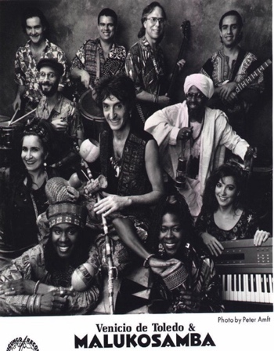
While performing in “The North Wind Ensemble” he met and became good friends with Emanuel “Manny” Bance, flautas, singer and songwriter, who was a member of “Maluko Samba” Afro Brazilian rock band lead by Venicio Del Toro. Manny introduced Muntheru to Venicio and right away Vinicio realize that a percussionist was the missing piece he needed for his nine piece ensemble.
Many days Muntheru would practice congas on the street near and around the Belmont EL station. He would meet with the El-Amin Life Productions musical Director, Bezerrah to plan the organization and development of a community based cultural center in that neighborhood.
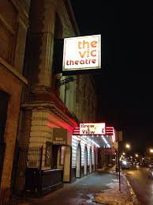
They eventually met Richard Bosserman, the owners of the Vic theater, who was in the process of removing the valuable artifacts from the soon to be condemned and demolished building. Muntheru submitted his proposal for the Community Cultural Center to the Bossermans for their approval that would allow Mujaahid sound systems to set up, rehearse and produce live performances until the building was scheduled for demolition. Richard Bosserman liked the proposal so much that he without Muntheru‘s knowledge rewrote, submitted the proposal to the city of Chicago, and was granted landmark status for the building.

in 1979 owner Sargit Sikan rented the building to community theater activist Richard Bosserman, who hoped to restore the theater and create a performing arts space. During this time the bookings shifted back to second-run mainstream movies, along with live theatre and musicals. Bosserman’s funding eventually ran out, and after sitting dormant for a period of time the building was scheduled to be demolished
Due to the proposal submitted by Muntheru the The Vic Theater was designated a Chicago Landmark and Cultural Center that later became a very popular venue for live entertainment.

1983
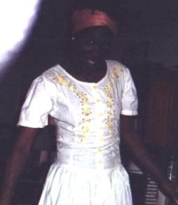
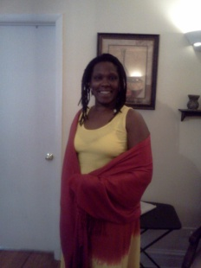
Muntheru met Denise Thomas, who became his long-time friend, lover, and companion at The Wild Hare nightclub one night. He found Denise to be very sexually attractive, emotionally, stimulating, intelligent, and receptive to his conversation. After talking with her, he found out that she was 21 years old, married with five children (Ramon, Melvin, Michael, Marvin, and Crystal) was going to school and out for a night of relaxation. From across the crowded dance floor, her image resonated natural beauty from within. She wore no make up. Her hair was trimmed close to her scalp. With a dark Ebony complexion accented by her distinct African features her warm, but turbulent spirit projected through her innocent eyes is what really attracted him. He was caught under her spell. Denise was born in America, offspring, of a Black American mother who was addicted to cocaine, and Black Jamaican father who took her at six months old back to Jamaica to be raised by him until she was 11 years old. She was sent back to America to be adopted by her foster mother where she grew up in the Chicago Housing Authority (CHA) Cabrini Green project. At the age of 15 Denise became pregnant with her first child Ramon and was forced into an arranged marriage with an older man, Melvin Beard, who was not the father of the child. Her foster mother knew that this older man that work for the railroad would be able to care for Denise and her unborn child better than the adolescent young man who got her pregnant. While married to her husband, Denise had four more offspring by the time she met Muntheru.

1984
It was around this time that Muntheru moved out of the mansion to his next-door studio apartment at 5300 North Sheridan Rd. because it was announced by the owner that the property had been sold. The mansion and adjacent nightclub were about to be demolished to be replaced by a high-rise apartment complex. Before the building was torn down, it was rented out to a Polish family with two teenage boys that wanted to sell their cars. Each one had Chevrolets one had an Impala, and the other had Caprice Classic. Muntheru was making enough money selling Rasheed Natural Fragrances, performing Mujaahid Entertainment Services And other El-Amin Life Productions operations to buy both vehicles the impala for $150 and the caprice classic for $200.
Muntheru was interacting among various members of the AACM, such as Malachi Favors, Kahel El-Zabar, Hamid Drake, Saleem Muhammad, Phil Corhan, Light Henry Huff, Douglas, Ewart, Kieth McEachron, Paul Cotton, Shanta Nurullah, Dee Alexander, Don Moye and members of the African community of Chicago. He started performing with Light Henry Huff as drummer and road manager using one of the cars to make out of town trips. One weekend the band had a gig scheduled for Cleveland, Ohio Muntheru had not yet received the title for the caprice classic but wanted to leave it in the shop down the street from his house for an oil change and tuneup. He used the Chevy impala to transport the band and equipment to the gig. When he returned on Monday to pick up his vehicle, the owner of the shop denied ever receiving the vehicle. Muntheru presented him with the receipt, but the owner claim not to have any record of the transaction and that the receipt have been signed by one of his employees who no longer work there. The person that signed the receipt and took possession of the vehicle also lived in that apartment building where Muntheru resided. Muntheru the proceeded to take legal action against the auto repair shop and report the vehicle stolen to the Chicago police department. Sent a letter to the Illinois attorney, general citing the owner for fraudulent business practices. He also filed a lawsuit summonsed, the owner of auto repair shop to appear in court for damages and costs. The police found a vehicle, but it was stripped for parts, and declared a total loss. The vehicle had not yet been insured, so there was no claim. The owner of the car repair shop shut down the business and could not be located by the sheriff. The case was eventually dropped. During the course of Muntheru, taking these actions, someone dropped a firebomb in his other vehicle.

The Chevrolet impala had minor interior damage to the upholstery and was still drivable, so Muntheru was able to continue using it to earn his income through El-Amin Life Productions trans cultural international caravan.

1985
Roots Vibration Reggae Band

1986

1987
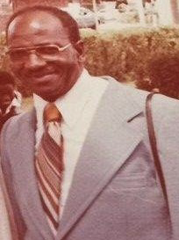
That was the year his daddy died January 24, 1987. he died of lung, brain cancers, extensive multiple melanomas, seizures and pneumonia. His burial was at Gethsemane cemetery Detroit, Michigan. He never will be forgotten. All of Muntheru‘s closest friends whom he knew growing up with him knew his father as “papa Shaw” he was looked upon as the ideal father. He never raised his voice, use any profanity and did not drink alcohol, but he did smoke cigarettes, drink coffee and eat pork. He was old-school like that. When Muntheru received the news of his father’s condition he immediately boarded a train to Detroit to see if he could be of any assistance in comforting his father. When he got there, He found his father lethargic, unresponsive, and looking pretty sick. So right away Muntheru began to pull out all of the training and teaching he’s received from preventative and alternative health care in self-defense. He began to talk with his father and read to him out of the holy Bible and the Holy Quran. As he continued to read, it seems like there was a breath of fresh air in the room, and he had captured his father’s attention. His father opened his eyes, looked at Muntheru and asked, “am I in heaven?” Muntheru had cleaned and sanitized the whole room earlier that day with essential oils. There was a glow about the room. The very next day his father was up and walking around talking on the phone, laughing and joking Muntheru had change the diet that they were feeding him to an all-natural food consisting of fresh raw vegetables and fruit that gave him enough energy to get out of bed. Muntheru brought his acme juicer with him in order to get the most nutrients out of the fruits and vegetables in a concentrated form that could be drank rather than eaten. This works faster. His father was so impressed that he wanted his son Warner Jr to come live with him in Detroit. His father had a plan to buy a house for him so that his son would always be there to help take care of him. He was afraid that his daughters were going to allow them to put him back in the hospital. And he was not happy with the treatment he was receiving in daughter’s home. Even though she was a trained nurse and knew how to take care of him. He was afraid of his other daughter Marilyn, who seemed to have resentment towards him for sending her to Detroit to be raised by her uncle Pike, who allowed pedophiles to molest her pretty much all of her life. No one knew! Muntheru agreed to honor his father’s wishes and told him that he had to go back to Chicago to secure his businesses and return in two weeks but before he could return, he had been notified that his father had been sent to the hospital and died a few days later of pneumonia. Muntheru later, returned to Detroit for the funeral and delivered at awe inspiring eulogy to the rest of his family with the name Allah, the beneficent, the most merciful. I don’t think anyone knew that Muntheru could speak so elegantly, expressing so much love, understanding, and compassion.
1988
A while after returning from Detroit Muntheru would continue to travel back-and-forth to the Southside where he would attend services at the Muslim temple #2 on 71st and Stony Island, visit his 80th and Emerald home where his brother Demetrius eventually locked him out. He was still going to his martial arts school on 95th and Jeffrey, finally his vegan restaurant & health food store on 79th and Damen completing his circuit but now he will have to travel all the way back the same day to the north side, which was a long journey. He would continuously make these rounds for a number of years. It was difficult at first because he was walking, traveling on public transportation, or getting a ride
from friends. He was mostly walking. He walked all over Chicago from 79th St., straight up Halsted to Foster Avenue it would take him 6hrs 25min to make the 16.1 mile journey. His studio apartment became the sanctuary from which he was able to operate all of his businesses and begin his climb to success…

Manifest
- American Management Company
- El-Amin Life Productions Cultural Institute
- Fuad American School of Health & Self-Defense Science
- Rasheed Natural Fragrances Distribution. Company
- N.O.W. Community Food Cooperative
- S.P.A.C.E. Art Productions Studio
- Tawa Promotions
- Majestic Moving Services LLC
- Ma’Idah herbs, and spices
10. Root Vibration Enterprises
11. El-Amin Life Productions LTD
12. Mujaahid Entertainment Services

1989
He was very well known throughout Chicago in many diverse cultures and organizations. He established connections with groups like the “Black United Front”, “Yahweh Ben Yahweh, The Hebrew Israelites”. The UNIA, “Universal Negro Improvement Association.”, IPAE , “The Institute Positive Education”, Mid West Soarring, “Save Our Ancestors Remains & Resources Indigenous Network Group”, “The Rastafarian Brotherhood”, “The All African People’s Revolutionary Party”, N’ Cobra, “National Coalition of Blacks for Reparations in America”, “The Black Panther Party”, “The Kemetic Institute”, A.A.C.M. “Association for the Advancement of Creative Musicians”, The NOI “Nation of Islam” the list goes on and on. Muntheru knew thousands of people as a people whom he interacted, transact business, associated, networked, and performed with during his quest to make the dream a reality. All of these organizations were immensely powerful in our community, in their own right but the assault by the oppressive and imperialist forces of bigotry, institutional racism, exploitation, and oppression, stifled the growth of our community, taking out many of our powerful leaders by way of assassination, imprisonment, or exile. We are at the mercy of a demonic system, and only way to survive is through unity within a culture. This is why a cultural institute is necessary to instill the proper values and morals in our young minds, and provide leadership from our older men and women
who have experienced things that we do not want the younger minds to have to endure...
1990
The new decade marks the directive to siege the time… he knew that his life would not be complete without a helpmeet in his life to achieve his destiny. He began by associating with some of the women that he met while working in the Cultural Community on the southside of Chicago to no avail. One day, while he was promoting the distribution of Rasheed Natural Fragrances from within retail outlets like health food stores, boutiques, and beauty shops found around Harpers Court in the Hyde Park community where he would often do promotion and retail sales on the streets. The fragrances had been getting extremely popular with a lot of repeat buyers. People were demanding them in the stores, so when he came to some of those stores with wholesale offers. It was not difficult to close the deal. On this day, he was wearing a beige suit and vest with brown pinstripes, brown tie haircut in a short Afro style, thin mustache, really looking, clean and fresh. As he was completing the closing of the deal with the owner of the Bonnie Sante health food store. He noticed an incredibly attractive, young, sexy woman standing next to him, quietly breathing in a seductive way. Being instantly attracted he introduced himself to her and offered to buy her a drink from the juice bar. They talked for a while to get to know each other and found that the attraction was mutual. Her name was Sandra Denise Bouey from St. Louis Missouri, she was here in Chicago, visiting her aunt on the southside of Chicago and would be there for the rest of the month before going back home. They exchange information, name, phone number and address and planned to see each other again. She was somewhat secretive she did not give an exact address location of where she was staying in Chicago or where she lived in St. Louis, but that did not bother Muntheru he was simply happy to have met someone that he could relate to romantically. When they would talk on the phone, she expressed how much she wanted to see him again. So, they planned a rendezvous where he would drive from the north side down Lakeshore Drive and meet her near where she was staying around 35th and Rhodes Street from there they would go back to his apartment where they would spend the night together. She was deeply passionate, and he was very romantic. There were times that she would make it up to his apartment on her own somehow either by bus or taxi she never would say she would just show up. They spent a lot of time together until about one week before it was time for her to go back home to st. Louis. Muntheru had made plans to ride back with her on the train and said that he wanted to meet her family. She agreed but seem to be troubled by something. On the day that they were to leave while sitting on the train. She dropped the bomb on him by telling him that she was pregnant and was pregnant when she met him. And she saw the man that would be the father of her child in the train station. She told Muntheru she did not want to have a confrontation and told him to get off of the train. When he seemed like he was not going to comply, she got angry and yelled get the fuck off the train get the fuck out of here. So Muntheru sadly exited the train, and as he was leaving, he saw the man she was speaking of being the father of the child. He was tall and good looking. Muntheru could see why she would be attracted to him, but she said he was violent and abusive. Her mother liked him and wanted them to be married. That’s why she ran away to Chicago. Muntheru had tears in his eyes as he watched the train, depart the station, knowing that he would never see her again. They would still talk on the phone long distance for many years…

1991
Met Nettie Elizabeth Johnson

1992

1993
Started Warner R B Shaw Sr probate court proceedings

1994

1995
Yabba Griffith & Traxx Reggae Band

1996
Started Warner R B Shaw Sr probate settlement
Purchase used 1992 Chrysler Imperial

1997

1998

1999

Navistar Financial Corporation

2000

2001
Muntheru And Nettie break up

2002

2003

2004
Muntheru And Nettie marriage ceremony

2005
Muntheru And Nettie honeymoon and separation

2006
Muntheru And Nettie divorce

2007

2008

2009

2010
Navistar financial corporation downsize

2011

2012

2013

2014
Phyllis Robinson moved in with Muntheru

2015
Majestic moving services partner with UBER

2016
Muntheru purchase new 2015 Kia Optima SP

2017
Phyllis Robinson moved out of Muntheru’s apartment

Muntheru purchase new 2016 Kia Optima LX

2018

Muntheru purchase new 2016 Kia Optima EX

2019
Lease used 2016 Hyundai Sonata Sport II Sedan to

2020
Purchased new 2020 Toyota Camry hybrid XLe

2021

2022
Prostate cancer diagnosis

2023
Completed chemotherapy

2024

THE RENAISSANCE MAN
This describes an outstandingly versatile, well-rounded person. The expression alludes to such Renaissance figures as Michel Angelo, Leonardo da Vinci, and Galileo di Vincenzo Bonaiuti de Galilei who performed brilliantly in many different fields.

Entrepreneur
a person who organizes and operates a business or businesses, taking on greater than normal financial risks in order to do so.
Producer
a person, company, or country that makes, grows, or supplies goods or commodities for sale.
Administrator
An administrator is a person who ensures that an organization operates efficiently. Their specific duties depend on the type of company, organization, or entity where they work. Above all, administrators need to be highly organized and have effective communication skills.
Philanthropist
a person who seeks to promote the welfare of others, especially by the generous donation of money to worthy causes.
Manager
a person who controls the activities, business dealings, and other aspects of the career of an entertainer, athlete, group of musicians, etc.
Minister
The primary responsibilities of the minister are preaching and teaching. Ministers—men and women—are called by God to proclaim the gospel of Jesus Christ, administer the sacraments, and care for the members of the congregation. They are to build up and equip the church for its ministry in the world.
Journalist
a person who writes for newspapers, magazines, or news websites or preparesnews to be broadcast.
Artist
a person who creates art (such as painting, sculpture, music, or writing) using conscious skill and creative imagination. Like the great artists of the Renaissance.
The Renaissance was a fervent period of European cultural, artistic, political and economic “rebirth” following the crusades in the Middle Ages. Generally described as taking place from the 14th century to the 17th century, the Renaissance promoted the rediscovery of classical philosophy, literature and art.

The True Identity
Holy Name  مُنذِر صادِق مجاهد شاه  Shah Mujaahid Saadiq Muntheru  Muntheru Saadiq Mujaahid Shah  Warner Truthful Crusader King  Muntheru ( مُنْذِر ) Warner  Character:  Mu (م) prophet of doom  Nun (ن) scribe  dhal (ﺫ) mystic  Ruh (ر) spirit  Meanings:  Muntheru “Warner”  Saadiq “truthful, righteous”  Mujaahid “crusader warrior”  Shah “king ruler”  Religion Name  Din Al-Islam (the way of peace)  Muslim (submission to peace)  Totally submissive to the Will of Allah Who created everything in the state of Muslim with one word “BE”  National Name  Amerika  The Amir, meaning "lord" or "commander-in-chief", is derived from the Arabic root a-m-r, "command". Originally simply meaning "commander", it came to be used as a title of leaders, governors, or rulers of smaller states  The kA In ancient Egypt, was represented as a pair of ope arms, held upwards. These arms symbolized the transmittance of the ka force from father to son, God to man, king to man. | Family Name  Warner Raymon, Bernard Shaw Jr.  Meanings:  Warner “Army Guard”  Raymon “one who guards smartly”  Bernard “strong or brave bear”  Shaw “dweller by the wood”  Birth Name  Reginald Barry Shaw  Meanings:  Reginald “ruler’s advisor”  Barry “fairness, sharpness, and historical depth”  Shaw “dweller by the wood”  Tribal Name  Shabazz  Lost found aboriginal tribe, descendants of the original man, maker, owner, cream of the planet earth, god of the material world, Vice Regent of the physical universe, and crown of the creation!  Race Name  Bilalian  American descendent of slaves  Natural Name  Human Being  Created from a single soul Then being made from Water and the dust of the Earth “Black mud fashioned into shape” (sounding clay), Mind in earth “Humus Manu” to receive the breath of life “The Holy Spirit” from The Creator to become a living soul Homosapien (the only one of its Kind)

Family

Maternal

Henry Clay Brunson Sr. & Johnsey Jackson.
Henry Clay Brunson Jr.
Mildred Verdell Shaw
Ruth Johnsey Hyde
Nellie Mae McCloud
Henrietta Brunson
James Brunson

Paternal

