Cast Iron Seared Strip Steak with Herbs and Butter

2 thick inches of cast iron seared, butter basted, prime, beefy goodness... So much for meatless Monday.
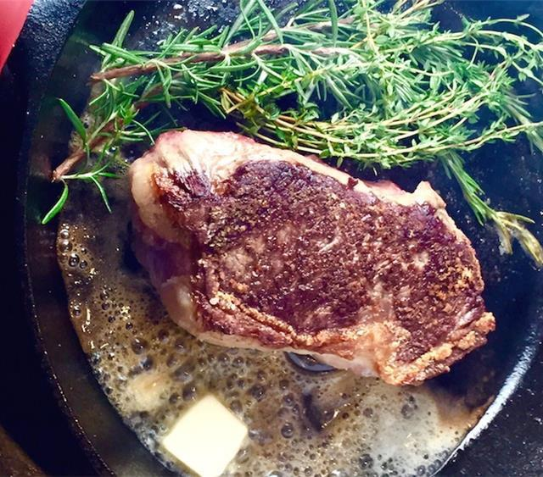
20MIN
Total Time
1 New York Strip Steak
1 Tbsp Oil
2 Tbsp Butter
3 sprigs Fresh Thyme
3 sprigs Fresh Rosemary
to taste Salt
to taste Ground Black Pepper

Cooking Instructions
Step 1
Preheat the oven to 400 degrees F (200 degrees C).
Step 2
Remove your New York Strip Steak (1) from the fridge and allow it to come to room temperature.
Step 3
Heat a cast iron skillet over a high flame 'till very hot. Season steak liberally with Salt (to taste) and Ground Black Pepper (to taste) ; cook in the skillet with Oil (1 Tbsp) . Cook 'till deep brown and crusty on the bottom — about four minutes.
Step 4
Flip the steak, and add the Fresh Rosemary (3 sprigs), Fresh Thyme (3 sprigs) and Butter (2 Tbsp) . Baste the steak with melted butter.
Step 5
Place in the oven and cook 'till done to your liking — about 8 - 10 minutes for medium rare, basting occasionally.
Step 6
Let steak rest at least 5 minutes before cutting.

