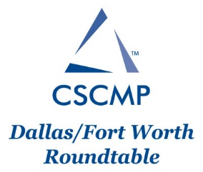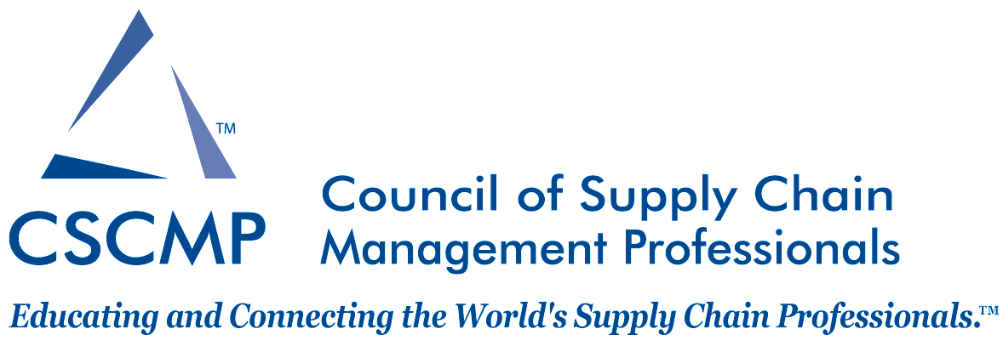

The DFW Roundtable of CSCMP is pleased to offer a $1500 student scholarship for spring 2018:

To apply for the scholarship, please submit a single document (PDF, MS Word, etc.) that includes the following application materials:

1. Application form (please see next page)
   1. Contact & degree information
   2. A one-page discussion regarding the applicant’s interest in supply chain management, his/her future career plans, and involvement with CSCMP, if any.
2. A copy of applicant’s résumé

Other material may be submitted optionally (ex: school transcript, recommendation letter from professor/instructor).

Applicant either can scan an image of materials into a document, or may download an electronic version of this document at https://dfw-cscmp.org/2018-spring-scholarship

Note that you do not need to be a member to apply but scholarship winners must be members of CSCMP, and must be full-time students. CSCMP membership information is available at: <http://cscmp.org/CSCMP/Join/Student_Membership.aspx>

Deadline: Monday, April 2, 2018.

Scholarship winners will be announced at the Golf Tournament in May 7th. School transcript will be required for finalists, to confirm GPA.

Submit applications electronically to: [dfwcscmporg@gmail.com](mailto:dfwcscmporg@gmail.com). Any questions can be directed to the same email address.



**Scholarship Application Form**

**Note: All full time students are encouraged to apply but you must be a current member of CSCMP to be eligible for the scholarships.**

Contact Information

|  |  |
| --- | --- |
| Name: | |
| Address: | |
| City/State/Zip: | |
| Cell Phone: | Email: |
| Degree Information | |
| University/Institution: | |
| Professor/Instructor: Prof. Email: | |
| Major: | Minor: |
| Overall G.P.A.: | G.P.A. in Major: |
| Total Credit Hours Completed to Date: | |
| Anticipated Term and Year of Graduation: | |

**In a one-page 12-point font single spaced sheet of paper, please provide a discussion regarding your interest in supply chain management and your future career plans. Also, include details on your involvement with CSCMP (roundtable meeting, national conferences, etc.), if any.**