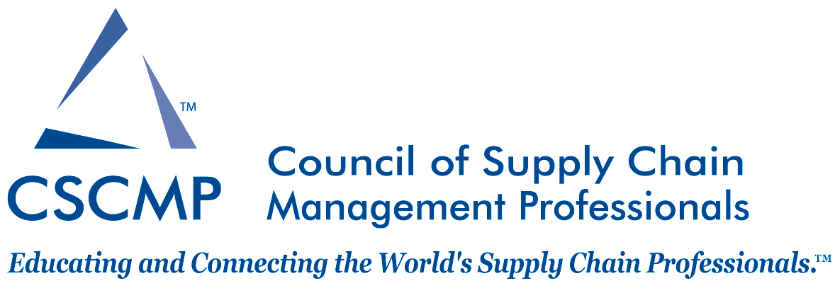
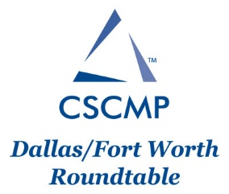

Scholarship Application Form

Note: All full time students are encouraged to apply but you must be a current member of CSCMP to be eligible for the scholarships.

Contact Information
Name:
Address:
City/State/Zip:
Cell Phone: | Email:
Degree Information
University/Institution:
Professor/Instructor: Prof. Email:
Major: | Minor:
Overall G.P.A.: | G.P.A. in Major:
Total Credit Hours Completed to Date:
Anticipated Term and Year of Graduation:

In a one-page 12-point font single spaced sheet of paper, please provide a discussion regarding your interest in supply chain management and your future career plans. Also, include details on your involvement with CSCMP (roundtable meeting, national conferences, etc.), if any.

