City of Rio Vista



201 S HIGHWAY 174

RIO VISTA, TEXAS 76093

**March 11, 2025** - **REGULAR MEETING**

**NOTICE IS HEREBY GIVEN FOR THE PURPOSE OF CONSIDERING THE ATTACHED AGENDA. THE GOVERNING BODY OF THE CITY OF RIO VISTA WILL MEET AT 6:00 P.M. ON THE 11TH DAY OF MARCH 2025, AT ITS REGULAR MEETING PLACE, RIO VISTA CIVIC CENTER** - **201 S HWY 174; RIO VISTA, TEXAS FOR THE PURPOSE OF CONSIDERING THE ATTACHED AGENDA.**

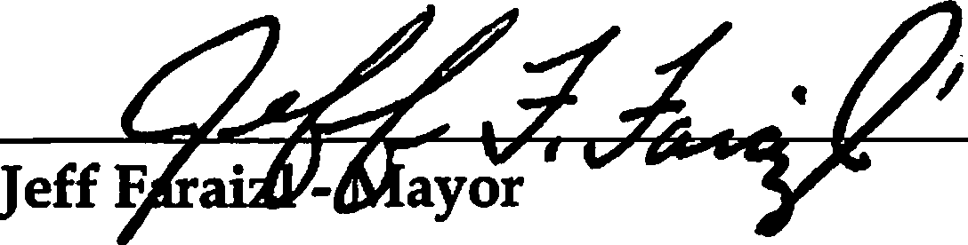

Posted on the 7th day of March 2025.

**AGENDA**

* **Roll Call**
* **Invocation**
* **Pledge of Allegiance American Flag Texas Flag**

Honor the Texas Flag; I Pledge Allegiance to Thee Texas, One State Under God; One And Indivisible.

* **Updates from the Mayor**
* **Presentations/Citizen Comments**

**UPDATE ON MUNICIPAL BUSINESS**

* Report from the Interim Chief of Police
* Report from the Dynamic Systems
* Report from the City Secretary
* Report from Attorney

**CONSENT ITEMS**

1. Approve City Council Minutes For:
   * February 11, 2025 - Regular Meeting
   * February 14, 2025 – Emergency Meeting
2. Approve Payment of bills for the Month of January.
3. Dynamic Services
4. Michael Hammond
5. Provenance Engineering
6. Public Management

**OLD BUSINESS**

* + 1. Review, discuss and take possible action on Oscar Martinez presenting his plans for a new subdivision Bluebonnet Bluffs Municipal Utility District at 6452 CR 1205 JCSUD will furnish water and all permutations thereof.
    2. Review, discuss and take possible action on restructure of policies and procedures for Police Department and all permutations thereof.
    3. Review, discuss and take possible action on discuss reviewing and approving Police Department Applicant and all permutations thereof.

**NEW BUSINESS**

1. Review, discuss and take possible action on Gabriel Ogualeye Olayemi requesting home on 401 Mesquite Dr be used as an Air BB and all permutations thereof.
2. Review, discuss and take possible action on approving Miranda Wyndham organizing the July and Xmas parades and all permutations thereof.
3. Review, discuss and take possible action on Kent Riker reporting WWTP updates and all permutations thereof.
4. Review, discuss and take possible action on updating fees for existing Subdivision Ordinance and all permutations thereof.

**EXECUTIVE SESSION**

*The City Council for the City of Rio Vista reserves the right to adjourn into Executive Session at any time during the course of this meeting to discuss any of the matters listed above, as authorized by Texas Government Code*

*§551.071- Consultation with Attorney; §551.072 -Deliberations about Real Property; §551.073-Deliberations about Gifts and Donations; §551.074* - *Personnel Matters; §551.076* - *Deliberations about Security Devices; and §551.087* - *Economic Development. All items listed are eligible for Council discussion and/or action.*

.

1. Review, discuss and take possible action on reviewing and approving Police Department Applicant and all permutations thereof.

**RETURN EXECUTIVE SESSION**

1. Review, discuss and take possible action on reviewing and approving Police Department Applicant and all permutations thereof.

**ADJOURN**

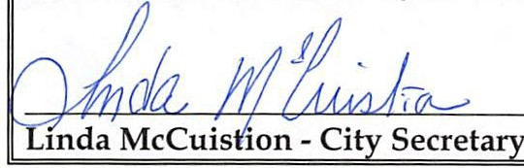

**THE AGENDA FILED AT POSTING TIME BY THE CITY SECRETARY UNDER THE OPEN MEETING ACT SECTION 551.041 OF THE TEXAS GOVERNMENT CODE (POSTING REQUIREMENTS SECTION) SECTION 551.043 OF THE TEXAS GOVERNMENT CODE (72 HOUR NOTICE REQUIREMENT).**

**CERTIFICATION**

I **certify that a copy of the agenda items to be considered by the Mayor and the City Council of Rio Vista, Texas was posted on the City Hall bulletin board March 7, 2025 by 5:00 p.m.**

I CERTIFY THAT THE ATTACHED NOTICE AND AGENDA OF ITEMS TO BE CONSIDERED BY THE MAYOR AND CITY COUNCIL WAS REMOVED BY ME FROM THE CITY HALL BULLETIN BOARD ON THE DAY OF ,2025.

Linda McCuistion - City Secretary