City of Rio Vista


201 S HIGHWAY 174
RIO VISTA, TEXAS 76093

November 18, 2025 - REGULAR MEETING

NOTICE IS HEREBY GIVEN FOR THE PURPOSE OF CONSIDERING THE ATTACHED AGENDA. THE GOVERNING BODY OF THE CITY OF RIO VISTA WILL MEET AT 6:00 P.M. ON THE 18TH DAY OF NOVEMBER 2025, AT ITS REGULAR MEETING PLACE, RIO VISTA CITY HALL - 201 S HWY 174; RIO VISTA, TEXAS FOR THE PURPOSE OF CONSIDERING THE ATTACHED AGENDA.
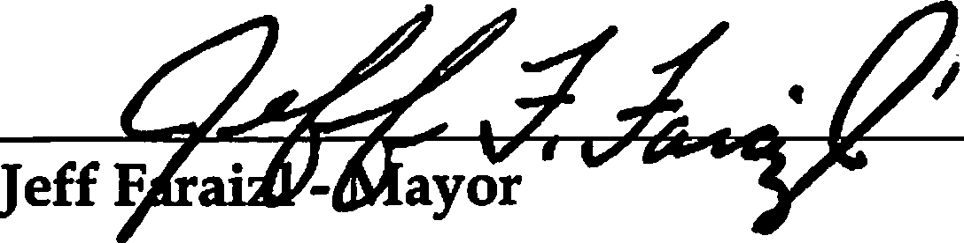
Posted on the 13th day of November 2025.
AGENDA

- Roll Call
- Invocation
- Pledge of Allegiance American Flag Texas Flag
Honor the Texas Flag; I Pledge Allegiance to Thee Texas, One State Under God; One And Indivisible.
- Updates from the Mayor
- Presentations/Citizen Comments

UPDATE ON MUNICIPAL BUSINESS
- Report from the Chief of Police
- Report from the Public Works
- Report from the City Secretary
- Report from Attorney

CONSENT ITEMS
- Approve City Council Minutes For:
  - October 14,2025 - Regular Meeting Minutes

Approve Payment of bills for the Month of October.
- Dynamic Services
- Grace Inspections
- Michael Wilson

OLD BUSINESS

- Review, discuss and take possible action on Mr. Frank Clewis new building sewer lines being
rerouted and all permutations thereof.

NEW BUSINESS

  - Review, discuss and take possible action accepting Daniel Trammell’s resignation for Place#2
City Council position and all permutations thereof.
- Review, discuss and take possible action on appointing and swearing in a new City Council member Place#2 and all permutations thereof.
- Review, discuss and take possible action concerning Core and Main meter options presented by Jayden Gordon and all permutations thereof.
- Review, discuss and take possible action on deciding a time frame Debbie Trussel will be allowed to temporarily live in an RV at 401 Hughes, her sister, and all permutations thereof.
- Review, discuss and take possible action choosing the construction company, from bids received, and recommendation from Kent Riker to build WWTP and all permutations thereof
EXECUTIVE SESSION
The City Council for the City of Rio Vista reserves the right to adjourn into Executive Session at any time during the course of this meeting to discuss any of the matters listed above, as authorized by Texas Government Code
§551.071- Consultation with Attorney; §551.072 -Deliberations about Real Property; §551.073-Deliberations about Gifts and Donations; §551.074 - Personnel Matters; §551.076 - Deliberations about Security Devices; and §551.087 - Economic Development. All items listed are eligible for Council discussion and/or action.

    - Review, discuss and take possible action on Mr. Frank Clewis new building sewer lines being
rerouted and all permutations thereof.
  - Review, discuss and take possible action choosing the construction company, from bids received, and recommendation from Kent Riker to build WWTP and all permutations thereof
RETURN EXECUTIVE SESSION

    - Review, discuss and take possible action on Mr. Frank Clewis new building sewer lines being
rerouted and all permutations thereof.
    - Review, discuss and take possible action choosing the construction company, from bids received, and recommendation from Kent Riker to build WWTP and all permutations thereof

ADJOURN
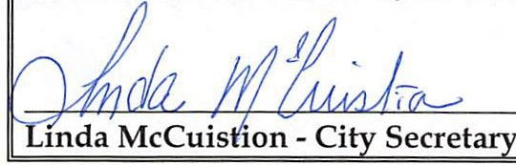
THE AGENDA FILED AT POSTING TIME BY THE CITY SECRETARY UNDER THE OPEN MEETING ACT SECTION 551.041 OF THE TEXAS GOVERNMENT CODE (POSTING REQUIREMENTS SECTION) SECTION 551.043 OF THE TEXAS GOVERNMENT CODE (72 HOUR NOTICE REQUIREMENT).

CERTIFICATION
I certify that a copy of the agenda items to be considered by the Mayor and the City Council of Rio Vista, Texas was posted on the City Hall bulletin board November 13, 2025 by 5:00 p.m.

I CERTIFY THAT THE ATTACHED NOTICE AND AGENDA OF ITEMS TO BE CONSIDERED BY THE MAYOR AND CITY COUNCIL WAS REMOVED BY ME FROM THE CITY HALL BULLETIN BOARD ON THE DAY OF ,2025.

Linda McCuistion - City Secretary

