City of Rio Vista



201 S HIGHWAY 174

RIO VISTA, TEXAS 76093

**February 11, 2025** - **REGULAR MEETING**

**NOTICE IS HEREBY GIVEN FOR THE PURPOSE OF CONSIDERING THE ATTACHED AGENDA. THE GOVERNING BODY OF THE CITY OF RIO VISTA WILL MEET AT 6:00 P.M. ON THE 11TH DAY OF FEBRUARY 2025, AT ITS REGULAR MEETING PLACE, RIO VISTA CIVIC CENTER** - **201 S HWY 174; RIO VISTA, TEXAS FOR THE PURPOSE OF CONSIDERING THE ATTACHED AGENDA.**

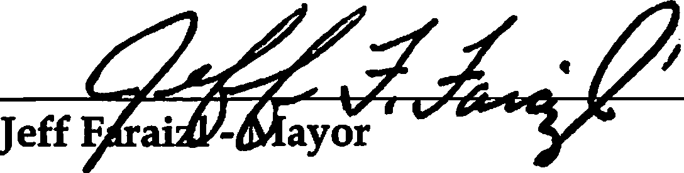

Posted on the 8th day of February 2025.

**AGENDA**

* **Roll Call**
* **Invocation**
* **Pledge of Allegiance American Flag Texas Flag**

Honor the Texas Flag; I Pledge Allegiance to Thee Texas, One State Under God; One And Indivisible.

* **Updates from the Mayor**
* **Presentations/Citizen Comments**

**UPDATE ON MUNICIPAL BUSINESS**

* Report from the Interim Chief of Police
* Report from the Public Works
* Report from the City Secretary
* Report from Attorney

**CONSENT ITEMS**

1. Approve City Council Minutes For:
   * January 14, 2025 - Regular Meeting
2. Approve Payment of bills for the Month of January.
3. Dynamic Services
4. Michael Hammond
5. Provenance Engineering

**NEW BUSINESS**

* + 1. Review, discuss and take possible action on Kent Riker reporting WWTP updates and all permutations thereof.
    2. Review, discuss and take possible action on Oscar Martinez presenting his plans for a new subdivision Bluebonnet Bluffs Municipal Utility District at 6452 CR 1205 JCSUD will furnish water and all permutations thereof.
    3. Review, discuss and take possible action on signing Order of Election and all permutations thereof.
    4. Review, discuss and take possible action approving and signing Interlocal Agreement with Rio Vista ISD to share election day with City Of Rio Vista on May 3rd in Civic Center and all permutations thereof.
    5. Review, discuss and take possible action on accepting Deanne Strother resignation for Court Judge and all permutations thereof.
    6. Review, discuss and take possible action on restructure of policies and procedures for Police Department and all permutations thereof.
    7. Review, discuss and take possible action on Police Department purchasing fuel for Police vehicles and all permutations thereof.
    8. Review, discuss and take possible on creating new ordinance and fee for construction of any new residential and or commercial community facilities and all permutations thereof.
    9. Review, discuss and take possible action on reviewing and approving Police Department

Applicant and all permutations thereof.

**EXECUTIVE SESSION**

*The City Council for the City of Rio Vista reserves the right to adjourn into Executive Session at any time during the course of this meeting to discuss any of the matters listed above, as authorized by Texas Government Code*

*§551.071- Consultation with Attorney; §551.072 -Deliberations about Real Property; §551.073-Deliberations about Gifts and Donations; §551.074* - *Personnel Matters; §551.076* - *Deliberations about Security Devices; and §551.087* - *Economic Development. All items listed are eligible for Council discussion and/or action.*

1. Review, discuss and take possible action on reviewing and approving Police Department Applicant and all permutations thereof.

**RETURN EXECUTIVE SESSION**

1. Review, discuss and take possible action on reviewing and approving Police Department Applicant and all permutations thereof.

**ADJOURN**

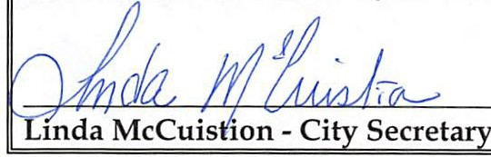

**THE AGENDA FILED AT POSTING TIME BY THE CITY SECRETARY UNDER THE OPEN MEETING ACT SECTION 551.041 OF THE TEXAS GOVERNMENT CODE (POSTING REQUIREMENTS SECTION) SECTION 551.043 OF THE TEXAS GOVERNMENT CODE (72 HOUR NOTICE REQUIREMENT).**

**CERTIFICATION**

I **certify that a copy of the agenda items to be considered by the Mayor and the City Council of Rio Vista, Texas was posted on the City Hall bulletin board February 8, 2025 by 5:00 p.m.**

I CERTIFY THAT THE ATTACHED NOTICE AND AGENDA OF ITEMS TO BE CONSIDERED BY THE MAYOR AND CITY COUNCIL WAS REMOVED BY ME FROM THE CITY HALL BULLETIN BOARD ON THE DAY OF ,2025.

Linda McCuistion - City Secretary