Dawn State*

A life with intimacy has no boundaries
no way to measure happiness,
musings, sorrow, or guilt.
There is a lovely freedom in being alone,
however,
and much spare time
but also great loneliness,
of course.
So you compose a running narrative of your world.
It seems you have a story to tell.

Experience shared is joy doubled, as Goethe said
and the need to share is fierce
but alas
no one is near enough
for long enough
to carry the thread
except in tiny fragments—
awkward sometimes wondrous glimpses
Into each other’s lives.

And so you become your own intimate,
your own muse, your own audience
as you struggle for the perfect word or phrase,
edit, lyricize (too often, you are told), and critique.

You hear the story in your head
as a composer hears the song.
You tell yourself the story and
you write down what you hear.

Some in the tribe are chosen,
compelled perhaps,
to tell the story of the world.
You seem suited to the task.

So you apply a writer’s structure
because you must
to the spellbinding but daunting
rush of events
that burst forth each day, seeking
a reassuring pattern
a familiar story arc
a comforting canon of grammar
or bit of wisdom or knowledge to pass along—
something that might make living more bearable
more meaningful more fathomable more joyous.
And it is joy you seek
above all else
let there be no doubt.
Comfort and joy as the carol goes
Comfort & Joy.

It has its moments,
this life lived in the dawn state of Ouroboros.
It’s a matter of survival.
It’s the only game in town.

You hear the story in your head
as a composer hears a song.
You tell yourself the story and
you write the story down.

Pamela Michael
Curry Canyon
July 19, 2013, edited February 24, 2022

*Jungian psychologist Erich Neumann wrote that the Ouroboros represented the pre-ego “dawn state” that characterizes the undifferentiated infancy experience of both humankind and the individual child.
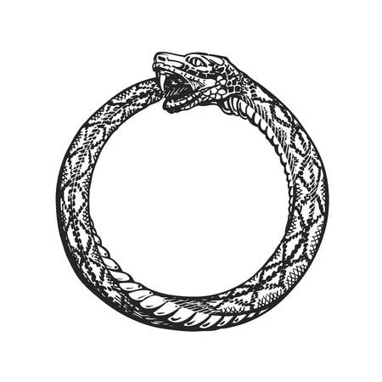
Ouroboros is a gnostic and alchemical symbol that expresses the unity of all things, material and spiritual, which never disappear but perpetually change form in an eternal cycle of destruction and re-creation.

