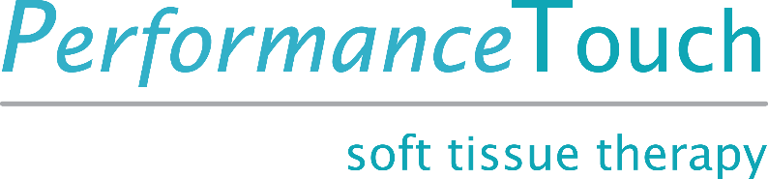

Advanced Myofascial Techniques for Sport Masterclass

Upper and Lower Body

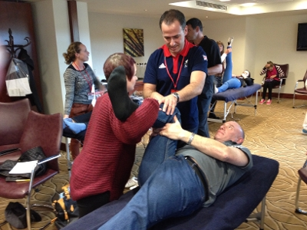

What is it?
Performance Touch Advanced Myofascial Techniques for Sport offers the student real world, clinically proven and easily learned techniques that are a must in today’s clinical and competition environment. Through the use of powerful, cutting edge Myofascial release techniques you and your clients can expect dramatic and lasting benefits. Over two days, you will learn a full body approach to lengthening shortened connective tissues as developed through the habitual overuse patterns of the modern athlete. These techniques have proven to be particularly effective for overall flexibility improvement, postural re-balancing, decreasing everyday tension and pain associated with poor posture and general training maintenance, allowing the athlete to train harder and longer.

Who is it for?
Masterclass workshops are qualified manual therapists. A good level of understanding of the muscular and myofascial systems is ideal.

ü Osteopaths
ü Manual Therapists
ü Massage/Soft Tissue Therapists
ü Physiotherapists
ü Sports Therapists

What you will learn:
An intensive, cutting edge approach to releasing Myofascial restrictions using Performance Myofascial Release Techniques (PMRT) all in a small group class environment.

Day 1: Performance Myofascial Release Techniques (PMRT) - Legs
Day 2: Techniques for the Upper Body

· an introduction to Myofascial and muscular anatomy and function of the feet, legs, hips, torso, shoulders, neck and arms.

· How to assess client ROM and Myofascial restrictions using visual body reading active and passive ROM.

· Direct Myofascial Release techniques specific to a wide range of sports/athletes and how to best utilize each stoke in supine, prone, side lying, standing and seated positions.

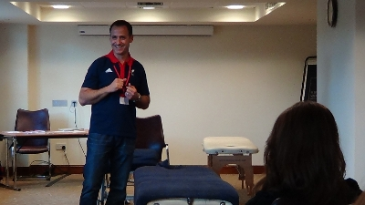

Workshop Dates:

Venue Location:

Workshop Cost: £245
`(manual and certificate of attendance).

Times: 9-5pm both days

**Class size - 12 maximum**

HOW TO BOOK OUR COURSES
Courses can be booked online from my website and paid for via PayPal. You can also contact me at stan@performancetouch.com or 07540 938285 to find out availability and to book. To secure your place on the course, please fill out the contact form on my website http://www.performancetouch.com. A £40 non-refundable deposit will be required to secure your place. Final payment will be required 2 weeks prior to the course date.

SENDING YOUR DEPOSIT/PAYMENT
Payment by cheque, PayPal and Credit cards are accepted. To pay by PayPal or Credit Card please visit my website http://www.performancetouch.com/cpd-masterclass.html and use the Buy Now button, alternatively, you can pay by cheque. Please make cheque payable to Performance Touch or Stan Mavridis and post to: 48 The Pastures, Lower Westwood, Bradford on Avon, BA15 2BH.

FINAL PAYMENT
Please send your final payment 2 weeks before course date. Cancellations > 4 weeks in advance will receive full refund; 4 weeks to 2 weeks prior refund = deposit withheld. All cancellations within 2 weeks of course date = no refund.

RECEIPTS FOR COURSE FEES
A course receipt will be emailed to you directly after the course.

