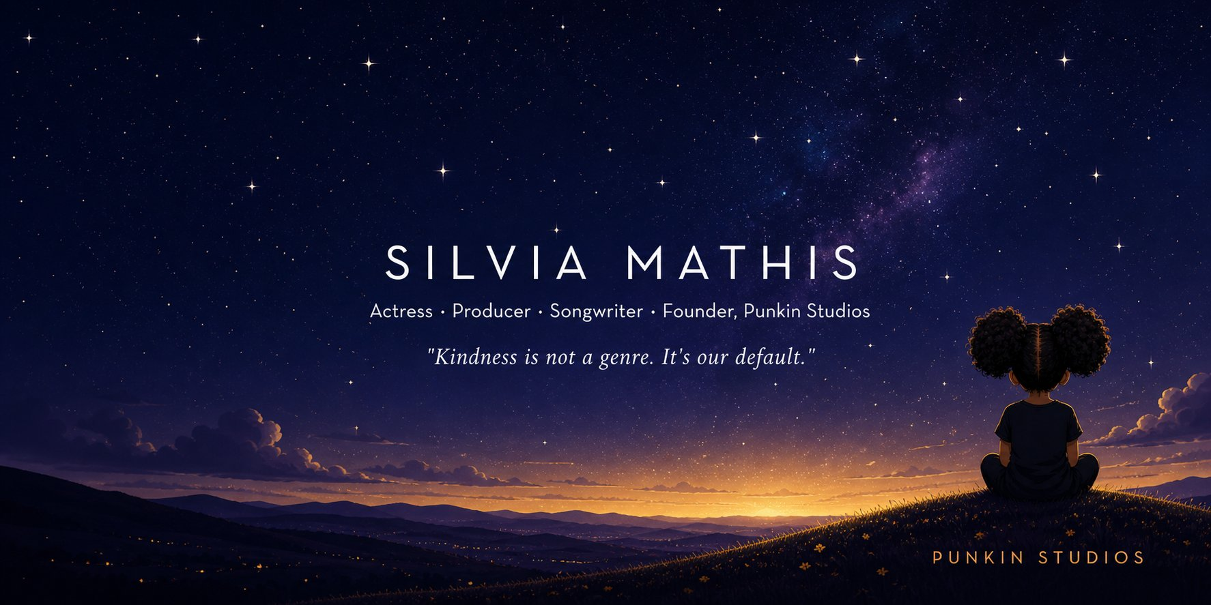
THE PITCH LAB
Written Pitch Template
A Punkin Studios Resource | Created by Silvia Mathis

Before you fill in a single field.
Click into any gray italic field and type over it. The formatting holds. The notes inside each section header are for your reference while completing the template. Remove them before you submit this anywhere. Work top to bottom. Each section builds on the one before it.

Let me tell you what actually happens on the other end.
I'm Silvia Mathis. Creative producer. Actress. Songwriter. Ghostwriter. Music publisher. Founder of Punkin Studios. I have spent more than three decades working across film, television, and music, developing original IP, directing on stage and set, pitching in rooms, sitting across from writers, and building things from scratch. My producing partner, Kevin Nicklaus, was SVP of Development at Warner Bros. He came up through legacy media. So did I, just from a different door.
I know what it looks like to pitch. And I know what it looks like to receive a pitch, read it in under four minutes, and have to make a call. I built this template from both of those chairs.
Here is the truth that folks won't tell you: the through line between pitches that get passed over isn't the idea.
Most ideas are actually pretty good. The through line is the presentation.

“Big chunks of unbroken text. A logline buried in paragraph three. Spelling errors that tell the reader you didn't care enough to edit before asking them to care. These things make a reader's eyes work too hard. And when a reader's eyes work too hard, they stop.”

Your idea deserves better than that. So do you.
I also want to say this: trends change. What is selling today will not be what is selling in eighteen months. But it could be what's selling again in two years. That's the nature of the business. I have watched cycles come and go. What does not change in any room, on either side of the table, is excellence, clarity, and heart.
Build to that. I can't guarantee what happens in that room. What I can guarantee is this: done right, your pitch will meet and exceed the standard this industry expects. It will announce your professionalism before you say a word. And whether you've been doing this for thirty years or thirty days, the pitch in your hands right now is the one that gets you taken seriously.
Your pitch has one job! Get them to read your script! That's it!
If you have been trying to figure this out alone, Googling what a logline is at midnight, second-guessing your format, wondering why you can't get traction, I see you. I've been there. This is for you.
Now go write something great. Silvia

What the industry says.
“There is no one else you should work with.”  Mark Wolper | Oscar, Emmy, Golden Globe & NAACP Image Award-winning CEO, The Wolper Org (Roots, Bates Motel, LA Confidential) | “Whatever hat she chooses to put on, she wears it well. A master of all trades and a Jack of none.”  Carvin Haggins | 25-time Grammy Nominee, Multi-Grammy Winning Songwriter (Michael Jackson, Taylor Swift, Prince, H.E.R.)
“Perhaps the most competent, creative, and team-oriented Creative Producer I've worked with. With Silvia, there are only opportunities and solutions, never problems.”  Mykelti Williamson | DGA Director & Actor (Forrest Gump, Fences, ATL) | “Silvia is a passionate, detail-oriented creative who understands the filmmaking process and communicates incredibly kindly and thoughtfully with other creatives.”  Roger M. Bobb | 8-time NAACP Image Award-winning Producer, Director & Writer
“She brings joy, wisdom, and vision to all her projects, and you leave better having been around her.”  Jaclyn Lindsey | Co-Founder & CEO, Kindness.org | “I've never felt safer as an artist. Trust is crucial on set, and she earns it.”  Keesha Sharp | Actress & Director, 3-time NAACP Image Award Nominee

01 | THE PROJECT  Be specific in every field. I promise you, vague pitches are easy to spot from a mile away, and they get put down fast. If you can't say it clearly here, on your own page, with no one watching, you will not magically find the words in the room.

Title | Your project title.  Make it land. This is the first word they see.
Format | One-Hour Drama Series / Half-Hour Comedy / Feature Film / Limited Series  Include episode count if you know it.
Genre | e.g. Psychological Thriller / Dramedy / Sci-Fi Drama  Two genres maximum. More than two tells me you haven't figured it out yet.
Tone | How does this feel? What two titles does it live between?  Use comps your reader has seen recently and will recognize immediately.
Logline | In [world], [protagonist] must [goal] before / or [stakes].  One to two sentences. If you can't write this cleanly, the concept isn't ready. Come back when it is.
Tagline | One line that makes someone feel something before they read another word.  Optional. Think poster copy. If you don't have it yet, leave it blank.

02 | THE WORLD  Your reader should feel like they have stepped into your world before they meet a single character. Specific details do that. A small town does not. Give us the thing only your story has.

Describe the world of your story in 2 to 4 sentences. Time, place, atmosphere, the unspoken rules. What is the status quo before everything changes? Be specific enough that only this story could exist here.

03 | THE CORE CONCEPT  Most writers skip this one. I notice every single time. This is not your premise, it is the engine underneath it, the thing that makes your story run different from every other story that sounds kind of similar on paper.

“The house does not trap bodies. It traps perception. Two people can stand in the same room and experience completely different realities. The horror is not seeing monsters. It is losing the ability to share reality with someone you love.”
Strong core concept. This is the level of specificity this section requires.

In 3 to 5 sentences: What is the distinctive mechanism of your story? What could not exist in any other project? This is your fingerprint on the genre. Make it specific. Make it undeniable.

04 | THE PROTAGONIST  Please do not give me a resume. Tell me who they are and what makes them worth following for six episodes or two hours. And remember, what they want and what they need are almost never the same thing. That gap right there is your whole show.

Name & Age | Character name, age or range.
Who They Are | Who is this person at the start of the story?  Occupation, world, defining identity. Who are they before everything changes?
What They Want | Their external goal. What are they actively chasing?  This drives the plot forward.
What They Need | What they actually need to grow or change.  Almost never the same as what they want. The gap between those two things is your show.
What's in the Way | The central obstacle or antagonistic force.  Be specific. 'A corrupt system' is not an obstacle. Find the human version of it.
Why We Stay | What makes it compelling to watch this specific person?  Sympathy is earned. What earns it here?

05 | THE ENSEMBLE  Every name on this list should have a job to do. Ask yourself honestly, what breaks if I delete this person? If the answer is nothing, I am sorry, but they have to go. It is not personal. It is structure.

Name / Role | Who They Are & Relationship to Protagonist | Narrative Function
Name, role | Brief description | Story function
Name, role | Brief description | Story function
Name, role | Brief description | Story function
Name, role | Brief description | Story function

06 | THE STORY  Present tense. Active voice. No plot dumps. Tell me the shape of the story, not a play by play of every scene. And if you catch yourself typing actual dialogue in this section, stop, take a breath, and zoom back out.

THE PILOT / OPENING ACT
Where do we meet the protagonist? What is the inciting incident? Where does the first episode or opening act end, and what question does it leave open? End on the hook.

THE ARC / WHERE IT GOES
For TV: describe the season arc and hint at the series-long trajectory. For film: describe the shape of acts two and three. This section proves you know your ending. Honesty about where you are in development is better than a promise you can't keep.

07 | THEMES & RELEVANCE  Not the plot. What it is actually about underneath the plot. And a gentle reminder, 'everyone' is not an audience. I know your story is for everybody in your heart. On paper, tell me who specifically is waiting for it.

Name the central themes in one or two sentences. Then make the case for why this story is necessary right now. What cultural moment does it speak to? Who is the audience, and why do they need it?

08 | LOOK & FEEL  Writers skip this one too, and producers notice every single time, I promise. Give me a point of view, not a Pinterest board. What does this actually look and sound like in someone's living room?

Visual Reference | e.g. Cinematically intimate, the visual language of Euphoria filtered through the grounded realism of The Wire.  One to two comp titles. More than two dilutes your vision.
Tonal Reference | e.g. The wit of Abbott Elementary carrying the emotional weight of This Is Us.  Tone and visual are different. Address both if you can.
The Feeling | When someone finishes watching this, what do they carry with them?  Not just moved. Moved how? Be specific.

09 | WHY THIS WORKS  This is not bragging, so relax. This is proving you understand that someone has to pay for this thing, market it, and convince an audience to show up. Think like the person who has to say yes.

Target Audience | Who is this for? Be specific.  e.g. 'Premium streaming audiences who watch elevated genre television in the Succession / Severance lane.'
Platform Fit | Where does this live? Network / Cable / Premium Streaming / FAST / Theatrical?  Be honest about where this belongs, not where you wish it belonged.
Producibility | What makes this achievable? Contained setting, small cast, limited visual effects?  Especially important for emerging writers. Show them you've thought about what it costs to make.
The Differentiator | What does this project do that nothing else currently on air does?  One to two sentences. If you can't answer this, keep developing.

10 | WHY YOU  This is the section almost everyone underwrites, and it might be the most important one. You are part of this pitch, whether you like it or not. A great project pitched by the wrong person for it is still a pass. So tell me why it has to be you.

“The industry is full of capable writers. Capability is not the pitch. Your specific lens, your lived experience, your perspective, your particular access to this story, that is the pitch. Nobody else has it.”

In three to five sentences: What is your personal connection to this story? What lived experience, research, or perspective do you bring that nobody else has? What makes you not just qualified, but essential?

11 | WHAT EXISTS  Only list what is actually real and finished. One complete pilot script beats five half-built things every time. And honesty here costs you nothing. We have all been at the starting line. Just tell me where you are standing.

Materials | e.g. Pilot script (complete). Series bible (in progress). Look book (attached).  List what exists. Don't overstate. Don't undersell either.
Attachments | Producing partner, director, or talent, if attached. Name and relevant credits.  Unattached is fine. Don't manufacture attachments.
Rights | Original IP / Optioned material (option expires ____) / Life rights secured.  If based on existing IP, address rights directly. It will be the first question.
Development Stage | e.g. Pilot complete, bible in development / Concept stage with treatment available.  Be clear about where you actually are.

12 | CONTACT & REPRESENTATION  Make it easy for someone excited about your work to actually reach you. And if your email address still has a number from middle school in it, please, for the love of everything, get a new one before this goes out. I say that with so much love.

Your Name | Full name as you want it to appear professionally.
Rep / Manager | Name, company, and email, if represented.  If unrepresented: 'Currently seeking representation.' Don't leave it blank.
Attorney | Entertainment attorney and firm, if applicable.
Email | Professional email address.  Not a personal Gmail. I say that with love too.
Website / IMDb | Links to your professional presence.  Both if you have both.
WGA Status | WGA member / WGA signatory / Non-union / Eligible.

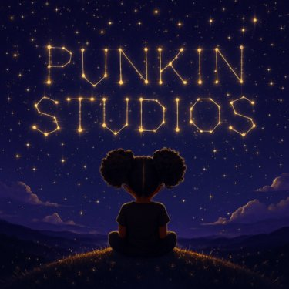
Trends change.
Excellence, clarity, and heart never do.
Kindness is not a genre. It's our default.
If you need a creative partner to talk through your pitch before it's ready, that's exactly what we're here for.
THE PITCH LAB | punkinstudios.com | hello@punkinstudios.com
© Punkin Studios. All rights reserved. Not for reproduction or redistribution.

