Verify Stimulus & Child Tax Credit Payments
Please follow the below steps:

- Log into your IRS account or create an account using this link: https://sa.www4.irs.gov/secureaccess/ui/?TYPE=33554433&REALMOID=06-0006b18e-628e-1187-a229-7c2b0ad00000&GUID=&SMAUTHREASON=0&METHOD=GET&SMAGENTNAME=-SM-u0ktItgVFneUJDzkQ7tjvLYXyclDooCJJ7%2bjXGjg3YC5id2x9riHE98hoVgd1BBv&TARGET=-SM-http%3a%2f%2fsa%2ewww4%2eirs%2egov%2fola%2f
- Once logged in, click tax records.
- Print the tax record page including the advance child tax credit and 2021 economic payment information, and email back to us at info@elcpa.net. (See below.)
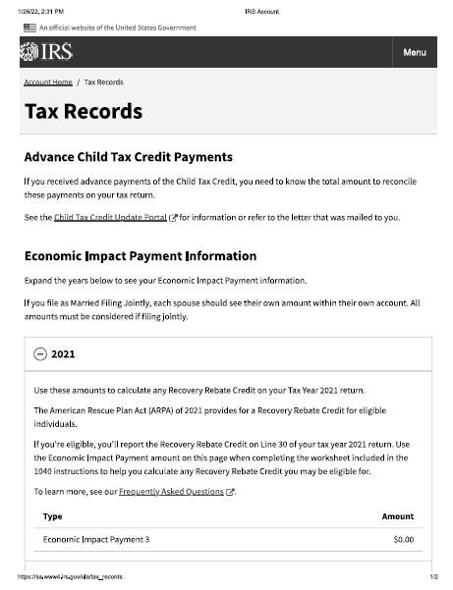

Verify Stimulus & Child Tax Credit Payments
Please follow the below steps:

- Log into your IRS account or create an account using this link: https://sa.www4.irs.gov/secureaccess/ui/?TYPE=33554433&REALMOID=06-0006b18e-628e-1187-a229-7c2b0ad00000&GUID=&SMAUTHREASON=0&METHOD=GET&SMAGENTNAME=-SM-u0ktItgVFneUJDzkQ7tjvLYXyclDooCJJ7%2bjXGjg3YC5id2x9riHE98hoVgd1BBv&TARGET=-SM-http%3a%2f%2fsa%2ewww4%2eirs%2egov%2fola%2f
- Once logged in, click tax records.
- Print the tax record page including the advance child tax credit and 2021 economic payment information, and email back to us at info@elcpa.net. (See below.)

