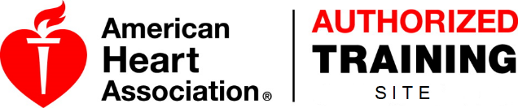
BLS Rules LLC
American Heart Association
Emergency Cardiovascular Care Program
Course Roster
rosters@blsrules.com - (Copy of Roster & tallied evaluation)

Submit rosters online: www.blsrules.com_instructor resources_ Course Roster Entry
Course Taught: | - Heartsaver First Aid  - Heartsaver First Aid w/AED  - Heartsaver AED  - Heartsaver Bloodborne Pathogens  - Heartsaver Pediatric First Aid w/AED |  | Billing Name:
 |  |  | Billing Address:
 |  |  | Instructor:
BLS Provider | - Initial □ Skills Test | - Renewal | Course Location:
BLS Instructor | - Initial | - Renewal | Course State - End Date | Course Start – End Time |  | Total Hours of Instruction
Heartsaver Instructor |  | - Renewal | Student/Manikin Ratio | Student/Instructor Ratio |  | Number of students to be issued cards:
STUDENT NAME (First Last): Please Print |  | STUDENT EMAIL: Please Print |  | Skill Check | Test Score |  | Course completed | Remediation
I verify that this information is accurate, truthful, and may be confirmed. This course was taught in accordance with AHA guidelines including use of current DVD and all students having access to a current course workbook before, during, and after the co+urse.

______________________________________________________________ ___________________
Signature of Lead Instructor Date

