Balanced and Unbalanced Connections

An in-depth look at the myths, half-truths and misconceptions about properly wiring your system.
By Mike Rivers • January 18, 2019
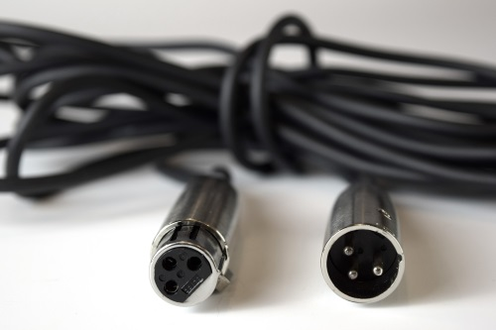

The significance of balanced and unbalanced connections between audio devices, as well as the meaning of the terms, is often misunderstood.
A balanced output can be designed, constructed, and connected in many ways, and there are several ways in which balanced and unbalanced devices can be interconnected.
Balanced connections have a long history that dates back to the early days of telephony. The phone company runs thousands of miles of unshielded cable between sources and destinations, with very little hum or noise added to our conversations. Yet sometimes it seems we can’t manage to connect two devices in the same rack in our studio without something humming, even if we use hundred-dollar boutique cables. By understanding the right and wrong ways of interconnecting audio devices, you can clean up your studio or sound system.

Myths, Half Truths, and Misconceptions
Thanks largely to the Internet, old stories die hard. To begin our study of making connections, let’s clear up a few misconceptions that have some basis in fact.

Unbalanced inputs and outputs are high impedance.
Nope. Some unbalanced inputs and outputs are indeed high impedance but high impedance connections in modern audio systems are only found in musical instrument pickups and instrument amplifiers. Why? Because they’ve always been that way.

Balanced inputs and outputs hum less than unbalanced because they’re low impedance.
Partially true. Most balanced outputs are low impedance, but with solid-state equipment, most unbalanced outputs are low impedance as well. When improperly designed or connected, low-impedance connections can hum badly. When properly designed and connected, unbalanced connections can be hum-free. The only high-impedance connections we must deal with today are between electric instrument pickups and amplifiers. It’s true that hum isn’t uncommon here, but it’s because of the design of the pickup, not the connection.

Balanced connections are “professional,” unbalanced connections are characteristic of consumer or “prosumer” gear.
This was close to true in the early days of the project studio but it’s no longer the case. The lines between “pro” and “consumer” are too blurry to make this generalization.
If you connect a balanced output to an unbalanced input, you’ll lose half the level. Sometimes, sometimes not. It depends on the output topology.
Now, on with the show.

The Real Meaning of “Balanced”
“Balanced” isn’t a characteristic of a device; it refers to the connection between two devices or between circuits within a device. Whether a connection between an output and an input is balanced or unbalanced is determined primarily by the source. You can unbalance a balanced source (an output), depending on what you connect it to and how you connect it, but you can’t balance an unbalanced source without adding components.
In order for an output to be balanced, the output signal must appear between two terminals, each having the same impedance with respect to a common reference point, which is usually ground. This is an important concept to understand. Contrary to popular belief, it is not necessary for the output-signal voltage to appear on both of the two output lines.
Further on, I’ll explain how and why this works.
Although the term “balanced input” is common, it’s really a misnomer. To make a proper balanced connection, a balanced output must be connected to a differential input. Half a million engineers aren’t going to quit calling an input “balanced” and start saying “differential” (nor will I) but the term’s significance will become clear shortly.

Balanced vs. Unbalanced Circuits
A device with an unbalanced output produces a voltage between a single “hot” output connection and the circuit’s signal common point, which is usually connected to the equipment’s chassis. The common term for this is “ground,” though it’s not necessarily electrically connected to the dirty brown stuff underneath the house. Similarly, a device with an unbalanced input receives its input voltage between a single “hot” input connection and ground.
