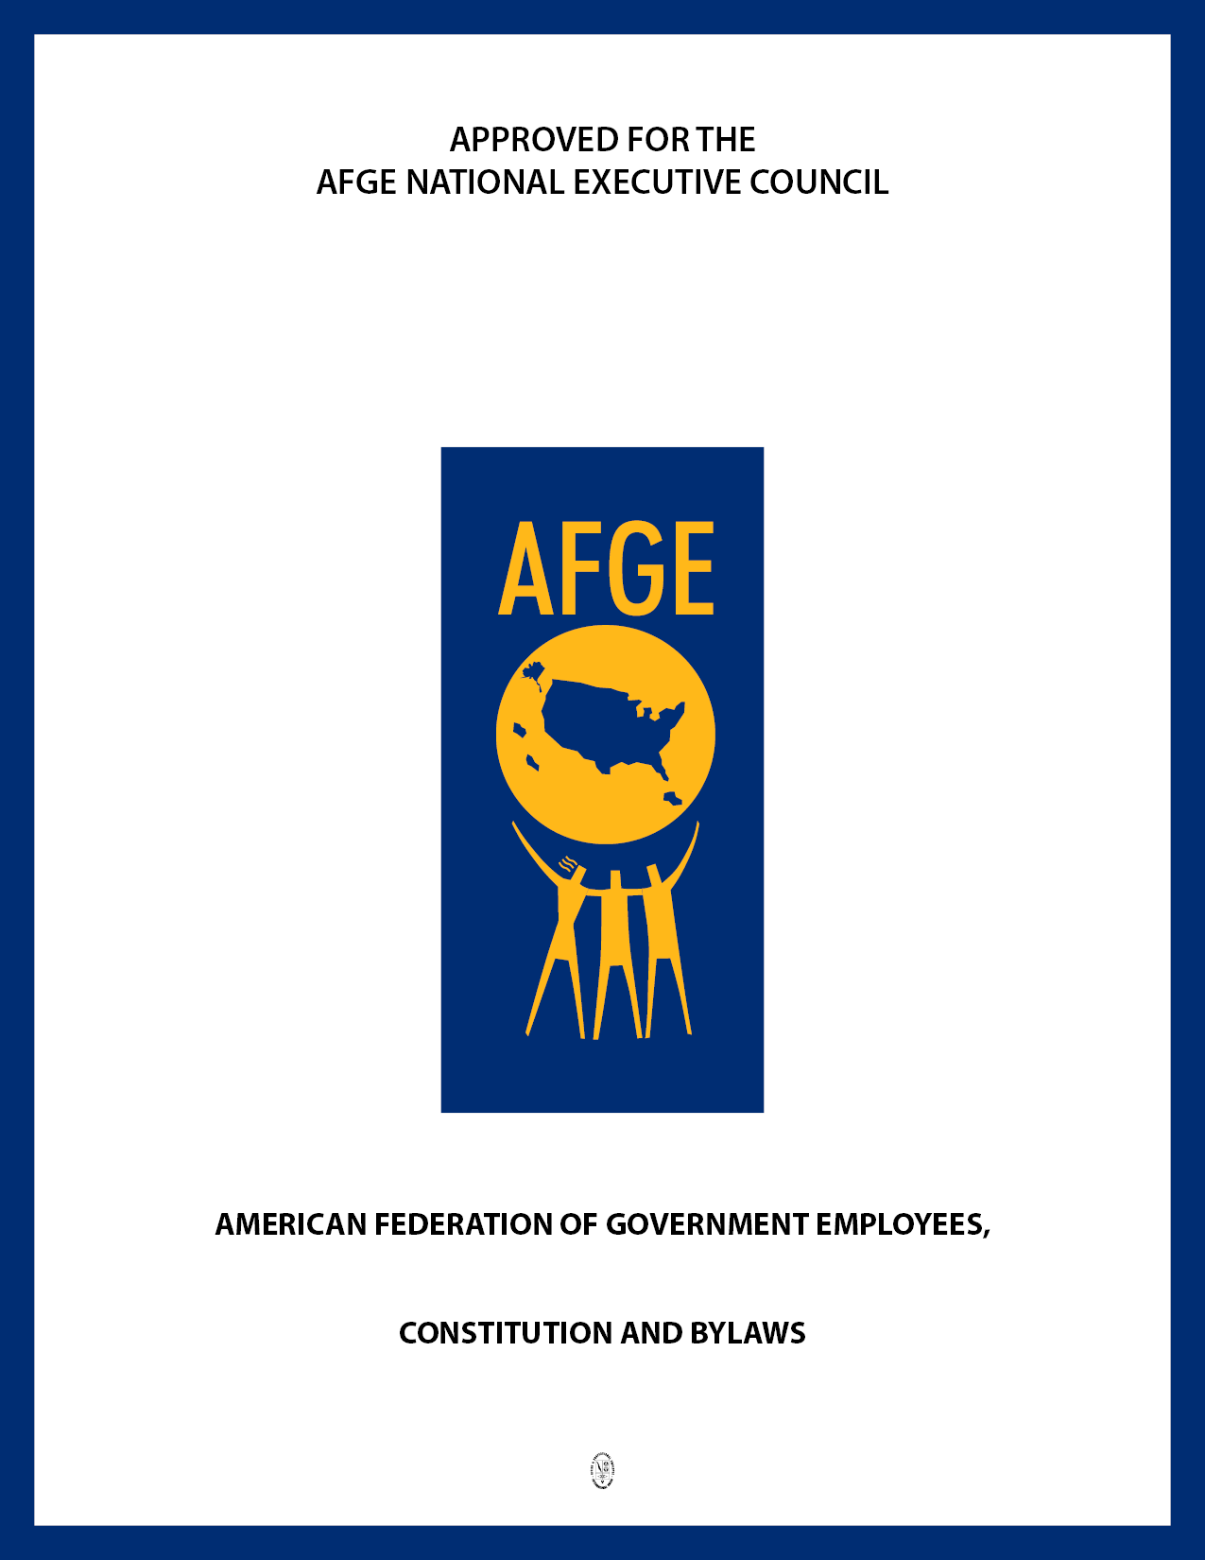
LOCAL 524

July 24, 2017

Standard Local Constitution

Article I
Name

Section 1. This local union shall be known as the American Federation of Government Employees, Defense Contract Audit Agency (DCAA) Local No. 524, AFL-CIO, as set forth in its charter. See AFGE National Constitution, Article XIX, Section 1.

Sec. 2. The headquarters and mailing address of this local shall be prescribed in the local's bylaws.
____________________

Article II
Objectives and Methods

Section 1. This local does not advocate the overthrow of the Constitutional form of government in the United States. The local does not discriminate with regard to race, creed, color, national origin, sex, age, political affiliation, disability, marital status, sexual orientation, or preferential or nonpreferential civil service status; and is not subject to corrupt influences or influences opposed to basic democratic principles.

Sec. 2. In the event any member(s) of the local is employed within a unit represented by an AFGE national bargaining council, the local shall affiliate with the national council(s). See AFGE National Constitution, Article XXI. The local shall pay dues and/or per capita tax to the national council for those members of the local employed within the unit represented by the council, as may be prescribed by the constitution of the council. See AFGE National Constitution, Article XXI, Section 1.

Sec. 3. This local is a separate, independent organization functioning in conformance with the AFGE National Constitution. Neither the local nor its officers, employees, members, or other persons has the authority to act, nor shall it be deemed to act on behalf of or as agent for the Federation or any of its other affiliates, unless such authority as applicable is expressly granted by the Federation by written authorization of the National President, or by an affiliate by written authorization in accordance with its governing procedures.
____________________

Article III
Membership

Section 1. All persons eligible for AFGE membership as prescribed by Article III of the AFGE National Constitution and who come within the local's jurisdiction as defined by its charter shall be eligible for membership in this local.

____________________

Article IV
Dues and Initiation Fees

Section 1. Dues shall be established and adjusted as may be necessary to ensure that they allow adequate funds for the payment of per capita tax and sufficient funds for the operating expenses of the local. See AFGE National Constitution, Article XIX, Section 4(a)(6) and 4(b)(6). Any change in the dues structure shall be accomplished by:

(a) Majority vote by secret ballot of the members in good standing voting at a general or special membership meeting after reasonable notice of the intention to vote upon such question; or
(b) By majority vote of the members in good standing voting in a membership referendum conducted by secret ballot.

Sec. 2(a). The local shall establish in its bylaws the amount of its initiation fee and the amount of its membership dues. See AFGE National Constitution, Article XIX, Section 4(a)(4)-4(a)(6) and 4(b)(4)-4(b)(6). Dues may be paid by payroll deduction or by advance payment for such intervals as prescribed by the local: quarterly, semiannually, or annually. If payroll deduction is available, a local may adopt a bylaw requiring payment of dues by this method. The local may establish a separate dues rate for retired members.

Sec. 2(b). Members may be dropped if dues are not paid by Tuesday of the last full workweek of the month, provided, however, that a reasonable amount of time after notice of delinquency is given.

Sec. 2(c). Local representatives, collectors, and shop stewards shall make remittance of all dues and initiation fees collected to the Treasurer within ten days and no later than the Tuesday of the last full workweek of the month.
____________________

Article V
Financial Records and Reporting

Section 1. All receipts, checks, and cash disbursements shall be properly recorded and accounted for in the financial records.

Sec. 2. The Treasurer shall sign and the President shall countersign checks covering proper expenditures for the local. In the absence of either the Treasurer or the President, such other officer as prescribed by the local's bylaws may sign in place of the absent officer.

Sec. 3. The officers, agents, shop stewards, or other representatives or employees of this local who handle funds or property thereof shall be bonded in accordance with law and applicable regulations. See AFGE National Constitution, Article XXIV, Section 8.

Sec. 4. In order for the bond to be effective, the local shall file with the National Secretary-Treasurer a copy of its annual audit in the format prescribed by Article XXIV, Section 8(d) of the AFGE National Constitution.

Sec. 5. All books, records, and financial accounts at all times shall be open to the inspection of the national officers or accredited representative of the National Executive Council and any duly authorized and accredited representative of the local. See AFGE National Constitution, Article XXIV, Section 9.
____________________

Article VI
Elected Officers

Section 1(a). The general officers shall be elected by the total membership and shall constitute the Executive Board of this local, and shall consist of the President, Treasurer, and Secretary and such others as the local's bylaws may prescribe. The local may adopt a bylaw combining the offices of Treasurer and Secretary.

Sec. 1(b). The local may establish bylaws which provide for the election of officers who are elected solely by members of a particular unit or work area and may provide that these officers will serve on the Executive Board.

Sec. 2. It shall be the duty and obligation of all local officers and all other official representatives of the local, whether elected or appointed, to support, advance, and carry out all provisions of the AFGE National Constitution, the standard local constitution and bylaws, official policies of the Federation and, to the extent not inconsistent with the foregoing, all official policies of the local. See AFGE National Constitution, Article XX, Section 2.

Sec. 3. The President shall be the executive officer of this local; he or she shall exercise general supervision over the affairs of the local and see that other officers comply with the responsibilities of their office and constitutional duties; comply with the National and standard local Constitutions; keep the membership apprised of the goals and objectives of the Federation; serve as an ex-officio member of all committees except the Election Committee, Audit Committee, and committee of investigation, or trial committee when he or she is bringing the charges or is directly or indirectly involved in the matter which gave rise to the charges; automatically serve by virtue of election to office as a local delegate to the district caucus, council meetings, the AFGE National Convention, and such other meetings participated in by this local as the local may be entitled; preside at all local meetings; and sign all documents pertaining to the office. If the President is unable to perform his or her regular duties because of sickness, leave, TDY, or for some other legitimate reason, he or she shall delegate the responsibilities of that office to the officer designated in the local's bylaws as provided for in Section 4 of this Article.

Sec. 4. The local shall prescribe in its bylaws that the Treasurer or Secretary (or such other officer as the local may establish) shall assist the President in performing the duties of that office. If the President is absent from a local meeting, the officer so designated will preside. In the absence of the President and the officer so designated to assist him or her, a chair will be chosen by the members from among those in attendance.

Sec. 5. The duties of the Treasurer shall be to maintain a bookkeeping system as prescribed by the National Secretary-Treasurer; make a financial report at each regular meeting; keep an up-to-date roll of the members; receive all monies and/or dues paid into the local and receipt thereof; keep records of all transactions; deposit money in the bank to the credit of the local; make regular monthly reports to the NST, which includes furnishing names and addresses of all new members or members who have severed their affiliations with the local and furnishing notification of changes in members' addresses; forward per capita tax to the National Headquarters in accordance with the requirements of the AFGE National Constitution (For regular locals per capita tax is payable before the end of each month, and all monies owed the Federation must be forwarded to the NST not later than the 20th day of the following month. See AFGE National Constitution, Article XXIV, Section 5(a). For insured locals per capita tax is payable in advance to the NST before the first day of each month. See AFGE National Constitution, Article XXIV, Section 5(b).); and perform additional duties and responsibilities as outlined in the AFGE Financial Officers Manual. Disbursements for payment of current bills (other than per capita tax, and approved budgeted expenditures) shall be approved by the local.

Sec. 6. The duties of the Secretary shall be to keep a complete record of the minutes of all meetings; maintain all election related documents (including copies of those pertaining to nominations, notices of meetings, and the minutes of any meetings, all of which must be sealed and preserved for one year after the election unless the records are requested by higher authority in the election appeal process or are still relevant), see AFGE National Constitution, Appendix A, Part I, Section 5(j); keep up-to-date the official copy of the bylaws of the local; conduct correspondence when directed by the President; and send out notices of meetings when required.

Sec. 7. No officer or agent of the local shall engage in any business or financial activities with or on behalf of this local which conflict with his or her fiduciary obligation to the local.
____________________

Article VII
Election Procedures

Section 1. The local's elections shall be conducted in accordance with the AFGE National Constitution and Appendix A thereof. Officers shall be elected for such terms as prescribed by the local's bylaws. No term shall exceed three years.

Sec. 2(a). In accordance with Appendix A, Part I, Section 1(e) of the AFGE National Constitution, the minimum qualifications for candidacy to local office are that a member must:

(1) Be a member in good standing;
(2) Be a member for one year of an AFGE local, immediately preceding the closing of the nomination process. This requirement does not apply to newly created locals or to unit-specific positions in new units; and
(3) Not be a member in any labor organization not affiliated with the AFL-CIO.

See AFGE National Constitution, Appendix A, Part I, Section 1(e).

Sec. 2(b). Candidates shall not run for more than one office in the same local election; however, candidacy as a delegate shall not be considered to be covered by this provision.

Sec. 2(c). No person who is identified with corrupt influences or who is affiliated with the Communist party or other totalitarian movements may serve as an officer of the local.

Sec. 3. The local shall prescribe in its bylaws the manner by which its elections will be conducted.

Sec. 4. In the case of a vacancy in the office of President, such officer as may be prescribed by the local's bylaws shall fill the office for the unexpired term. Vacancies in any other office unless otherwise prescribed by the local's bylaws shall be filled for the unexpired term by appointment by the Executive Board.
____________________

Article VIII
Executive Board and Committees

Section 1. The Executive Board shall meet at the call of the President.

Sec. 2. It shall be the duty of the Executive Board to devise and initiate such actions as may be necessary in the interim between the local's meetings, but such actions shall not be inconsistent with the objectives of the Federation and shall be subject to local approval.

Sec. 3. Expenditures by the Executive Board in excess of $500 per month must have prior approval of the local's members either as authorized by the budget approved by the local or by separate vote of the local's members. All expenditures authorized by the Executive Board will be reported in writing at the next regular meeting of the local. Upon request a copy of such report will be made available to any member in good standing of the local.

Sec. 4. The Executive Board shall prepare an annual budget subject to the membership's approval, which shall ensure at a minimum that the local's revenues are sufficient to meet its financial obligations.

Sec. 5. Standing and special committees may be established in the manner prescribed by a local's bylaws.
____________________

Article IX
Delegates

Section 1. Delegates, alternate delegates, and proxy delegates to the AFGE National Convention, district caucus, and council meetings must be elected by name and in accordance with applicable provisions of the AFGE National Constitution. See AFGE National Constitution, Article VI, Article VIII and Appendix A, Part I, Section 6.

Sec. 2. The local's President if elected to that office shall serve as a delegate to the AFGE National Convention, district caucus, council meetings, and such other meetings at which the local is entitled to representation. If the local is entitled to additional delegates, the additional delegates shall be elected by an election called for that purpose, unless the local's bylaws prescribe that the local's other officers shall serve as delegates by virtue of election to their office. In filling a vacancy without an election, only a person who is appointed or succeeds from a position in which the person was a delegate by virtue of election to the office may be a delegate by virtue of office in the new position.
____________________

Article X
Offenses, Trials, Penalties, Appeals

Section 1. All offenses, trials, penalties, and appeals shall be accomplished in accordance with the AFGE National Constitution. See AFGE National Constitution, Article IX, Section 5 and Article XXIII.
____________________

Article XI
Bylaws

Section 1. The local shall establish bylaws, establishing among other things the frequency and location of regular meetings, provisions for calling special meetings, a regular order of business, provisions for a quorum, the date, manner and location of nominations and elections, and other operating procedures of the local.

Sec. 2. No bylaw shall conflict with the provisions of the AFGE National Constitution, this constitution or, if applicable, the constitution of a national bargaining council.

Sec. 3. Bylaws shall be adopted and amended only after a one month notice to the local's membership and by two-thirds vote of members, either present at a membership meeting and voting, with provision for absentee vote, or by mail ballot. Such bylaws do not require NEC approval. Locals shall send a copy of their bylaws, the notice and membership meeting minutes to the district office.

Sec. 4. Copies of this constitution and the local's bylaws shall be available upon request to the Secretary to all members in good standing of the local.

____________________

LOCAL BYLAWS

Section 1. The headquarters of the local shall be the residence of the Local President.

Sec. 2(a). Regular meetings of the local shall be held quarterly. Members shall be able to attend and fully participate in membership meetings via a conference call line or other electronic means established by the Local.

Sec. 2(b). The meetings shall be held at a time and place selected by the Local President.

Sec. 3. Special meetings may be called by the President, two-thirds vote of the Executive Board or upon written petition of at least ten percent of the membership. Five days written notice of the specific purpose of the meeting must be given to the membership. No business other than that specified in the notice will be discussed.

Sec. 4. Only members of the local in good standing shall be allowed to vote.

Sec. 5. The regular order of business will be:

(a) Roll call of officers
(b) Reading of the minutes of the previous meeting
(c) Report of financial condition by Local Treasurer
(d) Reports of committees
(e) Unfinished business
(f) New business
(g) Comments for the good of the local
(h) Adjournment

Sec. 6. A quorum of this local shall consist of 5 members. A quorum of any committee shall consist of a majority of the members thereof.

Sec. 7. Unless otherwise specified by law (e.g., secret ballot election or dues) or by constitution, all questions before the local will be decided by vote of the members present first by voice vote, then by a showing of hands, and finally by a roll call of all members present.

Sec. 8. The time allowed for debate of any particular issue before the local and the time allowed for speeches will be 10 minutes. The time allowed for debate may be extended by a majority of those present and voting.

Sec. 9. The general officers of this local who comprise the Executive Board are as follows:

President
Executive Vice President
Treasurer
Secretary
Vice President DCAA Eastern Region
Vice President DCAA Central Region
Vice President DCAA Western Region

Sec. 10. In addition to the duties as outlined in Article VI, Section 3, additional duties of the President shall include but are not be limited to: calling meetings, plan and pursue policies and goals which will promote the welfare of the Local; to keep the Executive Board advised of his/her activities; to preside at Local meetings and meetings of the Executive Board. The President shall have the authority to appoint, hire and fire employees of this Local, with approval of the Executive Board. The President shall sign, and the Secretary-Treasurer shall countersign, checks covering proper expenditures of the Local. The Local President is empowered to bind the entire bargaining unit of DCAA on all nationwide issues, after discussion with the Executive Board. The President shall also devise and promote policies which address the interests of the Local.

Sec. 11. The Executive Vice President shall assist the President in the performance of the duties of that office at the direction of the President. The Executive Vice President shall preside at any meeting from which the President is absent. In the absence of both, a temporary chairperson will be elected by a majority of the body present. The Executive Vice President shall keep the President advised of his/her activities. In the case of vacancy in the office of President, the Executive Vice President shall fill the office for the unexpired term. In the absence of the President or Secretary-Treasurer, the Executive Vice President shall sign all checks covering proper expenditures of the Local.

Sec. 12. The Regional Vice Presidents (RVPs) shall serve as assistants to the President in performing his/her duties at the direction of the President. They shall act as liaison officers between the President and the members in the areas which they serve. They shall coordinate and be responsible for distributing information to and from the member in their areas. The RVPs have the responsibility of keeping the members in their geographic areas fully advised of the Local’s activities. Concerning matters that affect terms and conditions of employment, they shall consult with the President before providing guidance and advice to the members. RVPs will also complete projects assigned by the President and serve on committees appointed by the President. The RVPs shall keep the President fully advised of his/her activities. The RVPs must be from their region, and will be elected solely by the members of their region.

Sec. 13. In the case of vacancy in the office of President, the Executive Vice President shall fill the office for the unexpired term. In the case of a vacancy in any other office, the President with Executive Board majority approval, shall appoint an individual to fill the vacancy for the unexpired term.

Sec. 14. A Chief Steward shall be appointed by the Executive Board. Any other stewards as may be necessary shall be appointed by the RVP for that region.

Sec. 15. Such other officials of the Local (e.g., Case Manager, Administrative Assistant to the President, Recording Secretary, and Sergeant-at-Arms) as are deemed necessary for the effective conduct of business shall be appointed by the President, with majority approval of the Executive Board. Such appointed officials shall have no voting power in Local proceedings, and all activities of such appointed officers shall be under the strict control of the Executive Board. Appointed officials shall serve the Local during the term(s) of office of the appointing authority, unless sooner relieved by the President with approval of the Executive Board.

Sec. 16. Nominations of officers shall be held in August and elections and installation shall be held in September after proper notice to local members. A quorum is not required for nominations and/or elections. See AFGE National Constitution, Appendix A, Part I, Section 3. Candidates shall not run for more than one office in the same election; however, candidacy as a delegate shall not be considered to be covered by this provision. A runoff election, if necessary, shall be held as soon as possible at the same meeting or by mail ballot or secure and electronic option(s).

Sec. 17. Elections shall be conducted by mail ballot and the procedures set forth at Appendix A, Part I, Sections 3 and 5(e) of the AFGE National Constitution shall be followed.

Sec. 18. An Election Committee shall be voted on by the membership at a meeting preceding the start of the nomination procedure. See AFGE National Constitution, Appendix A, Part I, Section 2.

Sec. 19. All officers will be administered the "Oath of Union Officers" contained in the AFGE National Constitution upon their installation in office. Officers shall serve for three (3) year terms, beginning in 2017.

Sec. 20. The current edition of Robert's Rules of Order Newly Revised shall govern the proceedings of all meetings of the local, when not inconsistent with the provisions of the standard local constitution, the AFGE National Constitution, or these bylaws.

Sec. 21. The local's delegates to the AFGE National Convention, district caucus, and national council meetings, after proper notice to the local's members (see AFGE National Constitution, Appendix A, Part I, Section 3), shall be elected at a meeting of the local, excepting the local's President, Executive Vice President, Treasurer, and Secretary who if elected to those offices serve by virtue of office. At that or a subsequent meeting, the local shall vote upon the authorization of funds for the delegates' attendance at the National Convention, caucus, or council meetings. See AFGE National Constitution, Appendix A, Section 6(d).

Sec. 22. An Audit Committee shall consist of three members in good standing appointed by majority vote of the Executive Board. No executive board member may serve on the Audit Committee. Vacancies on the Audit Committee shall be filled by appointment of the President subject to the approval of the Executive Board. The Committee shall be responsible for evaluating on an annual basis the assets and liabilities of the Local on AFGE Form 41. To this end, the Committee shall conduct an annual audit within two (2) months after the close of the Local’s fiscal year and ensure that such audit, together with all Local records furnished, returned in a timely manner to the Local Secretary-Treasurer for the purpose of filing LM reports with the Department of Labor and Form 990 to the Internal Revenue Service, and any other forms as may be required by law or AFGE policy. In lieu of an Audit Committee, the Executive Board may decide to have the audit performed by an independent entity.

Sec. 23. The Local’s contract Negotiation Committee/team shall be designated by a majority vote of the Executive Board. The President and Executive Vice President shall be members of the contract negotiation team. The Chief Negotiator for contract negotiations shall be the President of the Local or his/her designee. The Local may request AFGE National assign a Chief Negotiator.

Sec. 24. In addition to the committees prescribed herein, other committees may be established as the Local President may direct. The membership of such committees, with the exception of the Election Committee, Audit Committee, and Negotiation Committee, shall be appointed by the President.

Sec. 25. The dues shall be $20.50 each pay period. The amount for retired members shall be $2.00 per month. There shall be no initiation fee for members. Members located in AFGE District 2 (New York, New Jersey, and New England) are eligible to participate in the District 2 dental insurance plan, and if they choose to participate, will be assessed a separate additional dues rate. There shall be no initiation fee for members.

Sec. 26. The Local's dues shall be increased automatically by the amount, if any, by which the National Convention increases the per capita tax. This provision cannot be removed without the approval of the National Executive Council.

