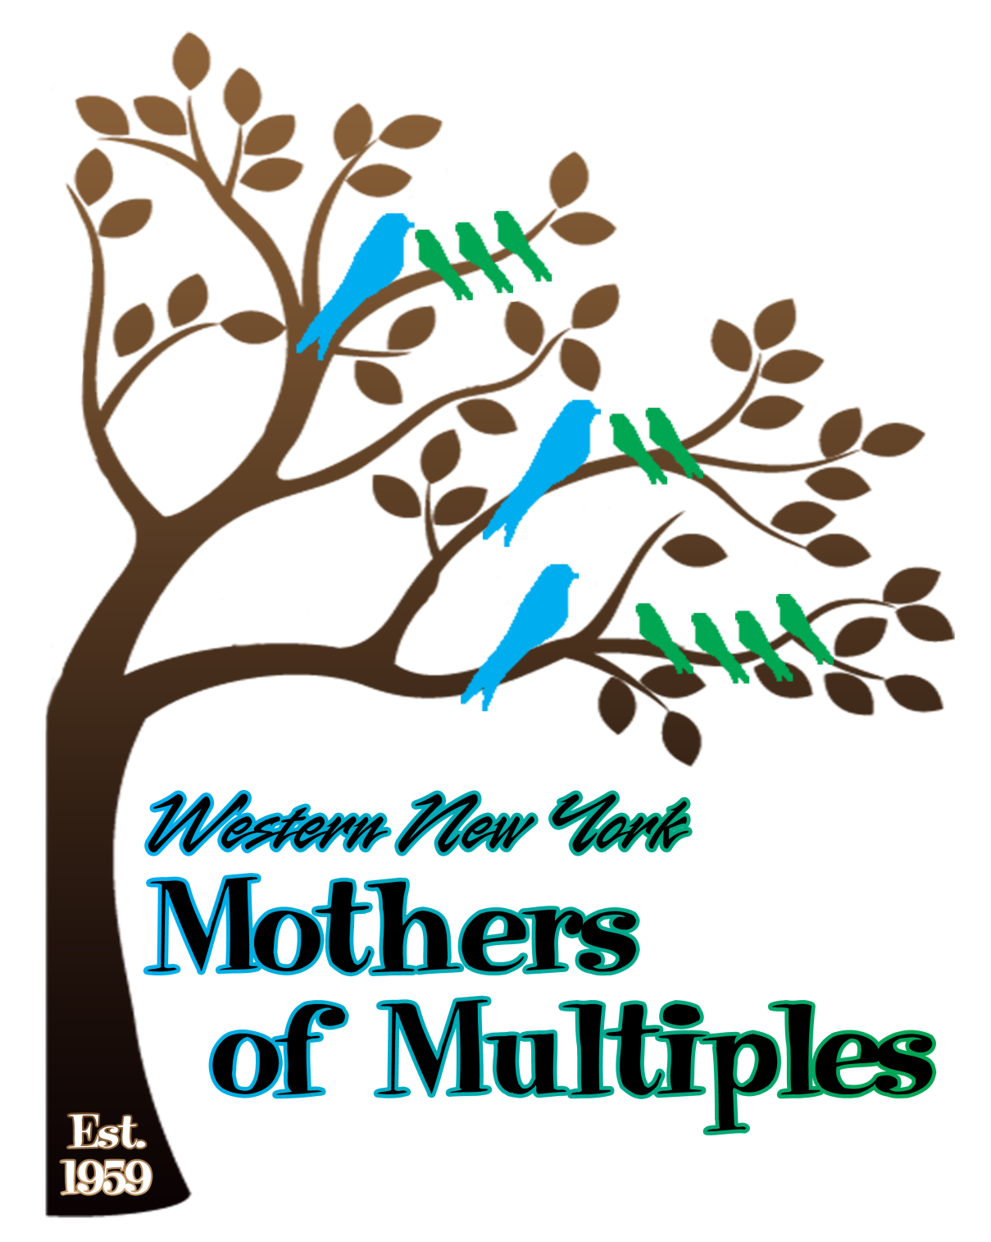
Name: _______________________________________________________________________________
Last First Middle Initial

Occupation:___________________________________________________________________________

Relationship: Married Single Other:_____________________

Partner’s Name:________________________________________________________________________
First Middle Initial Last

Telephone #:____________________ Email:_______________________________________________

Address (street, city, zip):________________________________________________________________

Your Birthday:_____/______/_________ Facebook Name:________________________________

How did you hear about us?: Facebook_________________Member___________________Marvelous Multiples_____________Other____________________________________________________________

Due Date/Delivery Date:____/____/______ Twins_____ Triplets ____ Fertility Drugs: Y N

Multiples’ Names & Birthweights: _________________________________________________________

______________________________________________________ Gestational Age at Delivery:_______

Identical ____ Fraternal ____ Sexes: _______ Age of mother at birth of multiples:________

Hospital:___________________________________ Doctor:____________________________________

History of multiples (yourself, children’s father, either family):___________________________________

_____________________________________________________________________________________

Other Children (please include name, birthdate, and sex):______________________________________

_____________________________________________________________________________________

