**FOR IMMEDIATE RELEASE**

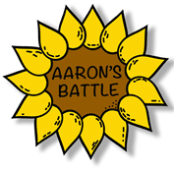

**Young Newlyweds Campaign to Beat Rare Cancer Odds**

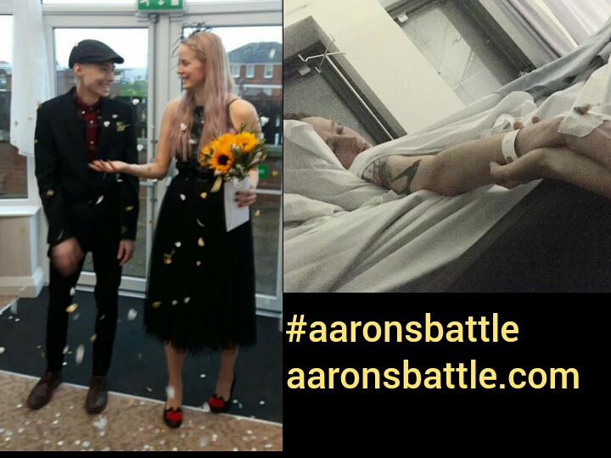

* **Living with terminal cancer aged 28 after repeated misdisagnosis.**
* **Rare childhood cancer called Alveolar Rhabdomyosarcoma.**
* **Need to raise £300,000 for life saving immunotherapy treatment.**
* **Paving the way for others with rare cancer to get access to specialised treatment.**

27th February 2018, North Lincolnshire: Aaron’s battle began in August 2016 when, at just 28 years old, he was diagnosed with a rare cancer called Alveolar Rhabdomyosarcoma; a soft tissue and bone cancer.

After being repeatedly misdiagnosed, by the time the cancer was detected, behind his left cheek, it had spread throughout his body and the prognosis was terminal. He has already been through 15 months of gruelling treatment but the cancer is aggressive and has a very high return rate. We believe his only chance at long-term survival is a treatment called immunotherapy that is not yet available on the NHS. Unfortunately, this treatment is very costly and needs to be obtained privately; £300,000 being the minimum amount needed.

This type of treatment is becoming commonplace in other countries and has proven to be very promising for Aaron’s type of cancer, but the rarity of Rhabdomyosarcoma means that it likely won’t be available on the NHS for some years. As this sarcoma is most common in children, we hope Aaron can find success with this specialised treatment, paving the way for others to obtain it in the UK in the future.

Although the doctors have told Aaron his cancer is terminal, we will never give up hope and strongly believe if he can get this treatment it will give him many more years with the people he loves.

Everything Aaron has gone through he’s always done with a positive attitude and a smile on his face. Aaron and his young wife Saraya are always reminding each other to appreciate the little things and make the most every single day, no matter what it throws at them.

Aaron has said, “The support I have received has been absolutely overwhelming; my friends, family and people I have never met have made me feel like I have an army in my corner. Reminders of that are what get me through the darkest days; knowing that people believe in me keeps me strong. I found it hard to ask for help at first but your ego soon disappears when its life or death and you realise how many people care and want to help you. I just want more time with my incredible wife Saraya. She is fighting so hard for my life. She inspires me each and every day.”

Saraya explains, “We have spoken to several other people that ran out of treatment options on the NHS, they were told there was nothing else they could do, to prepare to lose their loved one. They then obtained specialised immunotherapy treatment abroad and are now cancer free, with a bright future ahead of them. We are determined to make sure Aaron is one of those people. The treatment and service he has received on the NHS since his diagnosis has been amazing, and we are extremely grateful for this, but it will not give him the chance of a future. We need to raise this money in order to give him that chance. I will never give up on him.”

Raising awareness and education of rare cancers is very important. It can mean the difference between life and death. Early diagnosis is vital, making it easier to treat and more likely to be cureable. The rarity of Rhabdomyosarcoma along with other Sarcomas means that most doctors are not familiar with it, making early diagnosis very difficult. It is claimed that a sarcoma patient is wrongly diagnosed for an average of 14 months before finding out they have cancer. How can we expect doctors to diagnose a cancer that so little is known about? This needs to change and along with other people we are trying to make that happen. Nobody should be diagnosed with cancer that is already stage 4 and metastatic when they have been visiting the doctors with symptoms for months. Change needs to happen.

**Find out more by visiting our website** [**www.aaronsbattle.com**](http://www.aaronsbattle.com) **and follow us on social media for important updates and events you might be interested in, want to attend or support.**

**Donations are welcome at:** [**www.gofundme.com/aaronsbattle**](http://www.gofundme.com/aaronsbattle)

**Facebook:** [**www.facebook.com/aaronsbattle**](http://www.facebook.com/aaronsbattle)

**Twitter:** [**www.twitter.com/aaronsbattle**](http://www.twitter.com/aaronsbattle)

**Contact:** Saraya Gallagher at [aaronsbattle@hotmail.com](mailto:aaronsbattle@hotmail.com) and 07709810959

**ENDS**

**Notes to Editors:**

Aaron Winstanley is aged 29 and is from Barton upon Humber, North Lincolnshire.

Aaron’s diagnosis came in August 2016, at age 28, which was six months after he originally raised concerns with his GP.

Aaron has ‘Alveolar Rhabdomyosarcom’; a soft tissue and bone cancer that is most commonly found in children and young adults.

Immunotherapy treatment at the Hallwang clinic, Germany is Aaron’s best hope for survival.

Treatment is upwards of £300,000 but his wife (Saraya Gallagher age 25), friends and community are determined to raise the money needed; they have already raised nearly £40,000 from a variety of fundraising events and donations.

Both Aaron and Saraya along with family and friends want to help raise awareness of rare cancers and the importance of early diagnosis.