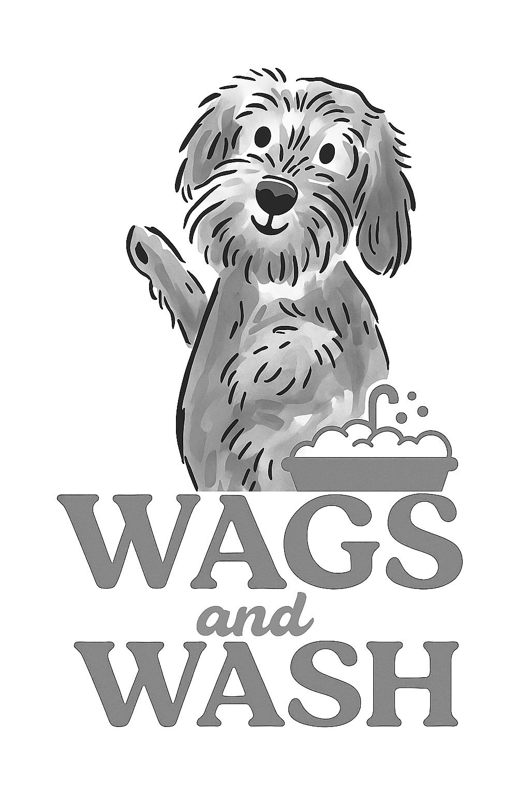
Wags and Wash Ltd
Dog Grooming Terms and Conditions

These Terms & Conditions are designed to ensure the safety, wellbeing, and satisfaction of all clients and their pets, as well as to protect the business and staff of Wags and Wash Ltd.
By booking an appointment, you confirm that your pet is fit, healthy and fully vaccinated (unless otherwise discussed and noted), the details provided about your dog(s) are correct, and you agree to the following:

- Please inform us if your dog is aggressive with people or animals. We may need to muzzle if we deem necessary. We will reserve the right to cease grooming at any point if a dog becomes uncontrollable and you will be contacted for collection/delivery of your dog immediately. In the event of this happening, the full cost of the groom will still apply.

- IN LINE WITH THE ANIMAL WELFARE ACT, IF THERE IS ANY MATTING THAT CANNOT BE BRUSHED OUT WITHIN 15 MINUTES, WE WILL CONTACT YOU TO ADVISE THAT THE COAT WILL BE CLIPPED SHORT, AND THERE WILL BE AN ADDITIONAL CHARGE FOR THIS SERVICE.

- Wags and Wash will not be held liable nor responsible for any after-effects of grooming, de-matting, clipping and/or brushing procedures or nail/claw clipping, neither are we liable for any problems uncovered as a result of a matted or otherwise neglected coat, including, but not limited to, irritation, redness to skin, or self-inflicted abrasions from excessive scratching, rubbing, or from any other pre-existing medical condition. It is understood that with all grooming procedures, there is an element of risk involved, and a risk assessment has been carried out to reduce any risk as far as possible.

- Grooming procedures can expose hidden medical conditions or aggravate problems. Wags and Wash will immediately inform you should it be deemed necessary and advise that veterinary care be sought. It is understood that in the event of an emergency, veterinary treatment will be provided should your dog’s health cause any concerns.

- Occasionally, grooming can cause dogs to become stressed. If we feel that your dog is showing signs of stress, we will stop any grooming immediately and contact you for collection/delivery.

- If we uncover fleas, worms or any other parasites on your dog, you will be contacted immediately to either be advised on what we can offer or to arrange collection/delivery of your dog immediately. Fees will incur if treatment is needed.

- If you need to cancel or rearrange your appointment, you must contact us either via email or by phone at least 48 hours before your appointment. If you do not show, you will be charged a £20 (no-show) fee when booking your next appointment.

- If you are more than 15 minutes late on arrival, we may no longer be able to accommodate your dog’s groom, and the no-show fee will apply.

- You will be contacted 15 minutes before your dog is ready to be collected/delivered. Please be prompt for collection/delivery, as dogs can become anxious whilst waiting for their owner. If you are more than 15 minutes late for collection/delivery of your dog, you will be charged £5 for every additional 15 minutes your dog is with us.

- We will advise you if any issues arise during your dog’s groom and will ask you to check your dog’s groom over before collection/delivery of the dog has completed. If you are dissatisfied with your dog’s groom, please advise us within 24 hours and we will endeavour to rectify any concerns.

- It is understood that any expenses of veterinary treatment obtained resulting from grooming, any after-effects of grooming or de-matting, will be covered by the owner.

- You consent to the publication of photos and videos of your dog(s) on the business’ website and social media platforms. If you do not wish for your dog’s image to be used or posted, please contact us accordingly.

