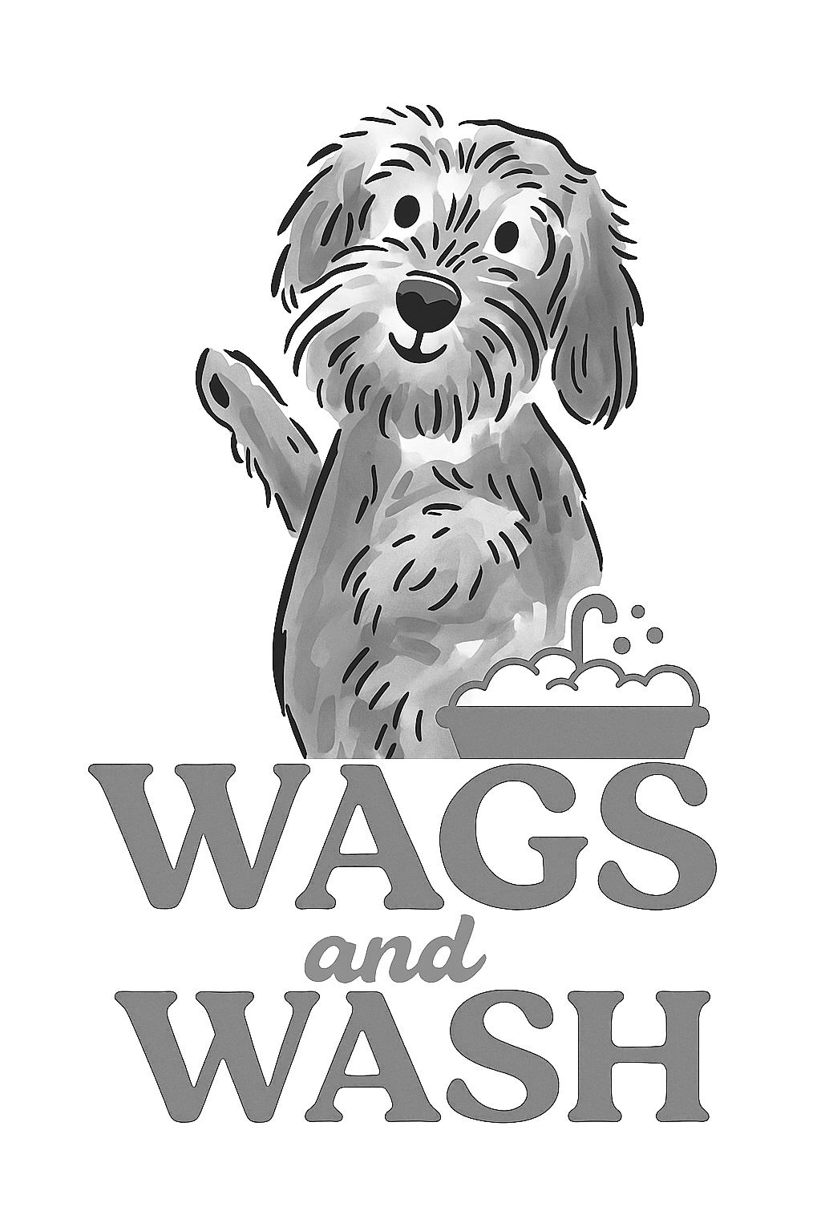
Wags and Wash Ltd
Teeth Cleaning Policy

Emmi-pet teeth cleaning is undertaken using an ultrasonic brush that omits no sound or vibrations. It is used to remove tartar build up already present in your dog’s mouth or as a preventative to stop a build up from occurring.
We will check all of your dog’s teeth in each session to confirm they are suitable for the cleaning process. Wobbly or damaged teeth cannot be cleaned. They will be at risk of falling out or being damaged further from the pressure. If they are found, our staff will recommend a visit to the vets for tooth removal. They can become very uncomfortable for a dog, and removal is the safest option for them. Your dog’s behaviour will also be assessed to ensure they are suitably comfortable with the process.
It is important to understand that to begin with, monthly sessions will be needed to remove the plaque from your dog’s teeth. If left longer, then the treatment could prove ineffective. Once the majority of plaque has been removed, then a longer time can be given between cleans, to instead become a preventative to further plaque build-up.
Just as humans should have their teeth brushed regularly, so should dogs. In the UK, 80% of dogs over the age of 3 experience gum disease and/or periodontal issues. Brushing is the best defence against this.
By booking an appointment, you agree for us to clean your dog’s teeth, with the understanding that this could take up to several sessions depending on the condition of the teeth. You are also confirming that you are happy for us not to undertake the clean if we find wobbly or damaged teeth, or if your dog’s behaviour is unsuitable for the process.

