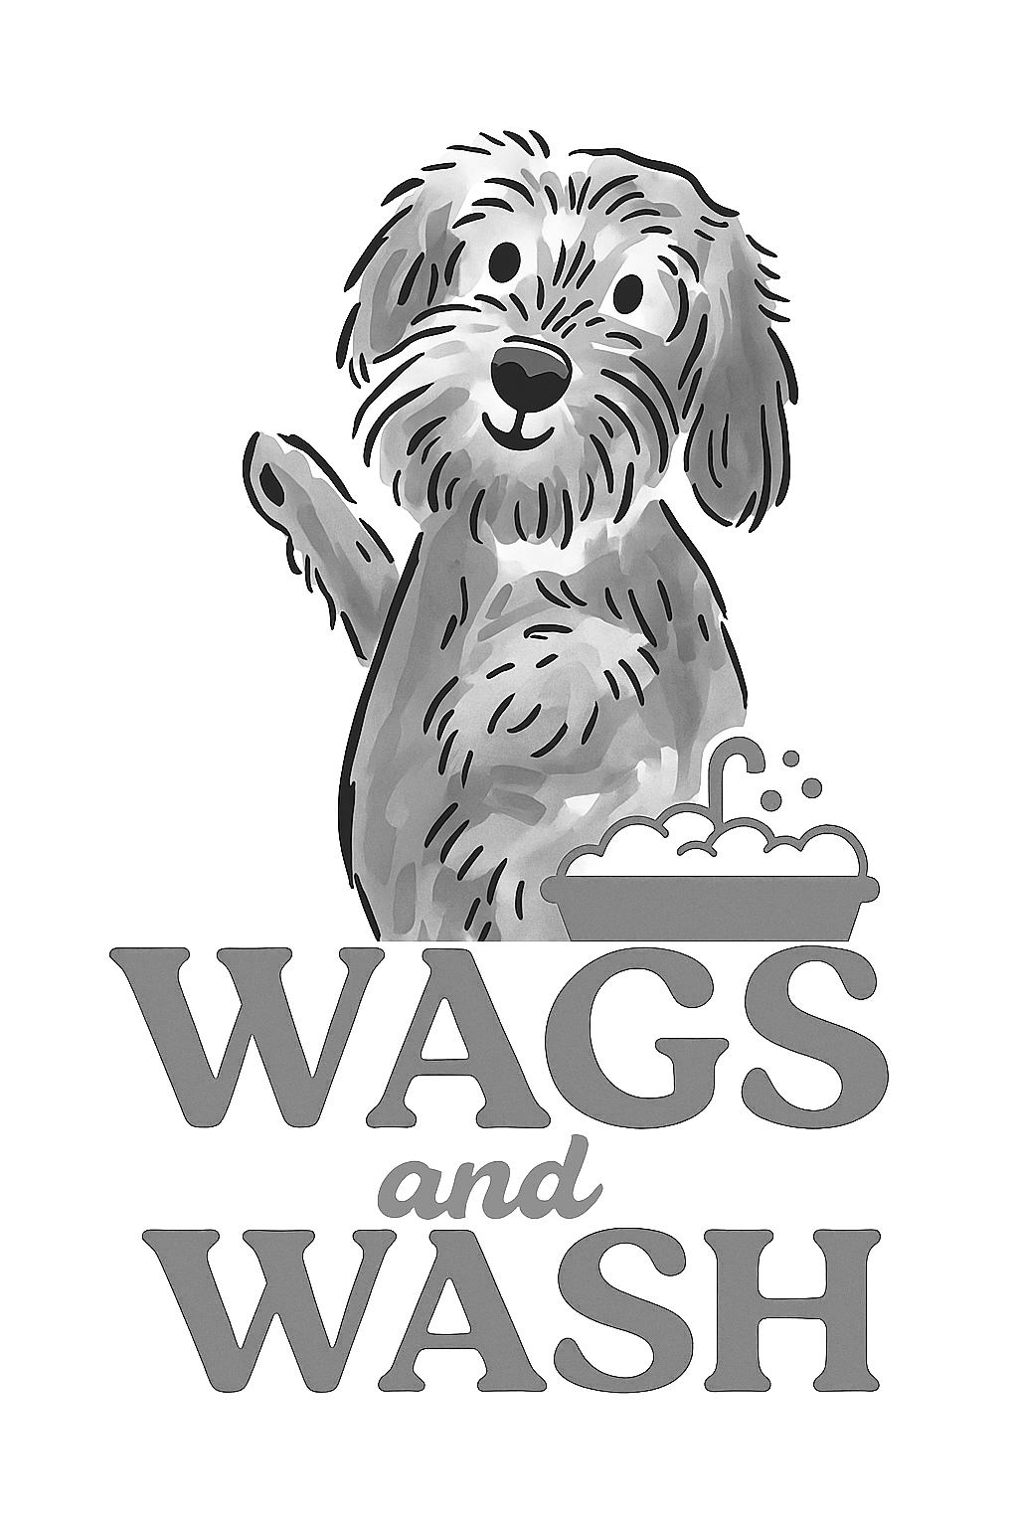
Wags and Wash Ltd
Privacy Policy

At Wags and Wash Ltd (referred to as 'we', 'us' or 'our'), we are committed to protecting the privacy and security of your personal information. This privacy policy outlines how we collect, use, disclose, and protect your personal data in compliance with the General Data Protection Regulation (GDPR), the Data Protection Act (2018), and any other applicable data protection laws in the European Union (EU) and the United Kingdom (UK). By accessing our website and using our services, you consent to the practices described in this policy:

1. Information we collect: We may collect various types of personal data from you, including but not limited to:
- Contact information (such as name, email address, phone number and postal address)
- Demographic information
- Payment details for purchases
- Information you provide in forms, surveys, or during customer support interactions
- Website usage information (through cookies and similar technologies)
- Any other information you choose to provide to us voluntarily

2. Legal basis for processing personal data: we will only process your personal data when we have a valid legal basis to do so, such as:
- When the processing is necessary for the performance of a contract or to take steps at your request before entering into a contract
- When the processing is necessary to comply with our legal obligations
- When the processing is based on your consent, which you can withdraw at any time
- When the processing is necessary for our legitimate interests or the legitimate interests of a third party, provided your rights and freedoms do not override those interests

3. How we use your information: we use the collected information for the following purposes:
- To process and fulfil your orders, purchases and requests
- To provide customer support and respond to your enquiries
- To send you relevant information, updates, newsletters, or marketing communications (where permitted by applicable laws and with your consent, if required)
- To personalise your experience and improve our website and services
- To analyse and track website usage, trends and user preferences
- To comply with legal obligations, resolve disputes, and enforce our policies

4. Information sharing and disclosure: we may share your personal data with third parties in the following circumstances:
- With service providers, business partners, or contractors who assist us in providing our services and operating our business (e.g. payment processors, and shipping companies)
- With authorised personnel within our business who need access to your personal data
- With law enforcement agencies, regulatory bodies, or other parties when required by law or to protect our legal rights
- With your consent or as otherwise disclosed at the time of data collection or sharing
5. Data retention: we will retain your personal data for as long as necessary to fulfil the purposes outlined in this privacy policy, unless a longer retention period is required or permitted by law. We will securely delete or anonymise your personal data when it is no longer needed.
6. Your data protection rights: you have certain rights regarding your personal data under GDPR. These rights include the right to access, rectify, restrict processing, delete, and object to the processing of your personal data. To exercise these rights, please contact us using the information provided at the end of this privacy policy.

7. Data security: we implement appropriate technical and organisational measures to ensure the security of your personal data and protect it against unauthorised access, loss, or alteration. However, please note that no method of transmission over the internet or electronic storage is completely secure, and we cannot guarantee absolute security.

8. Third-party websites and services: our website may contain links to third-party websites or services that are not controlled or operated by us. This privacy policy does not apply to those third-party websites or services.

