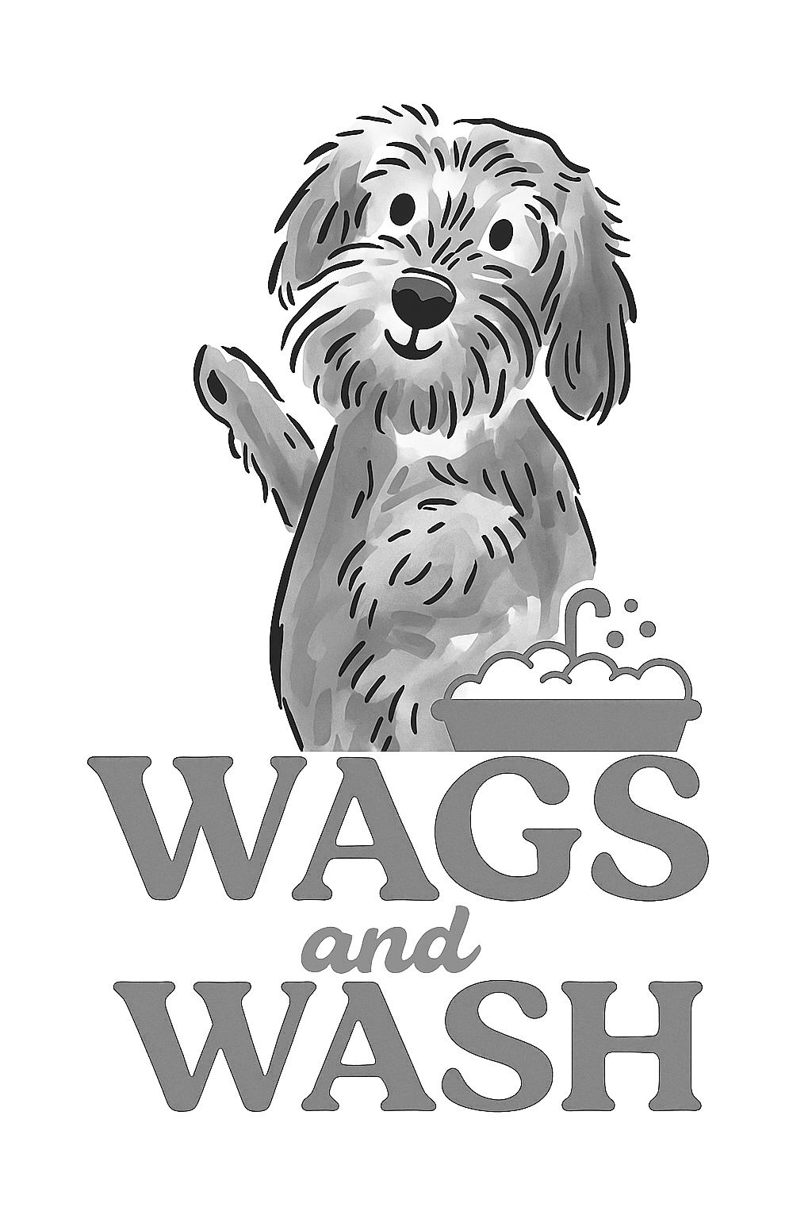
Wags and Wash Ltd
Dog Walking Terms and Conditions

These Terms & Conditions are designed to ensure the safety, wellbeing, and satisfaction of all clients and their pets, as well as to protect the business and staff of Wags and Wash Ltd.
By booking an appointment, you confirm that your pet is fit, healthy and fully vaccinated (unless otherwise discussed and noted), the details provided about your dog(s) are correct, and you agree to the following:
- Please inform us if your dog is aggressive with people or animals. We may need to muzzle if we deem necessary. We will reserve the right to cease walking at any point if a dog becomes uncontrollable and you will be contacted for collection/delivery of your dog immediately. In the event of this happening, the full cost of the service will still apply.

- It is understood that with all walking services, there is an element of risk involved, and a risk assessment has been carried out to reduce any risk as far as possible.

- Walking services can expose hidden medical conditions or aggravate problems. Wags and Wash will immediately inform you should it be deemed necessary and advise that veterinary care be sought. It is understood that in the event of an emergency, veterinary treatment will be provided should your dog’s health cause any concerns.

- If you need to cancel or rearrange your appointment, you must contact us either via email or by phone at least 24 hours before your appointment. If you do not show or fail to provide us with enough notice in the event of cancellation, you will be charged a £20 (no-show) fee when booking your next appointment.

- If you are more than 15 minutes late on arrival, we may no longer be able to accommodate your dog’s walk, and the no-show fee will apply.

- If you are more than 15 minutes late for collection/delivery of your dog, you will be charged £5 for every additional 15 minutes your dog is with us.

- It is understood that any expenses of veterinary treatment obtained resulting from walking, any after-effects of walking, will be covered by the owner.

- You consent to the publication of photos and videos of your dog(s) on the business’ website and social media platforms. If you do not wish for your dog’s image to be used or posted, please contact us accordingly.

