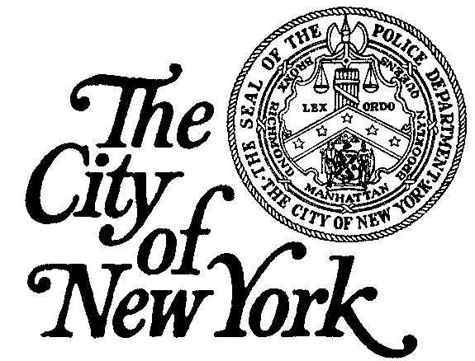
POLICE DEPARTMENT
Legal Bureau
One Police Plaza, Room 1406
New York, NY 10038

(646) 610-5400
POLICE DEPARTMENT
CHIEF OF TRAINING
One Police Plaza – Room 503
New York, NY 10038

(646) 610-5400

NEW YORK CITY POLICE DEPARTMENT AFFILIATED SPORTS TEAM INDIVIDUAL WAIVER

(Please Print) I, _________________________________________________________________ am over eighteen (18) years of age and reside at (Print Your Address) _________________________________________________.

In consideration for access to, and the use of, certain New York City Police Department (“NYPD”) facilities, including the NYPD’s Police Academy pool and/or training facilities as a member of an NYPD-affiliated sports team, which may include instruction, recreational events, sporting events and physical activities such as, but not limited to, swimming, running, calisthenics, and other inherently dangerous activities, I hereby release and forever discharge, and shall hold harmless and indemnify the City of New York, the New York City Police Department, and its agents, servants and employees (collectivity hereinafter referred to as the “CITY”) from all actions, causes of action, suits, debts, sums of money, accounts, damages, judgments, claims and demands whatsoever which I or my heirs, executors, administrators, successors and assigns may have now or in the future against the CITY arising out of my participation as a member of an NYPD-affiliated sports team including, but not limited to, the aforementioned activities and any acts related thereto.

I recognize and understand my participation as a member of an NYPD-affiliated sports team is not without varying degrees of risk, which may include, but are not limited to the following: injury to the musculoskeletal and/or cardio respiratory systems, which can result in serious injury or death, injury or death due to negligence on the part of myself, any training partner, or other people around me, injury or death due to improper use or failure of equipment, or injury or death due to a medical condition, whether known or unknown by me.

I willingly assume full responsibility for any and all risks that I am exposing myself to as a result of my participation as a member of an NYPD-affiliated sports team and accept full responsibility for any injury or death that may result from my participation.

I further represent and hereby certify that I am physically sound and know of no medical condition, impairment, disease, infirmity or other problems of any type that would increase my risk of illness and injury as a result of participation in any activities related to or arising from my participation in any events related to my membership in an NYPD-affiliated sports team. I understand there exists the possibility of adverse physiological changes during an exercise program, including abnormal blood pressure, fainting, disorder of heart rhythm, stroke, and in very rare instances, heart attack or even death. I understand that certain prescribed medications may exacerbate these physiological changes and create an even greater risk of physical damage or death.

I acknowledge that my participation as a member of an NYPD-affiliated sports team will be conducted off-duty and that any claims for injuries sustained related to, or arising out of, my participation as a member of an NYPD-affiliated sports team shall be submitted through my own personal insurance carrier.

With my full understanding of the above information, I agree to assume any and all risks associated with my participation as a member of an NYPD-affiliated sports team AND I AM PARTICIPATING WILLINGLY, KNOWINGLY AND VOLUNTARILY.

This release may not be changed orally.

Please Sign in Ink: ______________________________

Print name: ____________________________________

Title: __________________________________________

Date: __________________________________________

