Please print and retain this section for Information

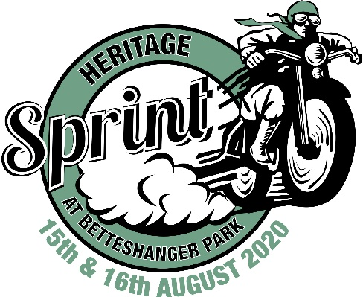

Heritage Sprint at Betteshanger Park
August 15th/16th 2020

MACHINE AND RIDER REGULATIONS

- CLASSES. There are three classes that cover all machines entering
a) CLASSIC (this approximates to an amalgam of ACU Vintage and Classic classes)–The class is divided into machines manufactured
- before 31st December 1945 (Class 1)
- between 1st January 1946 and 31st December 1960. (Class 2)
- between 1st January 1960 and 31st December 1986. (Class 3)
Capacities as follows
- Non-Japanese up to 500cc (Class A)
- Non-Japanese over 500cc (Class B)
- Japanese up to 500cc (Class C)
- Japanese over 500cc (Class D)
b) ROAD LEGAL – The class is divided into machines manufactured
- Before 31st December 1960. (Class 4)
- Between 1st January 1960 and 31st December 1986. (Class 5)
Capacities as follows
- Up to 550cc (Class E)
- Over 550cc (Class F)
c) JUNIOR SPRINT (Riders between 15 and 21 years)
- Any age road legal motorcycle up to 350cc or race machine up to 250cc (Class J)
- MACHINES
CLASSIC CLASS
2.1 The aim is to present machines as they would have looked in sprints or as production road and road racing machines held during the period that they represent.
2.2 Basic machine, engine type, frame, forks and wheels to be contemporary with the stated age of the machine.
2.3 Reasonable cycle part modifications are permitted e.g. smaller fuel & oil tanks, alloy rims & engine plates etc. Removal of certain components is permitted, e.g. mudguards, lights etc.
2.4 Working suspension must be fitted if part of the machine’s original specification. No blatantly unusual wheel sizes or types.
2.5 Internal engine modifications are permitted. External power boosting modifications must be contemporary with the machine’s stated age.
2.6 Turbochargers are not allowed unless part of the manufacturer’s specification for that particular model.
2.7 For all classes only petrol or Methanol may be used. Nitromethane is not allowed
- The addition of alcohol or octane boosters is permitted.
- Chemical based fuels such as C14 are not permitted.
- Nitrous Oxide is not permitted.
2.8 Treaded tyres must have a moulded tread depth of 2mm and show no signs of sidewall cracking. Slicks are permitted
2.9 Wheelie bars, forced induction and air or electrically operated gear-changers are not permitted
2.10 Standard chain guards, or guards manufactured from 3mm dural (or equivalent strength alternative) must be fitted to prevent the chain coming into contact with the rider as a result of a chain breakage
2.11 Machines must be fitted with easily accessible fuel control taps on all supply lines from the fuel tank
2.12 All machines must carry a Heritage Sprint round sticker (supplied) on front racing number plate or headlamp

ROAD LEGAL CLASS
2.13 Working lights must be fitted and lenses taped.
2.14 Horn must be fitted and working.
2.15 Wheelie bars or traction compound are not permitted.
2.16 Only streamlining of a type used in road racing is allowed.
2.17 Tyres must have a moulded tread depth of 2mm. Racing tyres and cut slicks are not allowed.
2.18 Fuel - Petrol only, (see para.2.7 above).
2.19 Working suspension must be fitted if part of the machine’s original specification.
2.20 Speedometers must work.
2.21 Machines must be fitted with what is generally accepted as a visible and effective silencer and be under 108db noise limit
2.22 Forced induction is not permitted unless part of the manufacturer’s specification for that particular
model.

JUNIOR SPRINT CLASS
  - Any machine entered must meet the specifications for their respective Classic or Road Legal classes as listed above

- RIDERS
3.1 Protective Clothing. Competitors must wear a complete leather suit of at least 1.2mm in thickness (on all parts of the suit), two-piece suits that zip together at the waist are acceptable. Each part of the zip should be securely attached to the jacket or the trousers respectively and the suit must zip together over at least 75% of the waist band.
3.2 Non-leather material may be used if it meets with the requirements laid down by ACU Racing Standing Regulations
3.3 Competitors footwear must be of leather (i.e. outer hide) or an approved substitute material and of a minimum height of 200mm to provide, with the suit, complete protection i.e. no exposed areas.
3.4. Competitors must wear leather (or an approved substitute material) protective gloves to provide, with the suit, complete protection. No areas of skin to be left exposed between the wrist of the suit and the wrist of the glove.
3.5 Helmets bearing the current ACU gold stamp and in sound condition and properly fitted must be worn by all riders and passengers when on track
3.6 All competitors to wear supplied, individually numbered bib

- OTHER
4.1 All competitors to bring fire extinguishers
4.2 Environmental mats – must be placed under all bikes when not in use
4.3 All waste to be correctly disposed of – off site. Ensure any spillages are cleaned – if this is not 100% possible please report to the organisers for assistance
.

PROVISIONAL TIMETABLE
(please note any timetable updates will be emailed to the contact address supplied)
Saturday
Technical Control – 08.00- 10.00
Track use - 10.00 – 17.30
Lunch break 12.30 – 13.15

Sunday
Technical Control – 09.30 -10.30
Track use - 10.30 – 16.30
Lunch break 12.30 – 13.15

FINAL INSTRUCTIONS

All riders must attend a briefing by the organisers to be held outside the signing-on office prior to 09.30am. Full details will be notified on the day.

It is the responsibility of all participants to ensure that the vehicle to be used is in a suitable condition to be driven at high speeds on the circuit for the duration of the activity.

Access to the track will be under the direction of the assembly area official, whose instructions should be followed at all times. Information regarding Health and Safety Regulations are displayed in the signing-on office from where copies are available. All participants must familiarise themselves with these.

