Please print and retain this section for Information

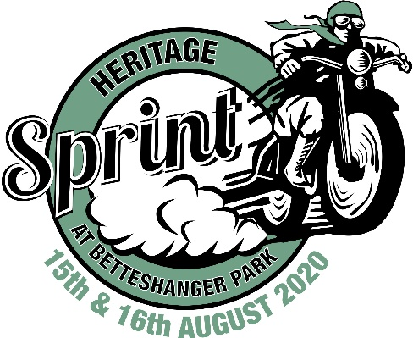

Heritage Sprint at Betteshanger Park
August 15th/16th 2020

SUPPLEMENTARY REGULATIONS

- STATUS: Heritage Sprint Ltd will organise a Private Hire Day at Betteshanger Country Park on August 15/16th 2020
- ENTRIES ADMINISTRATION to whom all correspondence regarding entries should be addressed.: Track Administrator. track@heritagesprint.co.uk
- TRACK PARTICULARS: The Sprint will be run over a length of 1/8th Mile,
- JURISDICTION: The meeting will be licensed by NoraSport Supermoto Ltd and held under these Supplementary Regulations and any further instructions issued or announcements made.
- OFFICIALS: Clerk of the Course: David Dearden, NoraSport Supermoto Ltd
- ELIGIBILITY: Classic and Road legal classes: Open to riders and passengers of 18 years or above who hold a current Competition or Parade Licence for Road Races issued by the ACU or the SACU or a current valid full motorcycle licence from the DVLA. Any entry forms received which do not quote a current Licence Number will not be accepted. Junior Sprint Class (riders aged 15-21) will be given one-day licence to allow entry but this must be applied for and signed by a parent or authorised guardian attending the event
- NUMBER OF PARTICIPANTS ON THE TRACK: Will be either one or two depending on class
- ENTRIES AND ENTRY FEES: All entries must be made on an official entry form and must be received by the Entries Secretary with the appropriate entry fee of £50 for the weekend. The closing date for pre-booked entries is July 27th “2020, There will be no entries on the day. BACS payments Heritage Sprint Ltd. Bank Details – Account: 34767894 Sort Code: 52-30-23. If you need to pay by cheque please email for a postal address where you can send it.
- WITHDRAWAL OF ENTRY: Withdrawal of entry prior to the meeting will be at the discretion of Heritage Sprint Ltd.
- INSURANCE: The organisers undertake to insure each rider and passenger, indemnifying him or her against any third party claims made arising out of the Private Hire day, excluding claims by any other riders or passengers, entrant, sponsor or mechanic.
- REFUSAL OF ENTRY AND ALTERATION OF EVENTS: Heritage Sprint Ltd reserves the right to refuse any entry, and to alter, abandon, combine, cancel or postpone all or part of the meeting,
- TECHNICAL CONTROL: Will be available from 7.30am. Riders are required to produce their machine together with their Technical Control card to the Technical Official. All riders and passengers must wear their protective clothing, helmet, boots, gloves, when being checked by the Technical Official. The Chief Technical Official may refuse to examine any machine that is in a dirty condition. Heritage Sprint sticker must be visible on the front of the machine.
- SIGNING ON: The Signing-on Office will be open at approximately 8.00am Saturday/ 9.00 am Sunday. All riders and passengers must sign on and produce their Licence and Confirmation of Entry, Any rider or passenger who is unable to produce their Licence may only take part in the meeting at the discretion the organisers. Junior Sprint riders may be exempt from this if they do not hold a provisional or full licence but must have a signatory parent or authorised guardian present to sign approval to enter.
- SITE ADMISSION: Admittance to the paddock will be allowed in the evening prior to the event. Arrivals permitted between 3pm to 9pm on Friday and from 7am on Saturday
- START OF SESSION: All sessions will be a clutch start. Burn outs must only take place on the concrete slabs provided. Timing lights will indicate the start of each run.
- LUNCH: 45 minutes to be taken at approximately 12.30.
- TYRES: Treaded tyres only must be used on road legal classes..
- ALCOHOL/DRUG USE: The consumption of alcohol or intake of non-prescribed medication during the meeting by riders, passengers or officials is forbidden.
- NOISE LIMITS: The maximum permitted noise levels will be 108 dBa for all machines. All machines shall be noise tested prior to going on circuit. Any machine that registers over 108 dBa will be excluded from the day. No refund will be made.
- ADMISSION TO CIRCUIT: Dogs are permitted but to safeguard both competitors and members of the public they must be on a lead at all times. The organisers have the right to remove anyone breaching this ruling.
- HELMETS: You must wear your helmet when riding your machine in the paddock, on your return to the paddock following a retirement. Your leathers must also be fastened. Any rider failing to comply may be liable to exclusion from the test day
- RUNNING OF ENGINES: Engines must not be run prior to the scheduled start time. Please note lunchtime is a quiet period and engines should not be run.
- CHILDREN: Riders and organisers must ensure correct supervision of their children at all times. The person associated with any child found to be responsible for any damage caused (or verbal abuse) to property or person will be accountable for any costs and will be excluded from the test day
- MARKING OF THE TRACK OR PADDOCK SURFACE: is not permitted.
- PASSENGERS MAY NOT BE CARRIED ON SOLO MOTORCYCLEs WHEN IN THE PADDOCK AREA OR ON TRACK
- PHOTOGRAPHY: It is a condition of entry that your consent is given for officially sanctioned photography of the day to take place and that publication of photographs is agreed to.

PROVISIONAL TIMETABLE
(please note any timetable updates will be emailed to the contact address supplied)

Friday
Sign on and Technical Control – 18.00- 20.00

Saturday
Sign on and Technical Control – 08.00- 10.00
Track use - 10.00 – 17.30
Lunch break 12.30 – 13.15

Sunday
Technical Control – 09.30 -10.30
Track use - 10.30 – 16.30
Lunch break 12.30 – 13.15

Sprints will be organised by class and will be repeated throughout the day according to demand. Sessions may be amended at the discretion of the organisers.

FINAL INSTRUCTIONS

All riders must attend a briefing by the organisers to be held outside the signing-on office prior to 09.30am. Full details will be notified on the day.

It is the responsibility of all participants to ensure that the vehicle to be used is in a suitable condition to be driven at high speeds on the circuit for the duration of the activity.

Access to the track will be under the direction of the assembly area official, whose instructions should be followed at all times. Information regarding Health and Safety Regulations are displayed in the signing-on office from where copies are available. All participants must familiarise themselves with these.

