GSMFGSMF



Black Iron Pot Cook Off Entry Form

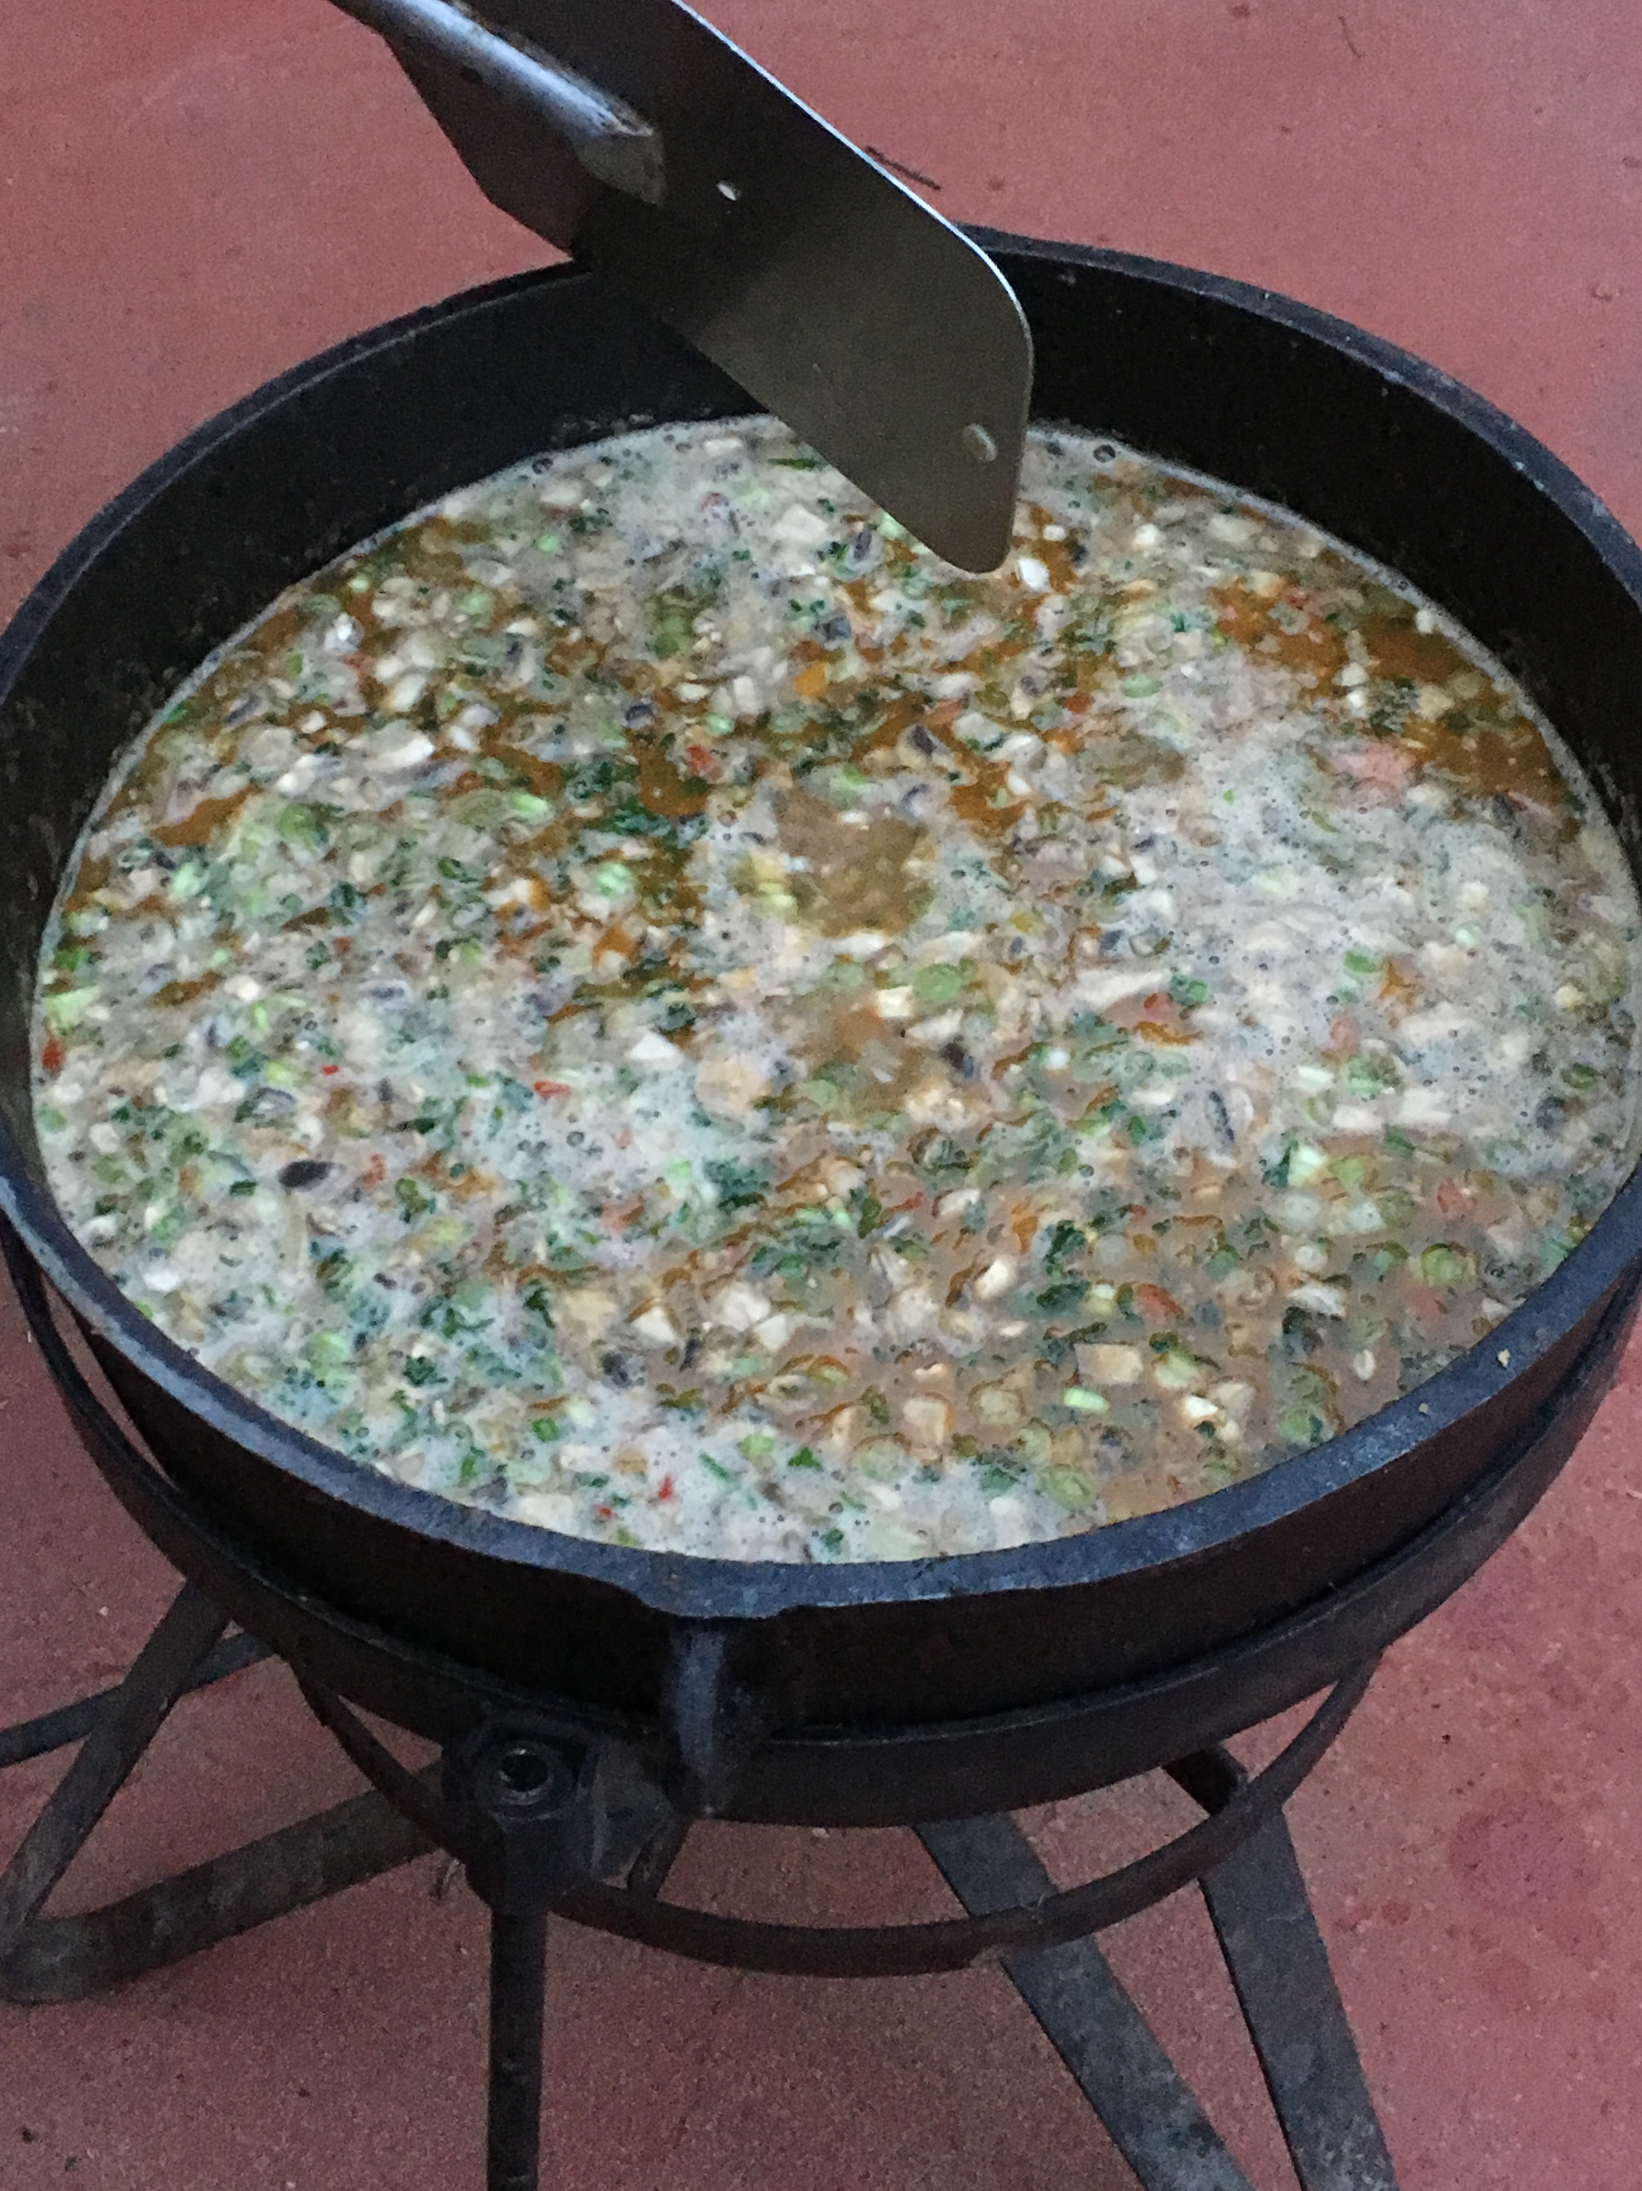

GSMF

Black Iron Pot

Cook Off

TEAM INFORMATION

Team Name: _____________________________________________________

Business/Organization (if applicable): __________________________________

Dish You Plan To Prepare: __________________________________________

TEAM CAPTAIN INFORMATION

Name: __________________________________________________________

Phone: ______________________ Email: ______________________________

Address: _________________________________________________________

City: _______________________ State ____________ Zip Code ____________

_______________________________________    _______________________

Team Captain Signature Date

By submitting this application, you acknowledge that you have read and agree to abide by the rules and regulations. You understand that you must cook your entry in a black iron pot on the premises the day of the event. You also understand that you are responsible for clean up of your area, including proper disposal of any grease/oil.

Entry fee may be paid on the GSMF website www.GarrettSoileauMemorialFoundation.com OR by check made payable to: Garrett Soileau Memorial Foundation and mailed with entry form to:

GSMF, ATTN: Cookoff, 70 E Stockbridge Landing Circle, The Woodlands, Tx 77382.

Rules and Regulations

Entry fee is $100.00 per team and proceeds benefit the Garrett Soileau Memorial Foundation.

Teams may cook any type of food they wish as long as the main dish is cooked in cookware made cast iron. All cooking of main dish must be done from start to finish utilizing cast iron cookware. Any prep-work such as cutting vegetables and meat may be done prior to arrival. No cooking of the main dish may be performed before arrival. Rice, pasta, etc. to be served with the main dish may be cooked prior to the event due to large quantities.

Each team or its sponsor are responsible for supplying their own ingredients, tent, tables, chairs, propane fuel, or any item or material the cook desires. All sample containers, serving containers, forks, and napkins will be provided by GSMF. Each team needs to be able to serve between 50-100 servings.

Each team is responsible for the set-up and clean-up of their booth areas. Booth dimensions are 10 feet wide by 10 feet deep. Please plan accordingly so that all teams can be accommodated. Teams may set-up their equipment beginning at 12 noon on Saturday, May 11th. Teams may begin cooking any time after set-up. All entries must be ready for judging at 4:00 pm. At 4 pm, the container to be judged will be picked up by a GSMF committee member and brought to judges. From 4:00 pm - 4:30 pm, samples may be given to patrons in order for them to vote for People’s Choice. After 4:30 pm, any food remaining will now be sold, with proceeds going to GSMF. Voting for People’s Choice will continue until 5:30 pm. Results of cook off to be announced at 6:00 pm.

Each team is responsible for the maintenance and clean up of its cooking area. The team captain will be responsible for the conduct and behavior of team members and guests. Teams will be responsible for providing a protective ground covering under their propane burner. You must properly dispose of grease/oil off premises. Disposal containers for grease/oil will not be provided. Each cooking team will be required to have a fire extinguisher in full view at all times.

Once a team’s entry fee is received, there are NO REFUNDS. Entries will be processed on a first-paid basis. Organizations and business booth areas may utilize advertising within the area of their booth. Advertising outside of the booth area is designated for event sponsor advertising.

Any food remaining after judging will be sold with the proceeds going to the Garrett Soileau Memorial Foundation. Tickets will be sold at our ticket counter, so you will not have to be responsible for collecting money, just prepaid tickets.

Awards will be presented for 1st, 2nd, and 3rd place, as well as People’s Choice.