Developing Exercise Evaluation Guides

Terminology
The Exercise Evaluation Guides (EEGs) are structured to capture information specifically related to the evaluation requirements developed by the Exercise Planning Team. The following evaluation requirements are documented in each EEG:
- Capabilities: The distinct critical elements necessary to achieve a specific mission area (e.g., prevention). To assess both capacity and gaps, each capability includes capability targets.
- Capability target(s): The performance threshold(s) for each capability; they state the exact amount of capability that exercise players aim to achieve. Capability targets are typically written as quantitative or qualitative statements and are composed of three parts: a critical task, an impact, and a timeframe.
- Critical tasks: The distinct elements required to perform a capability; they describe the specific actions needed to achieve the capability target. Critical tasks generally include the activities, resources, and responsibilities required to fulfill capability targets. Capability targets and critical tasks may derive from operational plans, policies, standard operating procedures, or discipline-specific standards.

Development Instructions
Exercise Evaluation Guides (EEGS) provides evaluators with a standardized tool to guide data collection and capture performance results during an exercise. Since each organization, jurisdiction, or entity has unique targets and critical tasks, each organization develops EEGs specific to its plans, procedures, and protocols.
The following step-by-step instructions will aid in the development of an EEG.

Step 1: Background Research
- Review the planning team discussions regarding mission area, capabilities, objectives, and evaluation requirements. These discussions take place at the Concept and Objectives (C&O) Meeting and/or Initial Planning Meeting (IPM).
- Review capability gaps from current threat and hazard assessments. These gaps are identified during the Integrated Preparedness Planning Workshop (IPPW) and documented in the Integrated Preparedness Plan (IPP).
- Research applicable authorities, policies, plans, procedures, and protocols to identify organizational capability targets(s) and associated critical tasks to be exercised and evaluated.
- Research previous and current After-Action Reports (AARs) and Improvement Plans (IPs) to extract capability targets and critical tasks to be exercised and validated based on common themes or trends.

Step 2: Build-Out
- Select Template: Select the appropriate EEG template(s), based on the mission area and capability. The planning team provides the mission area and list of exercise objectives and aligned capabilities. The EEG templates are pre-populated with the mission area, capability, and capability description.
- Insert Basic Information: Insert the exercise name and date, organization/jurisdiction, and the venue.
- Insert Exercise Objective: Insert the exercise objective aligned to the capability. Note: If multiple exercise objectives align to the same capability, separate EEGs should be developed for each objective- capability combination. The capability targets and critical tasks for each combination should be different.
- Develop Organizational Capability Target(s): Develop capability target(s) specific to the organization. The capability description may provide a starting point for developing capability targets; however, quantitative or qualitative measures are based on the organization’s plans, policies, and procedures. FEMA provided Core Capability Development Sheets are tools that organizations can use to build or sustain their capabilities and close identified gaps. Each sheet provides the following information based on the Core Capability.
- Training courses
- Standardized capability targets
- Nationally typed resources
- Planning partners
- Validation support
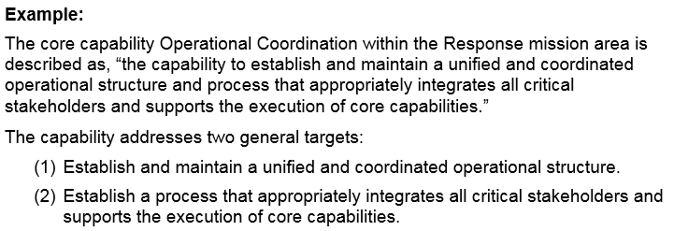
Add specific quantitative or qualitative measures to make the target measurable. Generally, the quantities/qualitative measures are based on targets identified as part of an organization’s or jurisdiction’s threat, hazard, and risk identification process, or in organizational plans, policies, and procedures.
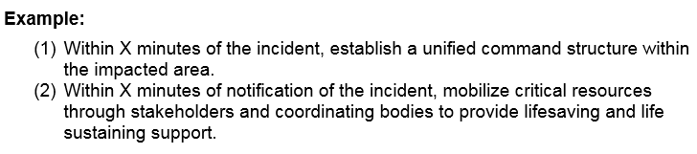
- Identify Critical Tasks: Identify the critical tasks needed to accomplish the capability target and demonstrate the capability. Critical tasks may be derived from organizational plans, policies and procedures; discipline-specific standards; AAR improvement areas or corrective actions; and/or national Mission Area Frameworks.
  - The capability targets and critical tasks in the EEG can be tailored to reflect the exercise type. In an operations-based exercise, evaluators observe exercise players performing critical tasks. In a discussion-based exercise, evaluators observe exercise players discussing or describing how critical tasks are performed.
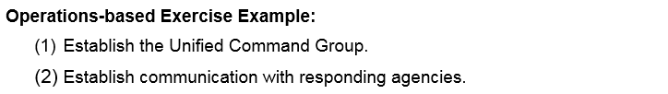
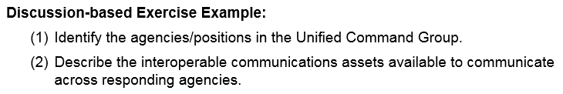
  - List the source(s) of the capability targets and critical tasks. This will allow evaluators to references plans or other documents as needed, as well as assist in the development of the AAR.
- Review and Refine: Review the EEG to ensure the capability targets and critical tasks can be accomplished within the time and scope of the exercise and organization’s extent of play.
- Finalize: Once the capability targets and critical tasks are finalized, copy the information to page two of the EEG.
- Coordinate with the Planning Team: Ensure that the draft and final EEGs are shared with the Exercise Planning Team. The planning team will use the capability targets and critical tasks to guide their development of the exercise scenario narrative, Master Scenario Events List (MSEL), and/or discussion questions.

