Great Value Mandarin Orange Whole Segments in 100% Juice, 48 oz, 12 Count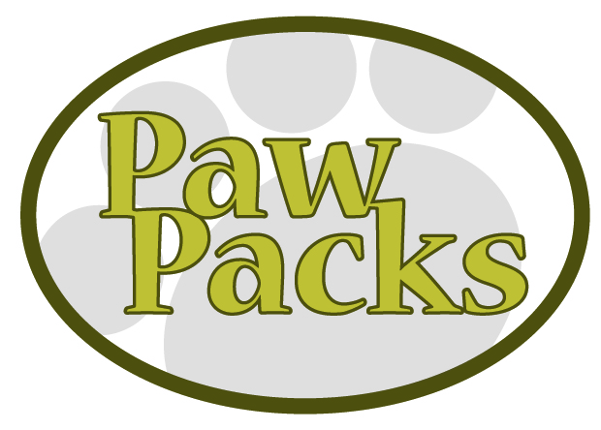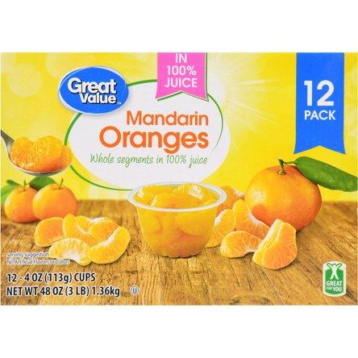

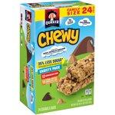

Quaker Chewy Granola Bars, Less Sugar Variety Pack, 24 Count

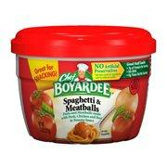

Chef Boyardee Spaghetti & Meatballs In Tomato Sauce, 7.5 oz

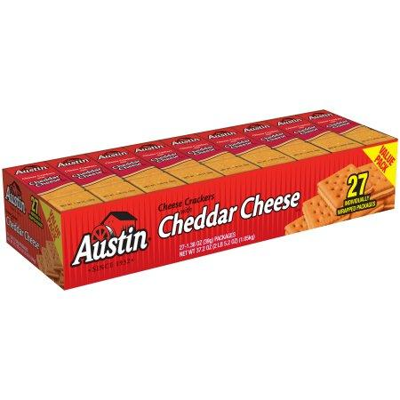

Austin Cheese Crackers with Cheddar Cheese, 1.38 oz, 27 count

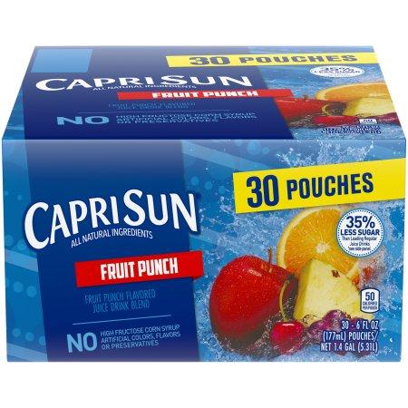

Capri-Sun Fruit Punch Juice Drink 30-6 fl. oz. Pouches

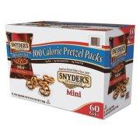

Snyder's Mini Pretzels 100 Calorie Pack, .92 oz, 60 Count

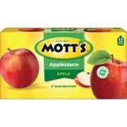

Mott's Applesauce, 3.2 oz, 12 count

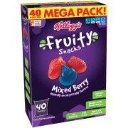

Kellogg's Fruity Snacks Mixed Berry Fruit Flavored Snacks 40 ct 32 oz.

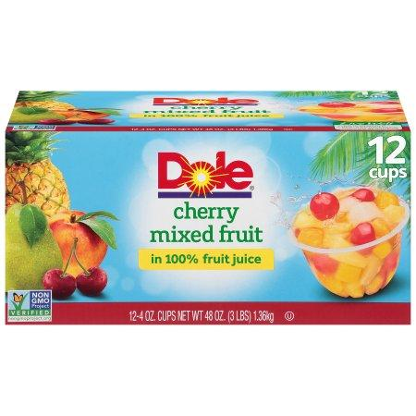

Dole Fruit Bowls, Cherry Mixed Fruit in 100% Fruit Juice, 4 Ounce (12 Cups)

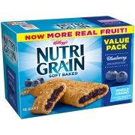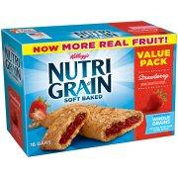

Kellogg's Nutri-Grain Value Pack, Soft Baked Breakfast Bars, 1.3 oz, 16 ct

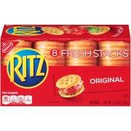

Nabisco Ritz Original Crackers - Fresh Stacks, 11.8 oz

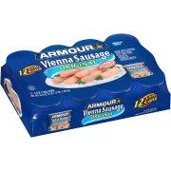

Armour® Original Vienna Sausage 12-4.6 oz. Cans

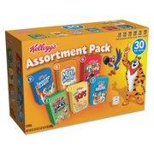

Kellogg's Breakfast Cereal Mini Boxes, Assorted, 2.39 oz Box, 30/Carton

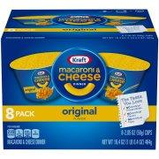

Kraft Original Flavor Macaroni & Cheese Dinner 8-2.05 oz. Cups

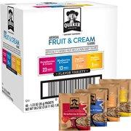Quaker Instant Oatmeal, Fruit & Cream Variety Pack, 48 Packets

[Order Online Here](http://www.walmart.com/lists/view-events-registry-items?id=e813fa9e-9f3c-4132-aa2b-1eebc7679a12)