https://www.amazon.com/hz/wishlist/dl/invite/efLoGmK?ref_=wl_share
•

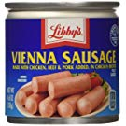

Libbys Vienna Sausage in Chicken Broth 18 Cans 4.6 oz. each
4.4 out of 5 stars (122)
Size : 18 Cans
22 Used & Newfrom $1.50
We need around 200 cans, so this can be a continuous purchase.
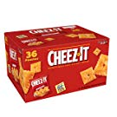

Cheez-It Baked Snack Cheese Crackers, Original, Single Serve, 1.5 Oz Pack of 36

•
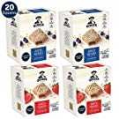

Quaker Baked Squares, Soft Baked Bars, Strawberry & Blueberry (20 Pack)Packaging May Vary

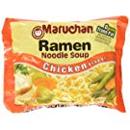

Maruchan chicken noodle soup pack of 36 - 3 oz

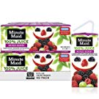

Minute Maid 100% Mixed Berry Juice, 6 fl oz Juice Box, Pack of 40
•
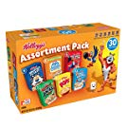

Kellogg's Breakfast Cereal, Assortment Pack, Frosted Flakes, Frosted Mini-Wheats, Froot Loops, Apple Jacks, Corn Pops, and Rice Krispies, 32.7 oz Tray (30 Count)

•
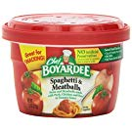

Chef Boyardee Spaghetti and Meat Balls 7.5 Oz Cups ( 6 Pack )

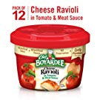

Chef Boyardee Cheese Ravioli, 7.5 Oz. Microwavable Bowl (Pack of 12)
4.1 out of 5 stars (445)

Best Seller
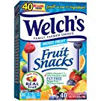
•
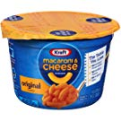

Kraft Easy Mac Original Flavor Mac & Cheese Dinner (2.05 oz Cups, Pack of 10)

