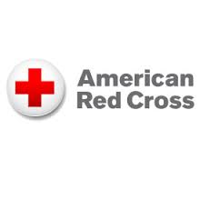

Lifeguard Certification /Recertification Course
Register Today!
Lifeguard Instructor/ EMT-Cardiac - Jonathan Murray
Contact at jmurray801@gmail.com 401-309-1742 or through
The Boys and Girls Club of Cumberland/Lincoln- 401-333-4850
Prerequisites
(Recerts not required to take prior to class)
Candidates must be 15 y/o, complete a 300-yard swim, retrieval of a 10lb brick from deep end, and tread water for two minutes without the use of their hands. This must be completed before the course can be taken. Must be taken at the Boys and Girls Club of Cumberland-Lincoln between 12pm-2pm on any Saturday or 1 hour before the start of the first class.
Candidates must bring a laptop to view PDF’s on, bathing suit, towel, and a positive attitude.
All other materials will be provided.

Certifications Received Course Times and Price
Lifeguard Certification Course
Two separate courses will be held:
First course held April 19th-22nd.
OR
Second course held June 21st-24th.
Times – 12pm to 7pm each day of the course.
Price - $275 CASH ONLY
Recertification-April 4th, April 20th, May 19th, June 22nd.
Time - 12pm to 10pm
Price - $150 CASH ONLY
- Lifeguarding
- First Aid
- CPR for Professional Rescuers
- AED for Professional Rescuers
- Administering Emergency Oxygen
- Blood Bourne Pathogen Training
- Epinephrine Auto Injector Training
- Asthma Inhaler Training

