The Women of WildAid Marine: Karima Cherif
March 30, 2021; Introduction & Interview by Mary Pantenburg, WildAid Marine Intern
Throughout the spring months, we will continue to highlight the incredible team behind WildAid Marine. The work we do to strengthen marine enforcement around the world could not be done without a diverse and dedicated group of experts.
Karima Cherif, Regional Project Manager
A one-hour interview with Karima is simply not enough, as she has a plethora of stories and advice to share. Karima is an assertive, driven, well-rounded photographer that has used her passion to make a positive difference for the oceans. While studying photography and traveling, Karima developed an interest in everything from plastic pollution to illegal fishing. These topics tugged her in the direction of marine conservation, where she felt she could make the most significant impact.
Karima’s passion for ocean conservation eventually led her to Africa, where she now works as a Project Manager for WildAid Marine in Gabon. These days, she strives to work efficiently with her time to balance her job with passion projects like diving and photography. Karima says, “If I can work for 2 hours a day and make an impact while also going swimming, I rocked my day!”
What do you do for WildAid Marine?
I am the Regional Project Manager for WildAid Marine in Gabon and also serve as the technical advisor and purchasing agent. I vet and purchase all the equipment that we are sending to our partners around the world.
Gabon is very close to my heart – when I was a child, my uncle was the Tunisian Ambassador in Gabon and I always wanted to go there. Gabon is a magical and sacred place, often referred to as the ‘Last Eden’ which is absolutely true! The mangroves and wildlife are incredible, including the famous ‘surfing hippos.’ The entire Gulf of Guinea is one of the richest fishing grounds in the world because five ocean currents converge there and the upwelling of different temperatures are teaming with life. The mangroves are nurseries for thousands of species of fish. Luckily, President Obonga created 23 marine protected areas in 2013 in Gabon recognizing that the natural heritage of his people and the world needed to be protected.
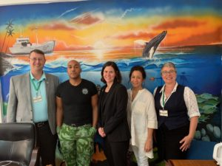
Karima (right) with the WildAid Marine team and partners in Gabon.
What first got you interested in oceans? Was it a documentary? A book? A friend?
My Polish uncle was a scuba instructor in Fiji when I was a child and, ever since then, I dreamed of being an underwater photographer and videographer…which I’ve been doing for almost a decade. In the late 1990s, I was mentored in Rangiora, French Polynesia by a French cinematographer that filmed “Le grand blu”. That same Polish uncle got me hooked on sailing and ironically enough ended up making his career as a fishmonger and named a 300-foot bottom trawler after my grandmother “Alina.”
Some books that inspired me were “Water Light Time” by David Doubilet and “Pool Light” by Howard Schatz. I had the honor to meet both of them. I ended up specializing in black and white infrared film for my underwater photography and ended up showcasing my work in several museums and galleries around the world. This background was very useful when choosing which IR/night vision cameras to acquire for our in-country partners and how best to protect this equipment from saltwater damage.
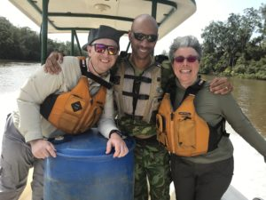
Karima (right) on assignment with WildAid Marine in Gabon.
How did your career in conservation start?
My career in conservation officially started in 2012 with Project Kaisei and Plastic Pollution Coalition. Project Kaisei was founded by Mary Crowley who is one of my personal heroes. To this day, Project Kaisei still collects ghost nets from our ocean. For Plastic Pollution Coalition, I was a project manager and social media lead. I led the development and implementation of programs to reduce single-use plastics at corporations and events such as Rio Earth Summit, Atlantic Nationals Regatta, and Outsidelands. I also lectured at Green Spa Convention, Monterey Peninsula College, Online Ocean Symposium, San Francisco Zero WasteYouth Conference, and Oakland Earth Day on plastic pollution reduction. I wrote two successful grants – the Buckminster Fuller Grant ($100K) and SF Zero Waste Grant ($4K) – and produced “Think Beyond Plastic,” an innovation competition encouraging businesses to create solutions that minimize plastic pollution.
My first project for WildAid Marine was a feasibility assessment for building a remote surveillance station in the Galapagos. The assessment reviewed whether it would be more cost-effective to build a ranger station on Pinta Island or to use a catamaran as a floating dock off of Darwin Island where much of the illegal shark finning took place. This project was a dream assignment because it drew on my sailing background, logistical analysis background, project management, and fuel consumption analysis which I love to geek out on!
More recently, I developed a ‘Tech Tool’ for our WildAid Marine team that is a compilation of what technological solutions, from GPS to radar and to waterproof cases, are the best for our projects. I also had the honor of participating in the development of O-FISH (Officer’s Fisheries Information Sharing Hub) which is WildAid Marine’s open-source mobile app that assists marine law enforcement agencies with vessel boarding.
What is one thing about your job or the work you do that might surprise people?
Our entire team works remotely. I can be anchored in the San Francisco Bay and be working with a site in Africa or South America. Our boss was in Hawaii for six months and I was in Newfoundland for three months and then Tunisia for two months, all while continuing my work.
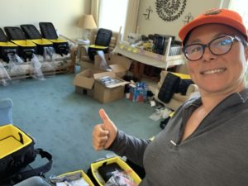
Karima packing surveillance kits for WildAid Marine.
What gives you hope for the future of our oceans?
I love the concept of the Ocean Decade that the United Nations launched in 2021. I think that COVID-19 has changed our world incredibly and now people recognize that we can accomplish so much without the carbon footprint of flying to exotic destinations, like Brazil and Palau, to talk about real ocean solutions. I am one hundred percent behind WildAid Marine’s objective to support 250 marine protected areas by 2025, and the United Nations’ objective to protect 30% of the ocean by 2030. The ocean needs all of us to join together.
It is my personal objective to also focus on protecting the other 70% of the ocean by using satellite technology, marine surveillance, and enforcement. I am also excited to see countries partnering up to share the responsibility to protect important waterways, like the shark highway between Cocos Island, Costa Rica, and the Galapagos Islands, Ecuador. Now that we have more experience with the importance of MPAs we can define their parameters by more critical data, such as spawning grounds, rather than just aiming for large MPAs.
If you could tell your younger self one thing, what would it be?
I would tell my younger self that the world is your oyster, imagine the life you want, and believe that you will make it happen.
What is the best advice for young women trying to go into conservation?
Take a piece of paper and write down five imaginary titles for your new career in conservation. Then go on LinkedIn and interview women that have those titles or something similar and, at the end of the interview, ask them for a job.

